Visit of Brod. Rene De Rueda to the Betan Centennial Forest
U.P. Miagao Campus, Iloilo Province
July 26, 2008

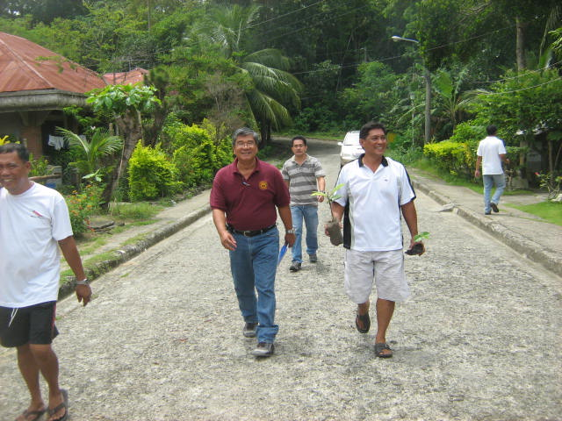

The site is barely 10 minutes hike…
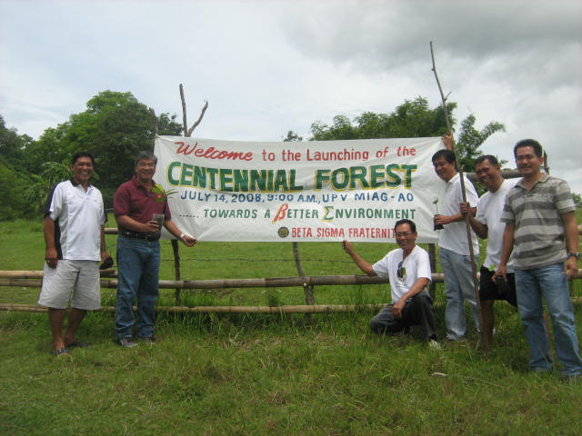
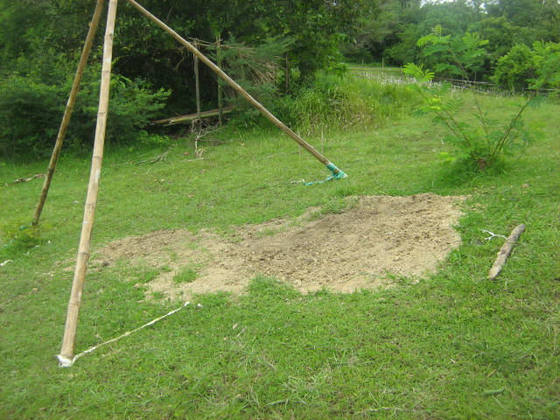

Time capsule buried here with souvenir pictures and documents of the Centennial Forest to be opened after 20 yrs.

On this site a gate and a signage of Centennial Forest will BE erected

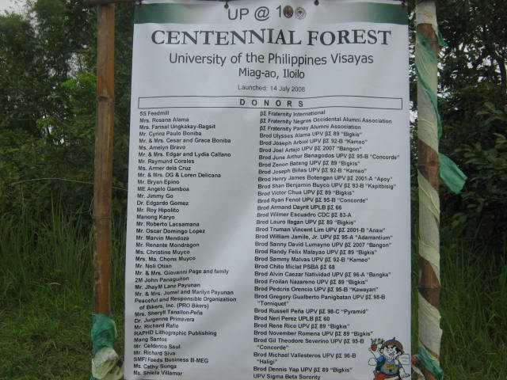

Wall of Donors will be properly walled on a Betan shed in the Centennial Forest Park. Target 2010.

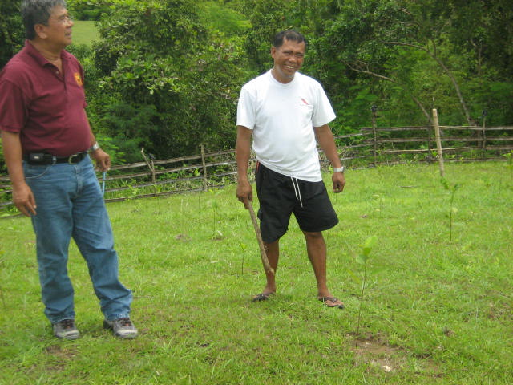0
So Brod Jules this is the 3 Has. Assigned by UP to the Fraternity for Tree planting. All the Deeds of assignment and documents are in Order as you mentioned.

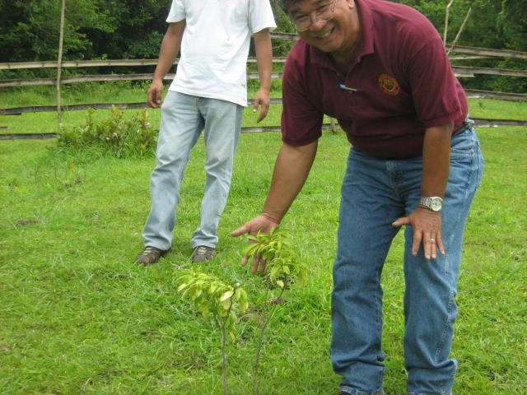
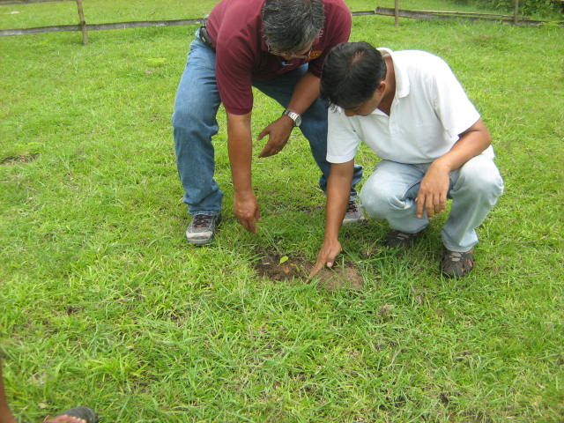

I am glad this indigenous specie is growing well. So we expect to plant 100 different species on this Betan Forest. And over 3000 plants. Wow.
Brod Froi to fertilize you need almost a teaspoon for each plant and a foot away from the plant. Inorganic for booster and go organic thereon.

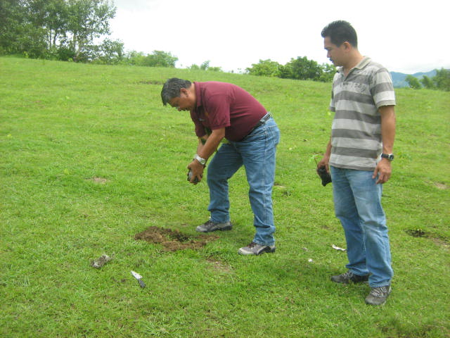
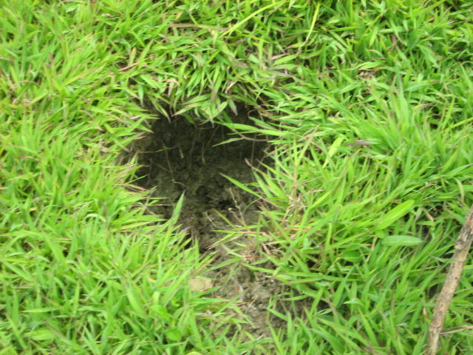

Brod Wilmer you should compressed the soil after taking out the nursery plastic bag before transplanting.
The young plant died here due to untimely transplanting of the seedling, not enough soil to built a soil mount which caused a water logged situation.

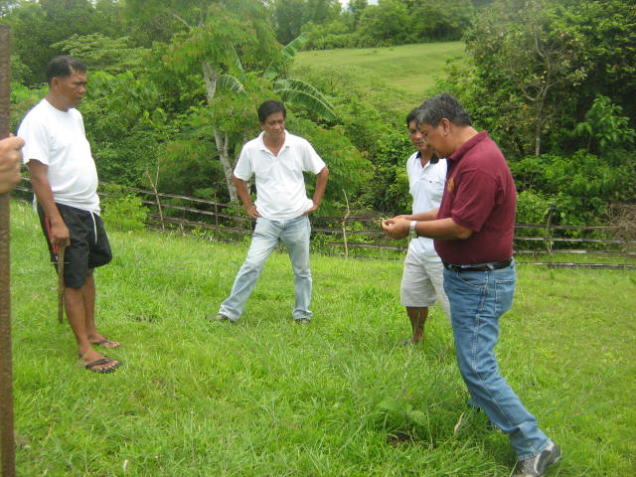
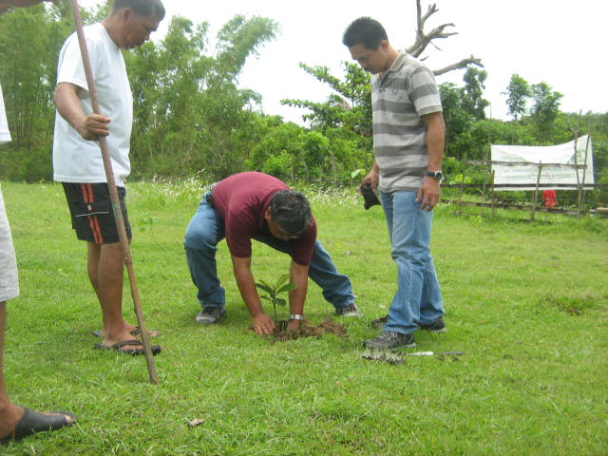

Brod Anthony this shrub is a cure for cancer called “Pandakaki”

Compressed the soil of the ground after you plant the seedling.

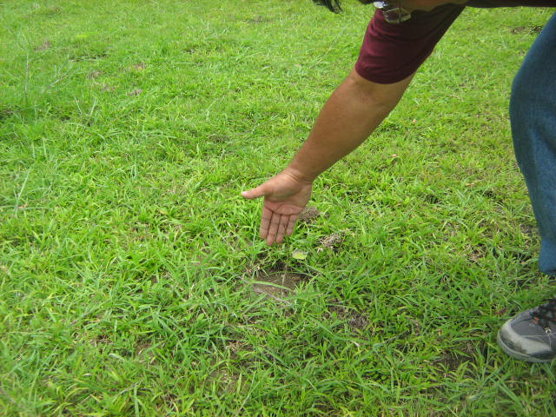
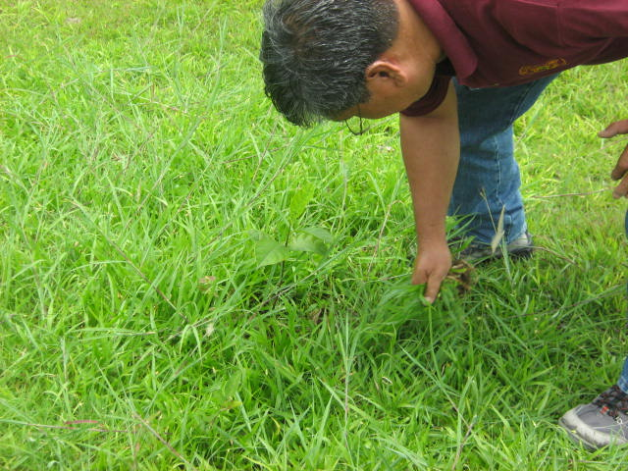
To young to be transplanted this one needs extra care

Certainly you need extra labor to weed and lessen mortality

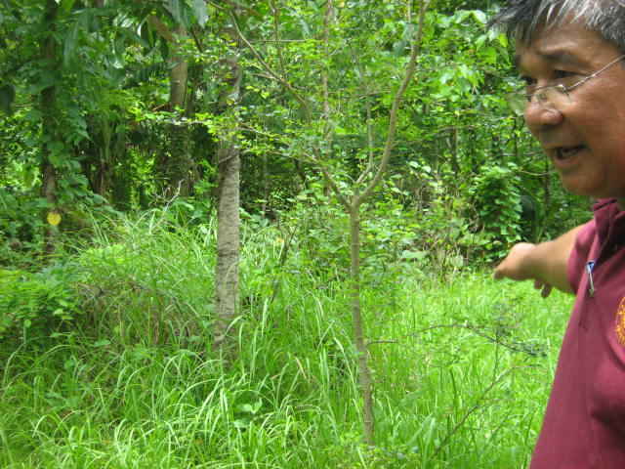
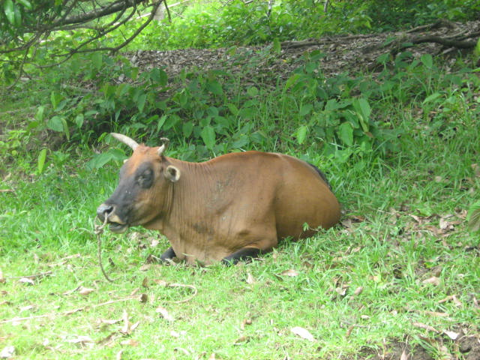

Brod Tawi this is a good place for your organic composting lots of leaves and shade

Brod Armand ahh domans pala ..ito ba ang isa sa mga baka which keeps on encroaching our project. Brods talk kayo sa owner or else make the owner our “utility worker” para ma keep away nila ang mga animals. Domans make a plan for pasture grazing for the animals outside the property. Siratro, Centrosema, Calipogonium, and some other leguminous plants ask from D.A for seeds.
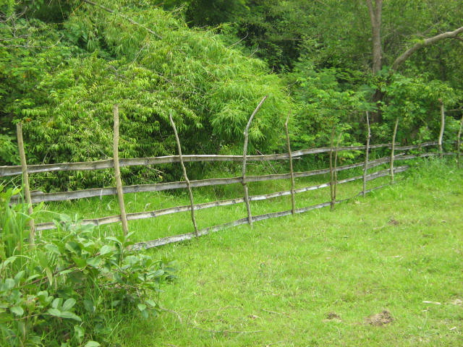

No wonder the animals come and go.. ito pala ang fence.

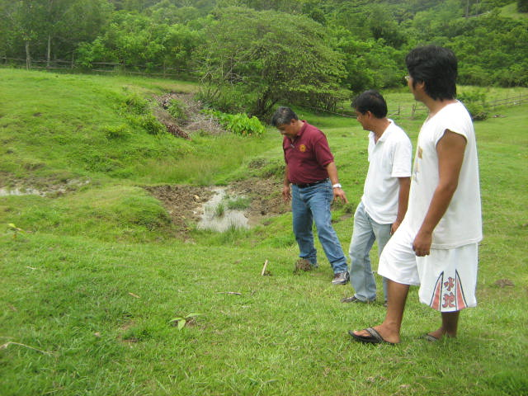
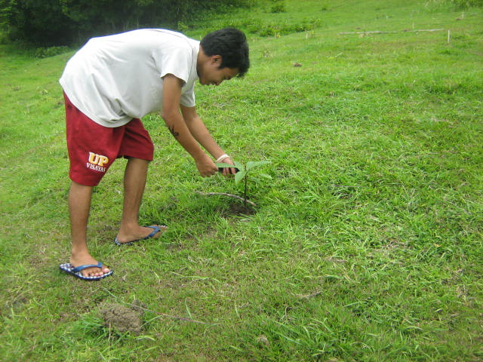

Sino kaya sa amin dalawa ng “apitong” na ito ang unang lalaki..Brod Joel ito.
This is a good water well para sa plants natin, bakuran ninyo brods para hindi na puntahan ng mga baka.

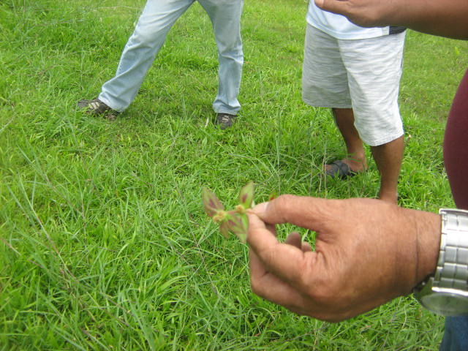
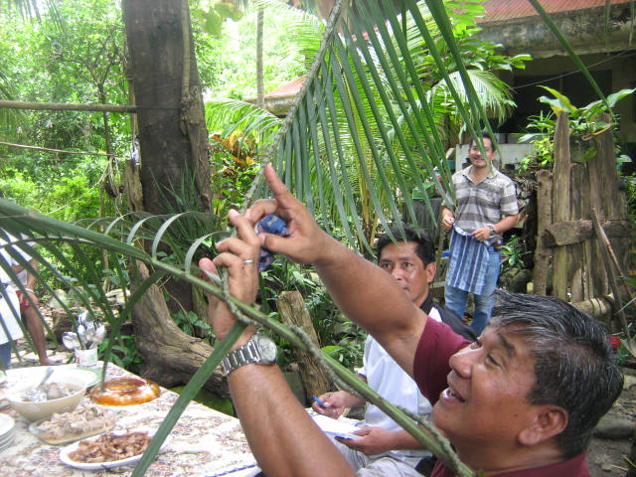
Brods educational lang ito. This vine is use for abortion called “manangal”
And this one is called “gatas gatas”
Boiled and taken as a drink it is a cure for “dengue fever”

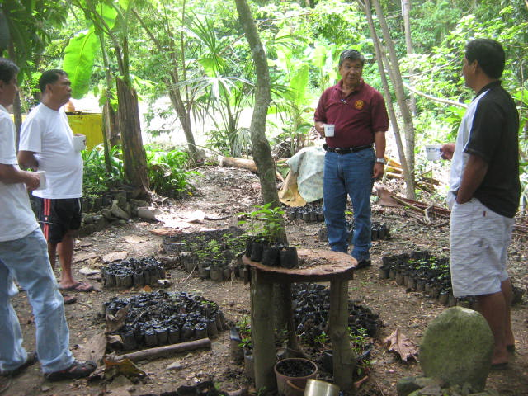
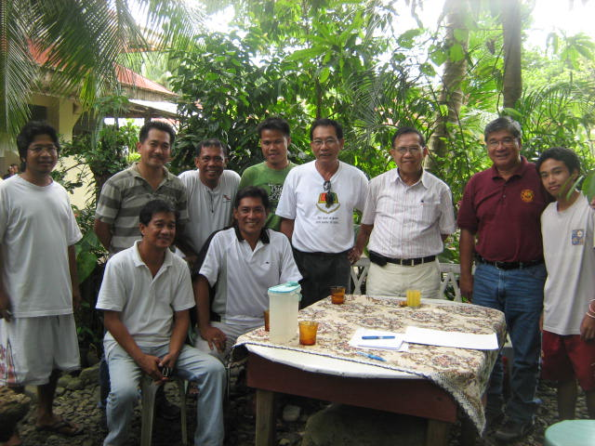
Ok na itong nursery however it needs to be relocated where enough Sunlight can get to the seedlings. A few meters from here.
Exit Conference with Brod Rene de Rueda and Brod Dario Sabularse( who came in just in time)
(From left) Tawi, Wilmer, Froi(seated) Julus, William, Anthony(seated) Domans, Dario, Rene, and Joel
Photo/Reported by: Armand”domans” Dayrit BS 66 UPLB

