Environmental Awareness
A monthly publication of UP BETA SIGMA FRATERNITY, INTERNATIONAL, INC.

September 2009
Tagore once said that plants are the earth's endless effort to speak to the listening heaven. Indeed, in a world that is at the cusp of disaster due to wanton human abuses, plants have been interceding in man’s behalf to avert a tragic outcome. However, in the process of cleaning up man’s mess, plants themselves have fallen victim to the very mess that they are fixing, some needlessly sucked into the abyss of extinction.
In this September issue of Environmental Awareness, Brod Vic Battad offers expert tips on plant care with the hope that every Betan may become an enthusiastic partner to a greener earth that the heavens will delight in listening to.
About the Author
Brod Vicente “Vic” Battad, UPLB 68a, has 11 years of Canadian experience in greenhouse growing - 9 years in tomato production and 2 years in floriculture, using state-of-the-art equipment for climate control and fertigation (fertilization and irrigation). Presently, he is one of the Growers of Rainbow Greenhouses, with a total growing area of almost 1.5 million square feet, in British Columbia and Alberta provinces. He is also a part-time Consultant on greenhouse tomato production with the Gerson Lehrman Group. He is a 1971 graduate of BS in Forestry from UPLB.
More about the author at the bottom of the article.
TIPS ON PLANT NURSERY
By Vicente “Vic” Battad, UPLB 68a

This article started as “Tips for Tree Nursery Practices (Part 1)” that was sent earlier to UPV Brods as informative reading materials for their Centennial Reforestation Project. In as much as Brod Willie “Tatang” Vergara thought that it would be a good write-up for the ENVIRONMENTAL AWARENESS column in our website, I expounded on some topics and added pictures to emphasize what I am trying to point out.

It would not be surprising at all if some of you might not agree with everything that is written in this article. It is understandable because I do not claim to be an authority on horticulture as I have no formal education on horticulture. My only claim is that I have a passion for learning, I work with no fear or shame of soiling my hands and I am not afraid to do things and learn from my mistakes. I am a Silviculturist (Forester) by profession, majored in Forest (Logging) Engineering and spent most of my career with the private/business sector. I left Benguet Management Corporation (BMC) when the company closed its timber operations because of the logging ban imposed by the government on areas above 1,000 meters in elevation (the habitat of the Benguet Pine forest is 1,000 – 2,000 meters above sea level).

Upon arrival in Canada, a former classmate of mine in UPLB and also a co-worker at BMC who migrated to Canada in 1989, gave me a tour of the tomato greenhouse where he was working. I was amazed by the greenhouse technology and was fascinated by their growing techniques that I decided to change my career. Being in my 40’s, I thought that it would be difficult for me to work in the forest and start again from the bottom, plus the fact that I may not be able to handle the severely cold weather in the mountains, that I decided to be a farmer instead. Furthermore, being an operations man for the past 25 years, I had to be away from my family most of the time that I thought of working near my family this time. I opted to work with my friend in his tomato greenhouse, starting as a crop technician and that ended my career as a forester and paved the way to my becoming a Grower (manager of a greenhouse) in Canada.

When first interviewed for the position of an Assistant Grower in a newly-built tomato greenhouse, I was asked, “What would a Forester be doing in the greenhouse?” I replied, “There is only one Plant Physiology --- a plant is a plant, whether it is a tree or a vegetable. All plants need water, nutrition, light, carbon dioxide, etc. The only difference between a tree and a tomato or other plants for that matter is their cultural requirements. With my educational background as a Silviculturist, it would not be difficult for me to learn how to become a horticulturist and grow tomatoes”

So I learned all the details of what is going on inside a greenhouse through sheer determination, dedication and “hard-knock”. This article is mainly based on my acquired knowledge by attending monthly growers’ meetings, seminars, study groups, reading books and articles for tomatoes and studying how to “read” or diagnose the plants. For floriculture, I gained a lot of new information by attending the Ohio Florists Association Short Courses and Trade Show, subscribing to magazines (Growers Talk), and reading pertinent articles on-line. All these acquired knowledge, experiences and learning through mistakes helped me in becoming a successful Grower in both Greenhouse Tomato Production and Greenhouse Nursery (Floriculture) Production.

Tips on Plant Nursery Practices: Plant Longevity

Growers have a saying: “Spare the roots, they can make or break your crop”.

The key to plant longevity is directly associated with root development. Healthy roots will continue to feed long after the plant is out-planted (planted outside the nursery). Some of the very important factors affecting root development are watering, media, nutrition, temperature, humidity, carbon dioxide and light. These factors can be controlled in a closed environment like the greenhouse, with the use of computers. In an open field, only watering, media and nutrition can be controlled. I would like focus my discussion on these three controllable factors.

Watering

So what is the big deal about watering? It may be nothing for a backyard gardener but it is a tough job if it is a large scale crop production like a greenhouse or nursery. A watering decision could be a million dollar decision or equivalent to the value of your crop. There is what experts call the “Art and Science of Watering” (P. Allen Hammer, Ball Redbook, Volume 2, 17th edition, 2003).

To understand the “Science of watering”, we need to understand the container root medium (potting materials) water relations with container capacity and perched water table.

Container capacity refers to the condition when a container is watered and drainage has occurred. The container is then considered fully saturated and watering further the plant will only result in additional drainage of water. A well drained root media should have a good balance of both water- and air-filled pores even when fully saturated, whereas, a poorly drained root media has little air-filled pores when fully saturated. This means that a good root medium should also hold enough water so it does not have to be watered frequently, yet it must have adequate air for root growth even at saturation point.

Perched water table refers to the “free water” at the bottom of the container after watering and drainage has occurred. This is considered “free water” because it is not held by the root medium and as if the bottom of the container is sitting in water.

Plants usually make roots only above the perched water table where there is adequate aeration (oxygen). As the medium dries up and the perched water table goes down, the plants will chase the water or search for water, hence, the plants make roots.

The art of watering is determined when the plants need watering and applying water properly. Generally, plants should be watered just before wilting or just before water stress occurs. Experienced Growers can easily determine by ocular inspection when a plant needs watering. Growers call it “dull” appearance of the leaves. A better way to determine moisture is to pop out the plant from the container and by using the back of the hand, feel the medium. If it feels cool, there is still moisture in the medium, but if it feels warm, then it is time to water. Watering properly means that the medium is fully saturated at every watering.

While checking the moisture of the medium, check also the roots. Healthy roots are white and the medium smells “sweet”. Unhealthy roots are hard to distinguish from the medium (dark colored) and the medium will smell rotten.

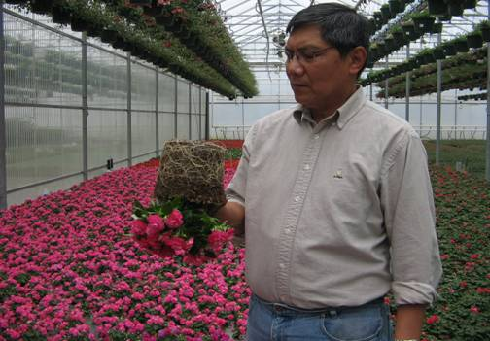
Visually checking the conditions of the roots and the moisture content
of the medium before doing irrigation or watering

Over-watering occurs when plants are watered frequently, and not by applying too much water during one-time watering. When over-watering occurs, the plant will not make roots and existing roots will die quickly.

Over-watering and under-watering are two ends of the same spectrum. In over-watering, the medium has insufficient time to dry between watering and the pores retain too much water for adequate aeration. This is not conducive to healthy root development but will result in increased root diseases. Low oxygen level in the medium suppresses growth and reduces nutrient uptake.

On the other hand, if the medium is allowed to dry too much before watering, (under-watering), the plants will also lack healthy roots. Under-watering can also increase the EC (accumulation of high salt) in the media and will burn root hairs. When the plants are watered again, the dead roots will rot, giving way to root diseases like Pythium, hence, the plant can no longer absorb water and nutrients necessary for plant growth. Watering practices play the greatest role in producing a healthy plant root system. Because the roots are unseen, it is easily overlooked in the plant quality equation until physiological problems can be seen from visible parts of the plants like leaves, flowers and fruits. By that time, it may be too late and flowers will be aborted, fruit quality suffers and the plant will die soon.
.
If you try to grow on the dry side, reduce your fertilizer to prevent accumulation of high salts. If you reduce irrigation, reduce also your fertilizer or you will fry the roots. Keeping salts and watering in balance is another key to produce good and healthy roots, hence, longer life for the plant.

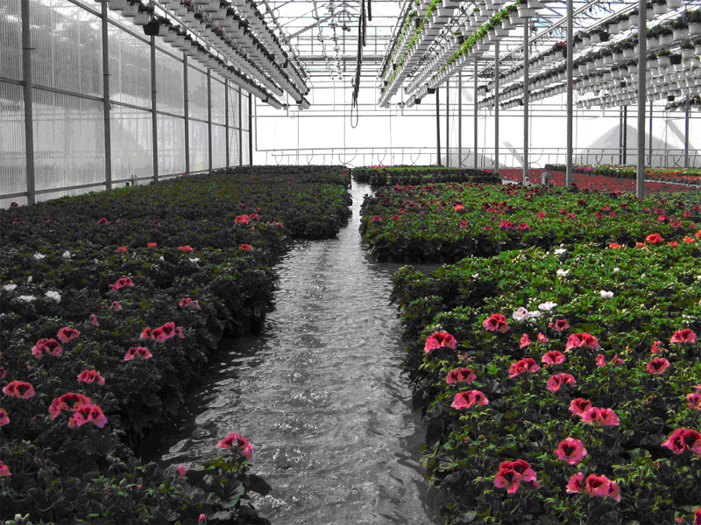
The “flood and ebb” type of irrigation for floriculture – the media moisture is uniform and fertigation
water is not wasted. The concrete floor is also heated to help dry the media and encourage rooting.

Growing Media

Tree planting stock differs from most ornamental plants because conservation and reforestation seedlings are essentially called “root crop”. This means that the quality of a tree seedling is determined by its out-planting performance – both for initial survival and for subsequent growth. We have to remember that after out-planting, the seedlings are left to the mercy of nature. Seedling survival and growth are directly related to the ability of the root system to immediately regenerate new roots (known as root growth potential or RPG) and grow out into the surrounding soil. For this reason, tree seedling container and medium should be designed to encourage the seedling to form a good root system in the nursery and also to protect these roots until the seedling is planted. (I mentioned to Brod Rene de Rueda during his visit to Everett, Washington early this year that one of the probable reasons for the low survival of seedlings in our reforestation projects in the Philippines is that the planting stock produced were not hardy and drought resistant enough to withstand harsh weather conditions in the field).

1. Physical properties

A good growing medium should be composed of lightweight organic and mineral components that are typically 60-65% solid by volume. This means that each container should have 40-35% pore space. The mixture of organic and mineral substances should provide plant support, air, and a water/nutrient reservoir that would provide nutrients and oxygen to the plant as it develops a healthy root system.

In Canada, the most popular growing medium comprises of peat moss, bark, sawdust, perlite, vermiculite, mineral soil, and muck peat soils. For greenhouse vegetable production, the most popular is sawdust. For floriculture, most mixes are either peat- or bark-based. With the scarcity of sawdust and bark coming from temperate hardwoods such as oaks, cedars, etc. (pine is not acceptable due to the presence of resin), imported coconut sawdust/coir became popular as an organic medium material both in greenhouse vegetable production and floriculture.

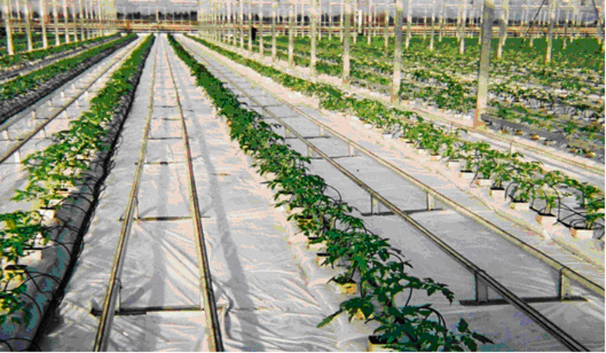
For vegetable crops like tomatoes, peppers and cucumbers, the growing block used is still made of rockwool (molten rock). The plants are placed on top of the sawdust bags (media) for 7-10 days so the plants could make more roots inside the growing blocks before they are inserted into the bags. These tomato plants were grafted, 2 heads per stock.

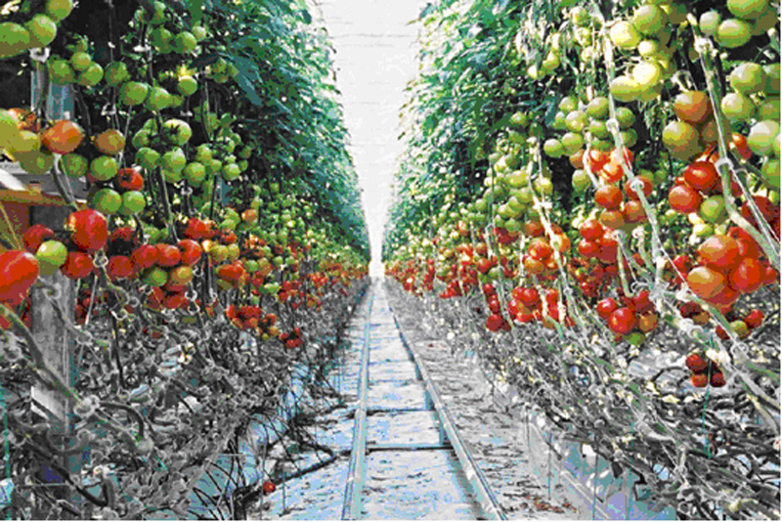
The same tomato plants 8 weeks after transplanting with the first trusses ready for picking. With strong root system plus the right climate settings, these plants are in a “fast-forward” mode. This variety (Clarence) is a medium-sized tomato with an annual yield of 54-55 kilos per square meter; for small-sized tomatoes like Campari, the yield is 37-38 kilos and for the beefsteak (large) variety like Rhapsody, 70-71 kilos. These tomato plants reach a length of 40-42 feet at the end of the season or 10-12 inches of growth per week.

In the greenhouse nursery where I work, we tried just recently, using a combination of coconut sawdust/coir (15%) and rice hull (15%) for our medium to reduce the bark and perlite/vermiculite components. The remaining 70% is still composed of peat moss, bark and perlite/vermiculite. This gave our medium a more organic and “greener” appearance as well as it is lighter in weight and drains faster. We found out that the plant can make roots twice faster than the peat-based medium that we had before. We also found out that coconut coir holds 10 times more air/oxygen. Furthermore, coconut coir and rice hull mixes decompose more slowly and shrink less over time, making them well suited for crops lasting longer than five months. For the Euphorbia (Poinsettia) that we planted this year, we removed totally the inorganic components (perlite and vermiculite) and increased the coconut coir and rice hull components.

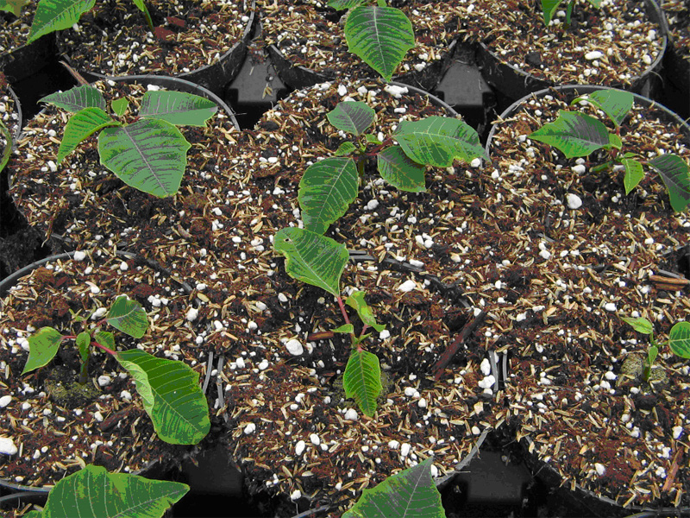
This medium is composed of 15% coconut coir, 15% rice hull, 20%
vermiculite/perlite (white colored) and the rest, peat moss (50%).

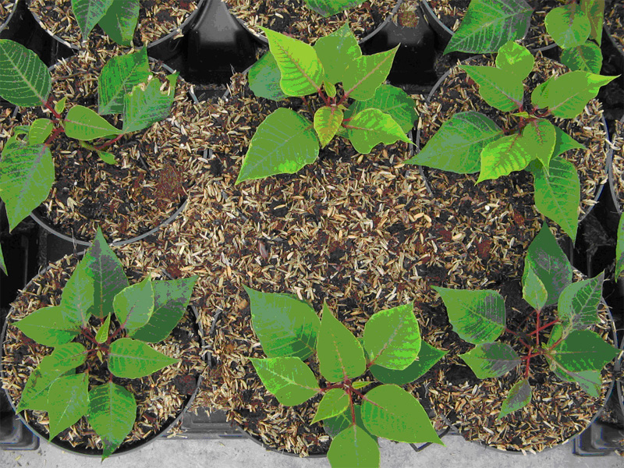
This is 100% organic: 25% rice hull, 25% coconut coir and 50% peat moss
In the Philippines, we have been using rice hull as a potting material for a long time. It is only now that it is being used here in North America. I am quite disappointed because the supply of coconut coir and rice hull in Canada comes from Vietnam and Sri Lanka and nothing from the Philippines
.
Another important consideration is media texture. Texture refers to the particle size of media elements and the air porosity level. Why is it important? Texture can affect drainage: the lesser air space in the media, the lesser it drains.
Do not compact the media. Compacted mix can definitely decrease the porosity. Once the medium is compacted in the container, it cannot be changed, unless the medium is repotted.

A medium that is compacted will dry out slowly, thereby decreasing the ability to feed the plant correctly and increasing the potential for root rot. A compacted medium will have less air and more water in the mix. This would reduce the ability of young roots to penetrate deep into the mix. Normally, when a medium has the proper aeration, roots can reach the bottom of the container in 7-10 days (for 6-8” pots) after transplanting, depending on the size of the pot.

One of the most critical aspects of plant production and also the most neglected is having and maintaining porosity. The amount of water needed can be adjusted, but the amount of air present in the mix can not be increased. Why? The air porosity is fixed at the time of potting and will only decrease over time. During transplanting, the physical properties of the medium will dominate the young roots and will dictate how fast and far they can grow. High porosity will bring rapid and robust growth and will allow the root system to take over the container. In my experience, the roots reached the bottom of the container, filling the whole container in 3-5 weeks. Low porosity will bring slow root growth and will delay or prevent the roots to completely fill the container due to poor aeration.

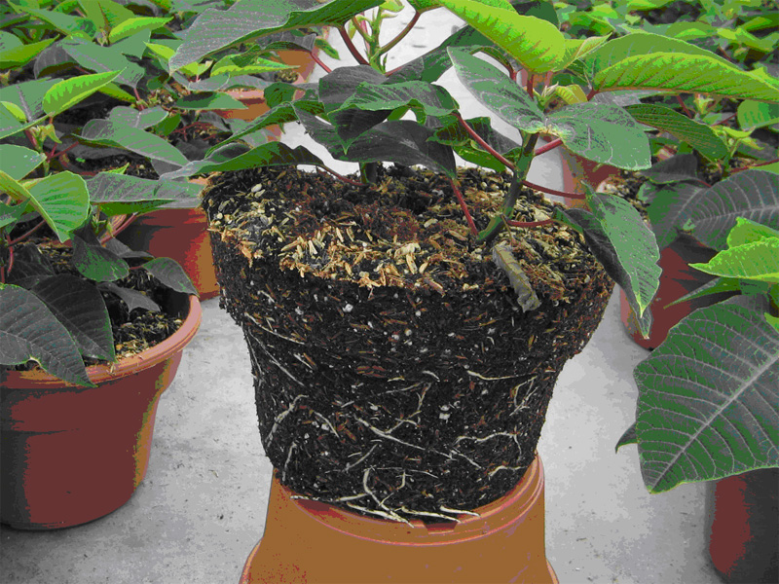
A 10-day transplanted Euphorbia (Poinsettia) showing the roots having reached
the bottom of the medium.

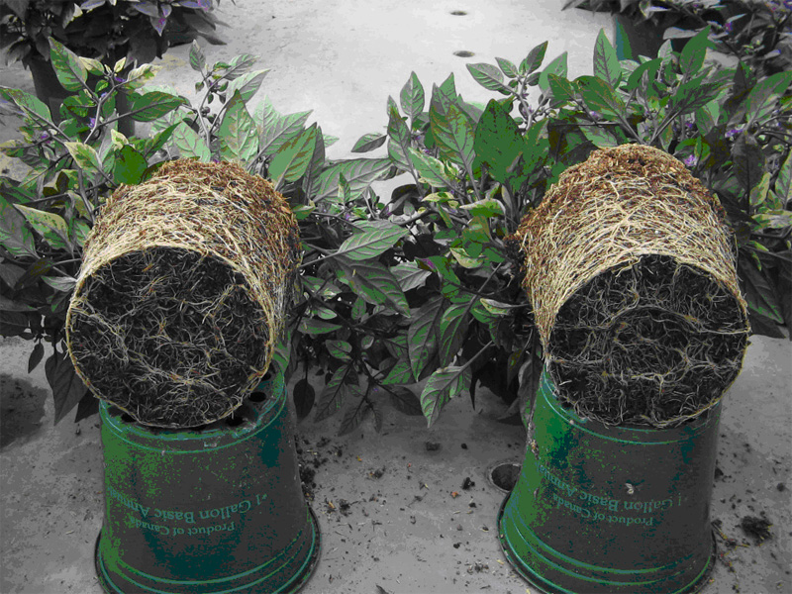
Two-month old ornamental peppers showing the roots having taken over the medium

If you are using coconut sawdust/coir, make sure to water the media thoroughly after transplanting to flush the excess salt especially if the source of coconut coir is taken from coconut trees near the seashore. This is my observation of coconut coir supply coming from Sri Lanka when I checked the EC (high) as soon as I saturated the bags with clear water.

Media Biology.

Bark or sawdust or coconut coir when adequately composted will suppress some root rots. During decomposition, beneficial microorganisms like nitrogen-fixing bacteria and mychorriza (beneficial fungus) colonize on the media mix. These beneficial microorganisms compete with the disease organisms and once the beneficial ones are in place, the pathogens have no place to live.

During my first time to use coconut bags as media for tomatoes, I observed the presence of mold-like mushroom in the media. I took a sample and sent to the laboratory at the University of Guelph in Ontario. The lab report showed that the mold is non-pathogenic and later the mold disappeared after a few weeks. However, I was advised to watch out for the slime mold (Ostracoderma sp) that has a gray threadlike structure (mycelium) that repels water. It grows quickly and causes the media to remain dry even with repeated watering. The report said that this is a common problem for open/field nurseries.

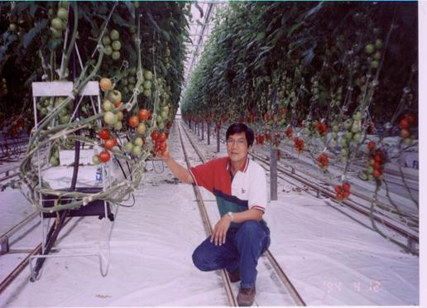

This is one of the latest innovations in greenhouse tomato production. The media are now coconut coir and are placed on top of an elevated (hanging) platform similar to a “gutter”. The excess fertigation water (leach) from the media flows to the end of the gutter where it is collected through a large drain pipe, passes through sand filter or UV rays to remove or kill the pathogens, then goes back to the fertilizer tank and recirculated (reused) again for fertilization.

Plant Nutrition

The nutrient demands for crop vary by development stage. Plugs and rooted cuttings require low fertility levels; nutritional needs increase as they become established and actively growing plants have the highest nutrient demands.

Fertilizers can give a lot of benefits to the plants: large leaves and stems and big flowers. Most people would think this is the making of a quality plant. But beware because when plant longevity is added into the plant quality equation, high fertilizer levels become a disadvantage. The more fertilizer a plant receives, the softer the plant becomes and the less time the plant will last when outplanted.

Among the factors affecting crop production, fertilizer has the greatest effect on plant longevity. However, it is not the application method that affects the plant quality but fertilizer nutrient ratios, source of nitrogen, and duration of application.

1. Acidity versus Alkalinity

It is important to know the optimal pH range for each crop because this will help determine if an acidic or basic fertilizer should be used. If not sure, a pH range of 5.6 - 6.2 would be safe with 5.8 as the generally accepted optimum pH. Low uptake of micronutrients (boron, copper, iron, manganese, zinc) will occur if the medium’s pH is above 6.5. Macronutrients like calcium and magnesium will be less available below 5.4.

Nutrient Ratios

a. Potassium-Calcium-Magnesium ratio – These three macro-nutrients compete with each other. Potassium (K) fertilization rate above 200 ppm can have an antagonistic effect on Calcium (Ca) or Magnesium (Mg) uptake by the plant. Supplying the plant with a K-Ca-Mg ratio (ppm) of 4:2:1 will limit any antagonisms.

b. Nitrogen-Potassium - Another example of mineral antagonism is the nitrogen-potassium (N-P) interaction; a 1:1 ratio is recommended.

c. Nitrogen nitrate and ammonium nitrate – Nitrogen nitrate should comprise 70% of the nitrogen supply of the plant and the remaining 30% should come from ammonium nitrate or urea.

For ready mixed or commercially blended plant nutrition, look for fertilizers that have low ammonium nitrate (Urea) and low Phosphorus (P) content. Ammonium nitrate is not only acidic (lowers the pH) but also makes the plant soft. It will make the plant nice looking (grow fast, lush leaves and big stem) but the dry matter content (density) is low. Such plant will easily wilt at the first sign of water stress when out-planted.
For Phosphorus, generally the plant needs only 5-10 ppm. For example, basic fertilizers like 15+2+20 or 13+2+13 have low P and ammonium nitrate. Beware of fertilizers like 14+14+14 Osmocote (type of slow-release fertilizer). This fertilizer has more than 50% ammonium nitrate (only 30% is needed). Use more than 50% ammonium nitrate or urea for short-term period only like correction of medium pH.

For tropical plants, I use the commercially blended 20+9+20 because it has low phosphorus (just enough) and low ammonium nitrate.
Another type of fertilizer that is popular for turf, tree nurseries and floriculture are the slow-release fertilizers. The nutrients are released slowly so plants can take up most of the nutrients and reduce wasted nutrients by leaching. It is very convenient because it requires less application. The downside is that slow- release fertilizers are more expensive but their benefits outweigh their disadvantages.

Water Stress (too much water) – Constant saturation (watering) of the medium will not only kill the roots but can also lead to plant nutrient deficiencies. As mentioned earlier, over-watering reduces the oxygen level, root growth will be limited and water uptake slowed. The inactivity of the root systems due to saturated conditions in the media can lead to insufficient uptake of all nutrients. Elements such as calcium, iron and phosphorus are mobile or transported via water flow and deficiency symptoms can develop rapidly.

Soluble salts level – Soluble salts refer to the total dissolved salts (fertilizers are salt-based) in the medium at any given time and is measured by electric conductivity or EC (salt is a conductor of electricity). When the EC of the medium is too low (below 0.25 millisiemens, mS/cm) or too high (above 1.25 mS/cm), growth is stunted and will result in mineral deficiencies and physiological disorders.

If a high clay mineral soil (low porosity) is used, the plant will have difficulty absorbing nutrients solution from the medium. Also a medium with high sand content will have low nutrient holding capacity resulting in physiological disorders. Both cases (high clay or high sand) will require frequent fertilization.

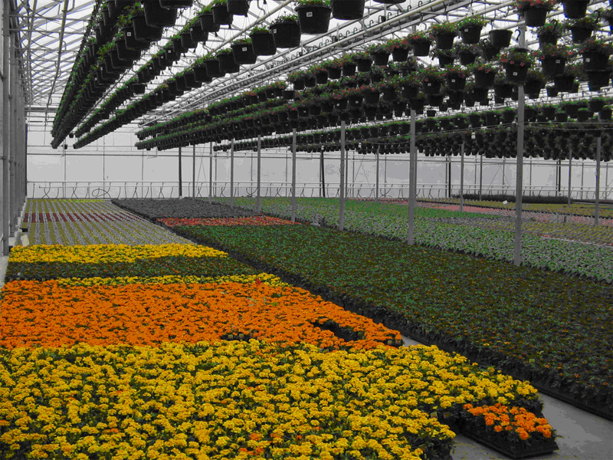
Maximizing the space inside a floriculture greenhouse. Two layers of hanging baskets
and 2 lines per house @ 500 baskets per line. There are several houses (8-12) in one
climate zone. Plants that have similar climate requirements are placed in one climate
zone and plants with similar watering requirements are placed in one house.

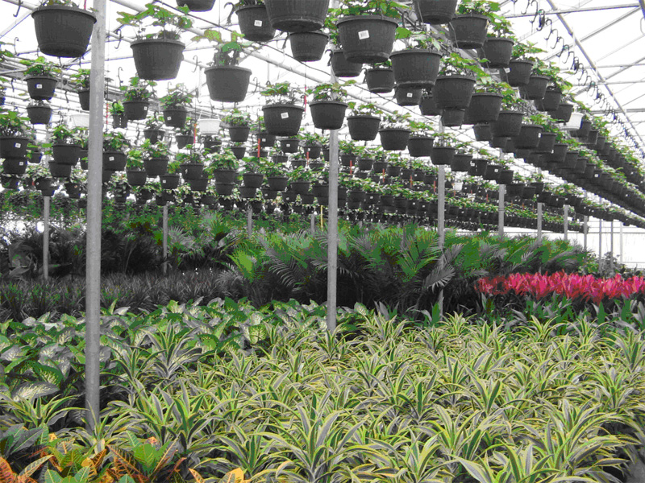
This is a tropical zone. With the aid of climate control programs, we can simulate
a tropical climate for these tropical plants even in cold countries like Canada.

MORE ABOUT THE AUTHOR (from Silviculturist to Horticulturist:
From corporate to farming)

Before migrating to Canada in 1997, Brod Vic has 24 years of work experience with the private sector and was involved in forest management, business management and strategic business planning. He was the Division Manager (Timber and Lime Division) of Benguet Management Corporation, a 100% subsidiary of Benguet Corporation. Being the concurrent President of the BMC Forestry Corporation, he was also in-charge of the Bobok Timber Project, Irisan Lime Project, Batuang Aggregate Plant, and Baguio Real Estate Development, all based in Baguio and Benguet.

When he left the private sector, he was Consultant with the DENR from 1995 to 1997 on matters pertaining to natural resources management plans, community-based forest management and protected areas and wildlife management; and on matters pertaining to international environmental commitments and those involved with the Asia Pacific Economic Cooperation (APEC) on Sustainable Development.

During the years that he was with Benguet Management Corporation, he attended short courses in business management (MDP) at AIM and strategic planning at the University of Asia and the Pacific (formerly Center for Research and Communications).

