Environmental Awareness
A monthly publication of UP BETA SIGMA FRATERNITY, INTERNATIONAL, INC.

The Case of the Damaged Coral Reefs
July 2008
Coral reefs are among the oldest and diverse forms of life. They provide food and shelter to fish and protect soil from erosion. A large part of the world’s population depend on the sea and its natural resources. An alarming 30 percent of coral reefs in the world remain healthy, down from 41 percent a few years ago. But there is hope, says author Popoy Castaneda. In one portion of his article, however, he presents another face of the marine protection programs in the Philippines -- the displacement of the subsistence fishermen who depend so much on the sea in order to provide food for their respective families.
Willie “Tatang” Vergara
About the Author
By this time, Brod Popoy Castaneda does not need much introduction especially for one who has been following his writings on this website. Suffice it to say that Brod Popoy is among the rich, if not the richest, sources of information pertaining to the marine and coastal situation in the Philippines.

Epilogue of “A Betan’s Journey Thru Time and Space”
By Brod Popoy Castaneda ‘55

From the wharf of Puerto Princesa where the Calypso departed for Singapore, I took a jeepney ride to the town of Inagawan. The Palawan Integrated Area Development Project (PIADP) office has a staff house in this town where I still enjoy status as a houseguest. After picking up my gear, I proceeded to the airport for the afternoon flight to Manila.

Back to the real world. I resumed my duties of managing the Mangrove Reforestation Project implemented by the Department of Environment and Natural Resources (DENR) for the Asian Development Bank. When the project was well on its way, Brod Delfin Ganapin, UPLB’72 reassigned me as a consultant for the Integrated Protected Area System (IPAS), a network of protected areas that the DENR was starting to organize in order to better manage and protect the country’s wilderness. My work was to assist in the survey and selection of areas all over the islands to form a network of protected areas insuring the survival of the Philippines’ wildlife and wilderness both on land and sea. After the surveys, I was tasked by Delfin to help in the formulation of management plans for the areas under the Debt for Nature Swap program, namely, Mt. Pulog National Park, Iglit Tamaraw Sanctuary, El Nido Marine Park and the St. Paul’s Subterranean National Park (now the Puerto Princesa Subterranean River National Park). It was at the tail end of this assignment when my two sons, who recently migrated to Australia, asked for help to take care of their kids. That meant I had to follow them to this foreign land. By June of the next year I was aboard a QANTAS jet bound for Sydney where I was reunited with my 2 granddaughters Dominique, six years old, and Denise, two. I had to “reinvent” myself to doing household chores, which was a great departure from doing marine surveys and ecological studies. I cooked meals, did the laundry, washed dishes, brought and picked up Dominique from school and baby-sit Denise.

On most nights, in the small room I shared with Dominique, I would go back to my canvas painting the birds of the Philippines – a way of coping with homesickness. I reminisced about the 19 or so years I worked for the good of the Philippine environment. I remembered my first visit to Apo Reef in 1958 skin diving and seeing for the first time the breathtaking beauty of a virginal coral reef. It was an experience that would eventually propel me to become a

professional diver and to work for marine conservation. Later, I would have the privilege to see the coral reefs of Palawan, which is reputed to contain 70 percent of the country’s coral reef treasure. I would also be sent to survey the reefs of the Visayan Islands to pinpoint areas for tourism development. I clearly remembered our first dive in Balicasag Island where we jumped into a milling school of palm sized Silver Trevally and for a brief second or two, we saw nothing but fish. I was told by the Peace Corps volunteers who were with me at the time that the Philippines is a divers’ paradise and presents the most captivating diving experience compared to the rest of the world. Indeed, I have witnessed the most beautiful marine resources our country could offer.

The Beauty and Magnificence of Healthy Reefs

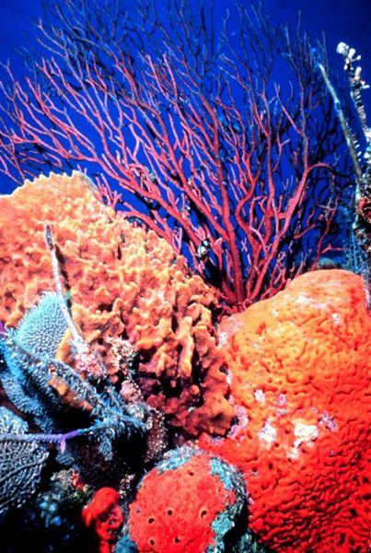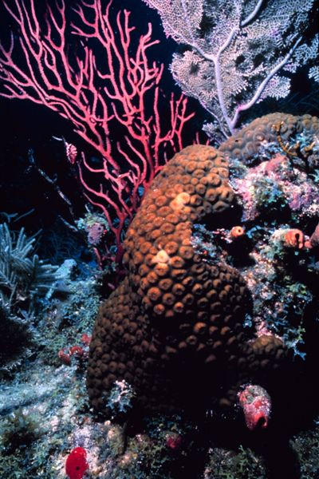

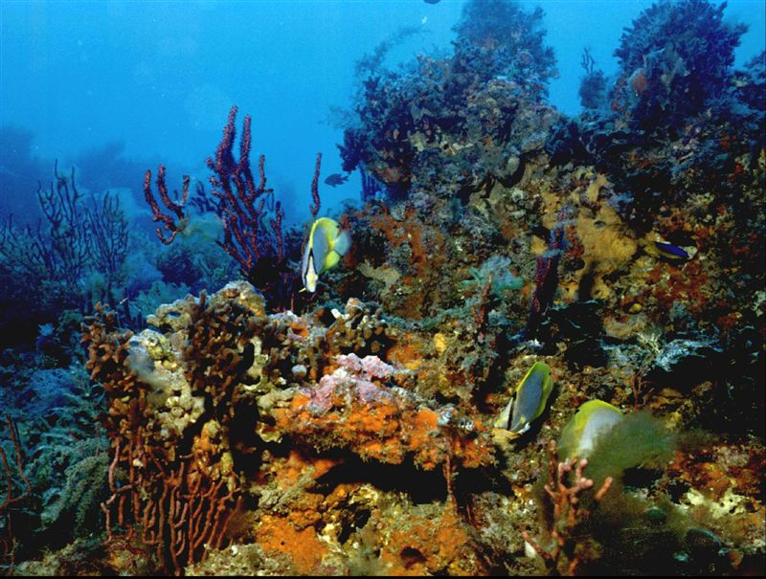

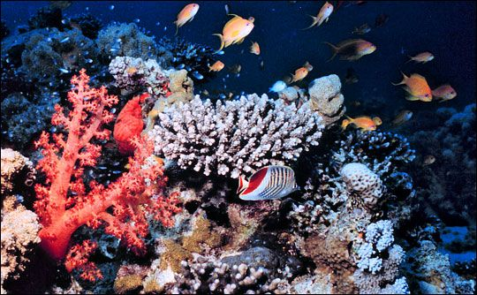

But then that early, the reefs were already being damaged, abraded and scraped by fishing activities, by blast or dynamite fishing or use of toxic chemicals, in addition to legitimate but intensive fishing activities by local communities of the coastal towns in order to wrest a living out of the sea. As a result, overfishing and other illegal fishing activities have decimated fish populations.

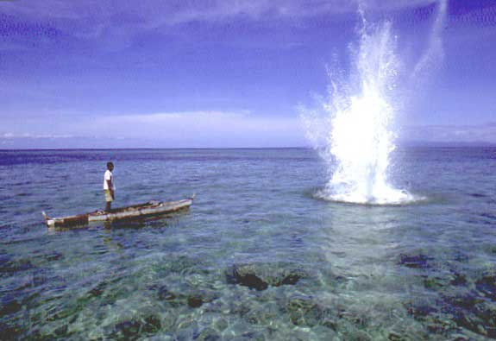
Blast Fishing

The Agony of Damaged Reefs

On a global scale, it is said that only about 30 percent of the world's coral reefs are healthy, down from 41 percent two years ago, according to a study released recently. Climate change is said to be the biggest culprit. The study found as many as one-fifth of the world's coral reefs have been totally destroyed. If there is any good news at all, the study said that about half of the damaged reefs could still be restored. Coral reefs are among the oldest and most diverse forms of life. They provide food and shelter to fish and protect shores from erosion. It is really amazing that these natural resources cover only one percent of the earth’s surface, yet mean so much in the economy of many countries -- $375 billion in economic benefits globally, according to the study by 240 scientists in 96 countries. With climate change (some call it global warming), the earth is now experiencing higher water temperatures and carbon dioxide concentrations, causing coral disease.

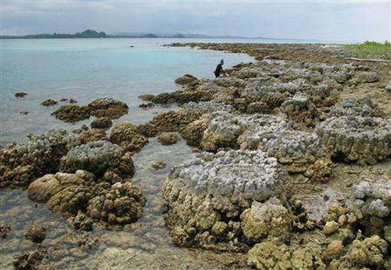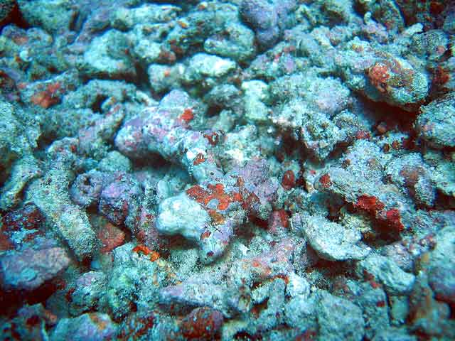

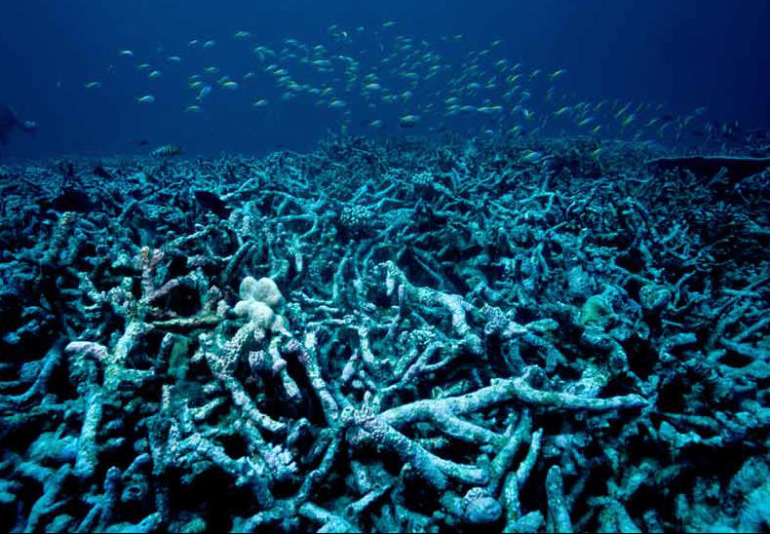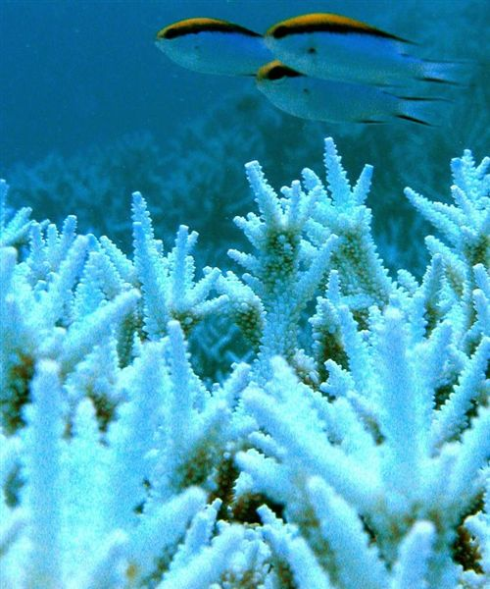
Damaged by warming Damaged by land disturbances

Today, the pressures of feeding a rapidly expanding human population have greatly reduced the numbers of large fish and made the lives of the people living in small subsistence fishing villages increasingly difficult. It was not very long when I came to realize how dependent fishing communities are to coral reefs, and that fishermen nowadays have to go farther and farther away into the ocean to be able to catch some fish.

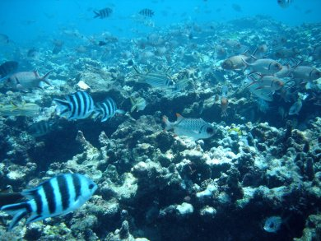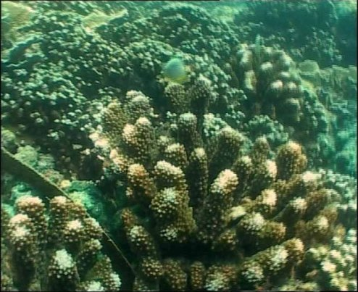
Bleach-damaged coral reefs

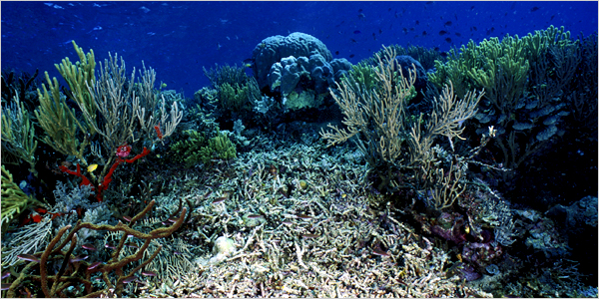
Reef damage from blast fishing

Among my fondest recollections was the opportunity to lead the biological survey and to study the now famous Tubattaha Reef. Yet even this vast isolated reef is not without its traditional divers. On summer months, the people of Cagayan islands travel more than a hundred nautical miles northeast and bring their Kumpits inside the reef’s lagoon. They stay anchored for weeks fishing and drying their catch. Such is the same for Apo Reef where artisanal fishermen from the coastal villages of western Mindoro traditionally fish. The more adventurous would bypass Apo Reef westward to Hunter Rock. The same situation exists at Scarborough Reef - 95 nautical miles west of Subic Bay, Zambales where fishermen from Zambales venture out to fish for tuna.

I also recalled our efforts during those early days to educate the people including those in the DENR and the Bureau of Fisheries and Aquatic Resources (BFAR) about the importance of the country’s coral reefs. Sadly at the DENR, the Marine Biologists of the Coral Reef Project would be referred to as “Don Quixotes” pursuing an impossible dream to preserve the precious coral reefs. But with the emergence of scuba diving as a popular sport, people began to appreciate the importance of the coral reefs. The DENR initiated the Marine Parks Program and even the Tourism Department embarked on a similar project.

Four years ago, after an absence of 12 years, I returned to the Philippines to write a book about the reefs of Palawan, a guidebook for divers. I saw that there were a lot of activities going on regarding our environment; more people are now aware of what is happening with our natural resources. Scuba diving had flourished even more, and even the not-so-young took on. High government officials had taken the sport, too, as a means of gaining status as environmentalists. Billionaires and millionaires are now taking up the cudgels for the environment -- the Zobels are with World Wildlife Fund, the Lopezes even have their own wildlife foundation. Especially among the Philippine rich and famous, it has now become fashionable to be labeled as an environmentalist -- a status symbol, by all means.

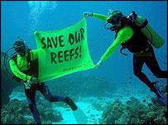
The name “Tubbataha” is the Samal word for “long reef exposed at low tide”. Samals are seafaring people of the Sulu Sea and are one of the few people who have accessed the park in the early 1980’s. Cagayanen people who are more geographically associated with Tubbataha Reefs referred to the park as “gusong”. (Source: http://www.tubbatahareef.org – The Official Website of Tubbataha Reefs)

Tubattaha Reef is now a UNESCO Nature Heritage site as well as the Puerto Princesa Subterranean River National Park. A lot of non-government organizations are getting foreign funding for environmental work from the International Union for Conservation of Nature (IUCN), UNESCO, and Conservation International. At present, the IUCN has a project studying Verde Island off Batangas as a center for marine species diversity in the region. A lot of areas in the marine environment are being earmarked for declaration as protected sites. In Palawan, environmental protection has been elevated to the status of a political issue during election, as Brod Del Ganapin had planned it to be when we were consultants.

Yet in spite of all these, the incipient issue about conflict in resource use and allocation remains unattended. In the Philippines, the fishermen are the poorest of the poor. A lot of fishing communities exist on a hand-to-mouth existence, which earned them the description of “subsistence fishermen”. These people do not eat if they do not catch anything. Right now a lot of traditional fishing grounds are depleted especially in the Central Visayas. This gave birth to a new boat culture -- fishermen from the Visayan Islands venture out as far as the South China Sea to fish, virtually living on board their big outriggers. Some of them are reputed to use dynamite and cyanide to fish. They have become a familiar sight in the isolated reefs and islands of Palawan. Being better equipped, they compete for the coral reef resources that the local island communities depend on. The government and the private sector are trying to remedy this situation by creating protected areas, but the implementation and management of this effort oftentimes neglect the welfare of the traditional users.

A stark example is Tubattaha Reef. When it was decided to impose the “no fishing-no taking” rules in the park, they dislocated the Cagayan Islanders who traditionally fish in the reef every summer. I have seen that all the coral reefs in the Philippines are traditionally used by fishing communities. These include the reefs at the edge of the Palawan Passage which are the traditional fishing grounds of the Pangawilan boats that originate from Mindoro and Batangas. Any management measure that fails to address their needs deny them access to the resource. In short, the preservation of the environment surrounding Tubattaha Reef should be accompanied by town settlement sites that will address the dislocation of the fishermen who depend only on their catch from the sea in order to feed their families.

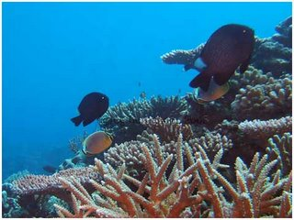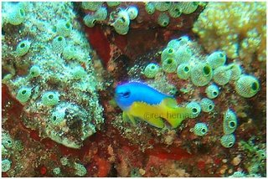

Philippine marine resources, most especially our coral reefs are beautiful. The country is being dubbed as one of the best dive countries in the world. The spectacular biodiversity of this country should be preserved for generations to come. Recent initiatives in both the government and private sectors to protect our marine environment are commendable. Yet what should never be forgotten are the traditional fishermen, who incidentally belong to the country’s poorest sector of society.

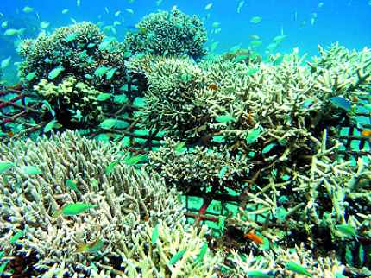
Healing our precious coral reefs

So here I am -- an old man, reminiscing about the past. Next year when I return home, I will go to Donsol, Sorsogon to swim again with the whale sharks and dive among the manta rays at the Manta Bowl at the Burias Pass. I will do this as often as I could, for in those brief moments underwater, I feel like a young man again.

And when it is time for me to go, I hope that the sea will take me in her fold.

