Environmental Awareness
A monthly publication of UP BETA SIGMA FRATERNITY, INTERNATIONAL, INC.

GARBAGE: Excrements of Industrialized Societies
May 2008
For years, the Smokey Mountain in Manila symbolized the overpowering stench of poverty suffered by those who have been marginalized by Philippine society. Many people around the world have heard about it, but very few have actually taken a whiff of that heavy air that makes it easy to comprehend why the place has been aptly called a “monument of shame”. Brod Willie “Tatang” Vergara is one of the privileged few who have been there.
In this month’s issue of Environmental Awareness, Brod Willie gives us his compelling account of coming into face-to-face confrontation with the Philippines’ towering “monument of shame”.
Gerry Abenes - Editor
About the Author
Brod Willie “Tatang” Vergara retired as Vice President and Senior Fellow of the Development Academy of the Philippines (DAP) in 1996. He currently works in the Project Development Office of the Department of Public Transportation, County of Sacramento. A staunch advocate and practitioner of environmental protection, Willie used to work in the Environmental Management Department and grows his own vegetables in his backyard.
All photos shown here were taken by the author. Some are winners in photo contests.

“To see the world in a garbage can
And heaven in a plastic urn
Hold eternity in rubbish land
Into infinity, an endless gloom.”
A parody of “Auguries of Innocence” by willie v.

Smokey Mountain in Tondo, Manila. 1987. That was where I found myself in pursuit of a mission to record the situation obtaining in this very heart of the country’s capital city. Objective: a slide presentation to be used by ex-Vice President Emmanuel Pelaez, then the newly appointed Ambassador to the United States, to generate funds to finance the education of 200 scholars from Smokey Mountain.

The dismal site I saw and the pungent air I breathed were just too much. I felt like Brod Noli Nolasco just delivered a blow of bag-wa (pronounced pakwa) right into my solar plexus. I was standing on a mountain of trash and rubbish, blurred and extinguished of all color by the miasma of toxic gas coming from the burning garbage. This place has become burial grounds for broken dreams and strangled passions, peopled by numberless silhouettes whose concerns seemed to be focused only on one thing: survival by any means.

All the idealism and dreams of the good life, all the poetry and the song; all sense and sensibilities, all the wisdom and imagination and hope seemed to be absent in this God-forsaken place. Vivid feelings and deep passion appeared to have been forced in upon themselves, bound inward by a stifling ring of frustration within the communal confines of the garbage heaps.

On this very mountain, the energy remains, but having no outlet, it constantly implodes in huge effusions that fog the atmosphere with soot and smog. The scavengers have a special term for the smoke coming from the heap of trash. They call it “asap” because it has particulates which irritate the eyes and cause labored breathing and often suffocate infants. It also causes acute and chronic

asthma, bronchitis and emphysema, constriction of the bronchi and tissue damage of the lungs. The particulates are also very potent carcinogens.

A recent report of the World Health Organization estimated that the level of air pollution in Metro Manila has exceeded allowable levels by as much as 300%. Much of the pollution comes from the very high lead content in the gasoline and the high sulfur content in diesel fuels used by almost a million vehicles, most of which are equipped with second-hand engines, are often poorly maintained and possess no pollution-control devices at all. Smokey Mountain also damaged the ozone layer thus allowing lethal ultraviolet radiation to reach the surface of the earth, causing higher incidence of skin cancer, wide-scale suppression of immune systems, increased levels of smog, lower crop yields and deterioration of marine harvests. Smokey Mountain has been contributing to global warming due to the tremendous amount of carbon dioxide released into the atmosphere by the continuous burning of trash. This in turn exacerbates the greenhouse effect that happens when chlorofluorocarbons, nitrous oxide, carbon dioxide, and methane are released in the air. Heavier than air, these gases do not dissipate but ring a barrier around the earth. Although sunlight can pass through the barrier and warm the earth, the resulting heat is prevented from flowing back into space. The heat trapped around the earth’s surface creates a greenhouse effect, just as glass traps heat inside a greenhouse. The consequences of such an event would range from heat waves and droughts to the expansion of deserts and flooding of coastal areas.

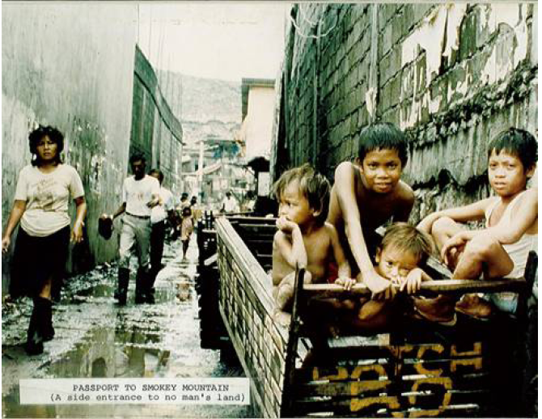

At the foot of the mountain, I saw the kariton boys come and go, as they traveled around the streets of the city with pushcarts (kariton) and scavenged for recyclables while the garbage were still be fresh in the streets. They often encountered brushes with the authorities because these boys reputedly scattered the garbage after they had chosen their “goodies”, meaning the recyclables, and leaving an already terrible and stinking site looking worse along the streets of Manila. Consequently, some of the impounded karitons were burned by the police.

Said the children whom I interviewed (see group picture), “We usually go out after dark in threes. We had to endure the heat of the sun and inhaled dust and ashes in the streets of the city. We slept in our pushcarts when we got too tired. Our only blanket was our weariness and our pillow the garbage we picked up… When heavy rain pours, our pushcarts would float like a banca through the flooded streets which were usually up to our waist…. Our clothes simply dried up on our bodies. After a long day’s work, we would push back our carts upward the mountain of trash, sometimes into the muck. There we would see worms squirm up our legs… But we have to do what we have to do to help feed our family. Mabuti na yung mabuhay ng marangal (better to live honorably) kaysa sa mga ibang tao na kumukuha ng hindi kanila (unlike others who steal).”

But there is one story I’ll never forget. The boy’s name was Inggo (not his real name, but you can see him in the B&W photo below). He didn’t know how old he was, but he thought he was five. He certainly looked older than his age and did not seem to have the innocent look of a five year old. Being an orphan himself, he lived with four other orphans in a small hut made of scavenged plywood and carton and rusted galvanized iron. Their hut would rain inside every time it rained outside. Like the four others who were a bit older than him, he had lived in this garbage dump virtually his entire life. But these orphans would get help from other neighbors when things got real bad, for instance, if one of them got to be seriously ill, which was not really very often. The SVD parish priest of Smokey Mountain, Fr. Benjamin Beltran, told me, “Infant mortality here is perhaps the highest in the world, pero kapag lumagpas sila ng apat na taon, mahirap na silang patayin.” (After age four, they are hard to kill.) Their daily routine followed the same pattern: they milled about the dump, waiting for the next truck to arrive, hoping for enough discarded food to get them through the day. They poked through the rubbish with a machete, and collected bottles and plastic for a few cents a sack.

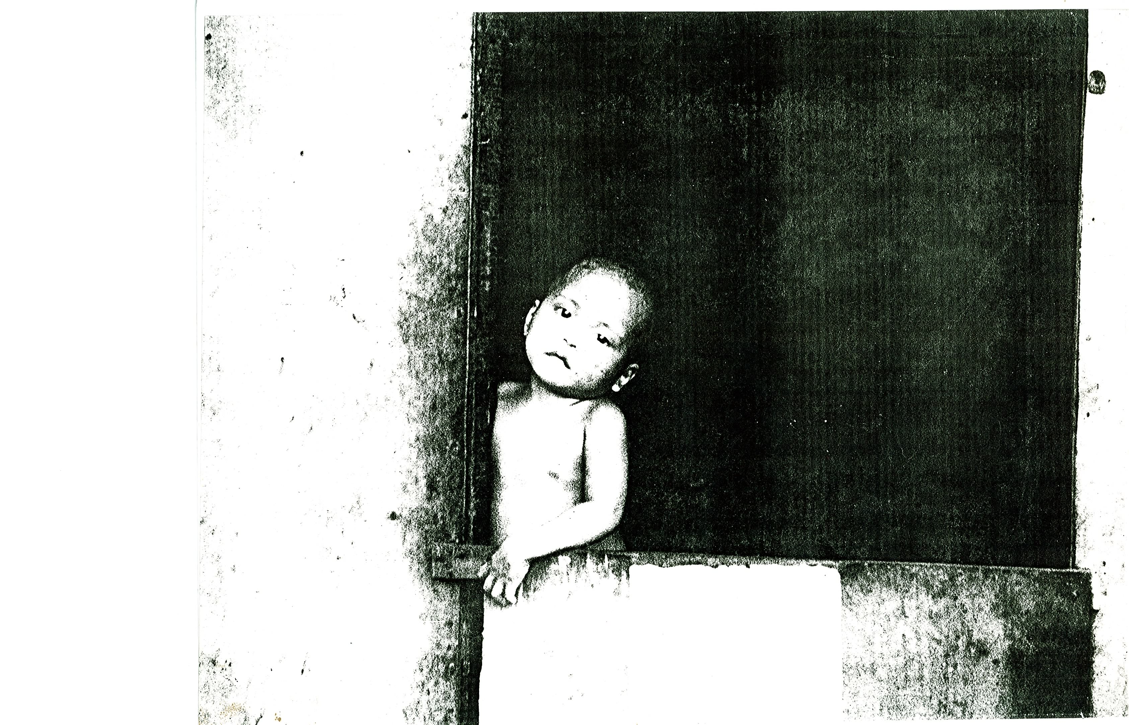

To fast-track, on the very same year that I went to Smokey Mountain came a barrage of news and editorials branding this place as the Monument of National Shame. Day in and day out, media people would have something unfavorable to say about this place. It did not take long for such shame to catch world attention. As a consequence, several charitable institutions all over the globe came over to lend their hand in restoring some amount of decency and harmony in this God-forsaken land. In fact, at some fleeting moment, it seemed to have become rather fashionable for people to do something for Smokey Mountain. I noticed many of Manila’s 500 having their photos taken in this mountain of trash. Ideologists from both the left and the right likewise registered their presence. And various church groups, too. The government of Germany donated a dozen sewing machines plus trainers to train the inhabitants to earn some livelihood. Credit cooperatives would be set up where the people would have a direct hand in managing some small-scale business. The funds that Ambassador Manny Pelaez would solicit were so easy to come by; and the 200 scholars, indeed, went to study technical courses that would eventually help alleviate the condition of the co-inhabitants.

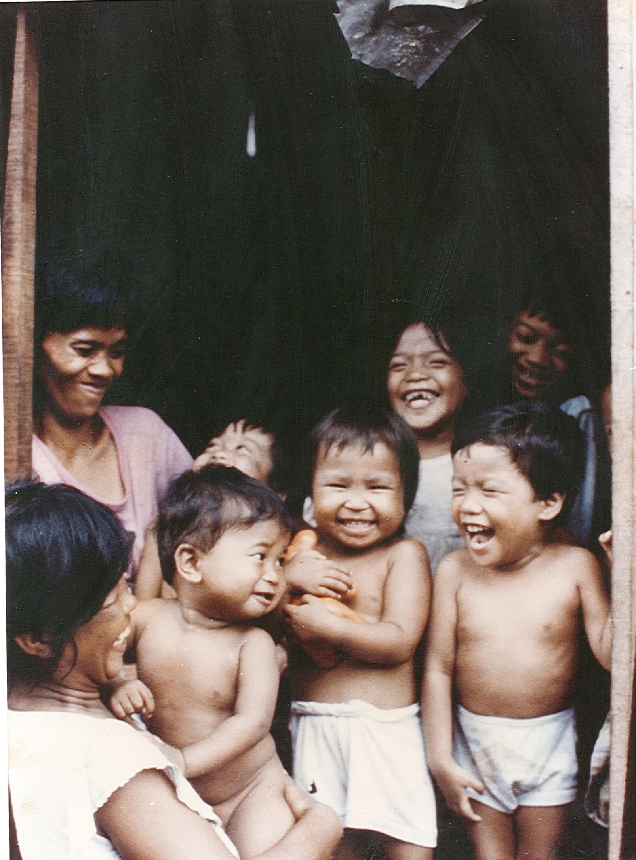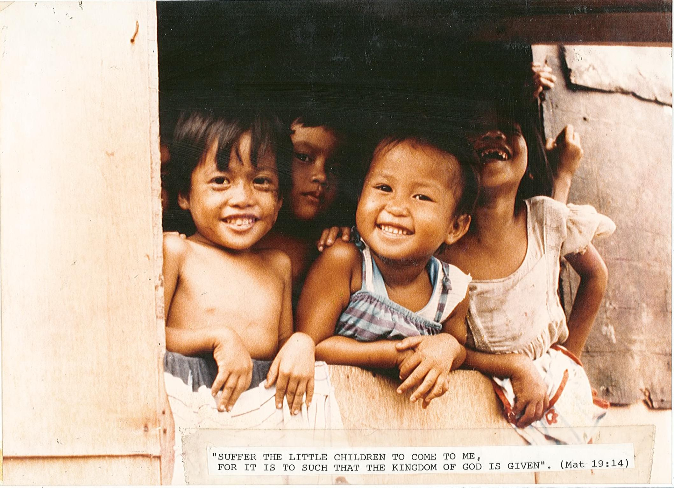

Suffice it to say that the Smokey Mountain story is one that miraculously ended in victory – a tale of a dramatic reversal from a state of despair to one of optimism, from eternal darkness to the dawning of a new day, from hopelessness to the blossoming of new dreams for the children to live in the life of freedom, that they are born not just to survive but to create and explore a world that is after all full of joy and color.

Unfortunately, the story does not end with Smokey Mountain. Most of the 6,500 tons of Metro Manila’s daily garbage was diverted to an even bigger garbage dump outside of Metro Manila that is now known as Payatas. And this place would later be known for another scandal -- the avalanche of trash in 1998 that buried hundreds of people.

In a recent email, Brod Pogs Gaspay wrote, “The other large landfills are the ones in San Mateo (much bigger than Payatas and Smokey Mountain, yet more of a problem though far from the sight of most Manilans) and the one in Carmona, Cavite. Other major cities are also beginning to have the same problem as Metro Manila and will just be a matter of time before they too become scandalous - Dagupan and Baguio I hear are already having problems. I imagine Cebu and Davao will have problems too.”

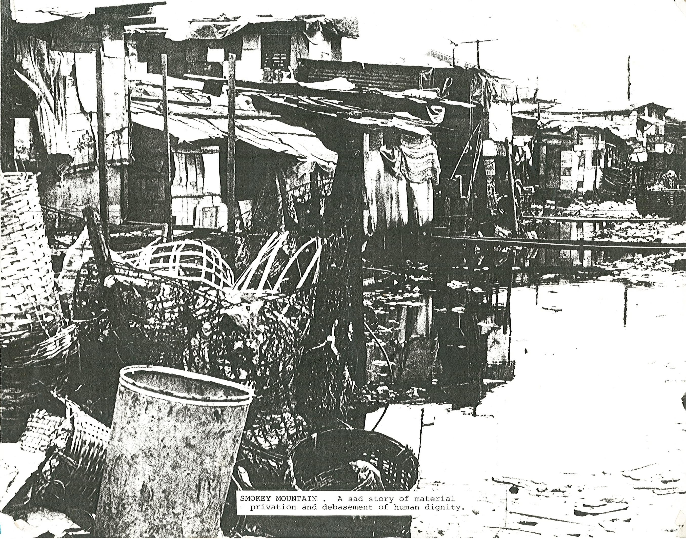

This sad plight is not limited to the Philippines, but occurs wherever overpopulation cum industrialization exists whether these be in Thailand, Burma, India, China, Argentina, Bolivia, Afghanistan, Indonesia or Bulgaria. More advanced nations like Australia, Belgium, England, France, the United States are not exempt. The list goes on and on.

In more developed countries, in spite of environmental regulations that protect the quality of streams, lakes, and wetlands, solid waste in the form of trash, litter, and garbage often end up in these surface waters. In urban areas, trash and dry solid waste often are transported by storm water runoff. In both urban and rural areas, these items sometimes are illegally dumped directly into a wetland, or deposited along riverbanks or lakeshores. Trash also comes from people who fish or participate in other forms of water-related recreation. Regardless of source or type, trash is a form of water pollution.

Discarded items like tires, plastic containers, and non-organic construction debris are usually seen in waterways that have become repositories for unwanted items, including couches and mattresses, cars and car parts; bicycles, shopping carts, bags of stolen property, fuel containers, and paint cans. The most common litter in U.S. streams is household trash, including plastic cups, plastic bags and wrapping materials, fast-food wrappers, plastic bottles, and other plastic containers. Plastics can be especially hazardous to wildlife. Depending on their form they can either be ingested, causing internal organ failure, or they can cause gradual strangulation.

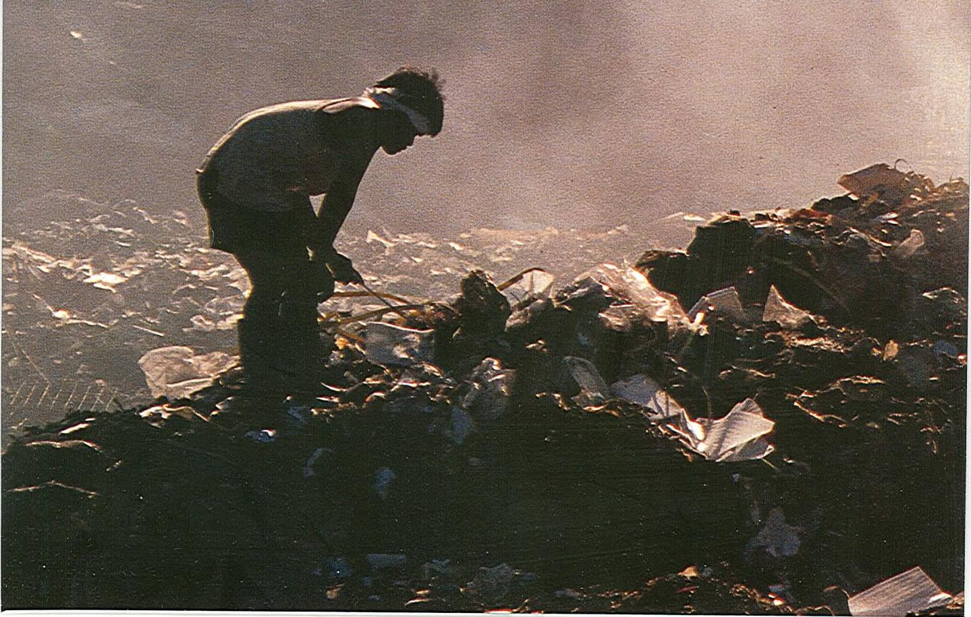

Organic waste (e.g., wood wastes) can have chemical and biological impacts on rivers and streams. They interfere with the establishment of aquatic plants, affecting the reproductive behavior of fish and other animals, and deplete the water of dissolved oxygen as they decompose. Further, toxic materials can leak or leach out of certain kinds of trash (e.g., pressure-treated lumber, used oil filters, and lead-acid batteries).

Humanity’s predatory relationship with Mother Earth might end up in a mass extinction similar to the one that occurred at the end of the age of dinosaurs. If we do not wake up from this ecological nightmare, the wrath of Mother Earth will be relentless when it comes.

It is my fervent hope that we have been reading all the previous issues in this monthly publication. A global problem such as this is everybody’s problem and it all starts from a heightened level of awareness and realization that, indeed, we are living in a fragile world. The wounds of Mother Earth sound a serious warning and beckon us to search for deeper sources of creativity in the depths of our inner selves. It is from this inner dynamism that we will discover the strength and the patience to build a world that heralds hope and harmony.

We have to carry out on a global scale, starting with our own little way, some form of direct action to combat environmental degradation. To be Servants of Mother Earth, not its masters, is worth considering as a worldview. By being so, we do not arbitrarily use the gifts of nature. By being servants, it will not be so difficult for us to sacrifice a little discomfort now so we can give tomorrow a chance to be as clean and green as we have seen in our days of youth. Our central concern should neither be what we produce, nor what we achieve. The basic issue is who we are, that we are here for a purpose. That purpose is a belief that in our hands, we can carve a better future.

POSTSCRIPT. All photos were taken in Kodak Ektachrome 400. These slide photos were converted into prints, resulting in more than 30% loss in quality due to the absence of any advanced conversion technology. Be that as it may, the prints (which were blown up to 11R) caught the eye of two artist greats – Brods Banz Banez and Ely Santiago. The color print of “Inggo”, the boy inside the hut was exchanged for a pastel painting, “Still Life with Fruits and Vegetables” by Banz; the color print of “The Smokey Mountain Huts” was exchanged with two Ely Santiago caricatures – but the second one was overtaken by his untimely death on February 17, 1993. Thus what you see here are mere Xerox copies of the prints.

