Environmental awareness
A monthly publication of UP BETA SIGMA FRATERNITY, INTERNATIONAL, INC.
April 2008
Plastics have made life a lot easier for people. It is perhaps one of the breakthrough inventions in the 1800s that has made living more and more convenient to everybody. But what are the costs of this durable and slow-to-degrade material? Of late, we have been reading a lot of literature related to the dangers of plastic water containers, and that some illnesses have been associated with microwaving food in plastic and even from drinking bottled water. Read more about how plastics is affecting our fragile environment including the release of toxic pollutants, greenhouse gas, ocean litter, and other costs..
Willie “Tatang” Vergara
ABOUT THE AUTHOR
Brod Gerardo "Gerry" Abenes, DVM, MVSc, PhD, UPD '66 is a Senior Scientist, in the Division of Infectious Diseases School of Public Health, University of California- Berkeley
Gerry was a Professor at UP Los Banos before coming to the US on a Postdoctoral Fellowship at Stanford University Medical School, and then at the University of California, San Francisco.
He also editor of this publication.

PLASTIC: CONVENIENCE AT THE COST OF BLIGHT
Gerry Abenes
======================================
“There ain't no such thing as a free lunch.”
The Moon Is a Harsh Mistress
Robert Anson Heinlein (July 7, 1907– May 8, 1988)
======================================
Plastic is arguably one of the biggest industrial blockbusters in history. Barely a century after it was first made, the material, in one form or another, has permeated virtually every aspect of human life. It’s everywhere in our home, our car, at work, in the streets. It is in almost everything that we touch from the moment we get up in the morning to the moment we go to bed at night. It is in our most mundane gadgets like toothbrushes and shavers, as well as in our favorite toys like the TV and the remote control. It has become the packaging of choice for much of what we use daily, from the critical- like food and water, to the trivial- like the various esoteric potions that pander to various parts of the anatomy. It can be found in almost every corner of the globe, from the equator to the poles.

Considering its ubiquitous presence, why then did jaws drop when Charles Moore said he saw plastic in the middle of the sea? Well, here’s the story.

Charles Moore was skipper of the boat Alguita that participated in the Transpac race from California to Hawaii in 1997. Sailing back to California with time to kill and fuel to burn, he and his crew veered towards the North Pacific Gyre, also known as the North Pacific Subtropical Gyre- a swirling vortex of ocean currents comprising most of the northern Pacific Ocean. For hundreds of years, sailors and fisherman have been keen to avoid the area because, as one of the six “ocean desserts”, it lacks the wind that sailors need to survive, as well as the nutrients to support large fish or the men who hunt them.

The North Pacific Gyre is located between the equator and 50º N latitude, about halfway between California and Hawaii. It comprises an area of approximately ten million square miles. It has a clockwise circular current pattern due to the convergence of four ocean currents: the North Pacific Current to the north, the California Current to the east, the North Equatorial Current to the south, and the Kuroshio Current to the west. Historically, the gyre’s circular currents have led to accumulation of natural debris in the subtropical high, for which it got its other unflattering names like the Great Pacific Garbage Patch, the Eastern Garbage Patch or the Pacific Trash Vortex. As recently as a few decades ago, however, the waste that accumulated there has biodegraded with the help of marine microorganisms.

From Moore’s own account, he looked out from the deck of his catamaran to relish the view of what should have been a clear blue ocean, and saw instead a sea of plastic in every color. Day-in and day-out, as he sailed through the gyre, “were shampoo caps and soap bottles and plastic bags and fishing floats as far as (he) could see”. “There was nowhere (he) could go to avoid the plastic debris”, the vastness of which has since been estimated to approximate twice the size of Texas.

Plastic debris anywhere else is bad enough because they do not biodegrade and re-enter the life cycle. In the open ocean they are a particular concern because they photodegrade into tiny pieces (“nurdles”) that resemble zooplanktons and fish eggs which are eaten by various marine animals, or taken up by filter feeders. The amount of nurdles has reached alarming levels; in fact, samples taken from the gyre in 2001, revealed that the mass of plastic has exceeded that of zooplankton by a factor of six.
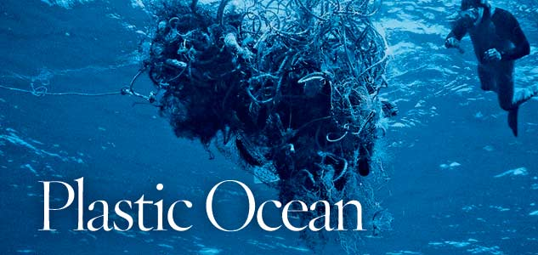
The nurdles and plastic polymers in the oceans are worrisome for a number of reasons. For one, plastic polymers have been found to soak up resilient poisons such as DDT and toxic polychlorinated biphenyls like a sponge. Indeed, a study by geochemists at Tokyo University found that non-water-soluble toxic chemicals could accumulate in plastic at levels as high as a million times their concentration in water. Also, plastic is indigestible even for microorganisms that normally degrade other debris. Thus, one might picture a best case scenario in which marine life that load up on plastic end up starving while feeling full; a worse case scenario, in which their digestive organs get clogged; or the worst case scenario in which toxic compounds that have been soaked up by the plastic polymers end up in the ocean food chain, and eventually at the dinner table.

There are also a number of unresolved health issues associated with plastics. Just recently, for example, a study by the U.S. Centers for Disease Control and Prevention, showed that the bodies of most Americans are laced with bisphenol A (BPA), an estrogen-like compound that is the primary component of polycarbonate- one of the most widely used plastics. The center found that significant levels of BPA were present in 92% of 2517 urine samples examined. Importantly, exposure to BPA appears to be continuous since the body metabolizes BPA in only a few hours. While the jury is still out on what high exposures to BPA mean for human health, one recent study published in the journal Reproductive Toxicology has found a link between BPA and female reproductive disorders such as endometriosis, cystic ovaries, fibroids and cancers. Moreover, Canadian scientists have also implicated plastic in findings of hermaphroditism in fish that populated water contaminated with plastic additives, leading them to speculate that plastics may play a role in declining fertility rates in humans. PET- the kind of plastic commonly used in water bottles, plastic bags and food containers, was also recently shown to release a suspected human carcinogen after repeated use.
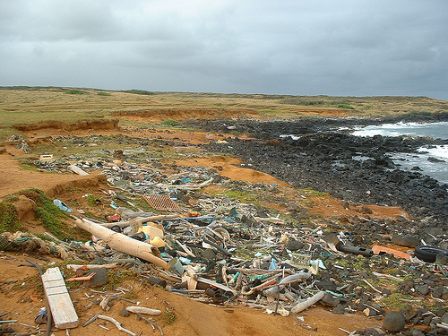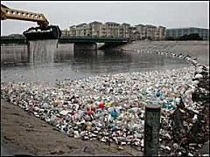
The plastic debris that is accumulating in the North Pacific Gyre could be just the tip of the iceberg, considering that there are at least six other known gyres in the oceans of the earth with the potential to accumulate such garbage. Furthermore, Greenpeace estimates that about 70% of the plastic refuse that makes it to the ocean sinks to the bottom. Lending credence to such estimate is a report by Dutch scientists about finding 600,000 tons of discarded plastic at the bottom of the North Sea alone.

The demand for plastic continues to rise worldwide and so is the nuisance associated with it. It is estimated that annual plastic consumption could reach 250 million tons by 2010. Worldwide consumption of plastic bags alone is currently running at between 500 billion to one trillion pieces annually. Most of these bags are used only once, and barely 1 to 3 percent of them are recycled. These plastic bags are finding their way from the land to the seas at an alarming rate. Indeed, during the 2002 International Coastal Clean-up, plastic bag was on top of the list of the most dangerous debris encountered.

For sure, plastic will continue to be a dominant fixture in our lives for the simple reason that it makes the daily grind so much easier for everyone. As plastic debris gets more pervasive, however, it is also becoming apparent that plastic’s promise of convenience does not come without a cost. The Pacific Garbage Patch is out there as a reminder of that price tag.

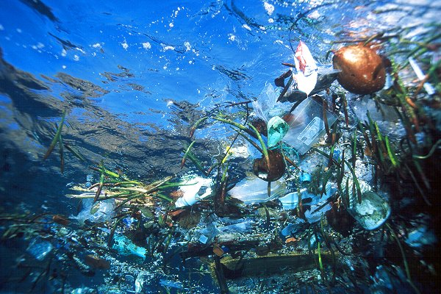

Floating ocean trash twice the size of Texas!

