Environmental Awareness
A publication of UP BETA SIGMA FRATERNITY, INTERNATIONAL, INC.

An Enormous Salmon Comeback
March 2012
Started way back in January 2008, Environmental Awareness for almost two years was a monthly issue, during Willie Vergara’s term as president of the UP Beta Sigma Fraternity, International, Inc.
Now on its 35th Issue, Environmental Awareness has dealt with various aspects of our Mother Earth – from useful and innovative farming and gardening tips, to the advocacy for cleaner ocean, rivers and air; from rainforests and marine life, to environmentally oriented exhibits in localities; from the destabilizing effects of the Arctic and Antarctic meltdown, to the perennial flooding problem in Manila; from toxic conditions brought about by poor garbage management, to problems encountered in our very own Centennial Forest in UP Visayas and how we have been able to cope with them.
Save for one guest writer, all 33 articles were written by UP Beta Sigmans across the batches (from Batch ’55 to Batch ’08) and geographical boundaries (Luzon, Visayas, Canada, Australia and the USA), belonging to various professions (government executives, economists, foresters, agriculturists, management consultants, etc.)
The commonality among these contributors is their philosophy that the environment should be preserved and protected so that our children and grandchildren will continue to enjoy the blessings of Mother Earth.

A Big Environmental Triumph
By Willie “Tatang” Vergara

After enjoying decades of robust salmon supply enhanced by the hatcheries of California, the government declared a complete shutdown of salmon fishing in 2007. It was not until 2010 that this ban was restored, but not until many measures to improve conditions susceptible to salmon propagation were adopted with the help and advocacy of the private sector and the cooperation of the California authorities.
On our December 2010 edition, we celebrated the comeback of the Chinook Salmon, featuring the year’s bountiful harvest after all the efforts were made to dramatically improve oceanic conditions, with cold water flows carrying much needed nutrient.
All the hatcheries along the Sacramento River have seen populations of fall-run salmon with impressive numbers, even double the amount we have seen when we wrote a similar article way back in 2010. Meanwhile, the Stanislaus River has seen dramatic increases in salmon populations this year. Likewise, the California Department of Fish and Game has reported record fall -run Chinook salmon on the Eel River. Other hatcheries throughout the state have reported improvements in fall salmon runs, which bodes well for other salmon runs that migrate during other parts of the year.
Yet in 2010, the commercial salmon season opened only for 8 days after a 3-year ban. Year 2012 will be a much different year, considering the abundance of salmon that will again be a joy to the once flourishing salmon fishing industry in California.
Needless to say, the salmon will be jumping off the coast of California this coming summer season and, for the first time in years, fishing hobbyists will be allowed to catch them in large numbers and satisfy their respective families with their abundant catch.
As I write this article, statistics show that there are more chinook salmon swimming in the ocean right now than anyone has seen since at least 2005. Experts have cited the ban on fishing, improved ocean conditions, the improvements of salmon paths, effective water management, and for nature’s part, the ample if not abundant rainfall in 2011.

 | 2009 | 2010 | 2011
American River | 3908 | 7234 | 12680
Battle Creek | 4820 | 15000 | 42000
Feather River | 6205 | 17209 | 34000
TOTAL | 16942 | 41453 | 90691
The encouraging numbers above and the chart below illustrate what I would like to call as an “environmentalists’ triumph’. (Data source: California Department of Fish and Game)
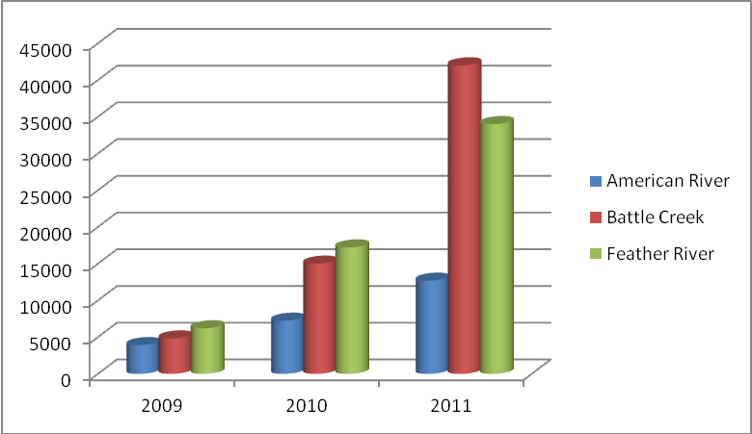
Experts claim that there are 820,000 chinook in the ocean now preparing to return to the Sacramento River system to lay eggs next fall. Another 1.6 million chinook from the Klamath River are out there, too, and it will be one of the largest salmon harvest on record.
The forecasts are based largely on the percentage of 2-year-old salmon that return early to the river system. A large number of these so-called jacks are usually a good indication of how many fully grown fish will return the next year. King salmon generally return three years later to spawn at the spot where they were hatched.
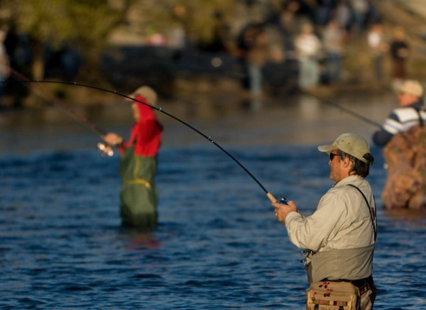
Already with the rivers coming back to life, anglers are having a hell of a time with their fishing hobby. Those who have been fishing during the past 10 years claim that the past season was never as good.
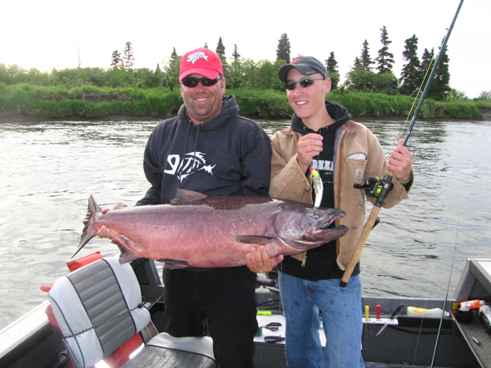
The anglers and the salmon fishing industry also have the salmon hatcheries to thank, aside from the environmentalists.
Take the case of the hatcheries along the Sacramento River. Once, when the rivers ran freely to the sea in the land we now know as California, vast numbers of salmon and steelhead returned to the waters of their birth to spawn and start the cycle of life anew.
About 95% of California’s historically productive salmon and steelhead stream miles have been lost due to human influence. Dams block access to most historic spawning beds can be destroyed by siltation from mining, logging and construction along streams. River bank reinforcements and dams cut off the supply of new gravel needed to maintain downstream gravel beds.
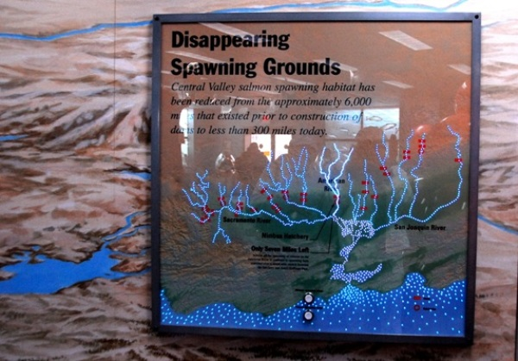
Cut off from thousands of miles of their historic habitat by dams, the species now depends largely on hatcheries.
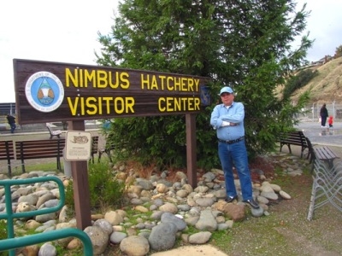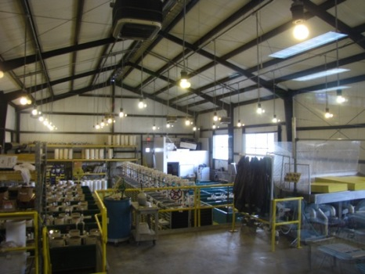
Rather than swimming into mountain streams, most of the run now ends up in the hatcheries, built to atone for the dams. There, males and females are killed and cut open, and their eggs and sperm mixed artificially.
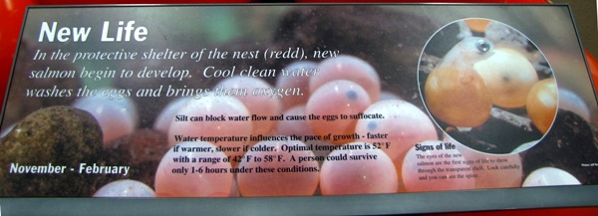
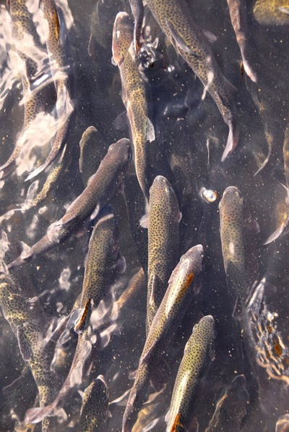
The resulting young salmon, or fry, are reared in tanks until they reach fingerling size. Most are then hauled in trucks to San Pablo Bay to help them avoid the pollution, predators and water diversion pumps in the Delta.
The Pacific Ocean is their home for the next two to four years, when the fish are mysteriously compelled to swim back into fresh water.
“Last winter made all the difference. Bountiful rain and snow delivered enough water to fill the state’s reservoirs and provide ample flow for fish migration. At the same time, the ocean improved with normal upwelling conditions that brought nutrients up from cold, deep water to charge the food chain. The large number of dolphins and whales in coastal waters provided one of the most spectacular pieces of proof. The ocean looks better than I’ve ever seen it,” said Larry Collins, a commercial salmon and crab fisherman and president of the San Francisco Crab Boat Owners Association.
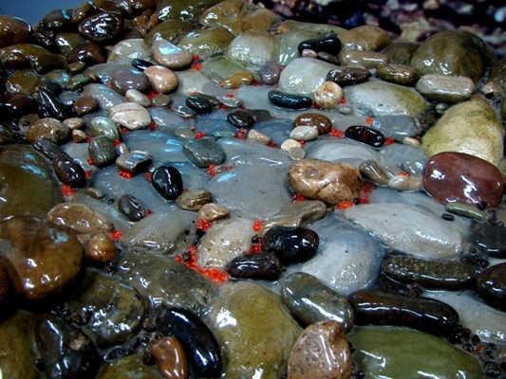
A new emphasis is being placed on creating additional wild spawning habitat. Gravel beds are being restored below the dams, and fish ladders are being built so salmon can again access old habitat above the dams.
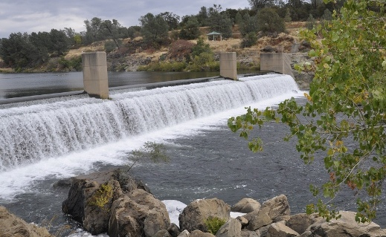

The gates, built in the 1950s, have historically been left open during the run to provide fresh water for urban and agricultural diversions. At the same time, the East Bay Municipal Utility District, which operates Pardee Reservoir upstream, released water in special pulse flows to help provide salmon with migratory cues.

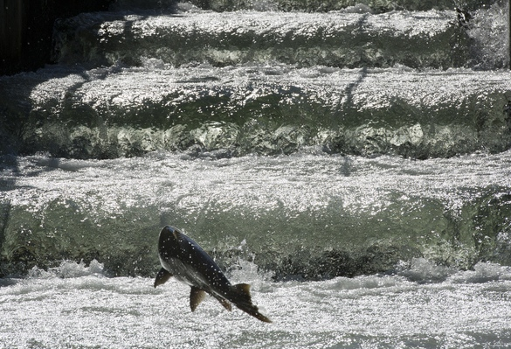

After living in the ocean for two years, the Chinook salmon mysteriously come back to where they were spawned. It is always a joy to go back to the salmon hatcheries every fall to witness the fish jumping up the ladder towards their respective spawning grounds, lay eggs themselves before they meet the end of their existence.

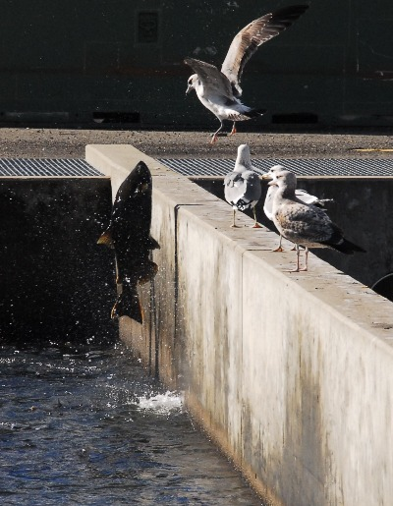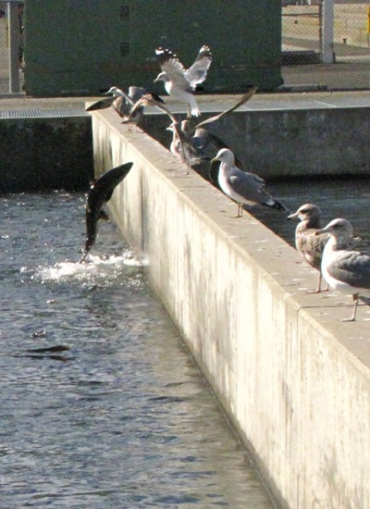

I would like to end this article by making a sales pitch: Visit Sacramento during the fall season and be a first-hand witness to one of nature’s mysterious wonders.

