Environmental Awareness
A publication of UP BETA SIGMA FRATERNITY, INTERNATIONAL, INC.

Comeback of the Chinook Salmon
December 2010
Started way back in January 2008, Environmental Awareness continued on as a monthly publication until the middle of this year. A quarterly issue was planned beginning January 2010 but the contributions kept on coming on a monthly basis – until July of this year.
Now on its 33rd Issue, Environmental Awareness has dealt with various aspects of our Mother Earth – from useful and innovative farming and gardening tips, to the advocacy for cleaner ocean, rivers and air; from rainforests and marine life, to environmentally oriented exhibits in localities; from the destabilizing effects of the Arctic and Antarctic meltdown, to the perennial flooding problem in Manila; from toxic conditions brought about by poor garbage management, to problems encountered in our very own Centennial Forest in UP Visayas and how we have been able to cope with them.
Save for one guest writer, all 33 articles were written by UP Beta Sigmans across the batches (from Batch ’55 to Batch ’08) and geographical boundaries (Luzon, Visayas, Canada, Australia and the USA), belonging to various professions (government executives, economists, foresters, agriculturists, management consultants, etc.)
The commonality among these contributors is their philosophy that the environment should be preserved and protected so that our children and grandchildren will continue to enjoy the blessings of Mother Earth.

Environmentalists score a big win
By Willie “Tatang” Vergara

Salmon have returned to California and Oregon rivers and streams in impressive numbers this fall. The big comeback is without a doubt a stunning victory by environmentalists who have for the past decade been advocating for clean oceans, rivers and sewages, thus restoring hope that years of shortages and fishing closures are over.

Since April 2008 commercial fisheries in both Oregon and California were closed due to the extremely low population of chinook salmon. The low population was largely blamed on the collapse the Sacramento River run, one of the biggest salmon passages south of the Columbia. Scientists from Universities and Federal, State, and Tribal Agencies concluded that the 2004 and 2005 broods were harmed by poor ocean and river conditions in 2005 and 2006, in addition to “a long-term, steady degradation of the freshwater and estuarine environment.” Such conditions included weak upwelling, warm sea surface temperatures, and low densities of food. Scientists blamed poor ocean conditions and a century of habitat degradation in freshwater spawning areas.

The comeback of the Chinook salmon is a dramatic turnaround from previous years when populations of these fishes hit historic lows so that the government officials were prompted to close commercial fishing in 2008 and 2009.

River and ocean conditions have improved, and myriad small habitat projects are starting to bear fruit. For instance, the volunteer group Save Auburn Ravine Salmon and Steelhead persuaded landowners with some help from authorities to remove the irrigation dams. Federal law now requires removal of these dams so salmon can pass.

Consider the following encouraging statistics from California’s Fish and Game Department:

- The Shasta County hatchery, the Central Valley's biggest producer, has spawned about 16,000 Chinook so far. That compares with about 6,500 last year.

- The Feather River hatchery in Butte County, operated by the California Department of Fish and Game, had spawned about 2,600 salmon as of Nov. 6. That is about double last year's count at the same time.

- The Mokelumne River hatchery, a smaller producer in San Joaquin County, had spawned just over 700 fish as of the same date, or five times more than in 2009.

- Nimbus Hatchery on the American River opened just two weeks ago and the photos below give an apt description of the Chinook salmon comeback.

Innovative projects by environmentalists involving both public and private lands have preserved and grown the habitats of more than 50 threatened and endangered species. They have helped protect the water supply that is so vital to residents and to California Central Valley farmers, who grow one-quarter of America’s produce. Additionally, they have created more recreational space for visitors to enjoy in the years to come.

Consider what the Nature Conservancy Group and its partners have done so far with regards to the revival of the Sacramento River:

• Planted well over a million seedlings, using a broad mix of native plants
• Created the Sacramento River National Wildlife Refuge—an important stopover
for migratory birds on the Pacific Flyway
• Protected a corridor of 24,000 acres of land, with a 2015 goal of 30,000 acres
• Restored 6,000 acres of riparian habitat
• Increased the amount of land available for public use
• Created education and incentive programs that encourage farmers to use
the land in more environmentally beneficial ways
• Inspired public agencies and private individuals to join in these important efforts

The return of the Chinook salmon is definitely one of the biggest arguments towards the conservation of nature. Hopefully beginning this year and in the years to come, the efforts of the environmentalist will result in more and more fish products as the population of America continues to grow.

Below are photographs taken by me and my brother Ernie, who came to Sacramento for the Thanksgiving Week during a brief visit in one of California’s salmon hatcheries. Both of us feasted on picture opportunities as we were pleasantly surprised by the multiplicity of salmon fingerlings ready to leave freshwater for the ocean for the first time.

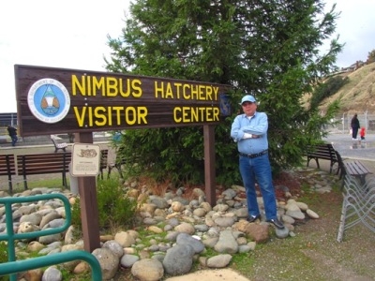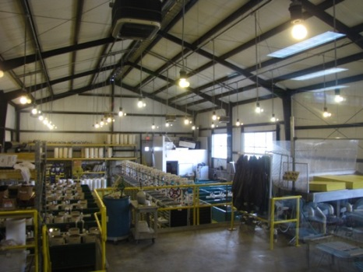

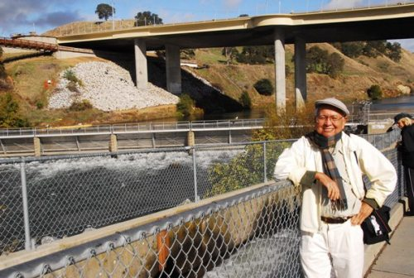

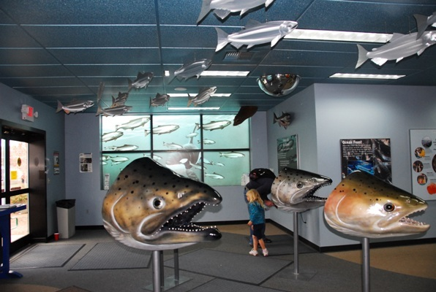

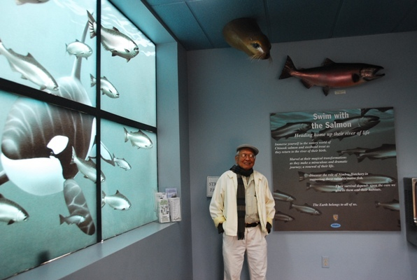

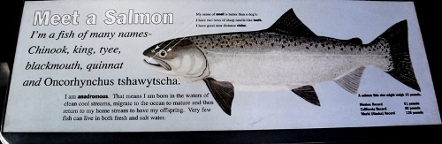

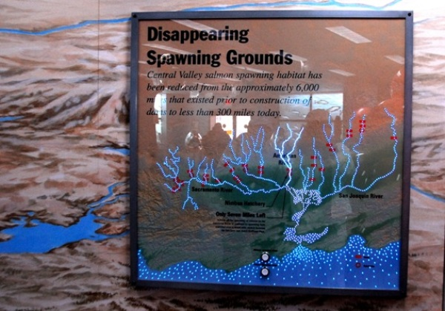

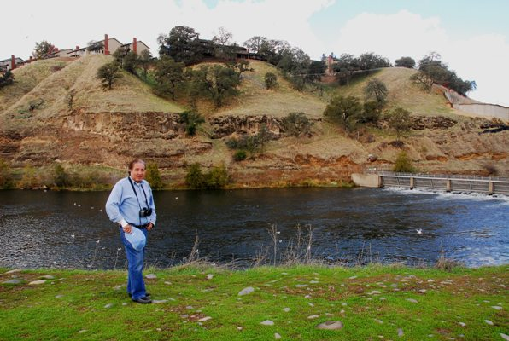
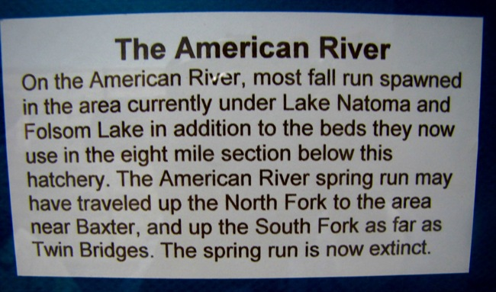

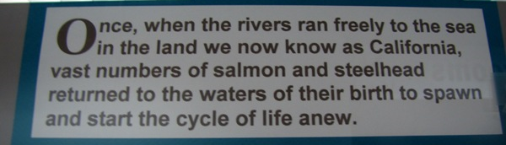

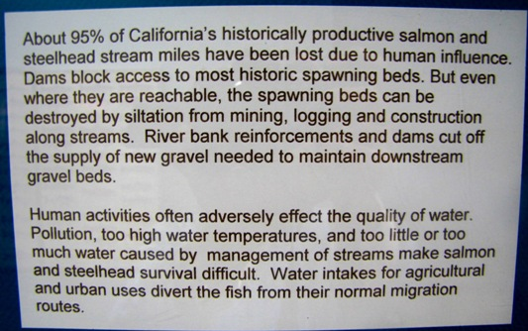

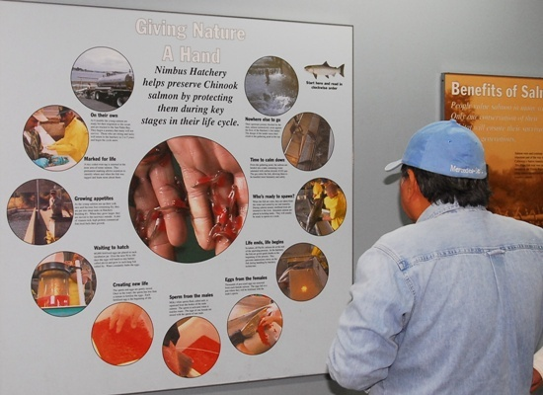

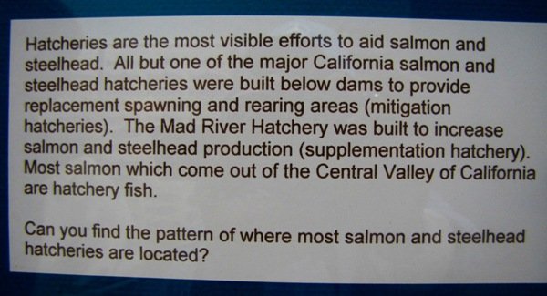

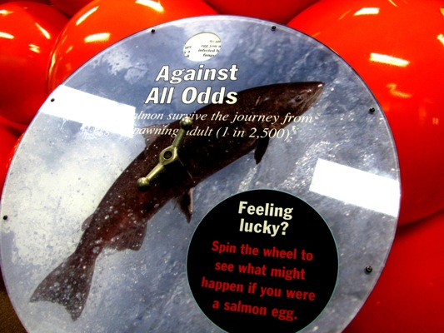

Would you believe that from the vast ocean, the Chinook come back through the American River (see picture below) after escaping their predators and surviving natural catastrophes …

… and would swim upstream through rocks and other obstacles, jump up the ladder (see photo below) in order to reproduce before they finally die?

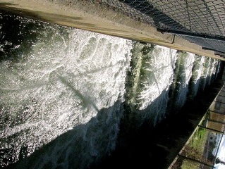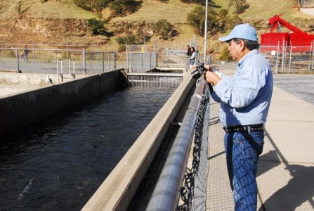

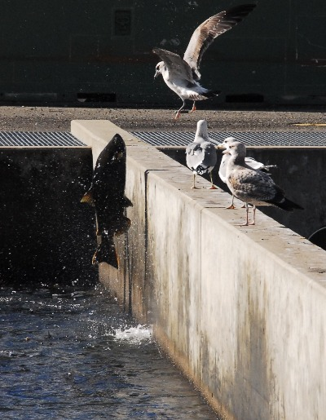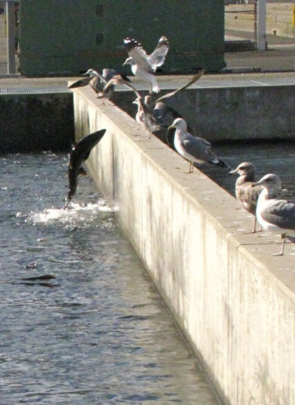

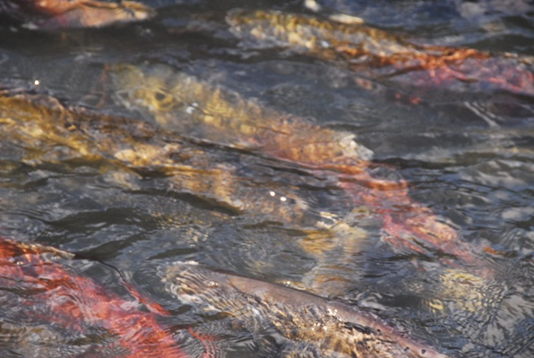

Above: As nature has so ordained, salmon come back to their source bearing the injuries of a long a difficult journey from the ocean through the rivers.

Below: How salmon eggs look when magnified.
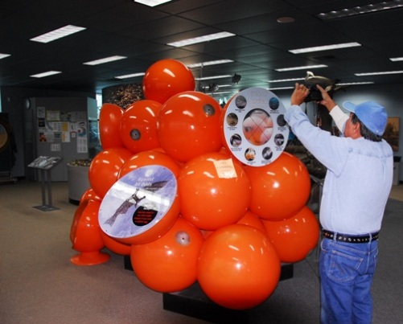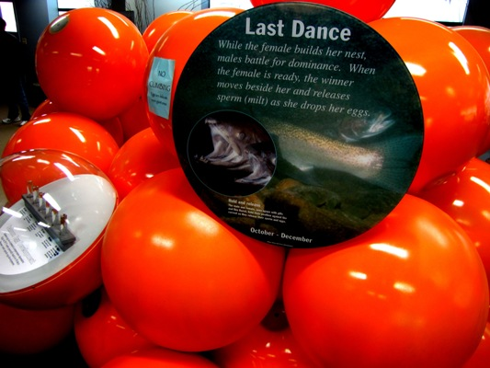

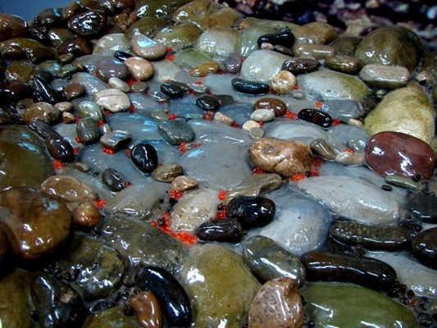
Above: Salmon eggs over river gravel

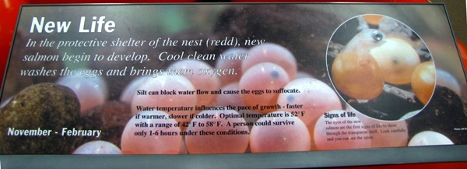

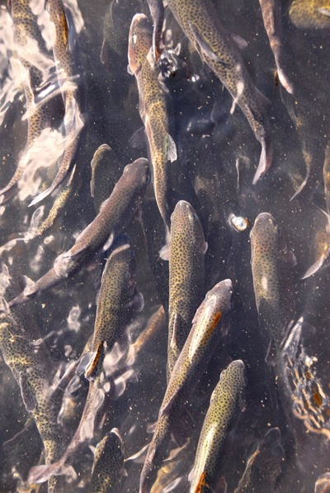

What a beautiful sight: Hundreds of thousand salmon fingerlings get ready to go back to the river. Juvenile salmon grow in clean, productive estuarine environments and gain the energy for migration. Later they change physiologically to live in saltwater. They rely on eelgrass and other seaweeds for camouflage (protection from predators), shelter, and foraging habitat as they make their way to the open ocean.

The Message:
Let’s keep our rivers and our oceans from all types of pollutants.

