Environmental Awareness
A monthly publication of UP BETA SIGMA FRATERNITY, INTERNATIONAL, INC.

Shall We Start Building An Ark?
June 2010
The author goes historical this time around, and traces the loss and exploitation of our country’s forest cover.
He proceeds to explain the details that occur in over-logging, as in the destruction of several layers of “water absorbents” underneath the rainforests, that had been the major cause of disastrous floods.
About the author
With this latest article, Brod Popoy Castaneda is decidedly the most prolific contributor to our Environmental Awareness publication. He must be one of the most well-rounded and talented Filipino environ-mentalists as could be seen from his varied contributions to this website. A professional diver, he has written a lot about underwater wonders. As a dive master, he was one of the most treasured resource of the legendary Jacques Yves-Costeau aboard the marine research vessel Calypso. As an artist, he has done a lot of nature-related art.

Part of his “Philippine Birds” collection is found in this website under “Artworks”, paintings by Popoy Castaneda.

Why rainforests are vital life support system
by Brod Popoy Castaneda, UPLB ‘55

Since the beginning of time, man had depended on the wilderness as a source for his basic needs for survival and existence, food and shelter. Even primitive societies of the present day that live in the rainforests depend on the forest for their basic needs and as a source of materials for trade with the outside world. As civilization progressed the needs of man became complex and more of the forest’s resources were exploited, more timber forest products harvested for trade and commerce. At the turn of the century as human population increased, more trees were cut down to give way for human habitation and agricultural crops.

Very few countries in the world had so much forest cover than the Philippine Archipelago in point of percentage of land area. Only a few hundred years ago at least 90 to 95 percent of the Philippines was forested with some seasonal forests and open woodland mostly in Luzon (like the pine tree forests in the Mountain Province) breaking the expanse of moist green rainforests. When the Spanish conquistadores arrived in the 16th century, scattered coastal areas were cleared for agriculture and human settlements. Some forests have also been cleared in the interior as well, specifically for rice cultivation of the Central Cordillera in northern Luzon now known as the rice terraces. These were scattered minuscule clearings of the slash and burn agriculture of the different indigenous culture in the various islands.

By 1600, the population of the Philippines was probably about 500,000 and the old growth rainforest covered 90 percent of the total land area. It was the Spaniards who initiated the harvesting of timbers from the rainforests; the hardwood timber from tropical rain forests were vastly superior compared to the pine and oaks of Peninsular Spain or Mexico for shipbuilding and for the construction of buildings and fortifications in their colonies. The rainforests in the vicinity of Manila were exploited for this purpose. Logs from the rainforests of the Sierra Madre were harvested and floated across the Laguna de Bay down the Pasig River, then to the shipyards in Cavite or sawn into lumber for shipment via the annual galleons overseas. Yet at the end of 300 years of Spanish colonial rule, rainforests still covered about 70 percent of the Philippines, but some islands like Cebu were heavily deforested while others were virtually untouched, although the fertile agricultural plains of Luzon had largely been cleared at this time. Most of the highland rainforests remained intact. Mindanao was untouched because of hostilities from the Islamic tribes; Mindoro’s rainforests were protected by a virulent form of malaria, and Palawan because of its isolation.

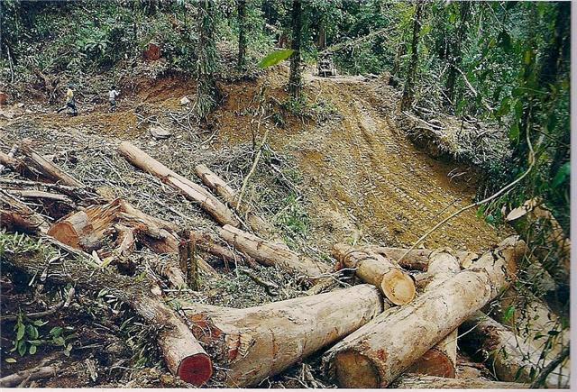

It was during the American colonial period that rainforests were cleared for commercial purposes, logging provided profits for American companies and the cleared area allowed for the expansion of rubber and pineapple plantations. But it was at the end of World War II that the harvesting of timber from the Philippine rainforests was methodically commercialized. Large tracts of the tropical rainforests were awarded as timber leases to commercial logging companies. Timber by the millions of board feet were harvested and shipped overseas. The tall emergent trees and the mature trees of the main canopy were cut down at first in a selective logging scheme and when these choice species of trees run out, the timber companies resorted to clear cutting.

In an archipelagic nation like the Philippines which is composed of small islands (even Luzon and Mindanao are classified as small island) mostly mountainous with narrow and limited coastal plains, the existence of rainforest is critical and is a vital life support system, for water management and conservation, for soil conservation and the preservation and management of coastal resources which is critical to fisheries. The rainforest with its multilayered structure of trees, interlocking vines or lianas, climbing bamboos, rattan tree ferns, and palms were abundant and many ferns, aerial mosses and orchids festoon the tree trunks. This presents a huge volume of biomass unsurpassed by the other forest type which is significant in conserving water.

The tropical rainforest canopy where sunlight scarcely penetrates is a gigantic natural greenhouse. Within the canopy the air is warm and humid; with the humidity rarely dropping below 90 percent with the water vapor coming from that transpired by the vegetation and the water evaporating from the foliage and forest floor. At the top of the canopy when this moisture-rich air collides with the cooler air of the monsoon from the sea which is also moisture-laden, it condenses into rain. The rain water does not fall directly into the forest floor, but is caught by the foliage of the canopy and gently drips down to the forest floor. Here at the forest floor is a carpet of dead leaves and small branches. Beneath this layer is the layer of decaying leaves and other vegetative matter which is in the process of being gradually broken down into organic matter by various fungi and soil bacteria. Beneath this second layer is the rich organic humus layer of the topsoil, and beneath this layer is the hard rocky subsoil, This layered composition of the forest floor is like a sponge that absorbs the water from the rain giving time and allowing the water to slowly seep in down through the rocky subsoil into the natural underground water deposits or aquifer, or to be gradually released from springs in the lowlands. What water that remains on the surface of the forest floor and on the foliage evaporates within the canopy atmosphere and joins the water vapor transpired by the vegetation rises up to the top of the canopy to meet the cool monsoon air and again condenses into rain. A meter of rainfall in the higher elevation rainforest hardly causes any flood since most of the water simply disappears in the natural sponge of humus and soil.

This cycle is repeated and is a daily occurrence in the rainforest especially during the monsoon periods. In between the two monsoon season is what we call the dry season where rain occurs rather briefly, but nothing is wasted for the rainforest recycles every drop, and the springs, and streams continue to flow for the aquifer was recharged to full capacity. Given this, there is no water shortage for irrigation, for hydroelectric power and for domestic use.

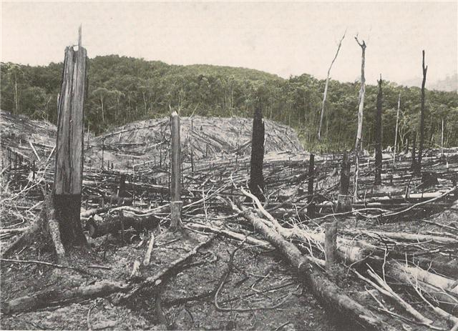
A vast area in Tatay, Palawan cleared in favor of a tree farm.

But as more trees specially the tall emergent ones as well as the mature trees of the main canopy is cut, the forest’s capacity to conserve and recycle water is diminished. Sadly, these include rattan, palms, orchids and other forest products. When a tree is cut or naturally topples down, the resulting open gap is repaired by the rainforest itself. But when too many trees are cut beyond the forest’s capacity to repair itself, large areas of the forest floor are exposed to the violent battering of the rain, and the forest’s water absorbent layer of humus and top soil are washed away by a series of heavy rain, exposing the rocky subsoil layer. Subsequent rains will just flow downhill on its surface, not allowing the water to seep down and recharge the water table and causing floods on the lowlands. Also, the topsoil is washed down and will cause sedimentation of rivers, streams and lakes.

Eventually as large tracts of forests are cleared, entire water sheds are damaged and the floods becomes more disastrous, causing landslides and washing away the rich topsoil of agricultural lands (one of the worst economic consequence of rainforest destruction is soil erosion which reduces soil fertility by 30 to 70 percent), damaging infrastructures and loss of human lives and since the rainwater have flooded down the denuded slopes instead of entering and refilling the underground water system to feed the rivers. During the dry season there is no water for our irrigation, for hydroelectric dams and even for domestic use. Also, generally unnoticed are the wide plumes of muddy sediment water from nearly every river flowing out to the sea during the rainy season -- a mute but clear testimony to the impact of deforestation to coral reefs and other marine coastal resources.

