Environmental awareness
A monthly publication of UP BETA SIGMA FRATERNITY, INTERNATIONAL, INC.
March 2008
For ages, coastal communities have turned to the vast coastal resources for sustenance and protection from some of nature’s upheavals. These resources are now on the verge of collapse in many parts of the world because of human abuse, indifference and neglect. In this month’s issue of Environmental Awareness, Brod Popoy Castaneda writes about the fragile coastal resources of the Philippines, and highlights how human activity has contributed to their rapid decline.
*Note: All photos provided by Brod Popoy Castaneda.
-Gerry Abenes (Editor)
ABOUT THE AUTHOR
Brod Porfirio (Popoy) Castaneda, UPLB’55, is an Environmentalist and worked with the DENR for 20 years as an expert on marine protected areas. He was a former dive master/dive guide, and served on board the Calypso, the research ship of Jacques Cousteau. Brod Popoy is also an avid painter of birds and wildlife. A true lover of the sun and surf, Brod Popoy is now living in Sydney, Australia.

A Primer On Philippine Coastal and Marine Ecosystems
By Porfirio “Popoy” Castaneda

Concern for the coastal regions and their resources came about barely 30 years ago. At first, management and protection of the resources were targeted to each specific ecosystem or resource. Later, however, as it became apparent that the ecosystems comprising the coastal resources are tightly interlinked by common ecological processes, a comprehensive approach in management and protection was adopted. The move to a comprehensive management approach became a practical necessity, as foresters studying mangroves recognized the applicability of marine biology in studying the mangrove ecosystems, marine biologists studying coral reefs realized the impact of deforestation and the resultant flooding and siltation on the coral reefs, and fisheries biologists began to appreciate the needs for mangroves and seagrass beds as nursery areas for fishes. The Philippines was one of the first countries to adopt this comprehensive approach to managing coastal resources. Consequently, the coastal zone assumed the explicitly defined entity as that part of the coast directly affected by, or affecting, the sea.

The significance and importance of coastal and marine resources in an
archipelagic nation like the Philippines cannot be over emphasized. The coastal and marine resources- composed of the ecosystems like mangrove forests, coral reefs, seagrass beds, sand beaches, beach forests and shallow marine areas- provide shelter, habitat, feeding, spawning and nursery grounds for various edible and commercially important marine organisms. As such, they serve as a very rich fishery resource for a country like the Philippines where seafood supplies almost all of the protein needs and much of the livelihood of large portions of the population. For the sustenance fishermen, who comprise the poorest segment of the coastal population, these resources are the primary life support system. Importantly, the coral reefs, seagrass beds and mangrove forests also buffer the coastal settlements from storm-generated waves, tsunamis and floods.

Coastal and marine resources are also important in other ways besides providing for coastal dwellers. They also shelter rare and endangered species of birds and mammals, and provide nesting beach areas for rare and endangered marine turtles. They impact deep-sea fisheries by sheltering fry of tuna and other open ocean species. They are also important venues for a fast
burgeoning tourist industry- drawing thousands if not millions of foreign tourists to enjoy the beaches and experience the thrill of scuba diving in the lush coral reefs.

The coastal resources are critically interlinked, and in turn dependent for their integrity on the inland and upland ecosystems such as rainforests, grasslands and agricultural areas. This is much more so in the smaller islands of the archipelago where there is virtually no flat coastal area. The mangrove forests on the land ward side serve as nursery areas where newly hatched fry from the reefs are swept into the maze and tangle of roots. There, they settle down to nourish on detritus converted by bacteria from the mangrove leaf litter. As they grow into fingerlings, they migrate out to the sea where the reef species seek shelter among the corals. The seagrass bed is the transition zone between the mangroves and the reefs. They are an important source of vegetable matter for conversion into detritus that serves as food for the fish fry and other herbivorous fish. They also provide shelter for sea turtles and other marine species.

The element linking coastal resources especially mangrove forests, coral reefs, and seagrass beds to the upland and inland ecosystems is water. In an intact environment, water from precipitation is stored by the rainforest topsoil and released gradually even when there is no rain; thus allowing for a generally even supply of water that run off to the coastal areas. In the coast where the fresh water mixes with the saline seawater, there is a gradient of salinity in rivers or streams as they run toward the sea- with water becoming saltier as it nears the sea. This salinity gradient varies with the season, becoming more fresh in a specific locality during the rainy season and saltier during the dry season. Year-to-year, this variation in salinity is generally maintained, allowing the organisms- both plants and animals- to adapt to the changes. This is the salinity regime- best described as the salinity level of various zones in the coastal area in a year’s period. An intact inland/upland forest will provide for a constant influx of fresh water on the marine area thus enabling a constant salinity regime.

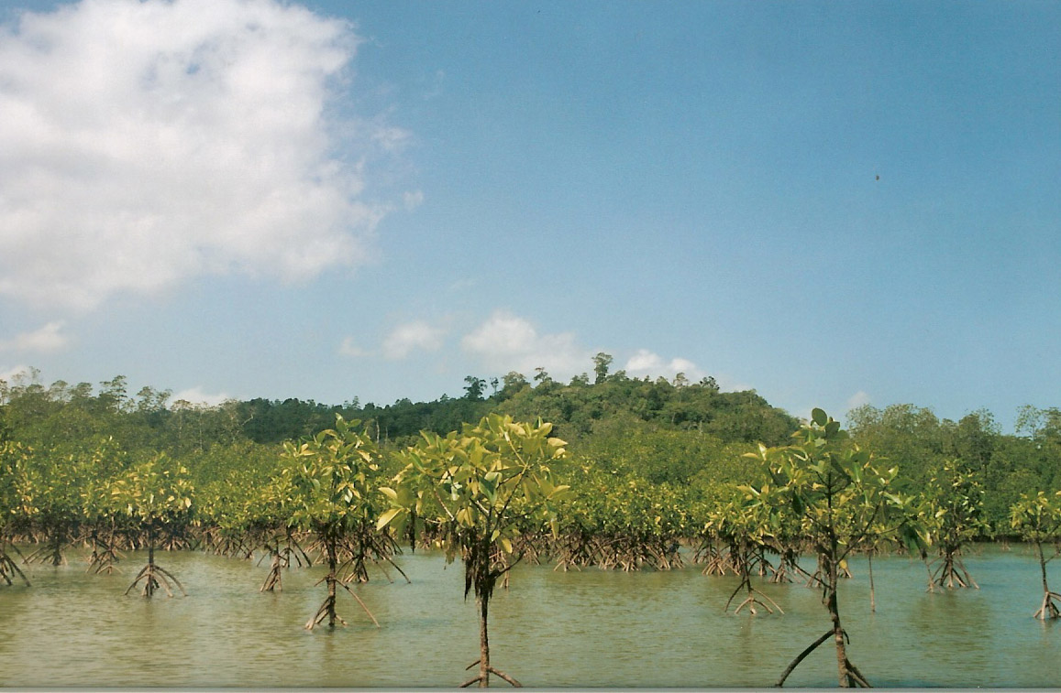

Deforestation will drastically alter the salinity regime. During the rainy season the forest floor, denuded of its cover, loses its water-holding capacity causing copious flow of fresh water, thereby drastically lowering the salinity. In summer, since hardly any water is impounded, the marine waters in the brackish areas become too salty for mangrove species and coral reefs to tolerate. Vast expanses of corals particularly, because of their strict salinity requirement, are more likely to perish from such fluctuation in salinity regime than from dynamite and cyanide fishing. Eventually, the ensuing erosion will deposit silt that the mangroves cannot tolerate. The silt will also cover the seagrass beds. The resulting water cloudiness will first inhibit the symbiotic algae from manufacturing food by photosynthesis for the host corals, thereby starving them. Then, the silt will blanket and cover the reefs suffocating them to death. In the Philippines, where the denudation of forest cover is a major environmental concern, the damage on coral reefs due to siltation is extensive, although mostly unseen unlike the damage from destructive fishing, which is more dramatic and the object of most conservation information campaign.

Intensive agriculture practices from inland agricultural areas also cause severe damage to coastal areas. The use
of chemical fertilizers, pesticides, insecticides and herbicides, pollutes the runoff silently killing the reefs and seagrass beds like cancer. Runoff water that dump chemical pollutants on the marine area, not only kills the reefs but also contaminates living marine organisms such as shellfish- like clams, oysters, and mussels, as well as crustaceans- like shrimps, crabs and lobsters, rendering them dangerous for human consumption. Construction of bridges, dams, irrigation systems and roadwork, which hinders or changes the drainage of surface water runoff or alter the flow of tidal currents stresses the coastal ecosystems by disrupting the local salinity regime. Also damaging to the coastal resources ecosystems is the rampant use of detergents that is fast becoming a serious threat to the coral reefs and seagrass beds not only in urban areas but in isolated villages as well.

Deserving special mention is the destruction caused by the fishermen and the coastal dwellers themselves. Mangrove forests are cleared for fishponds, removing an already productive ecosystem to give way to an artificial one. Mangroves are also logged for charcoal and raw material for synthetic textiles. Coral reefs are rampantly being damaged by destructive fishing techniques such as using dynamite and cyanide to capture live aquarium fishes and live food fish for the restaurant trade. Even the much vaunted ecotourism activities are putting pressure on the critical ecosystems of the coastal region. Dive boats are damaging the reefs with their anchors and careless tourist divers are stressing the coral reefs. One can visit the now world-famous tourist resort Boracay Island to see how over crowding and too much visitors have stressed the coastal environment. Because of overcrowding, raw sewage is now seeping into the drinking water supply and starting to kill off the coral reefs.

Yet, the greatest threat to our coastal resources remains to be the rapidly increasing population, not only in our country but in the whole world as well. The increasing demand for seafood by the international market has increased fishing activities. Year-in and year-out, fishermen are venturing further out to scour the sea for fish, using sophisticated and advanced fish capture technology if not destructive fishing techniques. The situation is such that some of our traditional fishing grounds in central Philippines have already been depleted. Fishermen in those areas are now venturing out as far as the coral reefs of the Kalayaan Islands, 100 nautical miles west of the main island of Palawan. This is for the fishermen who have big motorized outrigger bancas. But what about the marginal- sustenance fishermen with their small paddle bancas and hook and line?

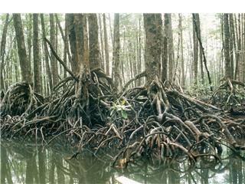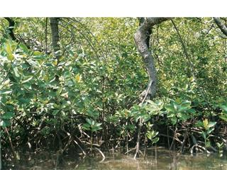

The tangle of roots is utilized by fish fry as a sheltering area from predatory species. The decaying leaves of the mangrove trees are converted by diatoms into a nutrient soup that nourishes the fry of fish and crustaceans.

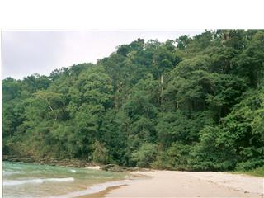

This is a beach forest and the adjacent white sand beach in Western Palawan.
There are very few intact beach forests left in the Philippines.

