Environmental Awareness
A monthly publication of UP BETA SIGMA FRATERNITY, INTERNATIONAL, INC.

HAPPY 40TH EARTH DAY!
Roseville and Placer County Celebrations
April 2010
Special Edition
The issue is written in time for the 40th Earth Day celebrations of the City of Roseville and Placer County last Saturday, April 17, 2010. Festivities will culminate in Sacramento County on April 24.
The green movement has become a way of life among the residents of these counties, as encouraged and augmented by government policy and programs, private initiatives among individuals, associations and companies.
Here, government has offered incentives to homeowners and to private companies to keep the green program going. Several sectors in the private industry have likewise responded by integrating their business strategies with environmentally sound practices.
Needless to say, as in some of the other past issues, this one is written in the hope that other localities and communities may be able to pick up some ideas that could be adopted in their own.
This is the 28th issue in as many months since we started this publication in January 2008. We had planned that beginning 2010, we would put some breaks by doing this on a quarterly basis. Luckily, it was not meant to be so. Thanks to our generous contributors.

By Willie “Tatang” Vergara

The world celebrates the 40th Earth Day today, and if our webmaster is able to spare his time (again and yet again!) this issue will be published on April 22, 2010, exactly 40 years since the very first festivities way back in 1970.

Earth Day was started by US Senator Gaylord Nelson, and he spent his whole political career promoting the cause of the environment. Exactly 4 decades ago today, Americans took to the streets to support this green movement. Since then, green programs have slowly become a global concern. Earth Day Networks continue to be formed around the world, and more and more people have begun to recognize the importance of taking care of Mother Earth.

The Philippines was not to be left out in this movement. Sluggish as it may have been in the beginning insofar as environmental pursuits is concerned, perhaps by a lackadaisical attitude from the government and private industry, the Philippines became one of 141 countries that joined the celebration.

What has happened in the past decades in the Philippines, especially with last year’s typhoons “Ondoy” and “Pepeng” as well as recent earthquakes and extremes in weather are clear indications of nature reacting to man’s misuse and overconsumption of resources. The politicos as usual kept pointing their fingers of blame once again, but there are also very positive developments in the Philippines like the millions of pesos put in by larger corporations in the Philippines like Ayala and San Miguel to save and possibly restore the badly devastated Philippine reefs. (At this point, I would like to invite you to read the articles of Brod Popoy Castaneda, an expert on aquamarine life and the Philippine reefs.)

Of late, the Philippine branch of Earth Day Network has established itself as an active supporter of the cause. This Network is a loose coalition of various sectors – private companies, media, churches, the academe, the government – advocating and working for a sustainable environment. It has currently more than 20,000 members in the Philippines with more than 17,000 partners and organizations in 174 countries fighting to save Mother Earth. Last year, 647 local government units in the Philippines participated in Earth Hour, in solidarity with other countries. This has increased to 1,077 LGUs this year, in addition to the business and private sector groups and individuals, who reportedly turned off their lights for an hour. At www.10mm.ph, Filipinos can make pledges of things they will do to save the environment. Each commitment is symbolized by a leaf on a tree on the site’s home page. Each leaf is also a thumbprint. The 10 Million Movement starts with the proposition that it is time for people to take personal responsibility for what is happening to the environment. The 10 Million Movement declares with conviction that the future is in our hands.

Especially for the City of Roseville and the Placer County, California, environmentalism has not only become a matter of awareness but also one of advocacy and practice. Compared to a decade ago, thinking green has become a mainstream concern. Protecting the environment has become a top-of-mind of most homeowners. Thanks to the local governments that have spurred the growth of the green movement by way of providing incentives and rewards. Thanks, too, to the cause-oriented groups that kept the “green ball rolling”, and to the private sector that likewise have integrated environmentalism into the life of their businesses.

On this same publication (May 2009), the City of Roseville and Placer County celebrated Earth Day’s 39th Year. This year’s celebration is definitely bigger in terms of variety of offerings, patronage, and number of booths, with several thousands visiting the Roseville’s Utility Exploration Center, where the exhibits were held.

Elsewhere in our immediate vicinity, about 270 people registered in advance to help pick up the trash along the American River Parkway. In 3 hours of seven work sites, the volunteers removed 5,581 pounds of trash, almost a ton more than last year’s spring parkway cleanup.

The photographs below will certainly tell much of the story. In a nutshell, what you see below are photos mainly of the festive atmosphere featuring booths and bands, visual and performing arts, children as well as adult education, informational leaflets and other printed advisory, abundance of library materials relating to the environment, water and energy conservation gadgets, programs in partnership with the private sector, exhibits inside the Center where children muddle through a “garbage mountain”, teens competing in an interactive video game with a localized ecology-theme a la “Jeopardy”, the famous TV program, workshops in composting and water-wise gardening.

In short, this is an excellent local approach to Environmentalism – all presented in a fun, thought provoking and life changing way.

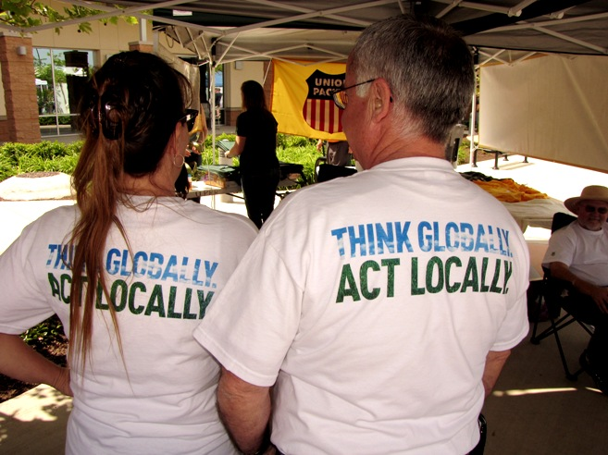
Think Locally, Act Globally was the title of our May 2009 issue.
That was also the message of Brod Secretary Victor Ramos in his article last June 2008.
“Think locally, act globally” has now become a household motto in Placer and Sacramento.

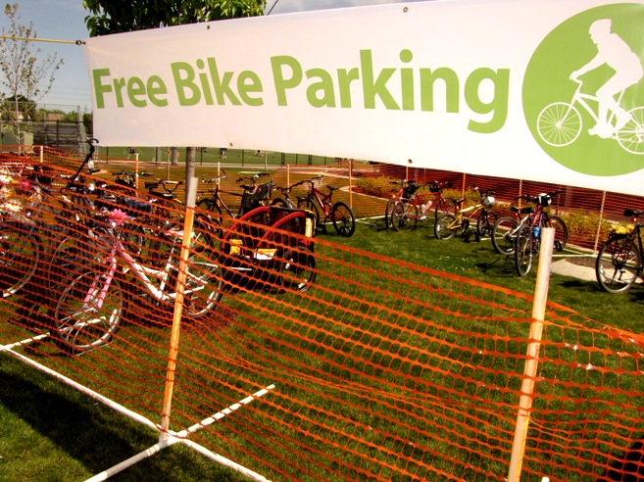
Especially for those coming from a biking distance, the organizers offered an incentive to use their bikes.
Above photo shows early birds availing of guarded bike parking.

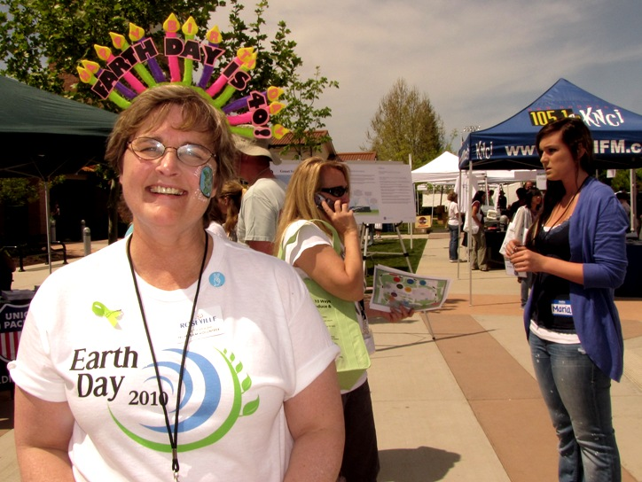
Above photo shows one of the organizers proudly showing her home-made Earth Day crown.

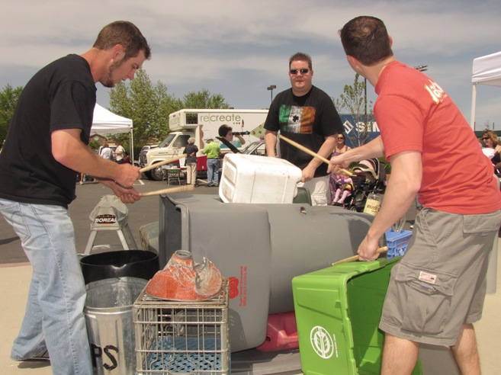
They call themselves “Petting Zoo” Garbage Can Band. They provided one of the most
Interesting entertainment numbers of the Earth Day Festival – 4 times during the day.

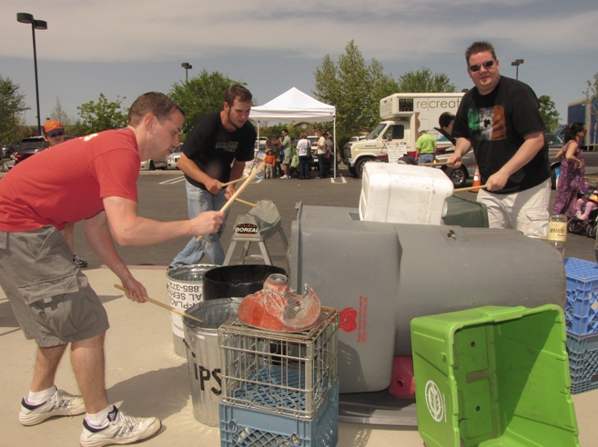

The Petting Zoo has performed in many places in Sacramento and vicinity because
the band members are so skillful in making music out of water bottles,
oil drums, plastic water buckets, soft drinks cases, bins and garbage cans.


These types of posters featuring children abound in the festival area.


A budding young artist tries out some eco-friendly, non-toxic art materials.


Dr. Solar provides a blend of comedy, magic, some flim-flam and a whole lot of pizzaz.

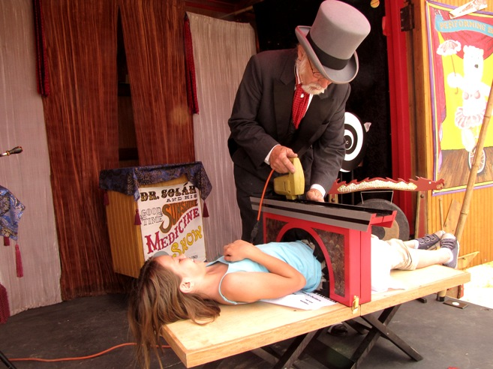
Dr. Solar with his unique humor provided a carnival atmosphere to the whole place.

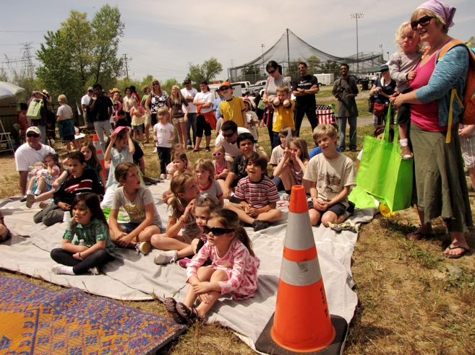
Children love watching Dr. Solar and his interestingly green ideas.


This man and his company is in the business of providing ink for your printers while
discouraging people to buy expensive new cartridges – certainly an attractive proposition.

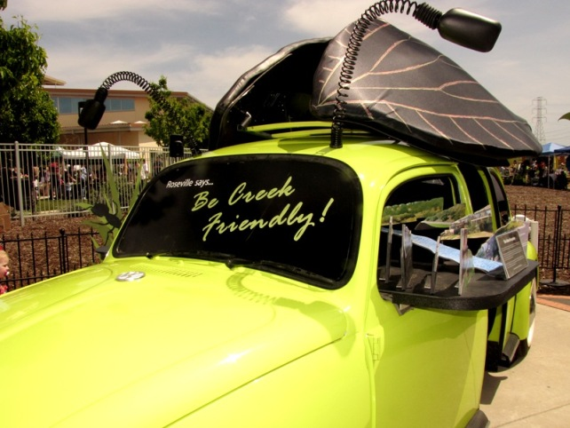
Inside this Volkswagen are small kids watching movies on environmentalism.

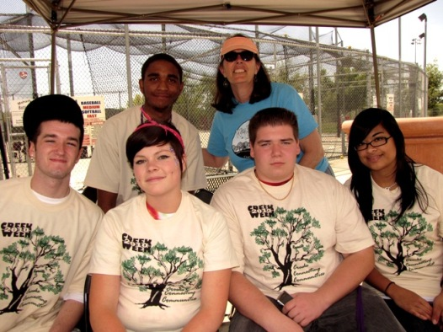
High School kids celebrating 2010 Creek Week are joined by their teacher in this photo-op.
There is also a Dry Creek Conservancy that has worked to preserve the creeks and open spaces,
monitor water quality and salmon counts, enhancing the breeding of salmon that swim to Alaska.

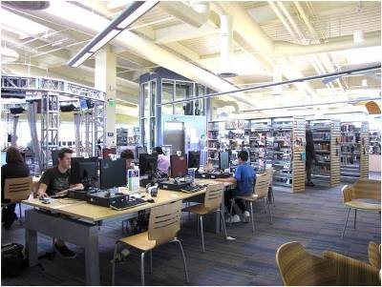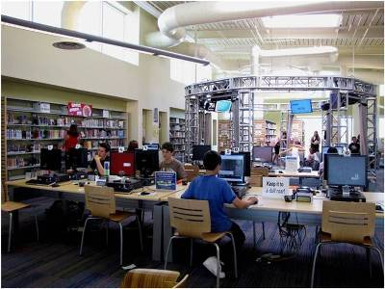
The Riley Library located at the Roseville Utility Exploration Center has one
of the most extensive collections of environmental books and periodicals.
Additionally, over 40 internet-connected public computers for self-guided research are available.

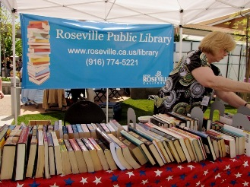
Book Exchange Program: Bad for the book business, but good for the trees.

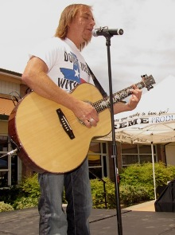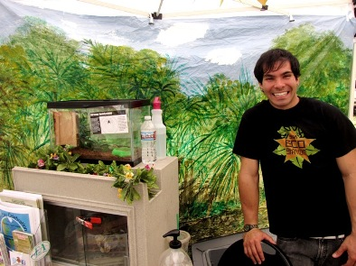
Balladeer Chris Martinez entertains big crowd with his environmentally-oriented music.
On the right picture, it was a pleasure to meet a new friend, Josh Moore,
of Filipino descent. A college student, Josh is into Environmental Studies.

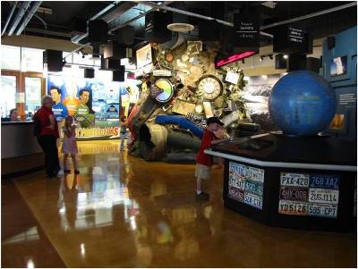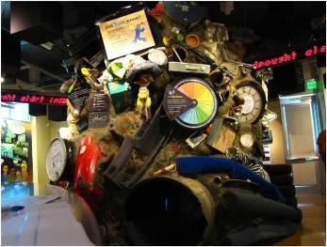
The Garbage Mountain shown in our May 2009 issue is still inside the
Utility Exploration Center, and continues to be patronized by small and not-so-small kids.

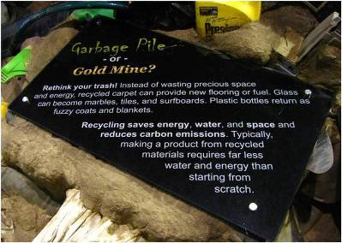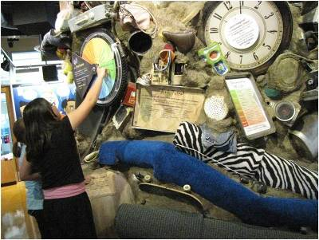
Mountain Detail

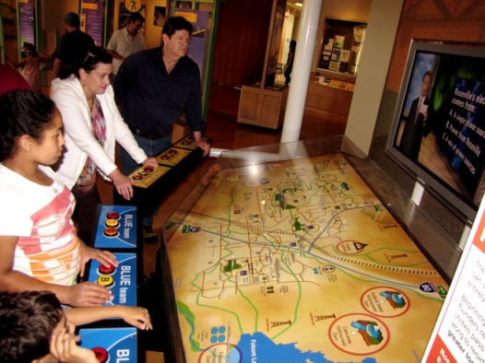
The interactive games are for both young and old.

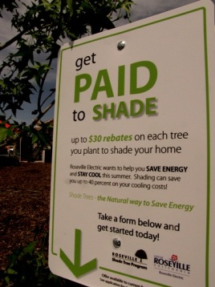
WOW! The government pays homeowners to plant a tree in their backyards.

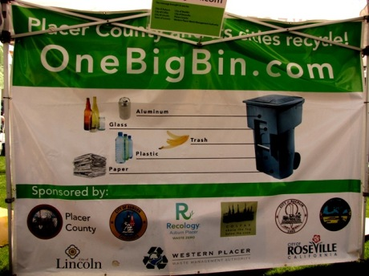
“One Big Bin” (not Big Ben) is a collaborative effort between
Western Placer Waste Management Authority and the Placer County and its cities.

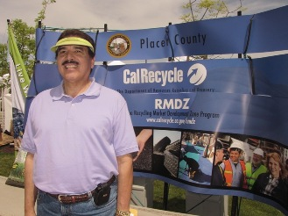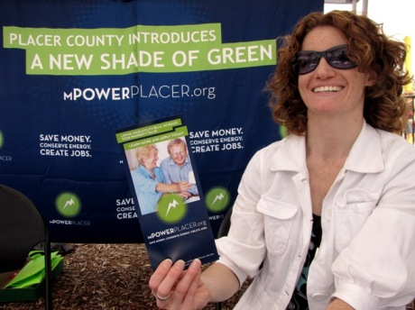
The mission of One Big Bin is to let those who live, work and play in
Placer County know about one of its best kept secrets, known as the MURF.
MURF means Materials Recovery Facility. The facility sorts, then recovers
recyclables such as cardboard, newspaper, mixed paper, plastics, wood, glass and metals.
MURF receives up to 1,000 tons of residential and commercial garbage every weekday.

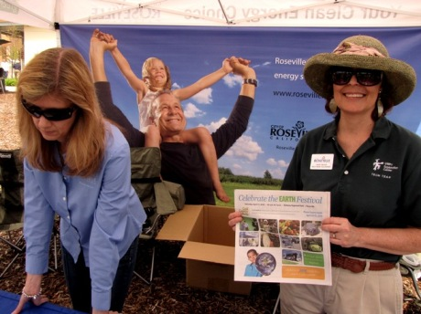
The Placer County government offers the financing for green projects, where money borrowed can help
save 10%-50% on home energy bills. Improvements include (a) high efficiency windows and insulations;
(b) tank-less water heaters; (c) low flow water devices; (d) heating, ventilations and air-conditioning systems;
solar energy systems; and many more. Minimum amount that can be financed is $2,500 at low interest.
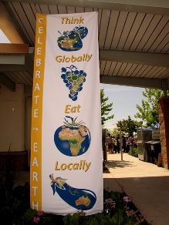

Above pic is a nice and creative slogan to promote and eat locally grown products.
UNFI is a company that promotes health foods and organic products.

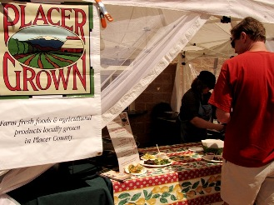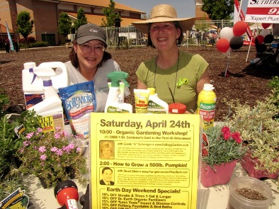

Above photo is one of many food booths where one may tame his/her hunger by eating locally-
grown food. At left, ladies promote free Organic Gardening Workshop and organic plants.

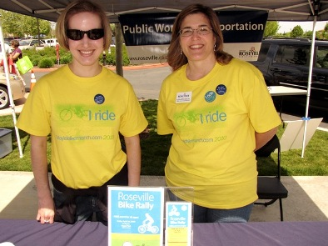
Almost every city in Placer and Sacramento counties have their own biking clubs.

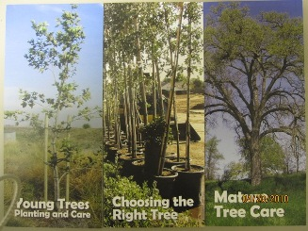
The festival is awash with many helpful and easily readable materials such as the ones above.

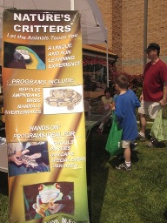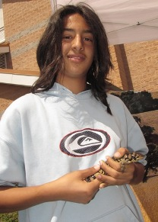
Let the animals touch you. Or you can touch and carry the animals yourself.

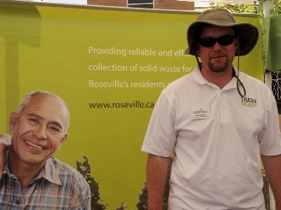
Look at ‘em trash talkers!

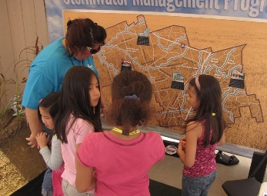
Children are exposed early to the importance of sound storm-water management.


This compact, easy to install device works wonders in saving water for your garden.
It automatically calculates evapo-transpiration then determines watering requirements.

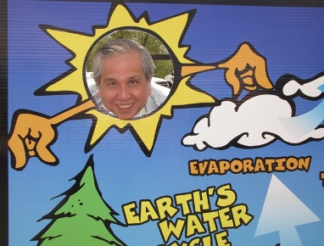
THANK YOU FOR BEING PART OF PROTECTING OUR ENVIRONMENT.

