Environmental Awareness
A monthly publication of UP BETA SIGMA FRATERNITY, INTERNATIONAL, INC.

Shall We Start Building An Ark?
April 2010
One of the most devastating disasters of recent memory happened last September 2009 when Typhoon Ondoy dropped 455 mm (17.9 in) of rain on Metro Manila in a span of 24 hours on Saturday - the most in 42 years. A month's worth of rainfall in a single day washed away homes and flooded large areas, stranding thousands on rooftops in the city and elsewhere.
The author expertly dissects the cause of this recurring flooding problem in Metro Manila.
About the author
With this latest article, Brod Popoy Castaneda is decidedly the most prolific contributor to our Environmental Awareness publication. He must be one of the most well-rounded and talented Filipino environ-mentalists as could be seen from his varied contributions to this website. A professional diver, he has written a lot about underwater wonders. As a dive master, he was one of the most treasured resource of the legendary Jacques Yves-Costeau aboard the marine research vessel Calypso. As an artist, he has done a lot of nature-related art. Part of his “Philippine Birds” collection is found in this website under “Artworks”, paintings by Popoy Castaneda.

An Anatomy of Metro Manila Floods
by Brod Popoy Castaneda, UPLB ‘55

The tropical monsoon begins in the South East Asian mainland where it gathers moisture and moves north eastward. The monsoon rains reach the Philippine Islands by the first week of June. Its moisture laden clouds bring rains to the islands of Luzon, the northern part of the Visayan Islands, Mindoro and Northern Palawan. This is the South-westerly Monsoon and its arrival signals the start of the rainy season which lasts until late October.

In the Philippines, the South-westerly monsoon is generally called in the vernacular as the “Habagat.” Concurrently in the area of the Marianas Islands in the South Pacific Ocean, another weather system develops, starting as a low pressure area, soon becomes a tropical cyclone called in this region as typhoons. During the South-westerly monsoon, the typhoons hits landfall in the Philippines between Samar Island at the south and as far north as the Batanes Islands, then it plows to the northwest towards mainland China or Japan.

Whenever a weather system of this type occurs, it sucks in and intensifies the South-westerly monsoon bringing more rain as it moves closer to the Philippines. Thus an approaching typhoon is always heralded by periods of heavy rainfall. As the weather system moves closer, the wind velocity increases generating huge waves that batter the western coastal region of the affected areas. When the typhoon hits the Philippines, the wind velocity it generates develops storm surges that cause flooding of the coastal areas. When storm surges coincide with high tides, a condition known as “king tides” occur, oftentimes causing disastrous flooding of the coastal areas. When “king tides” occur in places where big rivers or major tributaries drains into the sea in the western coast, it blocks up, if not reverse, the seaward flow of flood waters draining from the rain sodden uplands causing floods further inland.

Floods have occurred intermittently whenever an approaching typhoon intensifies rainfall, wind velocity, generating storm surges. In the urban areas such as the Greater Manila area, floods have begun occurring regularly during the South-western monsoon season even with just an occurrence of moderate rain. This can be generally explained by the rapid urbanization of the area where at present there is a continuous urban sprawl as far south to the northern Cavite town of Bacood, in Muntinlupa, north to Meycawayan, Bulacan and east to Antipolo and the town of Eulogio Rodriguez (formerly Montalban). Rapid urbanization has damaged or destroyed the natural drainage systems, where creeks and streams have been filled over for valuable dwelling space.

River banks and major tributaries have been overfilled with slum dwellings rendering the once free flowing water systems to mere stagnant cesspools and garbage dumps. Thus floods occur in many parts of the Greater Manila area whenever heavy rains occur and in occasions during typhoons the floods become disastrous causing damages to properties and infrastructures and loss of human lives.

Now, the floods have become even more disastrous and widespread, because another factor has emerged. The Greater Manila area is generally between two large bodies of water, Manila Bay on the west and Laguna de Bay (the lagoon of Bay) at the east.

At 949 kilometers in extent Laguna de Bay is the 3rd largest fresh water lake in Southeast Asia. It is a shallow lake of only 2.8 meters of average depth. Laguna de bay is the catch basin of 45,000 square kilometres of catchment (watershed) composed mostly of the west facing slope of the Sierra Madre mountain range. Twenty-one major rivers and major tributaries drain into the lake. At the lakes eastern shore is a hydroelectric power plant, where water power is provided by the water impounded at Caliraya Lake which is also an exclusive resort area. The lake is man-made and is approximately 200 meters higher than Laguna de Bay. In turn, Laguna de Bay is drained into Manila Bay by only one river, the Pasig River.

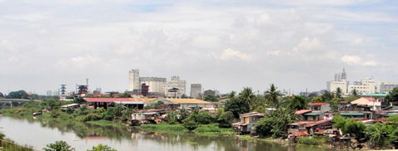
The Marikina River is a major tributary to the Pasig River.

There is only one river in the vicinity of Laguna de Bay that does not naturally drain into the lake, the Marikina River, which is a major tributary of the Pasig River. The Marikina River drains the slopes of the Sierra Madre mountain ranges in the vicinity of the Town of Eulogio Rodriguez, where there used to be a dam upstream but is now non-functional. Another major dam, the La Mesa Dam, an impoundment for Manila’s water system has its outlet valves into the Marikina River. This dam is supplied by the Angat-Ipo Dam system whose catchment is the slope of the Sierra Madre mountains north of the catchment for the Marikina River. The Marikina River drains into the Pasig River, and recently, to quell the river’s tendency to overflow its banks and damage the modern developments along it, a spillway was constructed to vent its floodwaters to Laguna de Bay just several kilometers north of the Napindan Channel where the lake enters into the Pasig River.

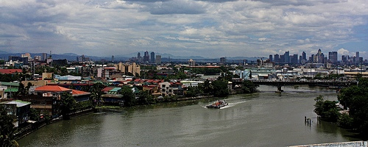
The Pasig River is notorious for wastes coming from factories.

The Pasig River, the only outlet of the big lake, has not been spared the damages of urbanization. It has been constricted by embankments and walls, rendered shallow by tons of sewage and solid waste dumped into it by factories, and has not been seriously dredged in its entire length. A great part of the Metro Manila’s storm waters and sewage drains into the Pasig River. Its major tributaries (called esteros) were utilized as commercial waterways in the olden days, are blocked up with slum dwellings and utilized as garbage dumps and cess pools.

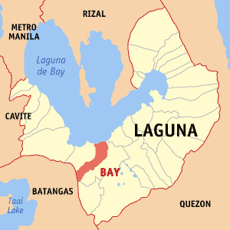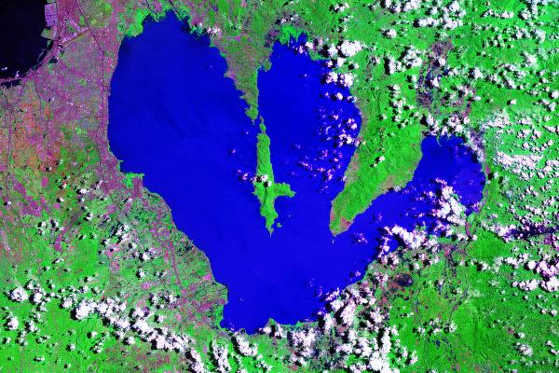
Map of Laguna de Bay; at right, satellite view of Laguna de Bay

Much can be said about the condition of the catchment of Laguna de Bay, but is best shown by what is taking place in the lake . During the height of the dry season the water of the lake is so low that salt water from Manila Bay intrude as far as the mouth of the Napindan Channel and during the height of the rainy season the lake shore towns have been regularly inundated.

The hydroelectric plant at Kalayaan has resorted to pumping up water from Laguna de Bay to Caliraya Lake to generate power during the dry season. The catchment basin of Laguna de Bay has been rendered ineffective because it is shallow considering the thousands of tons of topsoil and silt that flow into it. Before it had an average depth of 3.5 meters, but now a mere 2 meters.

Factories and housing developments intrude into its shore and the lake itself is overcrowded with rafts of the plant pest, water hyacinths and fish corrals. The same could be said for the nearby catchment of the Marikina River and the catchments of the Angat-Ipo Dams which supply water for Metro Manila.

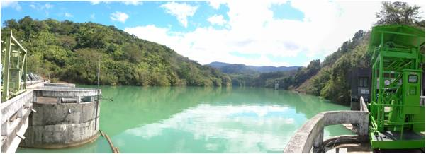
The Ipo Dam

Several days before September 26, 2009, a major low pressure area developed into a typhoon (code named “ONDOY”). Though initially announced as “still weak” as it approached the Philippines, the continuous rain in the greater Manila area proved to wreak havoc and disaster. This was aggravated by what was happening in the upland catchment of the Sierra Madre mountains, Laguna de Bay, Caliraya Lake, La Mesa Dam supplied by Angat and Ipo Dam which began to fill up. Laguna de Bay in turn was already flooded by September 25, the condition noticed only by a few lakeshore inhabitants.

The heavy, continuous rainfall was to be the heaviest rainfall ever recorded in at least 7 years. Typhoon Ondoy had hit landfall and generated a storm surge in the sea at the west coast. On that day high tide happened in the morning. Inured to the weather it was business as usual to the inhabitants of the area.

By midmorning, however, the Marikina River began overflowing its banks and the spillway gates were opened. But the lake was already flooded and so the flood waters rose up immediately inundating everything in Marikina, Cainta, Taytay and Pasig City forcing inhabitants of plush subdivisions to seek shelter on rooftops. South along the Paranaque–Muntinlupa area their drainage is Laguna de Bay thus water draining towards the lake which was already flooded resulted in flooding the subdivisions including the South Luzon Expressway. In the Metro Manila area, water draining into the waterways that run into the Pasig river was blocked by the flood caused by the meeting of the flood of the Laguna de Bay and the king tides of Manila Bay. The coastal areas did not fare any better since the king tides flooded the streets of Paranaque, Las Pinas, Navotas and Malabon. By late afternoon of the same day the waters has receded exposing the damage and the debris left by the flood, but in the towns along the shore of Laguna de Bay the flood stayed on up to the first week of November.

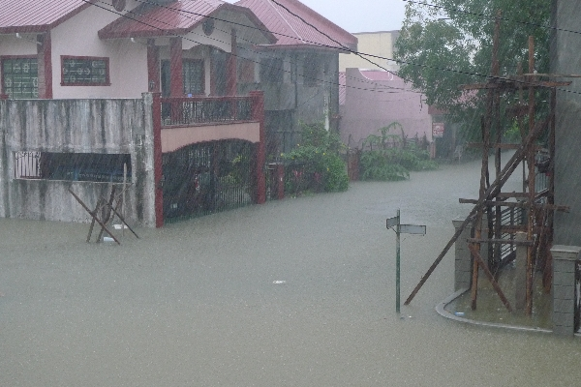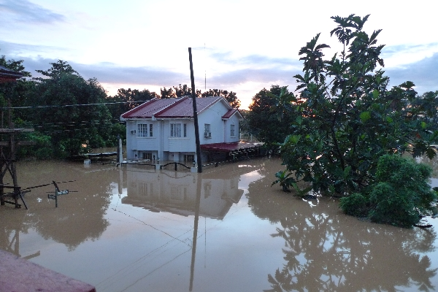
Cainta, Rizal, the home of Brod Simeon “Mon” Mamaril was among those submerged by floods.


Brods took the initiative to help Mon and his family.
From Left: Monsi, Mon Mamaril, Hepe, Dogwe, Jomar, Joey, Danilo

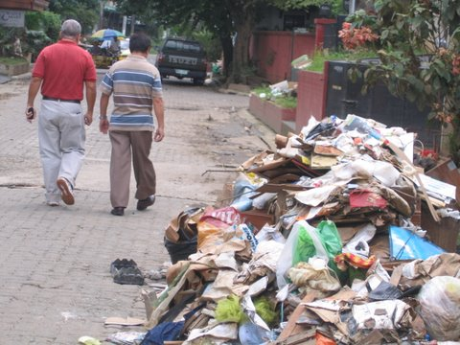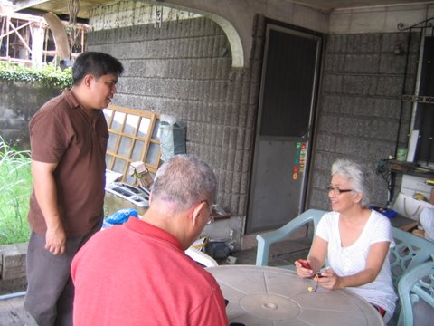

Same thing with Marikina and other places in Metro Manila. Photo above shows Raffy and Ollie with Mrs. Santos (wife of Brod Rolly Santos). The Oplan Sunshine organized by Raffy and OBBF also visited the families of Willie Nepomuceno, and Ricky Tolentino, also from Marikina

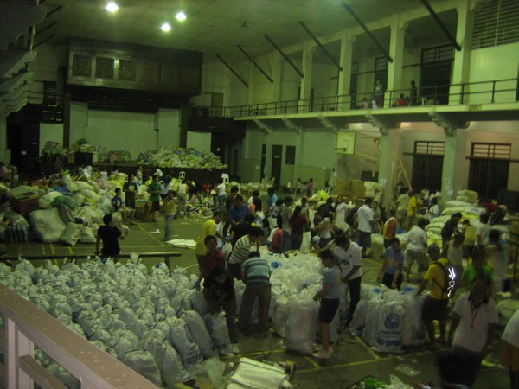.
UPLB Brods also helped in relief operations. Photo taken at Baker Hall, UPLB.

