Environmental Awareness
A monthly publication of UP BETA SIGMA FRATERNITY, INTERNATIONAL, INC.

XERISCAPING:
February 2010
Many areas of the world have been faced with increased demands on existing water availability. As increasing percentages of land area are being developed for residential housing, concern for water usage to maintain gardens have become more and more heightened. Water resources have been pushed to their limits owing to ever-increasing demand. Seasonal droughts inevitably resulted in water restrictions in many parts of the US. There is now a greater focus on water conservation, not just in times of drought, but in anticipation of future population growth. Cognizant of such problems, many environmentalists as well as community organizations are constantly finding ways to promote, educate, and learn more about how to use this precious resource most wisely.

About the author

Willie “Tatang” Vergara was introduced earlier, this being his fourth article. His other articles are: (a) Smokey Mountain in Tondo, Manila, (b) Think Globally, Act Locally – How Roseville City promotes environmental protection, and (c) The California Academy of Sciences in pictures. He has lived in areas of extreme drought like the driest part of Cubao, QC and inside a subdivision in Paranaque.

Eco-Friendly Gardening

By learning you will teach; by teaching you will understand.
--- Latin Proverb

DISCLOSURE: Though I have just started to slowly implement the concept of xeriscaping in my own home (therefore not yet an expert practitioner), a lot of the foregoing ideas are a product of research. For the past 7 years, I have been a regular subscriber of the monthly publication Sunset Magazine which deals a lot on the topic, a faithful fan of the weekly gardening advisory of Sacramento Bee, and an avid reader on the subject of water conservation. The reader may, therefore, confidently assume that the information herein will be useful to the interested learner of xeriscaping. This will deal only with the basics of water-wise landscaping and will not go as far as architectural design and other technical aspects.

Xeriscaping is water-wise landscaping. It is most useful especially for areas where water conservation is desired, promoted and/or legislated, and is most practical in places where drought is imminent. The etymology of the word comes from Greek xeros meaning "dry". Xeriscaping is, therefore, “dry landscaping”.

One would immediately think of using plants that live in the desert, such as cacti. This is true, but this would be too limited a view. The fact is that with just a little research of plants and their characteristics, plus some common sense, one may select from an array of beautiful plants for his/her own front or backyard. Properly installed and maintained, a xeriscape can use less than one-half the water of a traditional landscape.

Xeriscaping can take many forms. For some landscapers, it means grouping plants with similar watering requirements together. Indeed, one can combine the beauty of plants native in your respective areas with efficient water use outdoors. If you do this, you can just imagine yourself attending more often to the plants that need more frequent watering, saving you a lot of gardening time.

Plants most suited to xeriscape landscaping are sometimes referred to as "xeric" plants. Most xeric plants will need no supplemental watering once they have established. The establishment period after installation may require from 18 to 24 months. Almost any plant can be used in a xeriscape landscape if grouped according to its water needs. Annual and exotic plantings can be located in small, easily accessible areas to make maintenance easier. Irrigation can then be zoned according to plant water needs to make efficient irrigation possible.

Lawns: The Biggest Culprit

Did you know that lawns need much more water than your garden plants and trees combined?

In many places in America, including in the area where I live, people buy homes wherein the dominant landscaping element on the property is lawn grass. The assumption that a landscape will have lots of grass and that it will stay green all growing season is imbedded in the American psyche. Except during the winter months, the owners have been faithfully mowing their respective lawns for years, not to mention the amount of water that are used to make these lawns look verdant and healthy. In several towns and cities, 50 percent of water is being used for outside watering.
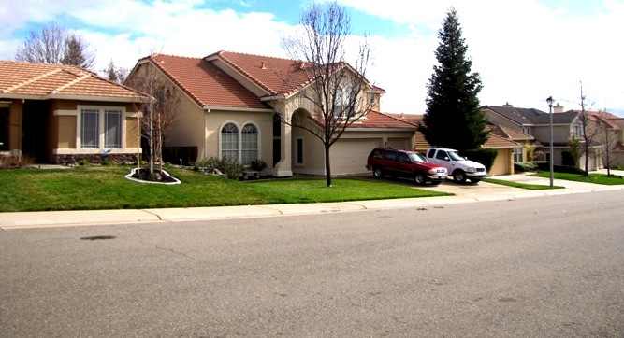
Many American homeowners are in love with open lawns, as in our neighborhood.

During summer, I had to shell out an additional $120 per month in order to water my lawn. Just simply thinking about better uses for the money spent on a lawn watering was enough incentive to think of alternatives. Rather than feeling sorry for the loss of lawn space, let us might as well think of the present predicament as an opportunity to seek better options. Why not cut back on the expense of a lawn by decreasing its area, relegating the lawn to an accent on the landscape rather than maintaining it as the dominant element? Yes, truly there are alternatives other than moving out and renting an apartment without a lawn to take care of.

The following options which, by the way are NOT mutually exclusive, may be adopted:
- Increase the area of cemented space on the driveway to lessen the lawn area. This is practically shooting two birds with one stone: (a) increasing the outdoor parking and (b) decreasing the area that needs watering.
- Convert part, if not all, of the lawn area into a rock garden.
- Use “artificial lawns” instead. This lends for zero watering, zero application of fertilizers, zero mowing, and zero weeding. In short, the use of artificial lawns means zero maintenance.
- Convert part of the lawn into flower beds or even into vegetable garden beds, for as long as it is seen by your neighborhood as acceptable. WARNING: In Sacramento, California, a lady homeowner had to be advised by the city government to find more “aesthetically acceptable” options to her vegetable garden at her frontage.
- Apply mulch beds of bark, stone or gravel.

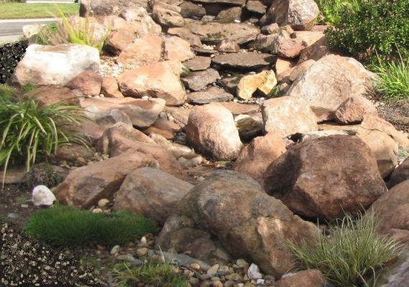
One of our neighbors was smart to have converted a significant part of his lawn into a dry creek.

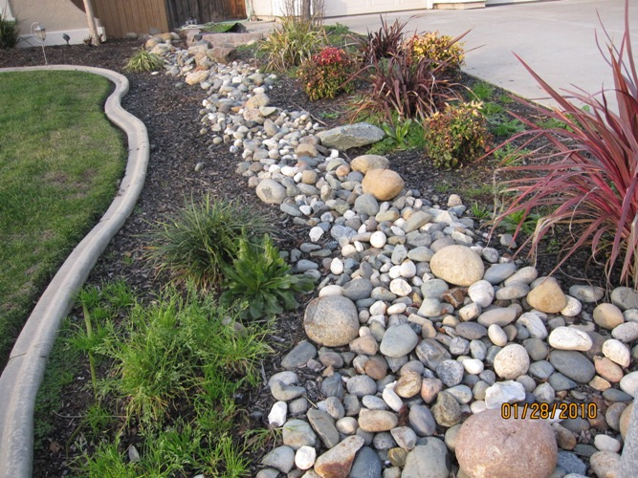
This one used a combination of rocks, mulch and plants with multi-colored leaves.
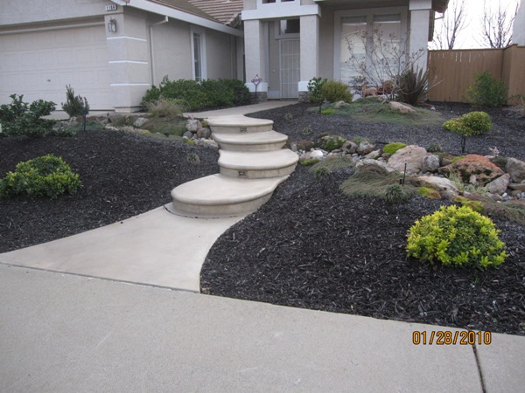
This neighbor completely got rid of his lawn and replaced the lawn grass with mulch.

Xeriscape landscaping, however, does not necessarily mean substituting rocks and desert plants such as cacti, euphorbia and agaves for one’s lawn. In no way does it mean “zero landscaping”. For one who wishes near zero maintenance, the photo below might be suitable. This xeriscaping idea below shows how simple it is to make something environmentally friendly with some gravel, rocks, and a few plants.

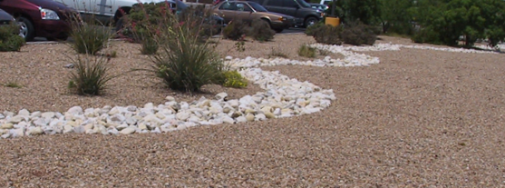
Circumstances such as drought may require one to adopt this simplest xeriscaping technique.

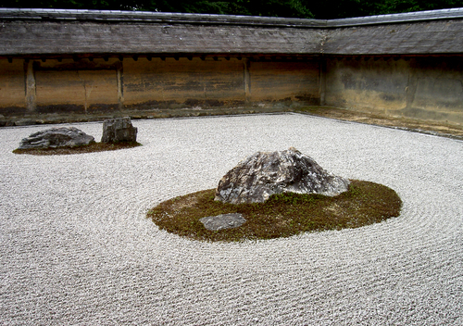
This Rock Garden in Ryoanji Temple in Kyoto has been a major attraction among several millions of tourists.

The secret to a successful xeric gardening if one desires a lot of colors is to know which plants are indigenous to a particular area. A good technique would be to go around the neighborhood and see which of the flowering plants have “naturalized” and are growing robustly. Going "native" in plant selections is sometimes equivalent to "drought resistant." Successful xeriscaping should, therefore, begin with proper planning, plant selection, and placement.

While xeriscaping minimizes the use of natural resources and the need for a lot of chemicals in the garden, one does not have to minimize or sacrifice beauty and character. In some xeriscaping ideas where using few plants is either necessary or desirable, a little creative thinking will add interest to an otherwise dull and oftentimes monotone landscape.

Benefits of Xeriscaping

- Saves Water. For most of North America, over 50% of residential water used is applied to landscape and lawns. Xeriscape can reduce landscape water use by 50 - 75%.
- Less Maintenance. Aside from occasional pruning and weeding, maintenance is minimal. Watering requirements are low, and can be met with simple irrigation systems.
- No Fertilizers or Pesticides. Using plants native to your area will eliminate the need for chemical supplements. Sufficient nutrients are provided by healthy organic soil.
- Improves Property Value. A good Xeriscape can raise property values which more than offset the cost of installation. Protect your landscaping investment by drought-proofing it.
- Pollution Free. Fossil fuel consumption from gas mowers is minimized or eliminated with minimal turf areas. Small turf areas can be maintained with a reel mower.
- Provides Wildlife Habitat. Use of native plants, shrubs and trees offer a familiar and varied habitat for local wildlife.

As a matter of fact, xeriscaping will allow you to use a wide variety of plants, with the use of some common-sense measures that will help to conserve water. Examples are shown below of flowering plants that do not require much water, such are gaillardia, Russian sage and bee balm. These are native to this particular area in Colorado. These do not require much additional water than the average rainfall.
 | 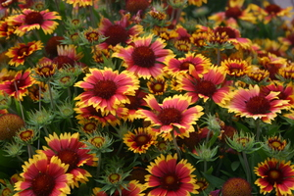 | 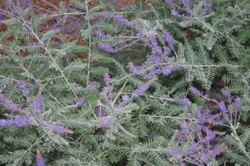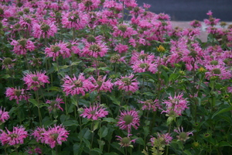
Colorado Demonstration Xeriscaped Garden (source: davesgarden.com)

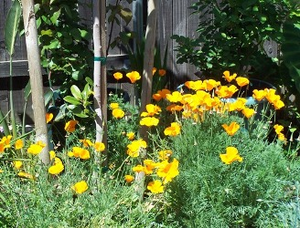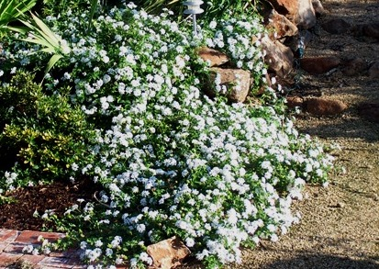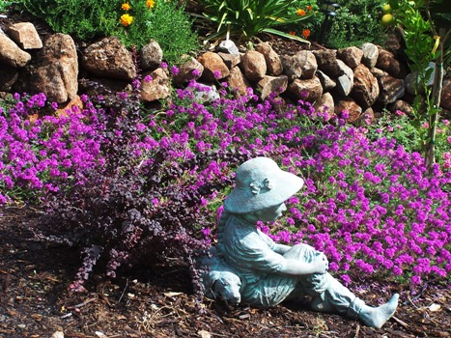
These three plants (from left: California poppy,lantana and purple verbena) on my garden come out with beautiful flowers every spring and summer without watering aside from rainwater during the winter and spring. These are strategically placed at the lowest area of my backyard garden.

The Backyard Garden of Bobby and Harlean Pascual

Among the members of our UP Beta Sigma Chapter of Northern California, I consider the garden of Bobby and Harlean Pascual as the best example of xeriscape landscaping.

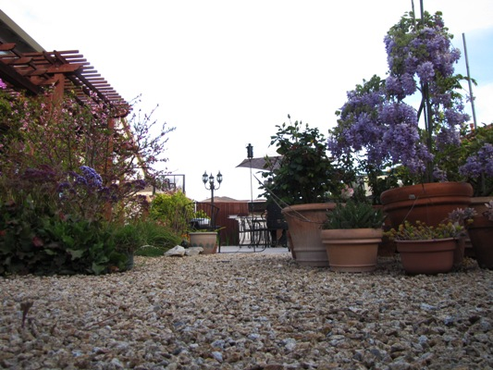
At left, Bobby(on his 60th birthday) and Harlean pose with lechon baka at the foreground. Note that there is no lawn to water because all non-cemented areas are covered with small white peebles. Most of his flowering plants are in big pots. (Plants in plants are also water-savers.)

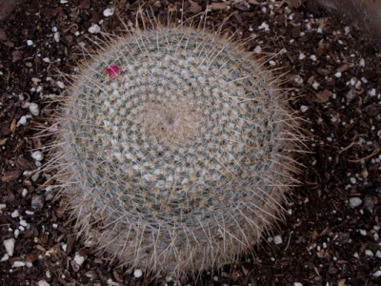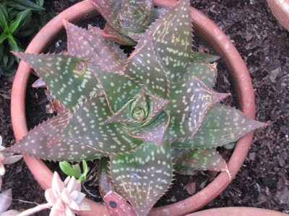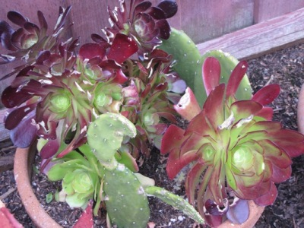
Above photos are among this garden’s many collection of cactuses and succulents.

Bobby and Harlean have chosen many other types of plants that require little water to live very well besides cactus and succulents. But of all the plants used in xeriscape, cactus have the lowest water demands, and have those spines are beautiful throughout the year. Most cactus flowers are beautiful and colorful and change to various colors in different seasons. Those that require special watering are placed in pots.

There are other special plants in the garden that do not fall under the topic of xeriscaping, but are certainly of interest to the lover of plants as well. For instance, in one corner beside the perimeter fence, Bobby has successfully grafted an apple tree that produces five different varieties of apples. We also had our fill of delicious oranges which we picked from Bobby’s perimeter.

Brod Pogs Gaspay, himself an avid gardener and collector of special plants, is one of Bobby’s admirers when it comes to backyard gardening. Neither Bobby nor Harlean have gone through formal schooling on horticulture and the like. Pogs could only guess Bobby’s qualification that led him to design such a beautiful xeriscaped garden. “Bobby is an Ilocano”, Pogs declares.

