Environmental Awareness
A monthly publication of UP BETA SIGMA FRATERNITY, INTERNATIONAL, INC.

The California Academy of Sciences
January 2010
It has been more than a year since the new building of the California Academy of Sciences, which mission is to explore, explain, and protect the natural world, was open to the public. Located inside the huge Golden Gate Park in San Francisco, the author spent almost a whole day during the New Year weekend to view what’s inside this 400,000 square foot structure that houses a planetarium, an aquarium, a natural history museum and a 40-story rainforest.

Eleven months ago, Ms Rose Veridiano first wrote about the CAS in this publication. Here, she gave an apt description about the different attractions this museum offers. The Academy’s collection has increased since then and the Planetarium now offers a new show, “Journey to the Stars” narrated by Whoopi Goldberg.

This issue attempts to interest both the adult and the very young reader with photographs of the museum’s vast collection. Let the photographs speak for themselves, so they say.

Some useful tips for the future visitor are also provided in order to maximize his/her visit to this world-class museum – so far the only one of its kind as of this day and age.

Willie “Tatang” Vergara

A Fabulous Visual Experience

Here are a few facts that the visitor should know:

What is it? The CAS is an international center for scientific education and research and is at the forefront of efforts to understand and protect the diversity of Earth’s living things.

What are some of the things that make this museum truly unique?
There is a planetarium that has the largest all-digital dome in the world with a 75-foot diameter projection. The viewer is assured of a unique experience due to a highly advanced video technology – with an imagery that creates an experience more like flying than watching a movie.

Secondly, the building is one of the most environmentally friendly facilities in the world considering the following features:

- It produces 50 percent less wastewater than any facility of its kind.
- It recycles rainwater for irrigation.
- It produces solar energy using the most advanced technology.
- It supports a green roof with several kinds of plants planted on it.
- Natural lighting is used in 90 percent of occupied spaces.
- Most of the areas are built on recycled concrete.
- That includes 11 million pounds of recycled steel.
- Scraps of recycled denim make up the wall insulation.

Some useful tips:
- To avoid a long walk from the parking area to the CAS building, arrive at the place one hour before the opening.
- To avoid having to pay $25 entrance fee ($20 for seniors), look for a CAS member for company. You and the CAS member could enter the facility one hour earlier than the non-members.
- You can visit the CAS for free every third Wednesday of the month.
- Upon admission into the building, immediately get a ticket for the planetarium. Not everybody who go to CAS get to see the planetarium because of limited seating capacity (150 people for each showing).
- Children below 3 years old are not allowed inside the planetarium.
- CAS is within the Golden Gate Park – 1,000+ acres and 3 miles long (larger than Central Park in New York). You may plan to spend the rest of your day visiting the attractions of Golden Gate that include: the Japanese Tea Garden; San Francisco Botanical Garden; De Young Museum; Conservatory of Flowers; etc.)

Interior and the Living Roof

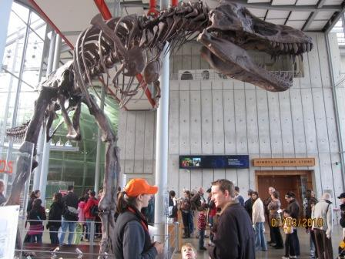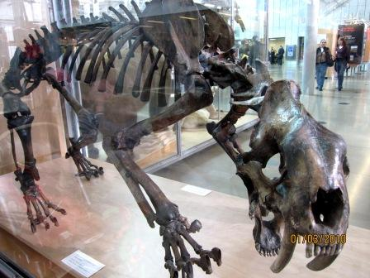

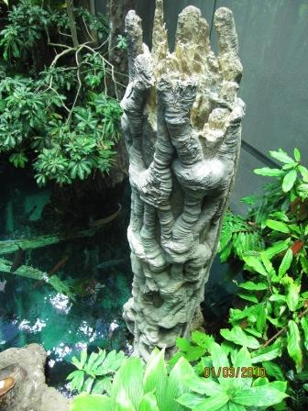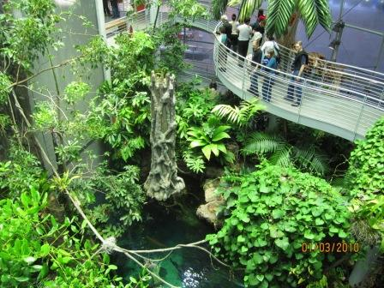

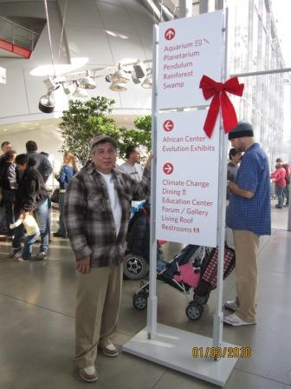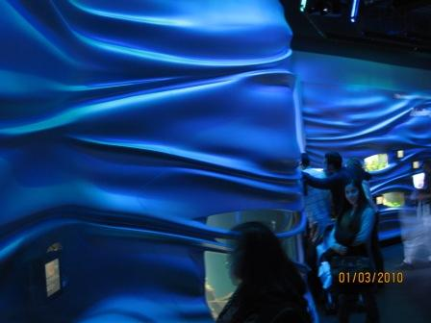

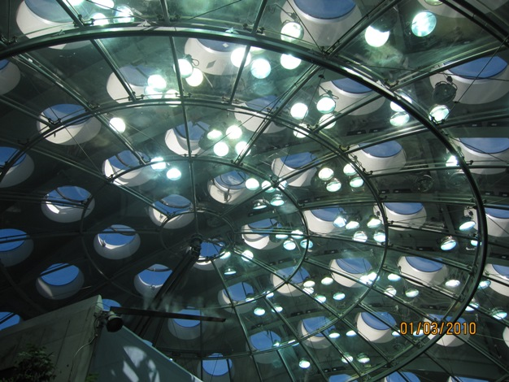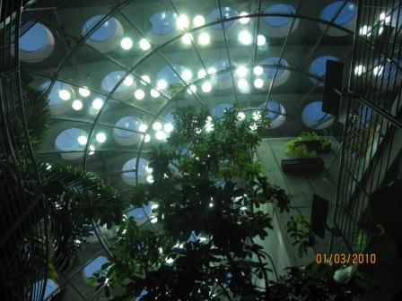
The Living Roof as seen from the CAS Lobby
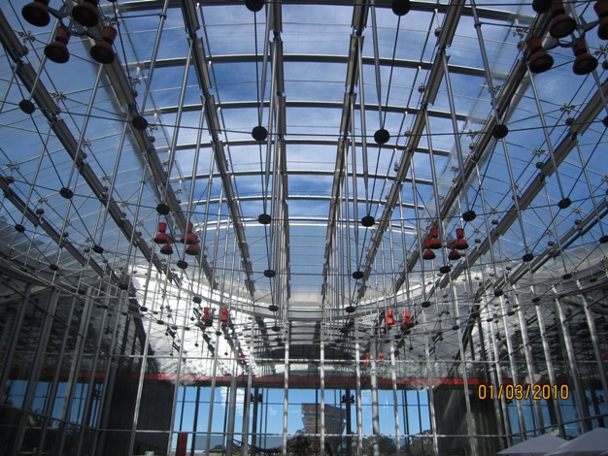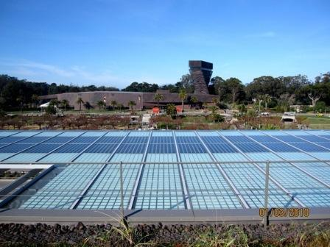
Left: Roof of the Cafeteria Right: De Young Museum seen from the rooftop
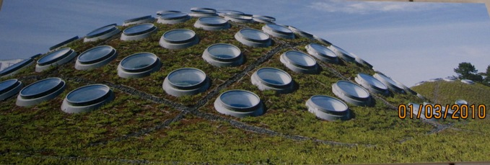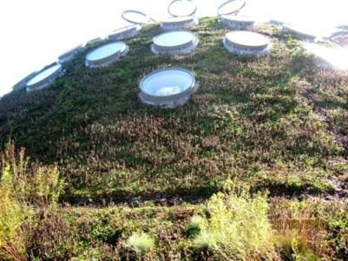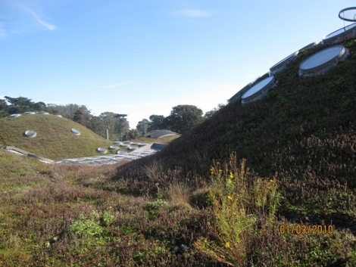
The Living Roof

Philippine Reefs and Corals

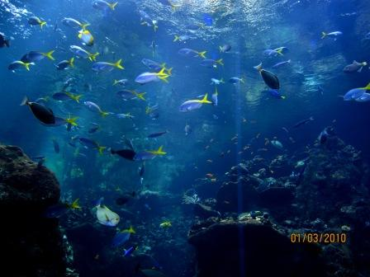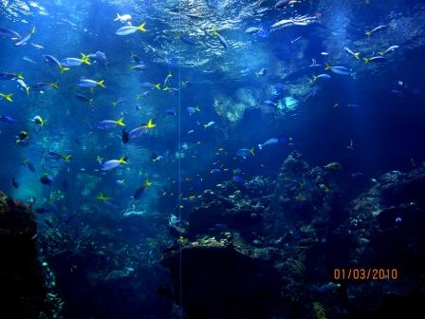
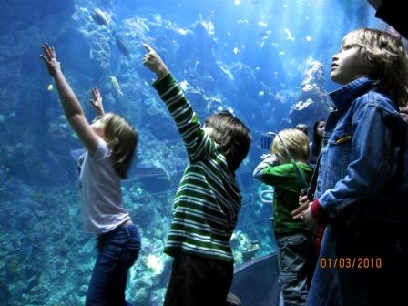

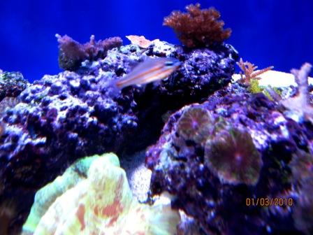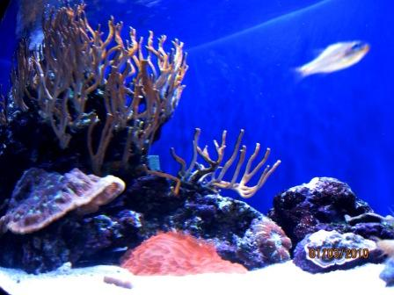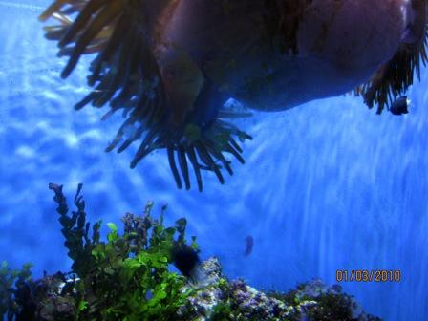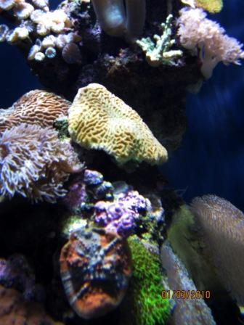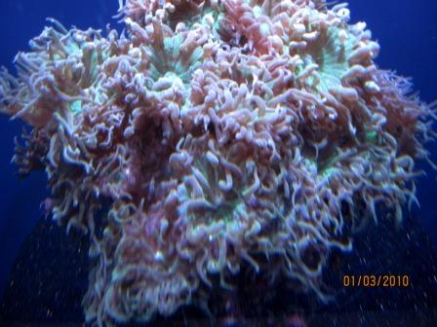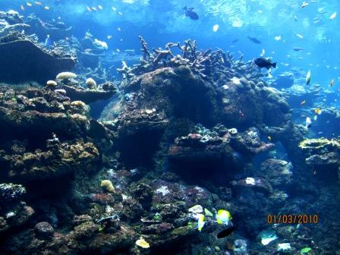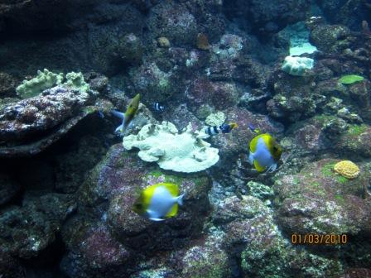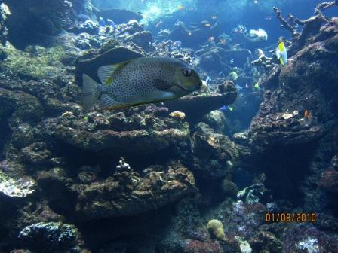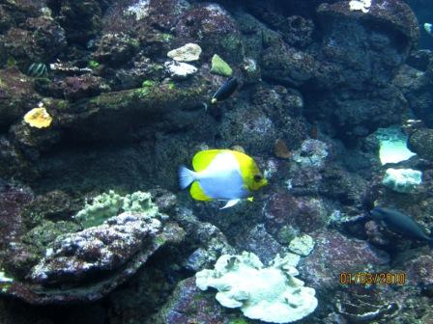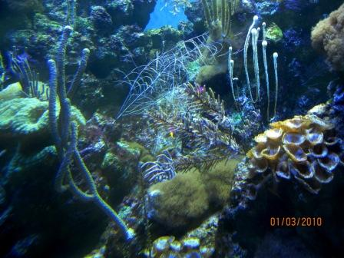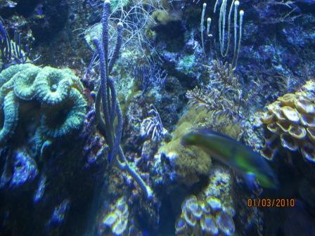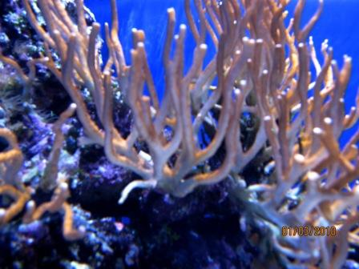

A Wonderful Jellyfish Collection : Gold, Blue and White

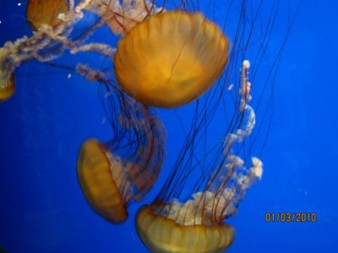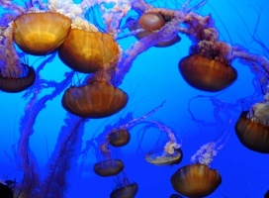

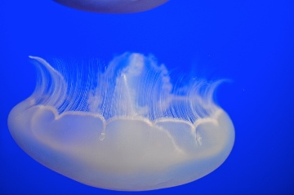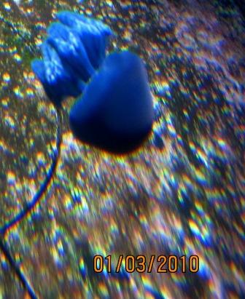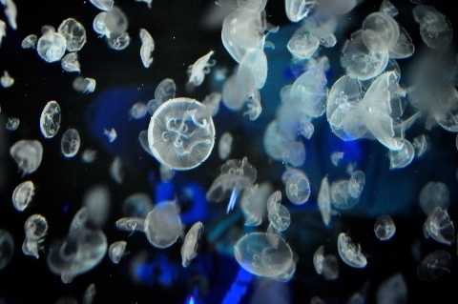

My Personal Favorites

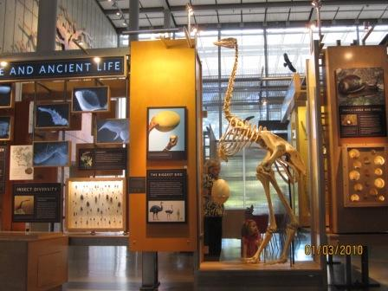
Elephant Bird -The Biggest Bird at 10 ft tall and 500 pounds

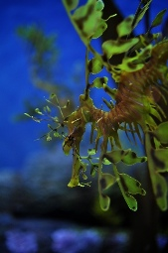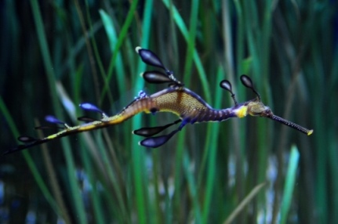
Leafy Sea Dragons

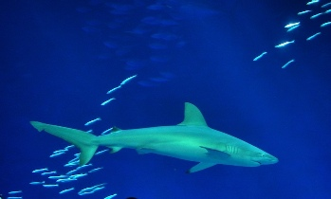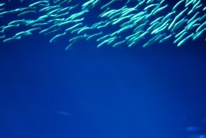
Shark and School of Fish

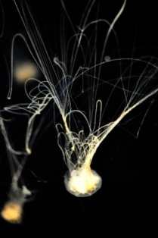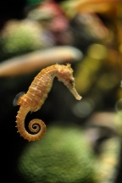
Left: Flourescent-like jelly fish Right: Spiny Sea Horse

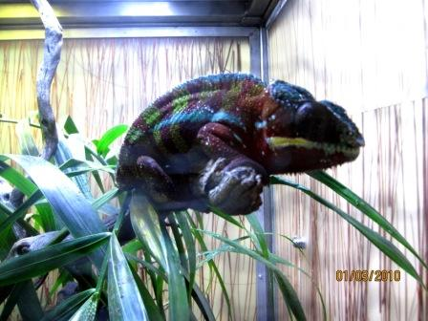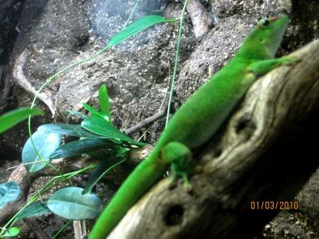
Panther Chameleon Green Geico

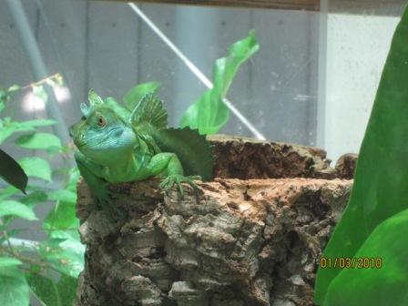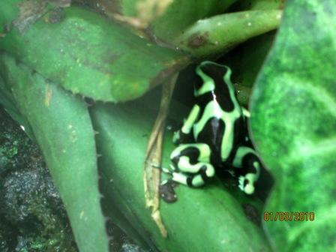
Green Basilisk Green and Black Poison Dart Frog

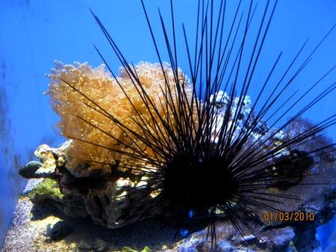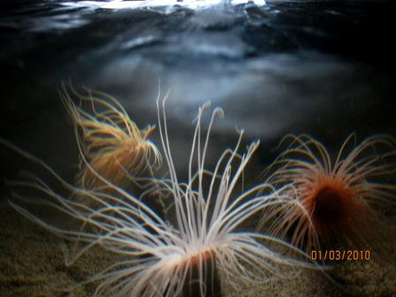
Long Spine Sea Urchin

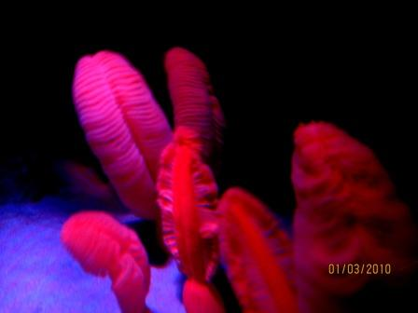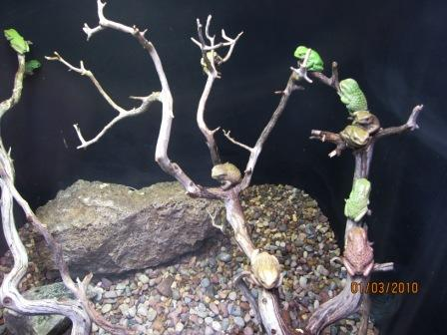
Left: Feather-like Pen Coral Right: Tiny Green and Brown Frogs

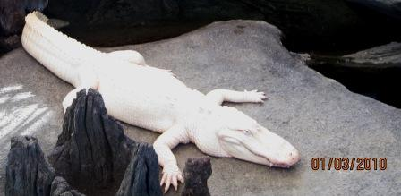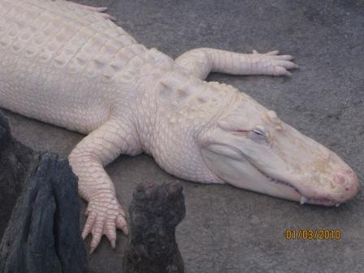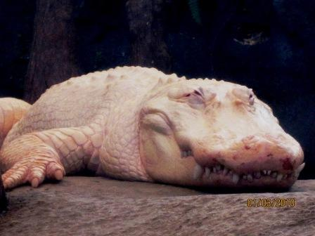
The Magnificent Albino Alligator

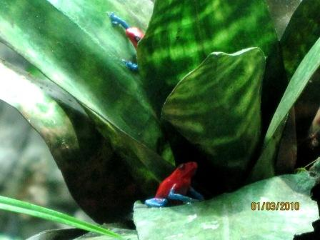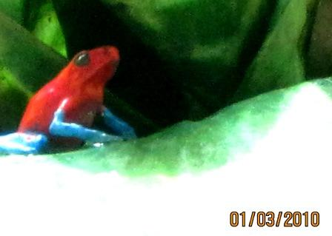
Strawberry Poison Dart Frog (also called Blue Jeans)

Other Interesting Flora and Fauna

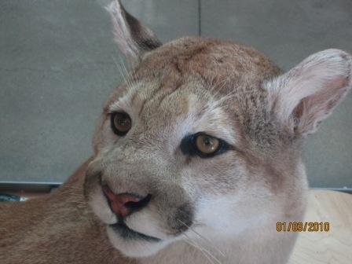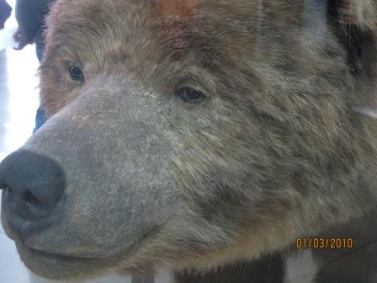

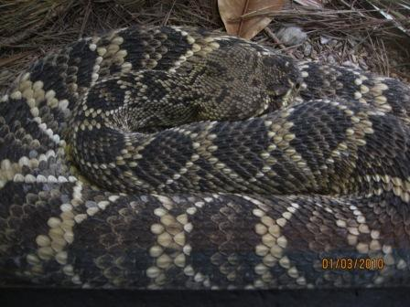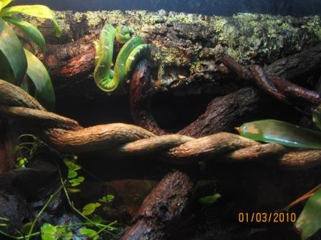

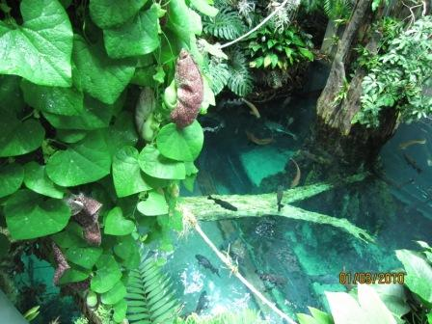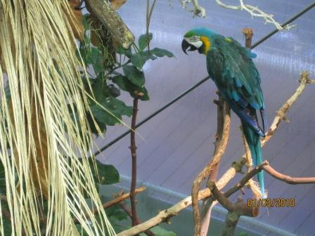

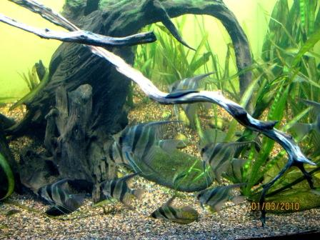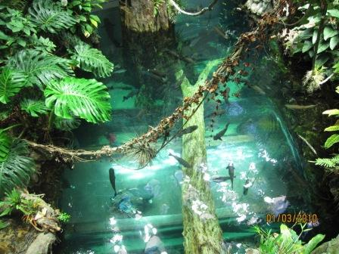

THE MESSAGE OF THE ACADEMY

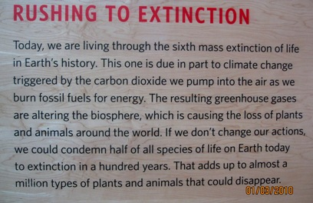

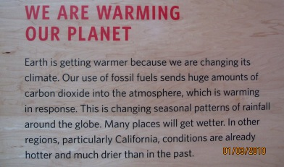

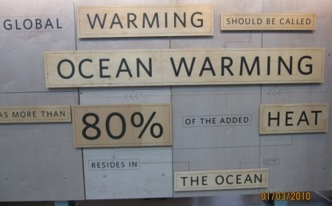

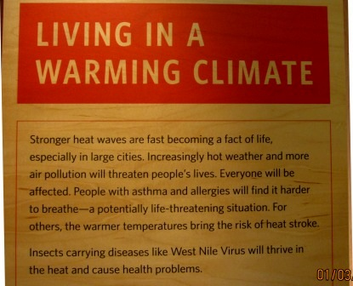

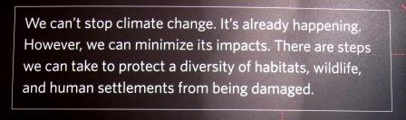

Some Fun Things You Can Do Inside the CAS

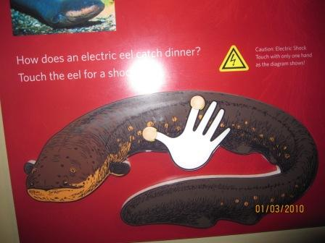
Experience getting electrocuted by an eel!

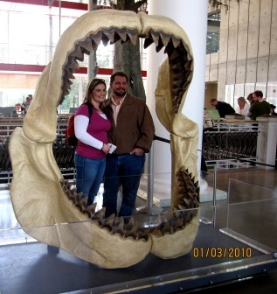
Have a photograph of yourself behind the teeth of the largest shark.

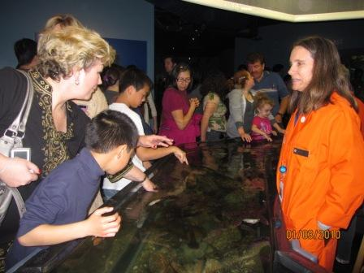
Admire and touch the creatures of the sea.

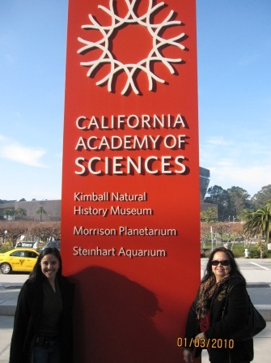
My daughter Ria, my wife Tess and I bid you goodbye, as we all say
“It was great fun, and it wasn’t just one of those things.”

