Environmental Awareness
A monthly publication of UP BETA SIGMA FRATERNITY, INTERNATIONAL, INC.

Greenhouse Best
November 2009
About the Author
Brod Vicente “Vic” Battad, UPLB 68a, has 11 years of Canadian experience in greenhouse growing - 9 years in tomato production and 2 years in floriculture, using state-of-the-art equipment for climate control and fertigation (fertilization and irrigation). Presently, he is one of the Growers of Rainbow Greenhouses, with a total growing area of almost 1.5 million square feet, in British Columbia and Alberta provinces. He is also a part-time Consultant on greenhouse tomato production with the Gerson Lehrman Group. He is a 1971 graduate of BS in Forestry from UPLB.
Before migrating to Canada in 1997, Brod Vic has 24 years of work experience with the private sector and was involved in forest management, business management and strategic business planning.
When he left the private sector, he was Consultant with the DENR from 1995 to 1997 on matters pertaining to natural resources management plans, community-based forest management and protected areas and wildlife management; and on matters pertaining to international environmental commitments and those involved with the Asia Pacific Economic Cooperation (APEC) on Sustainable Development.
Brod Vic is the Founding GP of the Beta Sigma, British Columbia-Canada Chapter.

Management Practices (BMP)
By Vicente “Vic” Battad, UPLB 68a

The foregoing BMP are mainly based on my work experiences from the different tomato and floriculture greenhouses where I worked for the past 12 years as well as observations in other greenhouses that I have visited both in British Columbia and Ontario provinces in Canada and the state of Washington in USA.

Introduction

Greenhouse growers and producers in Canada and the US must face more and more environmental issues and concerns every year. Federal, provincial, state and local governments have passed regulations and by-laws that are addressing concerns in the greenhouse and agricultural industry such as surface and groundwater contamination, water usage, and pesticide usage. Many of these regulations and by-laws have affected and will continue to affect both business and cultural practices in the greenhouse and agricultural industries.

For example, the city government of Delta, where 75% of greenhouses in British Columbia are located, had passed a by-law that tripled the rate for the use of city water by greenhouses and the owners of greenhouses must put up their own water recirculation system and/or water filtration within 3 years from the passage of the by-law or face penalties or closure.

Most greenhouse vegetable and floriculture producers and growers in North America have committed to the protection of the environment. They are committed to products that improve the quality of life for their customers as well as the quality of the air we breathe. Horticulturists by nature and by training are good protectors of the environment and recognize the importance of the environment and natural resources. The greenhouse industry for vegetable and floriculture has been a leader in establishing and implementing production practices such as integrated pest and disease management in order to protect the environment.

What are BMP?

Best management practices are not law or norms but activities, procedures, processes, innovations or systems as well as management initiatives or decisions that are effective and practical ways and means to prevent or reduce the discharge of pollutants into the environment. BMP are proactive practices that are intentionally done or avoid being done that would adversely affect the environment. Like the saying “prevention rather than cure”, BMP are implemented before a problem occurs rather than after a problem has occurred or observed and some type of “stop-gap measure” is needed.

BMP philosophy gives special attention to environmental protection but it does not sacrifice the quality of the produce or the crop. These individual BMP are freestanding rather than a set which means that growers and producers can implement as many effective ways and means as they deem necessary in their greenhouse or field operations. BMP come from growers, producers, owners, suppliers and even workers (suggestion program). These practices are mostly “common sense”.

However, protecting the environment comes with a price, and growers and producers are aware of the additional costs and economics of implementing BMP. Before implementing BMP, the following questions should be asked: 1) Is it affordable to implement this practice or procedure?; 2) Is the customer willing to accept the added costs?; and 3) Can I afford NOT to implement this practice or procedure?

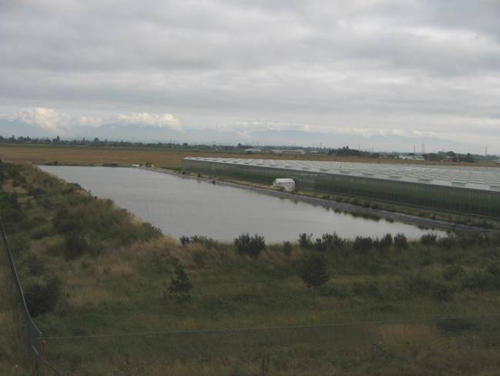

This is one example of a water collection pond for a vegetable greenhouse in Delta, BC which lately had been required by the city. The rain from the greenhouse 12-acre roof is collected in this pond and at full capacity, can supply the water requirement of the greenhouse for 3-4 months, using a water re-circulation system, thereby saving water and costs: more rains = more water = more savings.

Research showed that rainwater is better than groundwater because it is very pure and saturated with air. It has been found out that city water usually has 1 ppm flouride, that is four times the amount considered as safe for sensitive plants.

Issues and Concerns

This article will concentrate on only two major issues that specifically concern the greenhouse and agricultural industry and within the control of individual growers and producers:
- Surface and ground water contamination; and
- Water conservation

There are two major categories of BMP that should address the above-mentioned issues and concerns: structural and cultural.

Structural BMP

Structural BMP relate to physical structures such as site location, type of irrigation system to be used and drainage system.

Example of a site location BMP: Do not locate buildings over shallow underground aquifers and avoid building or growing on a high risk flood plain.

For irrigation BMP, the closed irrigation system is a good example. This system does not allow any effluent (water/fertilizer solution for irrigation) to escape from the production facility into the water channels. Containment and recirculation of effluent is an excellent technique to prevent runoff and reduce costs. Examples are flood and ebb tables, raised troughs and flood floor. The flood and ebb and flood floor irrigation are also called sub(terranean)-irrigation.

Since sub-irrigation results in very minimal leaching, fertilizer rates are typically 30-50% less than overhead (hand) watering and 30% less water is being used due to efficiency of water delivery (water is captured and reused), giving a total savings of 50-60% on fertilizer. Sub-irrigation systems compared to hand watering can provide reduced labor costs, greater crop uniformity, and reduced foliar disease incidence.

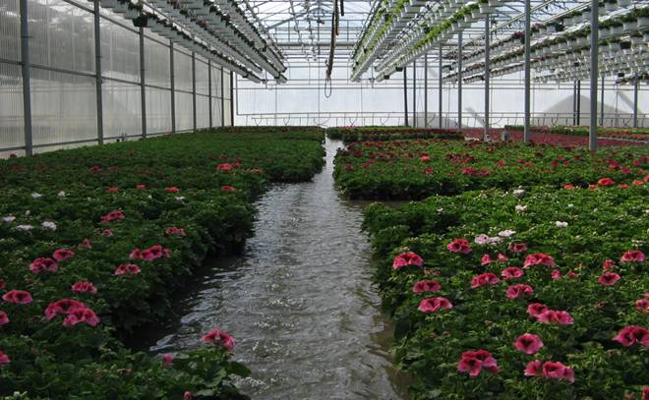

Picture shows a “growing bay” that is being irrigated (flooded). The water from both floor and table flood and ebb type of irrigation passes through a high speed sand filter before the water goes back to the fertilizer tanks for re-use. To prevent the spread of root-borne pathogens through re-circulated water, Rainbow Greenhouses uses a machine to extract the chlorine from potassium chloride (fertilizer). The chlorine is then used to disinfect the irrigation water using a proportioner @ 1 ppm.

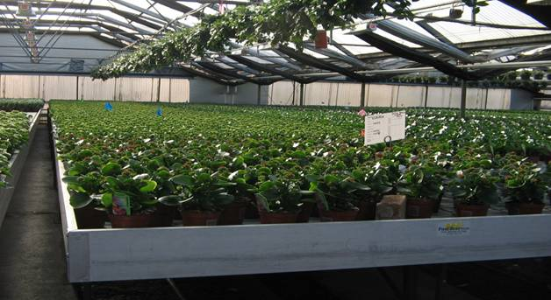
This picture shows flood and ebb tables for small plants (4” pots).

Another type of structural irrigation BMP is the overhead hanging basket system for floriculture. This system which is called ECHO system was pioneered by Cherry Creek Systems, based on a dry cleaner circular clothes conveyor.

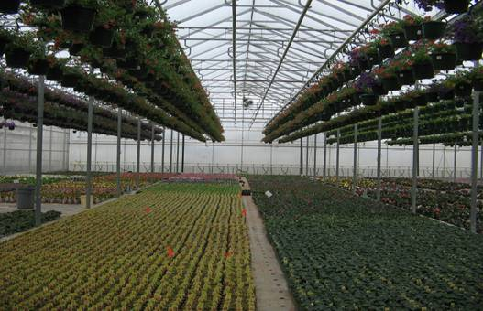
The above picture shows the overhead basket mechanization (computer controlled) at Rainbow Greenhouses. It allows for accurate measurement of water good enough for each basket plant thus, saves water. Watering takes place in one location, usually the walkway, so no baskets will drip on other plants placed beneath them. Systemic pesticides or growth regulators can be applied accurately and completely and where needed, finally, boost labor efficiency.

With the rising cost of labor, one area worth looking at is the place where watering is done manually or by hand. It is proven that watering by hand uses more water and it is not a cost effective way of watering. Irrigation booms put it right where the crop is and can be programmed right on the needed spot and skips empty areas, delivering uniform amounts of water which result in beautiful, even crops.
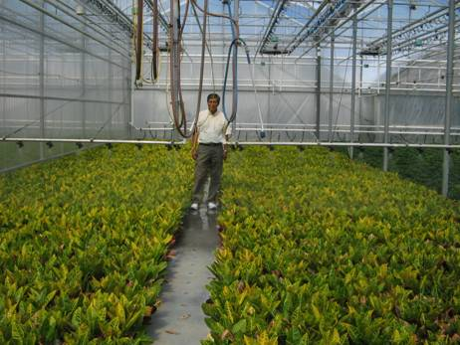
Irrigation boom at Rainbow Greenhouses

Cultural BMP

Cultural BMP are practices used in the production of plants that include: substrate/media management practices; surface and ground water contamination (fertilizer run-off) practices; water conservation practices; groundwater protection from chemicals; pest and disease management practices; and growing environment optimization.

Substrate/Media BMP

Examples of substrate/media management BMP:
- grow in media mixes that have greater water holding capacity
- decrease the leach percentage to reduce effluent volume
- fertilizer applications should be based on nutrient monitoring and plant need rather than time scheduling
- utilize man-made waste materials such as coir fiber, sawdust, tree bark and composted yard wastes in media mixes

BMP for surface and ground water contamination (fertilizer run-off)

Nutrients are essential elements of plant growth, but excess nutrients leaching into water channels are known to contribute to algal blooms.

Reasonable use of nutrients
- Be analytical by regularly testing water supply and soil/media before applying fertilizer. By testing, you can determine the plant essential nutrients that are already present and are not required in your fertilizer menu. Always apply the nutrients needed in the minimum amount required.
- Always check electric conductivity (EC), soil/media pH and water quality. Reduce leaching.
- Install water filtration and disinfecting systems to prevent the spread of root-borne pathogens through re-circulated water.
- Use low Phosphorus formulation on established plants. Reduce the use of ammonium nitrate (Urea).
  - Global research showed that there are strong correlations between phosphorus and algal production in freshwaters, and between nitrogen and algal production in estuarine and marine waters
  - There is strong evidence on the escalating worldwide use of urea and urea transport to sensitive coastal waters. Urea, a base form of nitrogen, is suspected of contributing to “Karenia brevis” known as “red tide”. K. brevis has been shown to increase production of brevetoxin up to 6-fold, when exposed to elevated urea levels of 0.5 to 1.0 mM in batch culture, compared to controls without urea enrichment (Anderson, Glibertz and Burkholders).
  - Further findings indicate that as Urea applications in agriculture, and nitrate (NO-3) in urban and suburban development increase, the most likely outcomes will be increased blooms of cyanobacteria and diatoms (Hudnell, K). Cyanobacteria produce cyanotoxin that is highly potent with an LD 50 (meaning Lethal Dose to 50% of test animals) according to an EPA study.
- Minimize nutrient application by knowing your plant watering regime.
- Maintain a buffer zone between any nutrient use and water bodies
- The rational use of nutrients can save money. Fewer application + lowest rate = Less cost. Good economics, too.

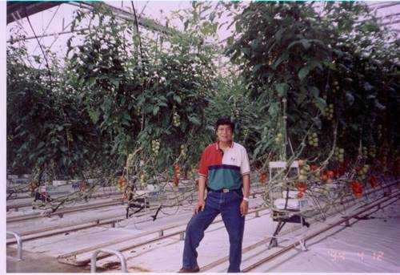
Picture shows a sample of the raised trough which is one of the latest innovations in greenhouse tomato production. The media are placed on top of an elevated (hanging) platform similar to a “gutter”. The excess fertigation water (leach) from the media flows to the end of the gutter where it is collected through a large drain pipe, passes through a high speed sand filter or UV rays to remove or kill the pathogens, then goes back to the fertilizer tank and re-circulated (reused) for fertilization.

Advantages of raised trough:
- Even growing surface
- Improved labor efficiency
- Nutrient recovery system. Re-circulation
  - Reduced water use, approx. 25-35%
  - Reduced fertilizer use, approx. 40-50%
  - Environmentally friendly
- Less diseases

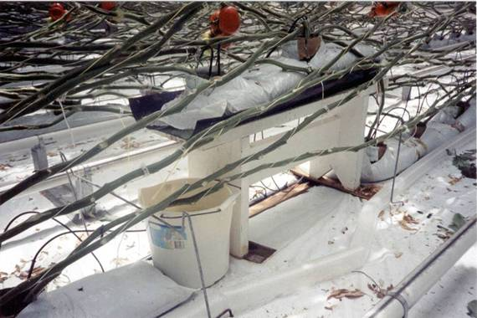
An improvised collector for leach water at Century Pacific Greenhouses (tomato) for daily monitoring of EC and pH using hand-held electronic EC/pH meters.

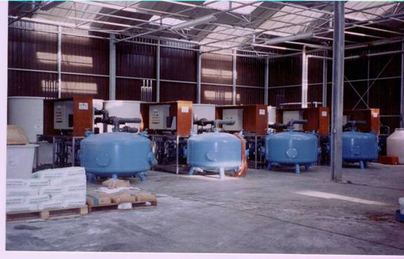
High speed sand filters (blue tanks) to reduce pathogens, thereby reducing use of chemicals.

Water conservation BMP
- Schedule irrigations by monitoring soil moisture to determine when to irrigate. Irrigation or watering should not be based on a fixed schedule but based on the plant water needs.
- Time the duration of water applications to avoid water movement beyond the rooting zone. Assess weather forecasts or patterns before irrigating. For example, do not irrigate the plants when it is raining or cloudy. Since the plants are not transpiring, this will result in water logging which will lead to root rot.
- Adjust amount of water application based on varying crop demands at different growth stages. This means gradually increase the amount of water as the plants grow bigger to prevent large amounts of unused residual fertilizers in the soil or media. Fertilizer leaching and ground-water contamination are also diminished.
- Irrigation water must be applied uniformly and accurately. Proportioners, injectors, functional flow meter and accurate pressure gauge are essential equipment for accurate application of irrigation water and chemicals.

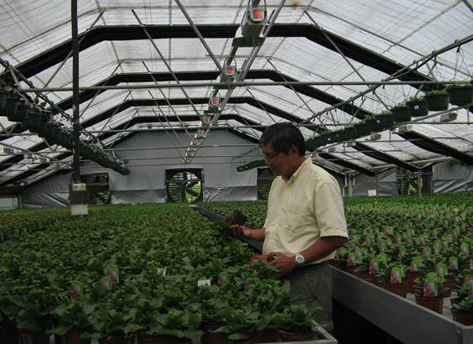
Soil moisture and root conditions are being checked before irrigating or watering.
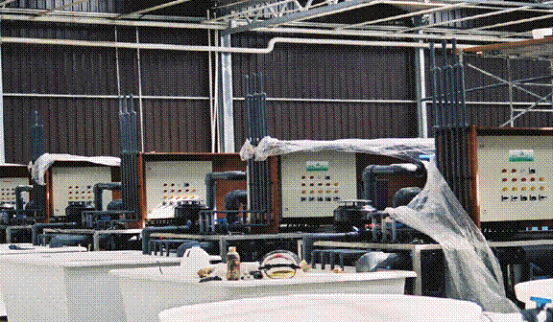
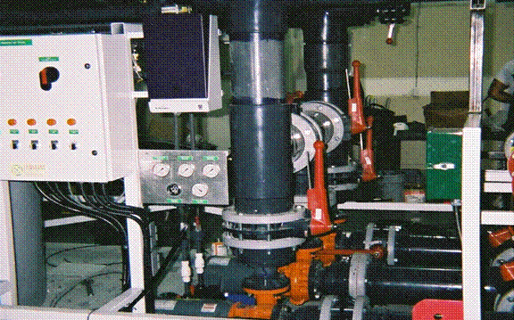

The above pictures show the nutrient system (fertilizer tanks, injectors, mixers and flow meters) at Millennium Pacific Greenhouses (tomato) in Delta, BC. A concentrated (2-3 times) fertilizer is mixed in the square white tanks and a desired EC and pH for fertigation is programmed in the computer with control factors (+ or - the desired EC/pH) and time duration. If the deviation on the desired EC/pH goes on for the programmed time duration, the EC/pH meter triggers the alarm and the computer stops the irrigation to prevent (high salt) damage to the plants.

TIPS ON PLANT NURSERY, Part II

Irrigation Best Management Practices (BMP) for Groundwater Protection from chemicals

- In North America, most chemicals being used in greenhouses and nurseries are systemic which can be absorbed by either the roots, leaves and stem of the plant, thus, chemicals can be injected into an irrigation system using chemigation (chemical + irrigation) equipment. Government regulations require the use of chemigation equipment to protect the water source from back-siphonage. Chemigation can provide excellent control of pesticide application timing and coverage, which can result in an overall reduction in the total amount of applied pesticides.

- The chemigation unit must be calibrated regularly to ensure that accurate amount of chemicals are injected into the irrigation system which is essential to good irrigation management. Accurate measurement of the amount of applied chemicals not only optimizes chemical usage but also ensures a uniform application over the entire crop. Association Short Courses and Trade Show, subscribing to magazines (Growers Talk), and reading pertinent articles on-line. All these acquired knowledge, experiences and learning through mistakes helped me in becoming a successful Grower in both Greenhouse Tomato Production and Greenhouse Nursery (Floriculture) Production.

Integrated Pest Management (IPM)
- IPM is a pest control philosophy that uses various management strategies to deal with pest problems. IPM recognizes that reliance on any single form of pest management does not provide optimal results. IPM promotes the integration of cultural, physical, biological, and chemical control strategies.
- The routine “spraying” of pesticides is no longer allowed on vegetable greenhouses in Canada and the US, though it is still allowed on a limited extent on nursery greenhouses. In some cases when chemicals are used in vegetable greenhouses, it is only done when infestation reached beyond economic threshold or outbreak level and only chemicals registered for vegetables by the Canada Food Inspection Agency (CFIA) are allowed.
- Integrated pest management has been in practice for years in the greenhouse industry but it never hurts to look for environmentally friendly pest management BMP.

BMP for Integrated Pest Management

- Scout and monitor pest population and incidence of diseases for judicious timing on the application of pesticides
- Employ cultural practices (good sanitation and housekeeping) to reduce the potential of diseases rather than relying on chemicals
- Integrate biological controls when appropriate
- Use bio-rational pesticides which have lower toxicities
- Plant pest-resistant cultivars - Many plant diseases and some insect pests can be avoided by growing tolerant or resistant cultivars. For example, tomato cultivars with improved resistance to some leaf diseases have less need for fungicide applications. Another example is grafting tomatoes to varieties that have strong root system and resistant to several root diseases.
- Maintain competitive plant growth through the regular use of good agronomic practices using good planting technique, high quality seed, timed planting and harvesting, and maintaining soil fertility through regular soil testing.
- Use biological control of pests, for example, a biological alternative to control whitefly is the parasitoid wasp Encarsia Formosa.
- Use preemptive techniques for pest management rather than responsive management - Preemptive management measures are implemented in advance of the actual observation of pests. Experience showed that this is the most effective means of dealing with certain pest problems. Responsive management can be quite limited once pests reached outbreak levels. Implement management strategies that maintain pests below threshold levels to avoid the use of expensive methods of pest control.
- Optimize timing of pesticide applications according to pest life cycles and economic thresholds of damage by means of regular scouting and monitoring to assess pest levels and crop damage.
- Rotate or mix pesticides to prevent development of pest resistance

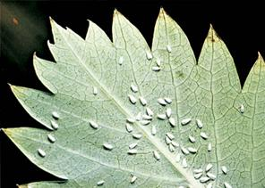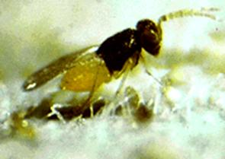
Greenhouse silverwing whitefly (left) and parasitoid wasp, Encarsia Formosa (right)

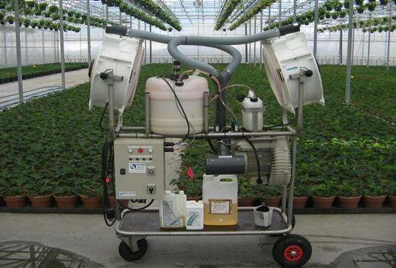
This is a time-controlled automatic cold fogger or Low-Volume Misting (LVM) equipment which is used for spraying chemicals at Rainbow Greenhouses. LVM sprayers create extremely small droplets (4-10 microns depending on the nozzle) that cover more surface area with less product (eliminating run-off) that saves on chemicals. It can be programmed to work at night when there are no people around which is safe and no labor is necessary. LVM sprayers are better at controlling insects and diseases as they cover all surfaces of the plant. This 30-liter capacity tank is enough to spray 2 acres of production area which makes it efficient and economical.

Whenever possible, use biorational pesticides. They are less persistent, less toxic, and less mobile in the environment.

- At Rainbow Greenhouses, we have tried neem oil extract from the Neem plant and garlic oil as biorational pesticides. Both are effective for several pests such as spider mites, aphids, white flies, fungus gnats and shore flies. For fertilizers, we are mixing kelp, an organic fertilizer derived from seaweed, with commercial fertilizers.

BMP for Sustainable Disease Management

- Like IPM, disease management is not just “spray and pray”. Sustainable disease management requires multiple techniques to reduce the incidence of diseases. The cornerstone of sustainable disease management is “sanitation”.
- Check planting depth – Follow the planting depth recommended for each species. Plants planted too deep are predisposed to crown rot which can prevent flowering. Too shallow planting will cause the plant to topple down.
- Adequate spacing – Crowded plants prevent good air circulation (high humidity) which promotes foliar diseases (downy mildew, Rhizoctonia and Phytophthora root and leaf rots) and causes plants to compete for sunlight and nutrients.
- Medium mix – The simple rule of thumb to prepare the right medium mix is that larger plants require larger size mix to facilitate drainage and reduces root rot.
- Appropriate watering – Watering is a challenge when you have a diversity of greenhouse plants (floriculture). Always remember that water is for the roots and you have to avoid overhead watering. If you have to do overhead watering, do it early in the morning so the foliage will dry before nighttime.
- Adequate fertilizing –Too much fertilizer predisposes plants to diseases and prevents flowering.
- Sanitation – Cleanliness maybe next to impossible but it can be done.
- Plant maintenance – Regularly remove rotten flowers and leaves. They are hosts to foliar diseases such as Botrytis, powdery mildew and other fungal diseases. Remove infected plants immediately to minimize the spread of diseases.

Phytophthora (root rot) means “plant destroyer” in Latin.

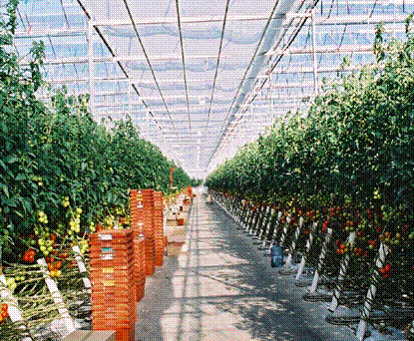

Cleanliness is still the best policy in the greenhouse. Pests and diseases are reduced by 50%.

Like people germs, plant germs are everywhere and are just waiting for conditions to be right for infection.

Optimization of the Growing Environment BMP

- Optimization of the production environment refers to the proper environmental controls during production that would reduce the use of chemicals. Examples are:
- adequately space plants (better spacing = more lights and lower relative humidity = less need for chemical height control and less disease incidence); spacing also reduces or eliminates the far-red light that contributes to plant stretching.
- use DIF (difference in day and night temperature) – low day temperature and high night temperature (negative DIF) or dip the temperature 2-3 hours before sunrise as alternatives to control height, thereby, reducing the use of plant growth regulators
- employ combination of night ventilation and heating to control relative humidity (lower relative humidity = less disease incidence = less chemicals)

Points to remember:

- Most disease problems are caused by over-watering (water logging), poor air movement, high humidity, poor sanitation and poor weed control.
- Most Insect problems are caused by poor monitoring procedures, improper pesticide applications and poor weed control.
- Use all non-chemical methods such as low temperature, low moisture, high light, low fertilization or fertilizer low in Phosphorus (P) and ammonium nitrate before applying chemical retardants or growth regulators.

A proactive attitude and a show of concern are the best efforts for the development of BMP. Always review current practices and if possible, innovate. As we say in Quality Control and Productivity Improvement circles, “Always challenge the status quo, there is always a better way of doing things”. Such efforts will be noticed by people and these spread around. Always talk confidently and positively about the environment.

