Environmental Awareness
A monthly publication of UP BETA SIGMA FRATERNITY, INTERNATIONAL, INC.

The 2009 Black Saturday Fires
October 2009
. This article is both relevant and timely considering the fire season in many parts of the world. Fire damage is by no means confined to Victoria, Australia. Millions of hectares in Southern Europe and African savannah are damaged each year. In Asia, a single fire in Kalimantan, Indonesia, damaged more than 3.6 million hectares in 1982. In North America, in spite of extensive, highly sophisticated prevention and control efforts, more than 2.3 million hectares of forest land still bum each year. In the portions of Latin America with extended dry seasons, much of the existing forest vegetation manifests adaptability to fire.
Using his versatile writing skills, Brod Jun Battad presents in laconic terms the horrible experience of Australia’s most catastrophic bush fires that is now known as Black Saturday.
About the Author
Brod Dionisio “Jun” Battad, UPLB 74d (The Lone Ranger Batch), has 18 years of experience in the applications of Geographic Information Systems (GIS) in natural resources management. Presently, he is a Senior Project Officer with the Department of Sustainability and Environment, Victoria, Australia. He is the Team Leader of a small multi-disciplinary group of GIS analysts, resource modelers and foresters.
Please see more info about Jun Battad at the bottom of the article.

in Victoria, Australia
by Dionisio Battad, PhD
Bushfires previously raged across the mountains around Los Angeles, causing enormous loss in lives and properties. I thought it may also be beneficial to share with you our experiences with bushfires during the last fire season.
Fire has always been a natural ecological process in Australia. It is considered as an integral component of most Australian ecosystems and habitats. Many plants have adapted their life cycle with seasonal fire events. A number of plant species rely mainly on fires for growth and development. For example, many Eucalyptus trees need periodic fires in order to crack the resistant seed coats and provide a rich medium for seedling growth.
November to March, which coincides with the summer season, is the time of extreme fire danger in Victoria. Every citizen, especially in fire-prone areas, prepare for this. There were catastrophic bushfires in the past such as the Black Friday fires of 1939 and the Ash Wednesday fires of 1983. The tremendous losses in life and properties from these fires have always remained in the people’s consciousness.
The fires that recently happened in the State of Victoria were even more catastrophic than the previous ones. It was not just a single fire but a series of bushfires that were burning across the State on and around Saturday, the 7th of February 2009. This day is now known as Black Saturday.
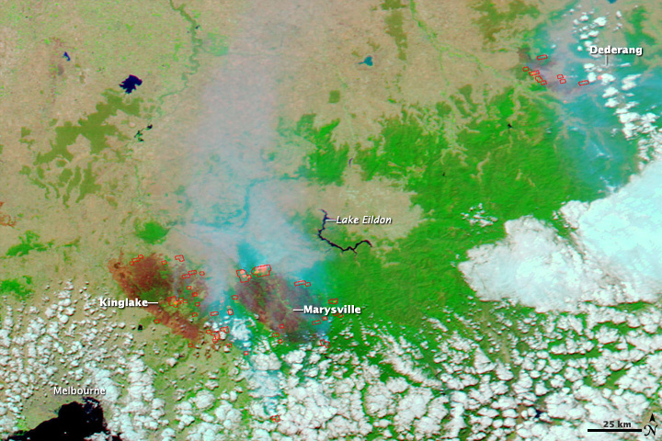
This is a MODIS (Moderate Resolution Imaging Spectroradiometer) image taken by NASA’s Aqua satellite on February 9. Burnt areas appear as brick red in colour and areas of intense heat are glowing pink. Smoke appears a transparent blue.

A multitude of conditions contributed to this catastrophe. A week before the fires, an exceptional heat wave affected south-eastern Australia. Weather conditions in other parts of the country created conditions that caused hot tropical air to be directed down over south-eastern Australia.
The country was also experiencing a major drought that has persisted for more than a decade. Rainfall has been lower than average for the past several years. There was accumulation of debris and litter from all the stressed or dead vegetation. All the major elements for a major bushfire to occur were there.
The weather conditions on that Saturday were considered as the worst bushfire-weather ever recorded in Victoria. Temperatures were in the mid to high 40s Celsius (approximately 110-120 degrees Fahrenheit). In the afternoon of that day, the fires which were later called Kilmore East complex were started by downed power lines. The Murrindindi complex fires started from a disused sawmill. There were other fires also burning at that time - the Bunyip forest, areas around the city of Bendigo, Churchill, the Wilsons Promontory National Park, etc.
Precipitated by an intense heat wave, winds in excess of 100 km/h fanned the fires over large distances, particularly in areas north-east of Melbourne. A cool change then hit the state in the early evening, bringing with it gale-force south-westerly winds in excess of 120 kilometres per hour (75 mph). This change in wind direction caused the long eastern flanks of the fires to become massive fire fronts that burned with incredible speed and ferocity towards towns and communities, burning everything on its path.
The strong winds blew embers, burning branches and barks over several kilometres away causing spot fires. These spot fires started new fires which caught a lot of people and communities unaware.
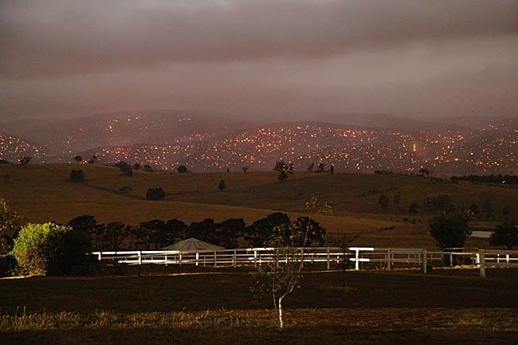
A view of the fires burning across Mount Disappointment (from The Herald Sun).
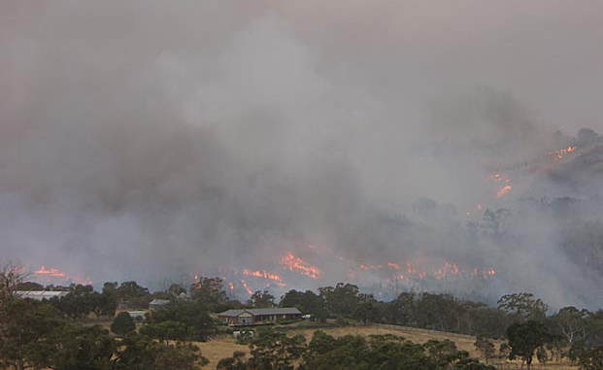
Another view of the fires burning at Kilmore East, Victoria (from The Herald Sun).

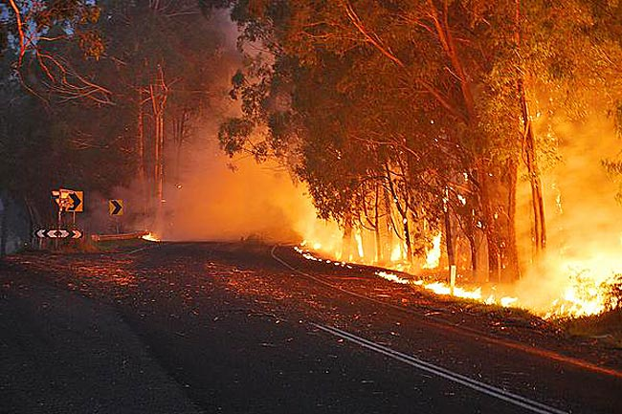

Fires burning along the road at Drouin, Victoria (from The Herald Sun).

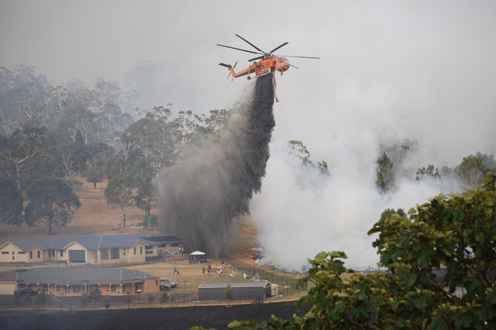

“Elvis”, the water crane, dumping fire retardants on the fire front approaching residential areas in Narre Warren, a suburb of Melbourne (from The Herald Sun).

Because of the enormity of the devastations and the expected long duration of the fire-fighting campaign, fire fighters from the emergency services, the Department of Sustainability and Environment (DSE) and NEO (Networked Emergency Organizations/other State government agencies) agencies had to ask assistance from other States, the federal agencies, military and from abroad. Fire fighters from New Zealand, USA and Canada sent fire fighters to provide assistance and relief to the exhausted fire fighters.

As employees of DSE, which is one of the leading fire management agencies in the State, we are required to perform specific roles during the fire season. We train for these roles and we are expected to perform these roles when required during the fire season. During major fires or other emergencies, some staff works at the Integrated Emergency Coordination Centre (iECC), housed at DSE. Others may be required to work at the fire front if they are trained and accredited to do so. Our normal work responsibilities become second fiddle.

The Beta Sigma Fraternity has also contributed to the fire fighting during the Black Saturday fires. Brod Martin Talento (UPLB 93C) worked as a Geographic Information Systems (GIS) Officer at the Mapping Unit, iECC. I also worked there as a State Situation Officer. When the Black Saturday fires started, it was my day off. I had been working there for the previous several days. Brod Martin went on duty that Saturday night from 7 in the evening. The fires had already started by then and were raging across the State. In the middle of the night, I received a call from him that the fires had broken the containment lines and that the major fire complexes, Murrindindi complex and the Kilmore East complex, have merged into the Kilmore East-Murrindindi Complex. This made the fire fighting efforts more complicated as it has created a mega fire with an active front and a perimetre that extends hundreds of kilometres.
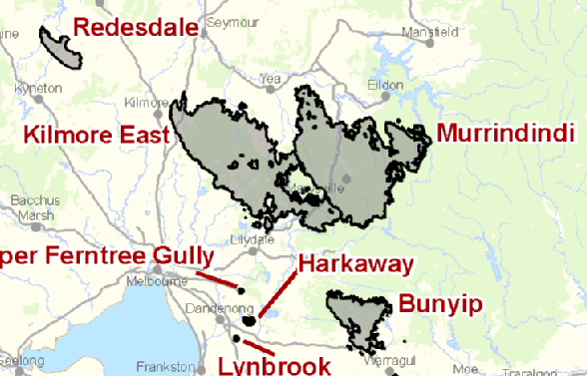
Map of the Kilmore East and Murindindi fire complexes.

The Black Saturday fires resulted in Australia’s highest ever loss of life from a bushfire. A total of 173 people are confirmed to have died from the fires. The fires destroyed over 2,200 houses, thousands of other structures, and farms. Many towns northeast of Melbourne were badly damaged or almost completely destroyed. The fires affected 78 townships and left over 7,500 people homeless.

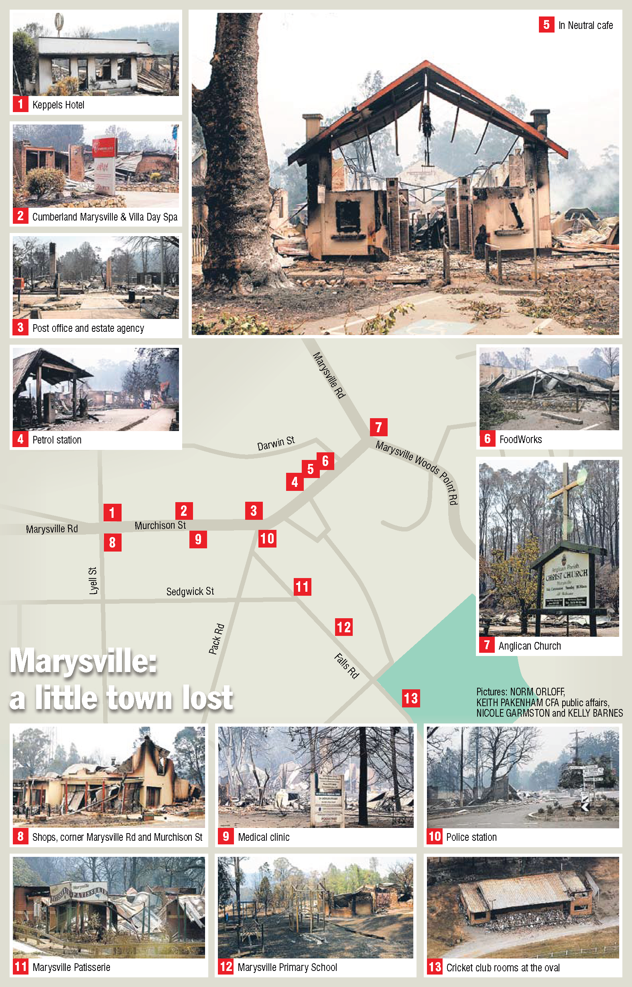
The extent of the devastations in Marysville, Victoria (from the Herald Sun).

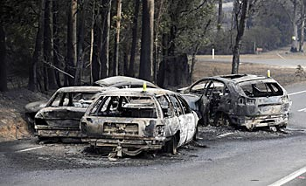
Burnt cars of the unlucky ones trying to escape the fires (from the Herald Sun).

Even after 7 February, the major fires still continued to burn. It was only on March 5 that the Kilmore East-Murrindindi fire was declared contained, 26 days after ignition.

The current focus of the work is now on recovery. Various agencies of the government, at all levels, are working together to rehabilitate areas affected by the fires. A Royal Commission has also been established to investigate the fire in order to provide the government with appropriate recommendations so that this catastrophic event will not occur again in the future.

The start of the next fire season is again approaching. DSE has started recruitment and training of seasonal fire fighters. Likewise, training sessions are being done to upgrade the skills of staff. Some fire experts have already warned that the coming fire season may be even worse than the Black Saturday fires.

MORE ABOUT THE AUTHOR

Dionisio Battad, PhD has 12 years of work experience with the Department of Environment and Natural Resources, Philippines. He was mainly involved in conservation project management. Just after graduation from UPLB in 1978, he managed the Bongabong Reforestation Project in Oriental Mindoro. He was a Senior Forest Management Specialist and also the Project Manager of the Asian Development Bank–financed Third Davao Irrigation Project-Soil and Water Conservation Component in Davao del Norte until he left the Philippines to pursue his advanced studies in 1989 at Texas A&M University as an exchange scholar.
After completing his studies, he worked as a Visiting Assistant Professor of Environmental Studies at The Richard Stockton College of New Jersey. He taught GIS, remote sensing, ecology and environmental science. In 1999, he was recruited and sponsored by DSE to work and migrate with his family to Australia.
He is happily married to a UPLB Sigma Betan (Yeyet Moral). They have 2 grown-up children. Their son is soon to complete his Ph.D. in Biochemistry at Monash University, Melbourne while their daughter is an IT Analyst with the federal government in Canberra, Australian Capital Territory.
He is a GI (Genuine Ilocano) from Magsingal, Ilocos Sur and is the youngest brother of Brod Vicente ‘Vic” Battad (UPLB 68A).

