Environmental awareness
A monthly publication of UP BETA SIGMA FRATERNITY, INTERNATIONAL, INC.
February 2008
In keeping with our Work Program, the UPBSFI, Inc. is now on its second month of providing its members with useful information regarding our environment. In this issue, Brod Gerry Abenes elaborates some of the points indicated in that very interesting quiz he made for us last month. The photos used here are first hand. Specifically, these were taken during our Alaskan cruise as narrated by Brod Norman Bituin.
It is the hope of this publication not only to make the reader become interested and knowledgeable in environmental issues, but also to derive practical benefits in being practitioners of environmental protection programs.
About the Author
Brod Gerardo "Gerry" Abenes, DVM, MVSc, PhD, UPD '66 is a Senior Scientist, Division of Infectious Diseases School of Public Health, University of California- Berkeley
Gerry was a Professor at UP Los Banos before coming to the US on a Postdoctoral Fellowship at Stanford University Medical School, and then at the University of California, San Francisco.

Trouble in Glacier Land
By Gerry Abenes


"Wise men are instructed by reason; men of less understanding, by experience; the most ignorant, by necessity; the beasts, by nature."
About the Author

Manny “Pogs” Gaspay, Ph.D, UPD Batch ‘68, was a Bureau Director of the DENR in etc etc

Marcus Tullius Cicero

I normally think of ice only in the context of my drink, or the
thermodynamic interaction between body heat and an ice cube. Lately, however, I have strived to become a more discerning iceman because of what has been appearing in the news. Or disappearing, to be more precise.

Here’s the skinny. Recent surveys of ice in the arctics show that glaciers are melting faster than predicted by computer modeling. What’s more, the rate of melting is faster than what can be accounted for by human activity. The implication? There’s a one-two punch that’s flooring the glaciers.

It used to be that about 10 percent of Earth's land is covered with glaciers. These are layers of snow compacted into ice by its own weight through hundreds of years. Most of these glaciers are in the Arctic and Antarctic regions but some are also dispersed in various inland areas, some of which may not have even crossed your mind. Like New Guinea, for example. Collectively, the amount of water that these glaciers hold is mind-boggling. Some estimates put it at 75% of the world's fresh water. To put that in better perspective, think of that amount of water pouring into the open seas and you might see your home become a prime beach-front property if you’re lucky, or an aquarium if otherwise. The hard math? Sea level would rise by about 230 feet (70 meters) worldwide-- enough to top a 15-storey building that is planted next to the beach!

More nitty-gritty. Last year’s data from the Colorado Center for Astrodynamic Research showed that 2007 broke the record for the lowest extent of Arctic sea ice, and that it broke the record by 1 million square miles-- an area about the size of Alaska and Texas combined. More importantly, there has been a nearly complete replacement of the oldest, compact ice with young, thin layers
of snow that melt faster. Factor in the intensifying forces that fuel global warming, and you’ll see why the Arctic is set for accelerated melting.

The Antarctic is in no better shape, either. In a recent paper published in the journal Nature Geoscience, researchers found that climatic changes appear to be destabilizing the vast ice sheets of the western region that had previously seemed relatively protected from global warming. The study found that 84% of the glaciers has retreated over the past 50 years in response to a warmer climate. More alarming, over the time period of the survey, the mass loss increased by 75% in 10 years. In 2006 alone, scientists calculate that melting glaciers spewed an estimated 192 billion metric tons of Antarctic ice into the sea. That’s more than twice the entire annual flow of the River Nile as it reaches the sea!

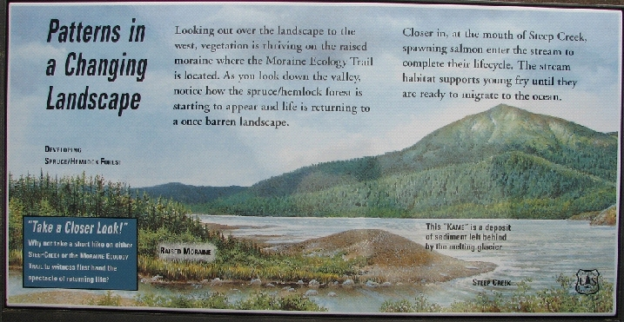

I thought you might ask what’s going on, so here’s what science has to say, in addition to other things. Temperatures across the globe have gone upward, hastening the rate at which ice glaciers melt. Humans, through activities that release ever-increasing greenhouse gases into the atmosphere, are responsible for this to a large extent. Antarctica, in particular experienced a temperature increase of about 4.5-degree Fahrenheit over the last 50 years. In some places across the world, small ice glaciers have totally vanished, exposing the earth underneath. Ice glaciers are able to deflect almost 80% of the sun’s radiant heat, while absorbing approximately the remaining 20%. This figure gets reversed when sunlight falls on earth-- 80% is absorbed and only 20% is deflected into space. Absorption of more heat increases global temperatures, leading to an increase in the temperature of seawater and faster melting of icebergs.

So what’s in it for you and me? You already know about rising sea levels. Now let’s talk about moving earth and altered ocean currents.

Let’s take on the moving earth first. As we learned from Geophysics 101, the earth’s mantle and crust are flexible (by geophysical standards). Glaciers, being quite heavy (easily a few trillion tons, no kidding!), weigh down on the earth’s surface much like a person weighs down on a trampoline. Obviously, as the glaciers melt, the tremendous weight is relieved, causing the flexible mantle and crust underneath to go through an “isostatic rebound”. This could, in turn, impact the stability of the tectonic plates underneath the earth’s surface. With stabilizing weight gone, the tectonic plates have more leeway to shift (and they do!) giving rise to earthquakes. Isostatic rebound is linked to the magnitude 7.2 temblor that shook Alaska in 1979, according to geoscientists at NASA's Goddard Space Flight Center and the U.S. Geological Survey. The accelerated rising of the European Alps, recently noted by researchers from the University of Milan, is also attributed to isostatic rebound caused by the melting of glaciers that started at the end of the last little Ice Age in 1850 when global temperatures began to warm.

Now, on to the altered ocean currents. You may recall from your Oceanography 101 that oceans are in constant motion due to winds that generate waves and currents, to the pull of gravity that creates the tides, and to a less known factor that occurs deep within the ocean called thermohaline circulation. Thermohaline circulation, (think thermo--for heat, and haline-- for salt) is driven by changes in the density of seawater. Interaction between heat and salt helps to determine the density of seawater; colder, salty water is denser than warm, less salty water.

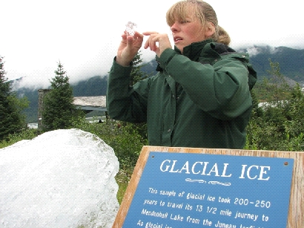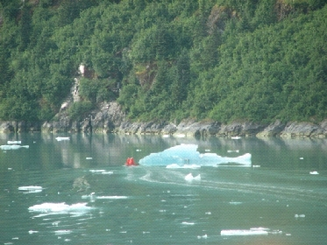

Also called the Ocean Conveyor Belt because it acts like one, thermohaline circulation plays a key role in modulating global temperature as oceans absorb, store, and redistribute vast amounts of the sun's heat around the globe. As such, this circulation is mostly responsible for why places at the same latitude across the globe have different average temperatures. It is slow-moving, it carries as much water as 100 Amazon Rivers combined with an average of 30 million cubic meters of water entering the circulation every second.

The Ocean Conveyor Belt transfers warm water from the Pacific Ocean to the Atlantic as a shallow current, and returns cold water from the Atlantic to the Pacific as a deep current that flows further south. Beginning in the central Pacific, it travels past the north coast of Australia and around the southern tip of Africa before moving up into the Atlantic. By the time it heads up the Atlantic, it turns into the Gulf Stream. As it passes Europe, the surface water evaporates and the ocean water cools, releasing heat to the atmosphere. This release of heat is largely responsible for the relatively warm temperatures enjoyed by Western Europe. As the water becomes cooler, saltier, and denser, it becomes heavier and sinks thousands of meters below the surface. The deep water slowly travels south through the oceanic abyss, eventually mixing upward to the surface in different parts of the world in as much as 1,000 years later.

Rapid thawing of arctic glacier is poised to throw a wrench at the Ocean Conveyor Belt. Over the past 40 years, salinity measurements within the North Atlantic have shown a gradually decreasing salt level. As the planet heats up further, the Atlantic Ocean could become more dilute due to increased precipitation and water from melting arctic ice. This could impact the Ocean Conveyor Belt leading to cooling of Western Europe as well as the eastern part of North America where average temperatures could drop by as much as 9 degrees Fahrenheit -- virtually plunging these areas into another Ice Age.

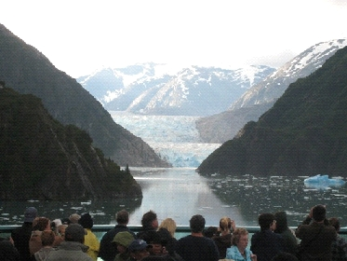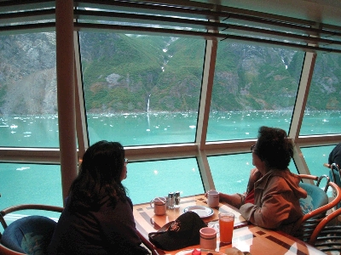

No one knows, at this point, how the saga of the glaciers will unravel. However, as global warming is set to worsen further from continued increase in atmospheric greenhouse gases, the expectation is that melting of the glaciers will only accelerate in the future. As the glaciers continue to recede amidst the onslaught of warming wind and tide, a grim picture of the future begins to loom large in the horizon: if and when the glaciers disappear from the face of the earth, various life forms in untold numbers could disappear with them.

=========

