Environmental Awareness
A monthly publication of UP BETA SIGMA FRATERNITY, INTERNATIONAL, INC.

August 2009
This monthly publication started way back in January 2008. Except for July 2009, we have faithfully kept our self-imposed commitment to this monthly publication going for at least a year. We have certainly passed that test, and this is now our 19th issue.
As part of our approved work program, we also said that that by the second year, we shall have graduated from just mere awareness to some form of involvement. On that account, we are very much ahead of schedule.
This article by Brod Johnny Regadio is an encouraging update about the UPV Beta Sigma Centennial Forest, a project which UPBSFI, Inc. has chosen to assist in no small terms. His ocular visit at the project site also shows that there are a few but critical actions that need to be done to ensure the success of this project.
Editor, Environmental Awareness
About the Author
Brod Johnny Regadio ’66, is a Forestry graduate and UPBSFI’s Project Manager of this particular project. After graduation, he immediately worked at the Department of Environment and Natural Resources and served this department for many years. He is now on his last month as a Board Director of UPBSFI, Inc. but has declared that his being a non-Director will not affect his commitment to this project.

THE UPVBSFAA CENTENNIAL FOREST
by Johnny Regadio

The UP Visayas Beta Sigma Fraternity Alumni Association (UPVBSFAA) Centennial Forest (CENFOR) was established in 2008 as a contribution to the centennial celebration of the University of the Philippines. It is intended to showcase the overall commitment of the UPVBSFAA and the UP Visayas Administration in addressing the global environmental problem and concern on climate change.

Specifically, the project aims to convert a three-hectare grazing land into a forest plantation that will ultimately be utilized as a forest park and botanical garden. Thus, the UPVBSFAA entered into an agreement with the UP Visayas Administration to spearhead the development, maintenance and protection of the area. It is a long term project and it requires continuing care, management and sustenance. Several attempts had been made in the past by various groups to regenerate the area but failed due to the lack of commitment and responsibility as well as the lackadaisical attitude of certain groups of people in the community. The UPBSFI, Inc. has taken on the role of an active partner-contributor to this noble project.

My trip to the Philippines early this year brought me to the Centennial Forest Project. It was my second visit to Iloilo City and my first in UP Visayas. I was blessed to have been accompanied by no less than the former DENR Undersecretary Brod Rene de Rueda.

The project site is situated within the jurisdiction of the UP Visayas in Miag-ao, Iloilo. It is about an hour drive from the City of Iloilo by public transportation or forty five minutes by private vehicle. It is accessible by tricycle from the town proper of Miag-ao with a short walking distance from the university staff housing.

The planting site is about three (3) hectares of rolling hills. It has been primarily utilized for grazing purposes and the soil is typically sub-marginal. It is mostly covered with short grasses and some spots of cogonal area. Some tree vegetation are found along the creeks and gullies and they are composed mostly of species indigenous to the area, like duhat, kasoy, tamarind, langka, camachile, bamboo, mango, acacia, takip asin, akleng parang, and ipil-ipil. There are also exotic species introduced around the area like golden shower, gmelina, and mahogany.

The entire three-hectare project is fenced with barbed wires and bamboo slats. There are a couple of gates that would allow cattle to pass through the area to get drinking water in the nearby creek downstream. However, allowing the animals to get into the planting site poses a big problem because sometimes they are left to graze in the planting site with ropes tied with them. Occasionally, the ropes get entangled with the seedlings causing severe damage or mortality.

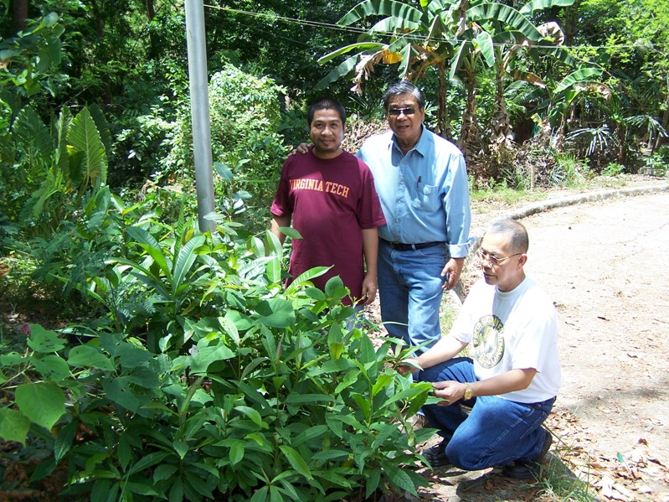
UP Visayas Brod Taui, and UPLB Brods Rene and Johnny R
inspect the different seedlings planted on the project site.

It was in the middle of the summer months when I visited the area. My ocular inspection of the planting site indicates that the soil needs to be reconditioned. The approximate survival rate of the seedlings planted last year in the first one (1) hectare area is only 60 %. Some of the seedlings planted were turning yellow and brown because of the searing heat, and lack of water and nutrients in the soil. The goal is to plant one hundred different tree species to represent the centennial celebration of the University of the Philippines. So far, only few species were planted and the most that would likely have a higher survival rate is narra, mahogany, duhat, tamarind, kasoy, camachile, kamagong (mabolo), and langka. The introduction of climax species like dipterocarps will need to wait until a forest canopy is established

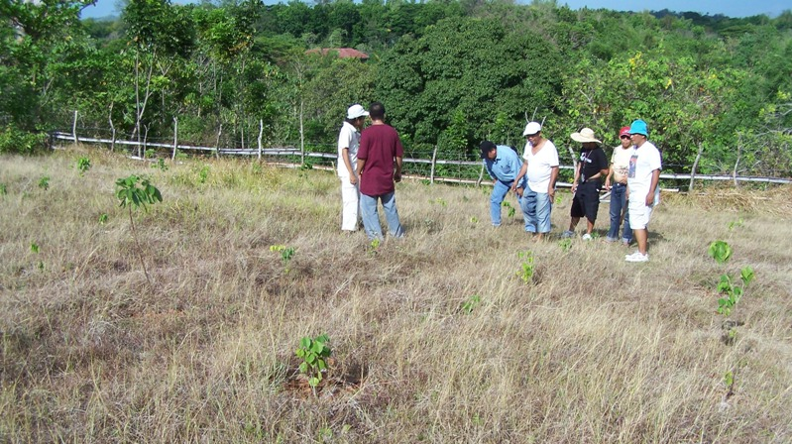.
Brods inspecting narra seedlings
At the time of my visit, there were five (5) cows grazing inside the plantation area. The calves were just roaming freely and sometimes the seedlings were being trampled upon. The owners just leave the cows there, especially if no one is in the area to watch. I was told that they intermittently hire one of the cattle owners to water the planted seedlings.

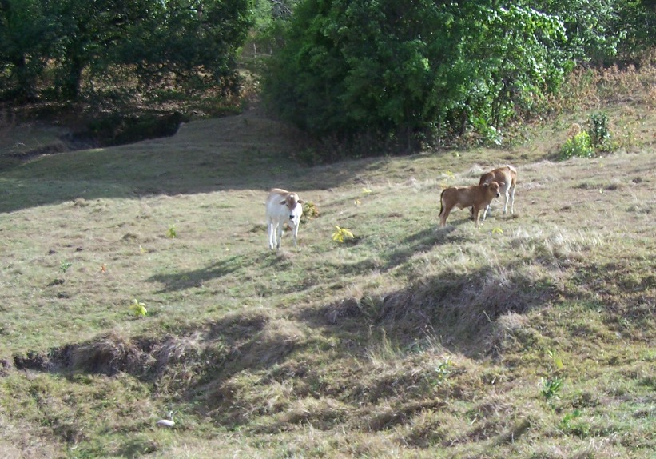
The Big Problem: Cows grazing on project site

The resident and alumni brods as well as our sorority sisters in UPV are diligently working hand in hand to ensure the success of the project. They have established a strategy where raising of seedlings is initially done in their own backyards. And once the seedlings attain a desirable size and height, they are brought to the university campus for hardening before they are planted into the field. These seedlings are temporarily placed along the roadside near the planting area. However, there is no sufficient space to accommodate thousands of seedlings where water is readily available.

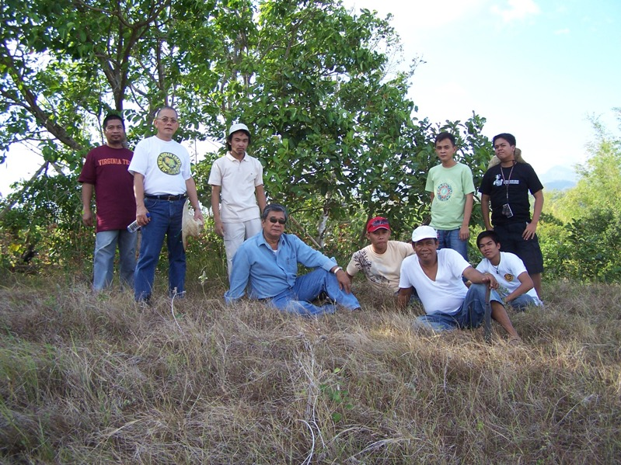
JR, Usec de Rueda, and UP Visayas residents and alumni

After our ocular inspection of the planting site, we had a short meeting with the brods. Unfortunately, there were no sisters available at that time because the school year just ended. We could have enjoyed more of our visit and stayed with them for a one night fellowship.

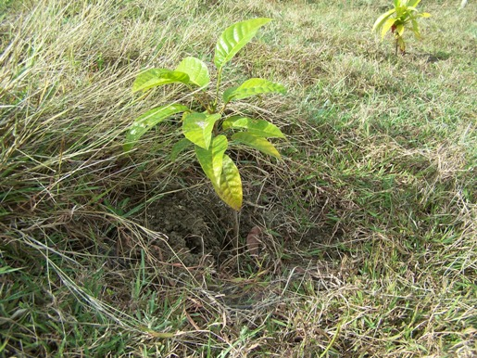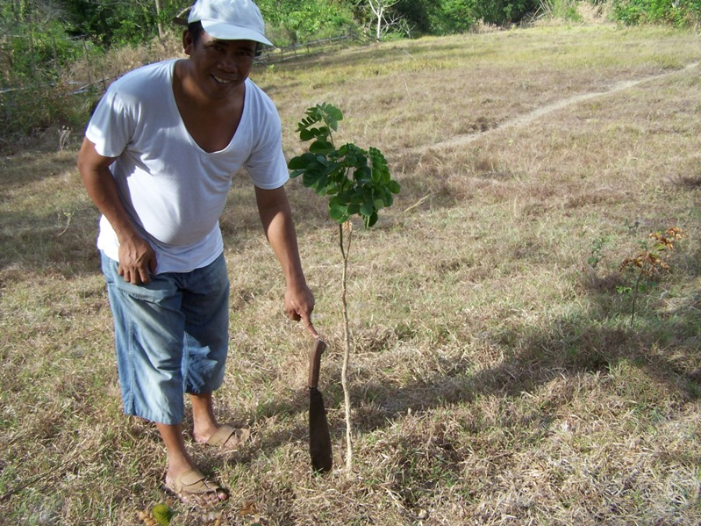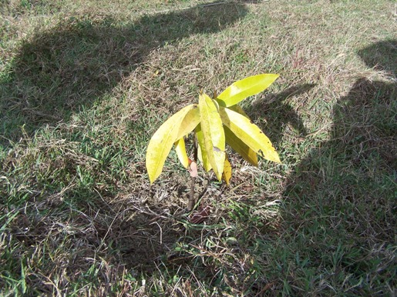
At Left: Mahogany; At Center: Acacia; and At Right: Kamagong

Among the things that were discussed are the following:

- The forest plantation must be properly secured from animals. The Project in Charge and some brods will have to meet with the UPV authorities and schedule a periodic dialogue with the cattle owners to resolve the issue of illegal grazing within the plantation.

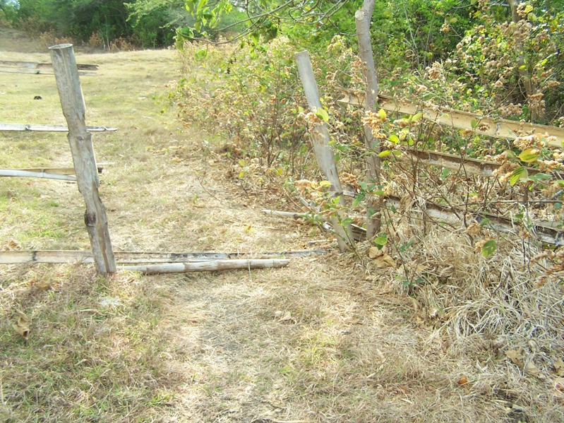
Gate to site illegally opened by cow owner.

- The planted seedlings must be maintained and protected regularly. A soil analysis was recently done and the report indicates that the soil needs to be supplemented with the basic elements for plant growth. It was suggested that the soil around the planted seedling shall be properly cultivated and sufficient amount of recommended inorganic fertilizer will be applied initially at the start of the rainy season. Then apply the necessary mulch to prevent weeds from growing and to keep moisture into the soil. Water the planted seedlings regularly, especially during the summer months. After a year, sufficient amount of compost will be applied into the soil around the plant. Weeding around the planted seedlings shall also be done in order to minimize damage in case of grass fire.

- A nursery shall be established near or inside the plantation area. It is necessary that seedlings shall be hardened so that they can easily adapt to the field conditions when they are planted. Water is essential in raising seedlings, thus, it was recommended that a flexible black water pipe (about 300 meters long) shall be procured and will be connected to the municipal water line towards the proposed nursery site. Plastic drums shall also be procured as water storage for nursery and plantation use. Furthermore, a shed made of available local materials shall be built as shelter and place for fellowship.

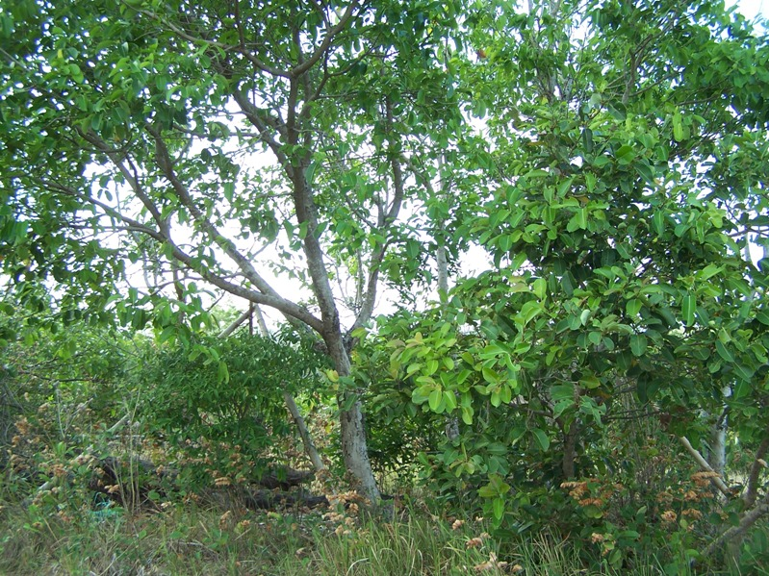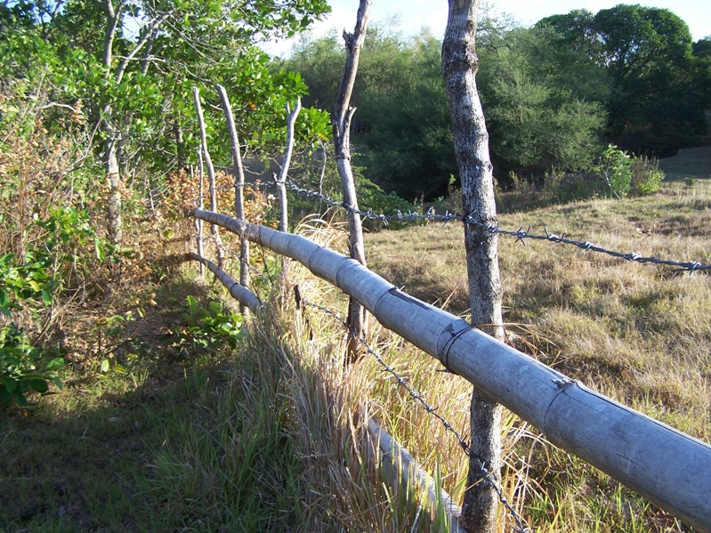
Left: The Proposed Nursery Site with natural shading;
Right: Perimeter with barbed wire fence.

- The UPBSFI previously committed $1,000.00 for this project and it is recommended that the balance of $500.00 shall now be appropriated for the purchase of flexible black water pipe, plastic drums, fertilizers, compost, and other materials for the establishment of a nursery shed and fixing of the gates.

- Fund raising activities shall be explored by the local brods and sisters in order to ensure that funds are available to support the needs of the project.

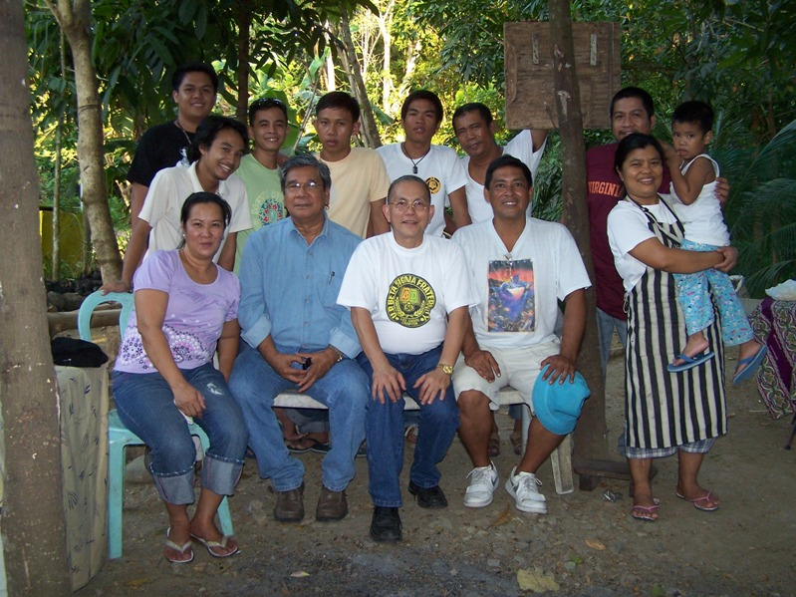
Brods and UP Betan Families
- Various public and private organizations shall be properly informed of the on-going development in the area in order to draw keen interest and continuous support for the project.

- An appropriate sign of the UPVBSFAA Centennial Forest shall be installed at the entrance of the project area, and “no trespassing” signs shall be posted on the fence.

- The commitment, diligence and generosity in terms of time, talent and resources of all UP Beta Sigmans and UP Sigma Betans in the region will undoubtedly ensure the success of the UP Visayas Centennial Forest. We, in the UPBSFI, will have to continue to provide the necessary support in the planning, implementation and monitoring of the various programs and activities of the project. We cannot afford to fail in this project because as UP Beta Sigmans “we never falter…we never fall.” We will always stand up and never lower the tone of our dignity.

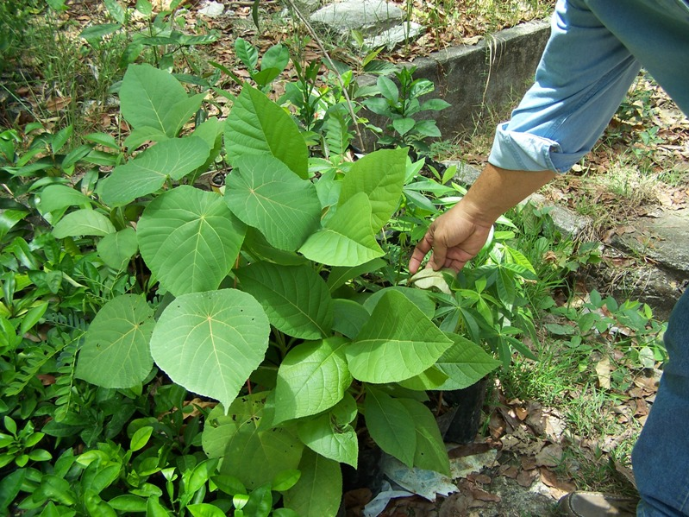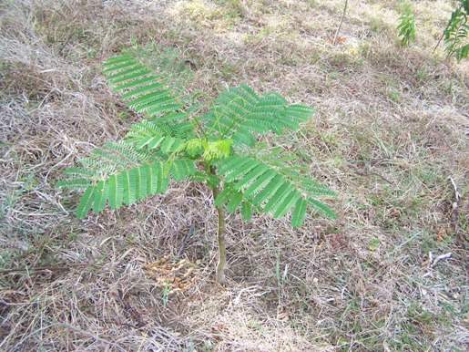
Left: Lush seedlings at nursery; Right: Fire Tree seedling

