Environmental Awareness
A monthly publication of UP BETA SIGMA FRATERNITY, INTERNATIONAL, INC.

THINKING GLOBALLY, ACTING LOCALLY
May 2009
Today, the environmental problems facing the world are enormous. Earth’s finite resources are being stretched to the limit by rapid population growth, air, water and soil pollution, and much more. Global warming, spurred by our use of fossil fuels for energy and transportation as well as mass-scale agriculture and other human activities, threatens to push our planet beyond its ability to support human life unless we can meet the growing need for food, energy and economic opportunity within a sustainable environment.
This article shows that there is reason to hope, if only communities around the globe like the one featured here are able to think globally… and act locally.
About the Author
Brod Willie “Tatang” Vergara ’67 migrated to America 12 years ago. Since then, he and his family lived in Placer County, 30 minutes from Sacramento, the capital city of California. He first acquired his technical knowledge from then DENR Assistant Secretary Brod Delfin Ganapin, UPLB ‘70. He now works with the Department of Transportation of the County of Sacramento. According to Willie, environmental impact assessment is foremost in all their development plans.

By Willie “Tatang” Vergara

Brod Alan Torneros, UPLB ‘80 relocated his family from the Bay Area (The City of San Francisco and surrounding cities near the SF Bay) to Placer County, further east going toward Reno, Nevada. His father-in-law who was so concerned about the safety of his daughter Racquel and his grandchildren warned Alan about the risk of transferring to what he thought was a no-man’s-land. That was in the Year 2001.

Little did Racquel’s dad know that Alan made his own extensive research before take on a major decision of uprooting his family in favor of a place that is relatively unknown even to most Californians. The Placer County and its vicinity cities -- Rocklin (where I also live), Roseville, Auburn and Lincoln -- were on their way towards being developed into ‘master-planned communities’. Integrated area planning of these areas in this part of Northern California included greening of desert lands, preservation of sprawling, rolling hills and natural wetlands, well conceived land use and balanced agro-industrial development, setting up of good schools, among many others.

Today, the administrators and inhabitants of these areas pride themselves of having converted barren lands into ideal communities that include the best grade-schools and high schools in America, a multiplicity of parks and recreation areas, clean air and ample / safe water, low crime rate, wide streets with beautifully landscaped center islands, good hospitals and health centers, upscale senior housing centers complete with facilities for the aged, and so many other amenities. Indeed, a haven for the young and old.

Part of a new tradition in Placer County is the partnership between the government, the private sector and volunteer-residents in putting up an annual ‘pakulo’ that relate to the further greening of their respective communities, and the promotion of beautiful, safe and clean physical environment.

Show-casing this year’s local ‘pakulo’ is what our May 2009 issue is all about. This article, or rather a pictorial, is designed with the hope that readers, most especially the advocates of environmental protection, might learn from the creative manner by which this local area in Northern California is able to impart environmental awareness among its young and old. “A picture is worth a thousand words,” so goes an old adage. The reader will not have to further strain his/her eyes by reading more text beyond this page. The photographs will certainly tell the whole story. In a nutshell, what you see below are photos mainly of the festive atmosphere featuring booths and bands, visual and performing arts, children as well as adult education, informational leaflets and other printed advisory, abundance of library materials relating to the environment, water and energy conservation gadgets, programs in partnership with the private sector, exhibits inside the Roseville Utility Exploration Center where children scramble through a “garbage mountain”, teens competing in an interactive video game with a localized ecology-theme a la “Jeopardy”, the famous TV program, workshops in composting and water-wise gardening.

In short, this is an excellent local approach to Environmentalism – all presented in a fun, thought provoking and life changing way.

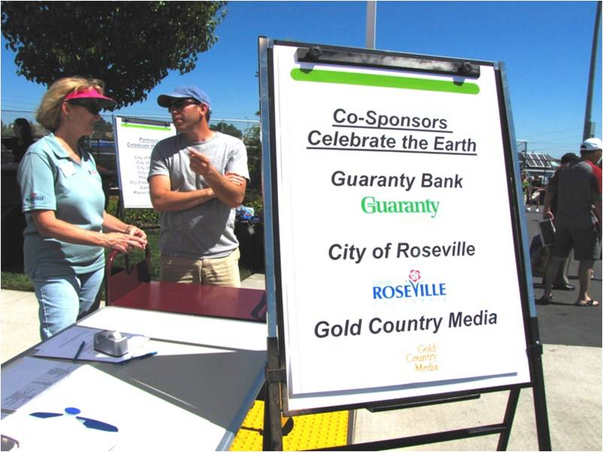\
The private sector teams up with the City of Roseville.

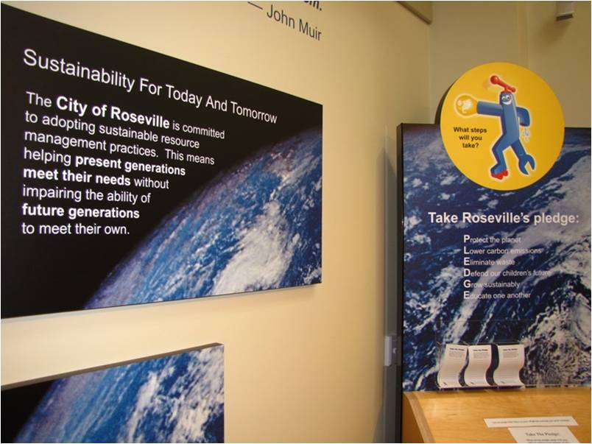
Commitment to protect the environment and ensure a safe future for children

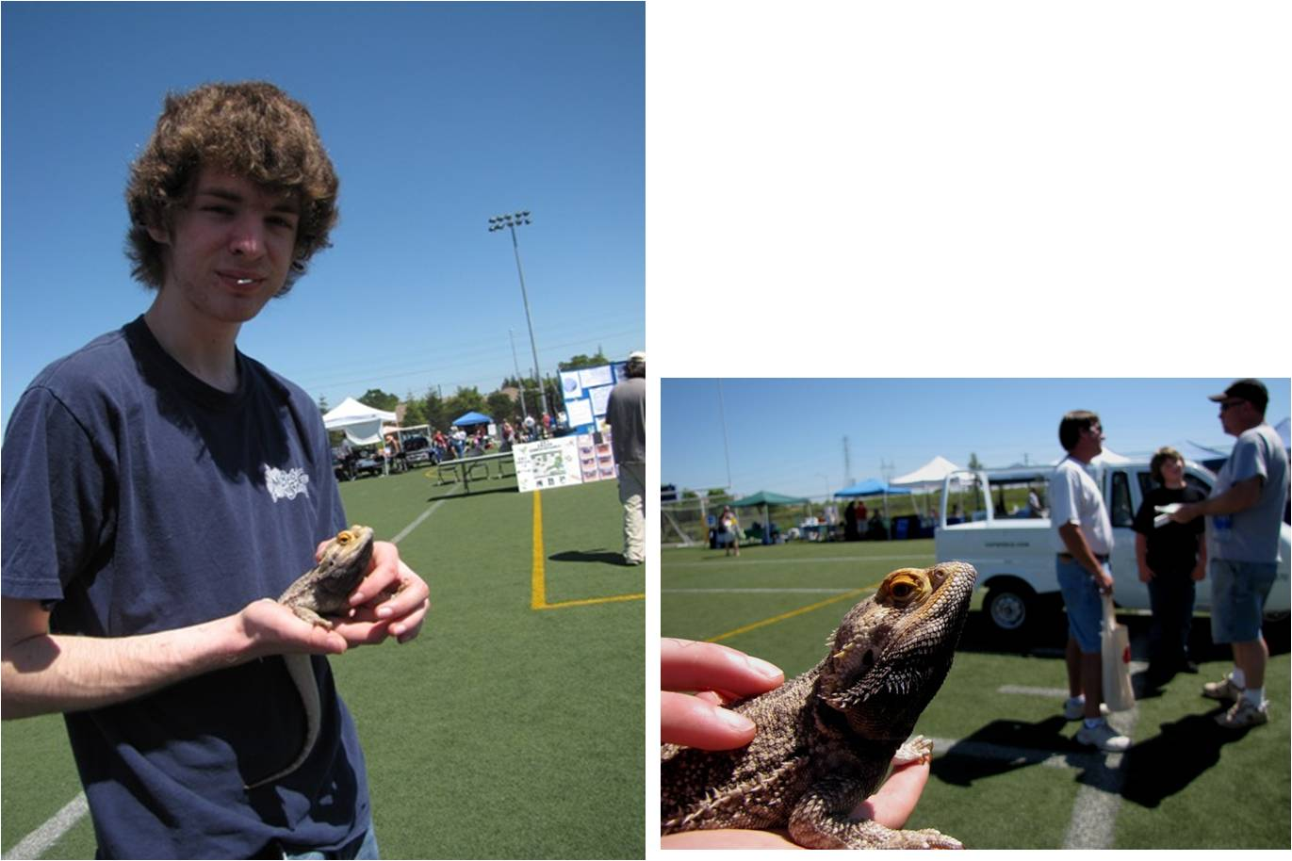
Young man and his bearded dragon, a native of Australia

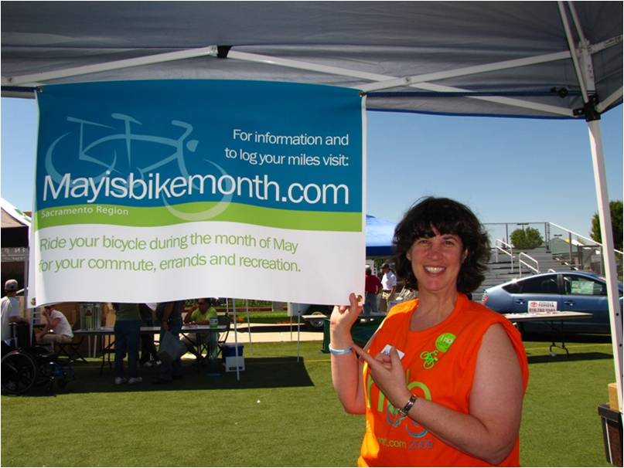
Bike for health and energy conservation

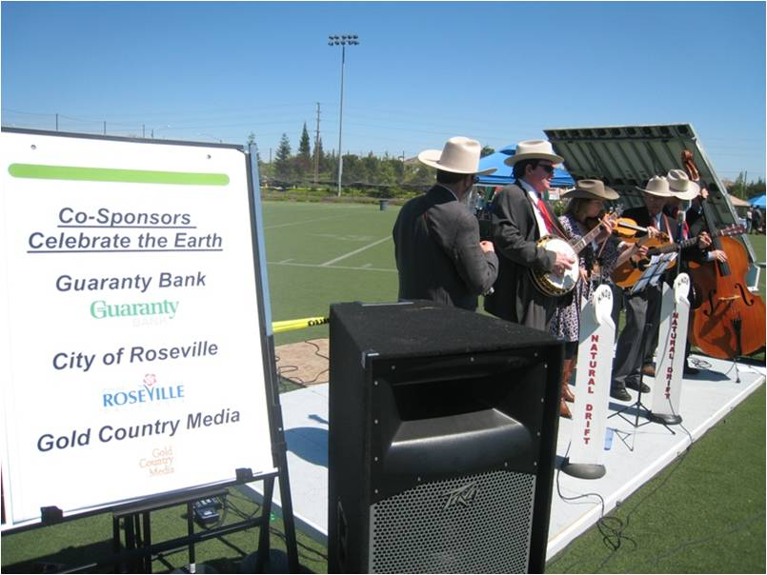
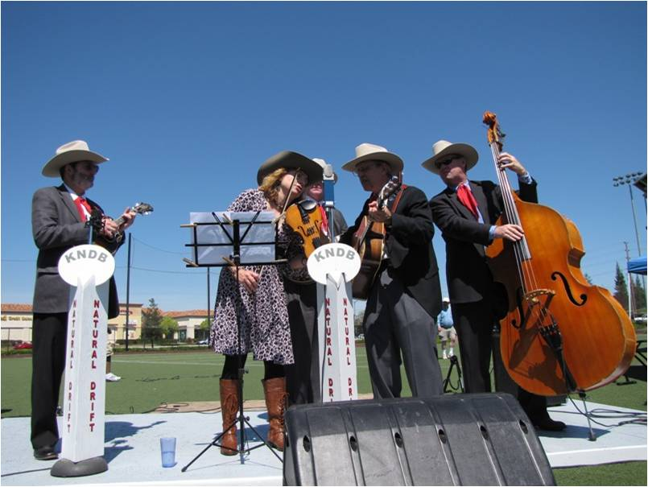
Natural Drift, one of three bands singing environment-related songs

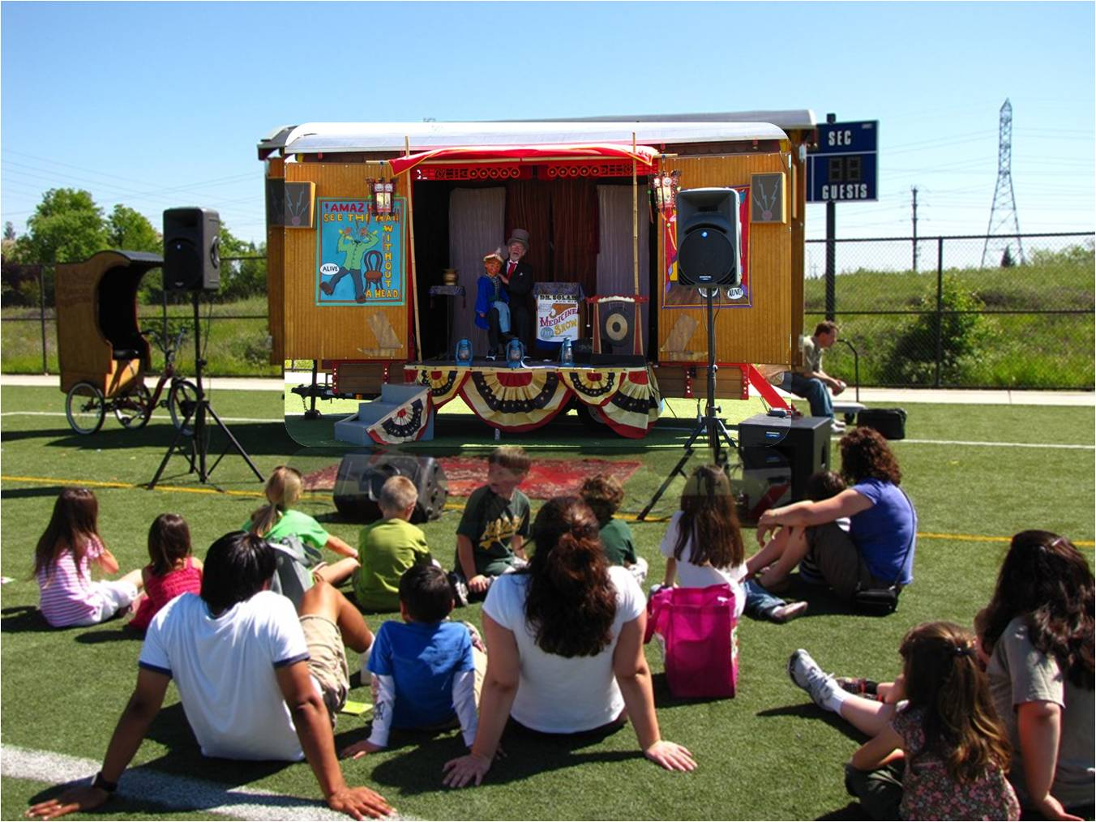
Children enjoying the puppet and the puppeteer talking about clean air and water

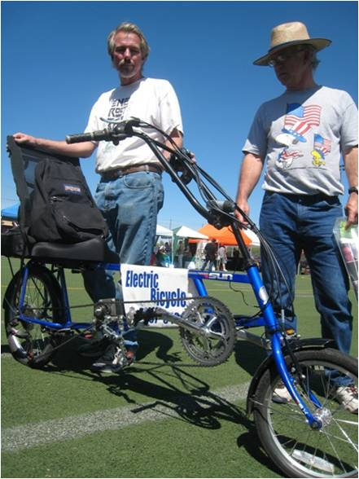
The inventor shows off his electric bicycle.

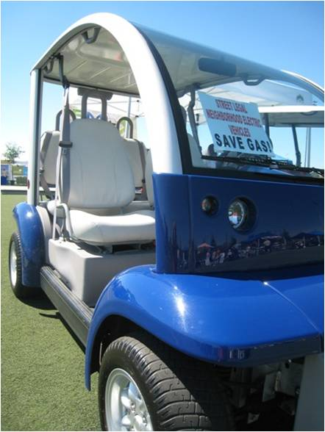
A fast, reliable and energy-saving way to protect the neighborhood

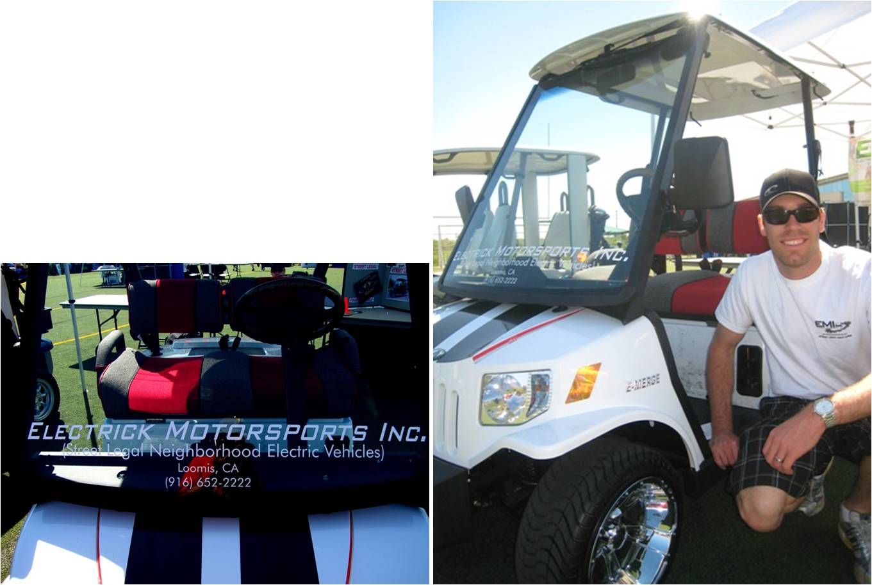
Electric vehicles are gaining popularity in Placer and Sacramento counties.

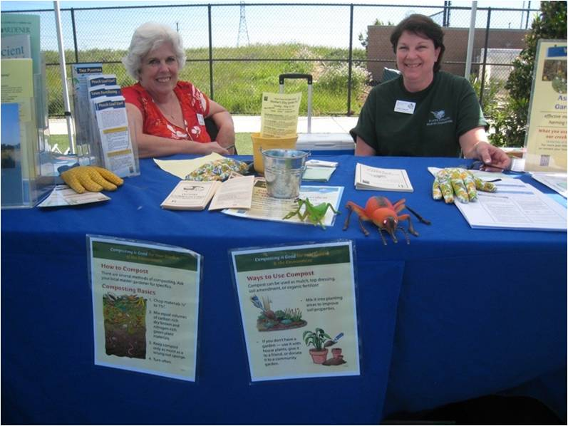
Promoting the production and use of compost

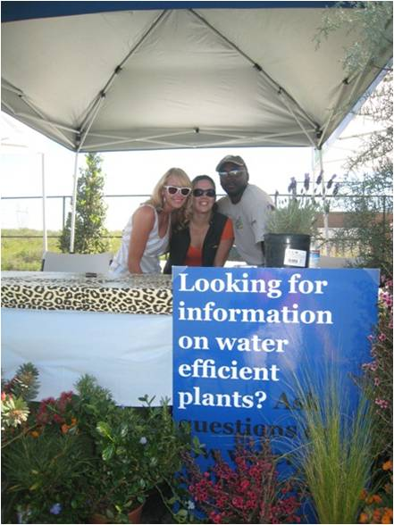
It is possible to beautify/landscape your surroundings and yet use minimal water.

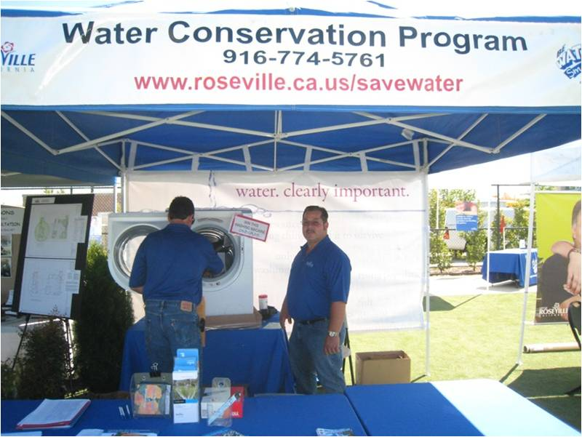
Selling an energy efficient washing machine

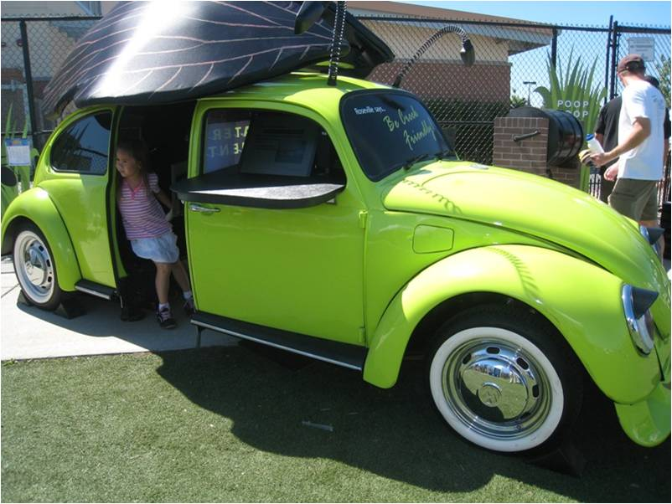
This little girl just saw a video inside the Volkswagen.

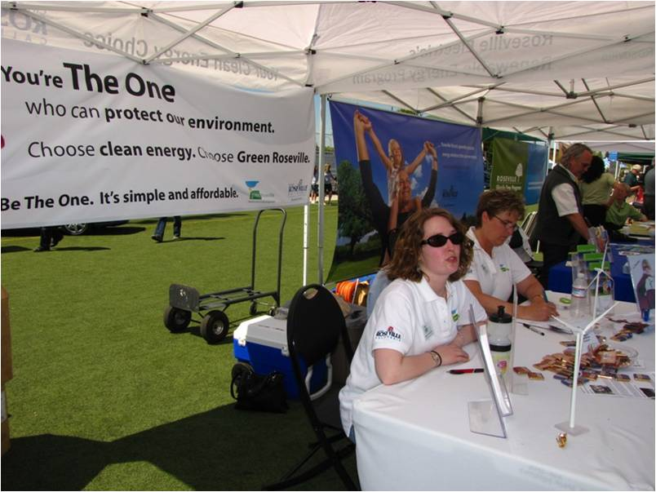
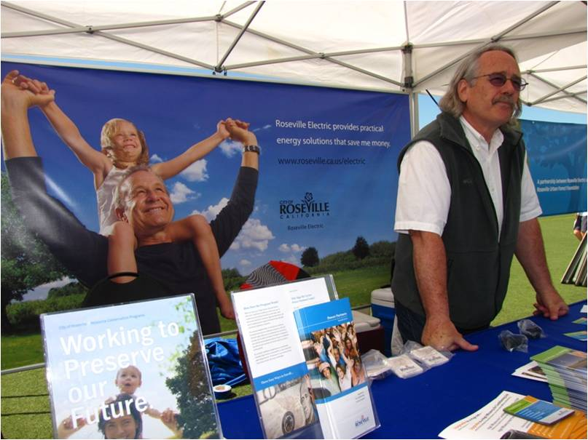
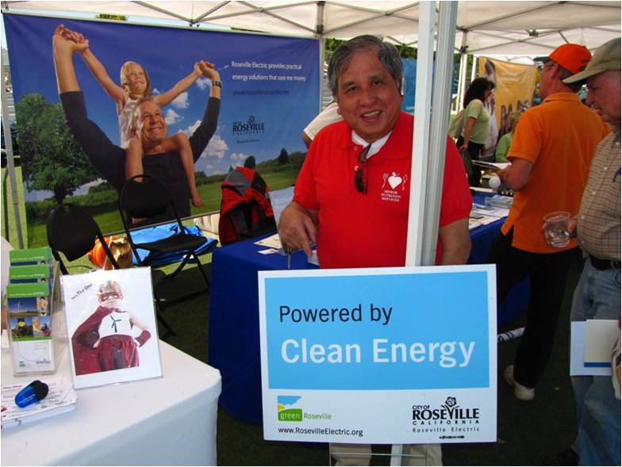
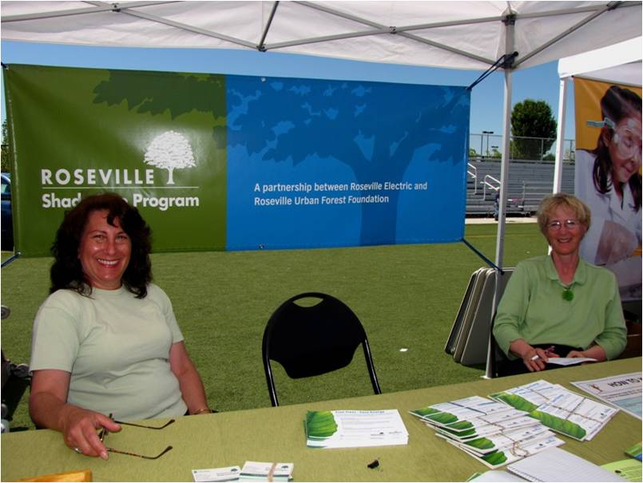
Partnerships, partnerships, partnerships in promoting the shade tree program

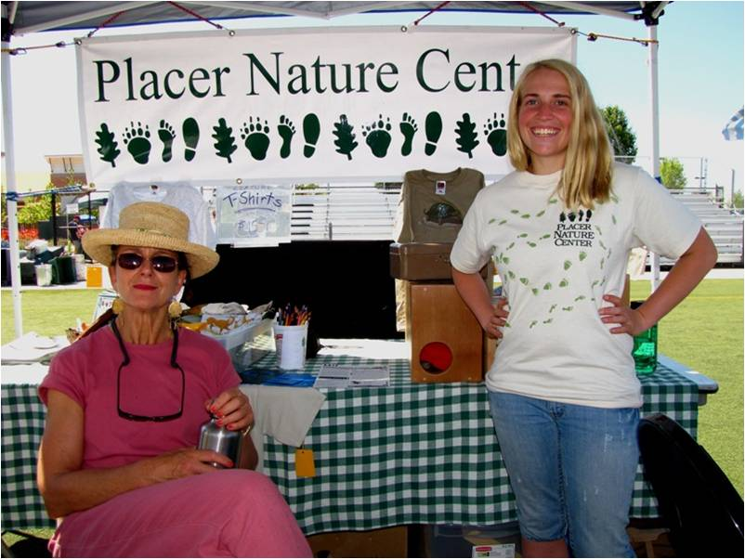
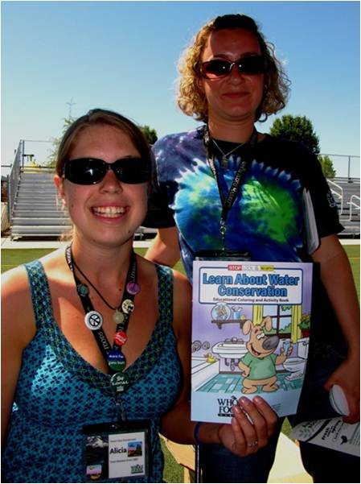
Water Conservation – this year’s major theme

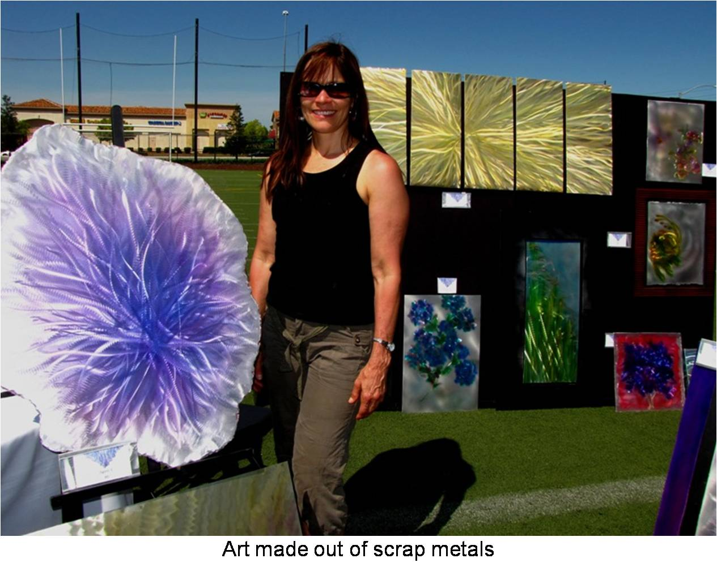
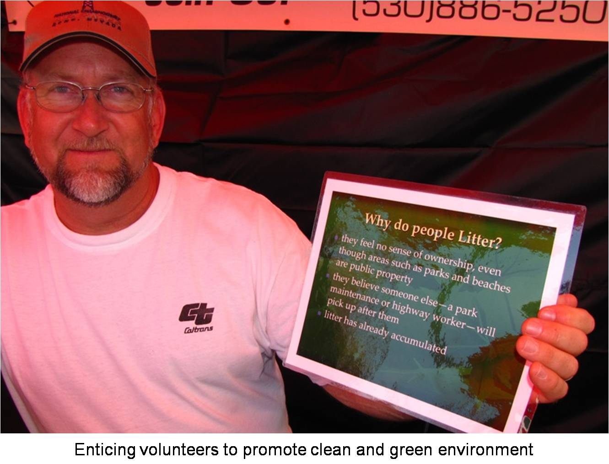
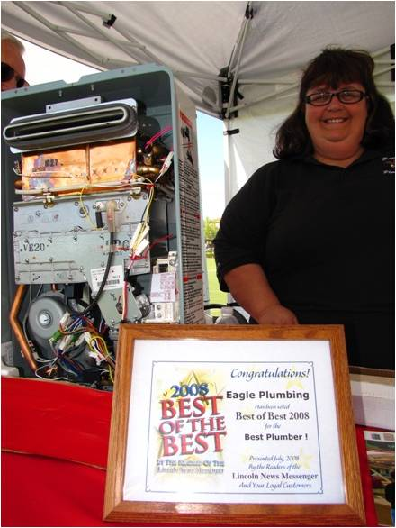
An award winning energy saver (Plumbing)

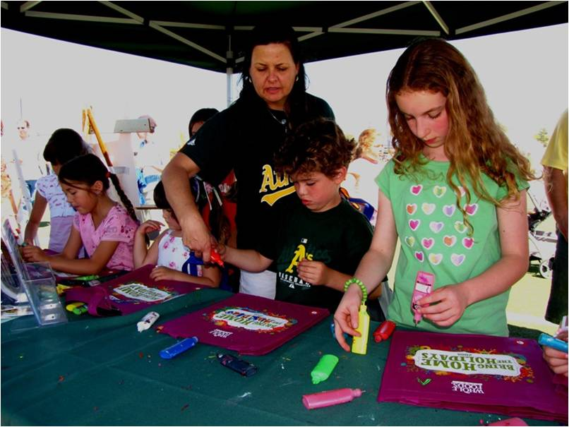
Children have fun doing artwork using organic materials.

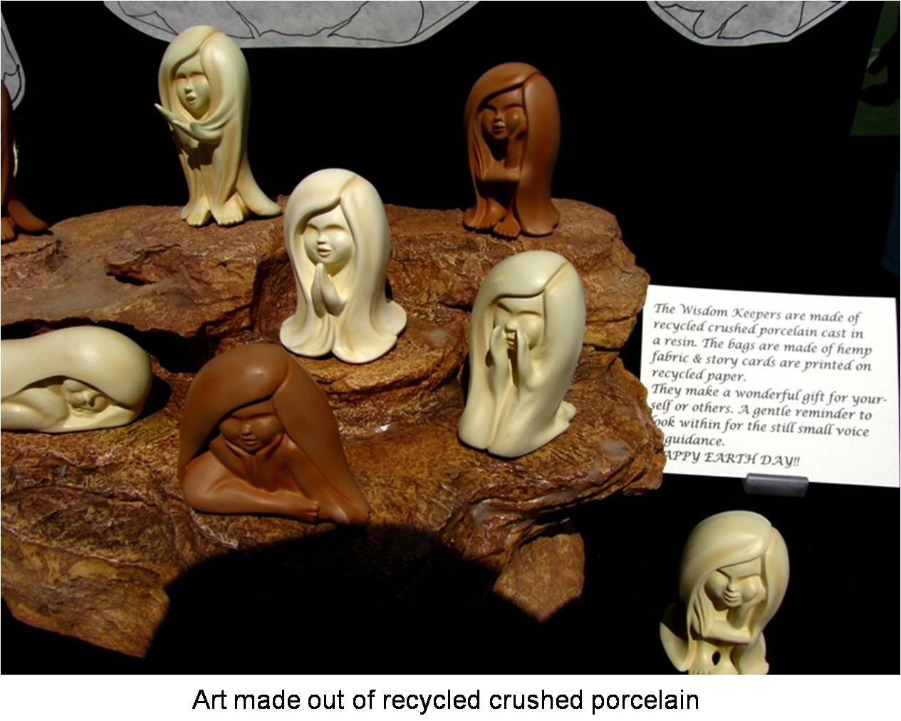
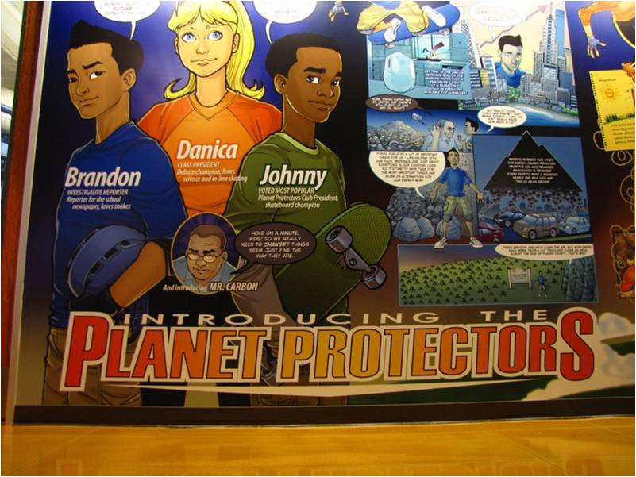
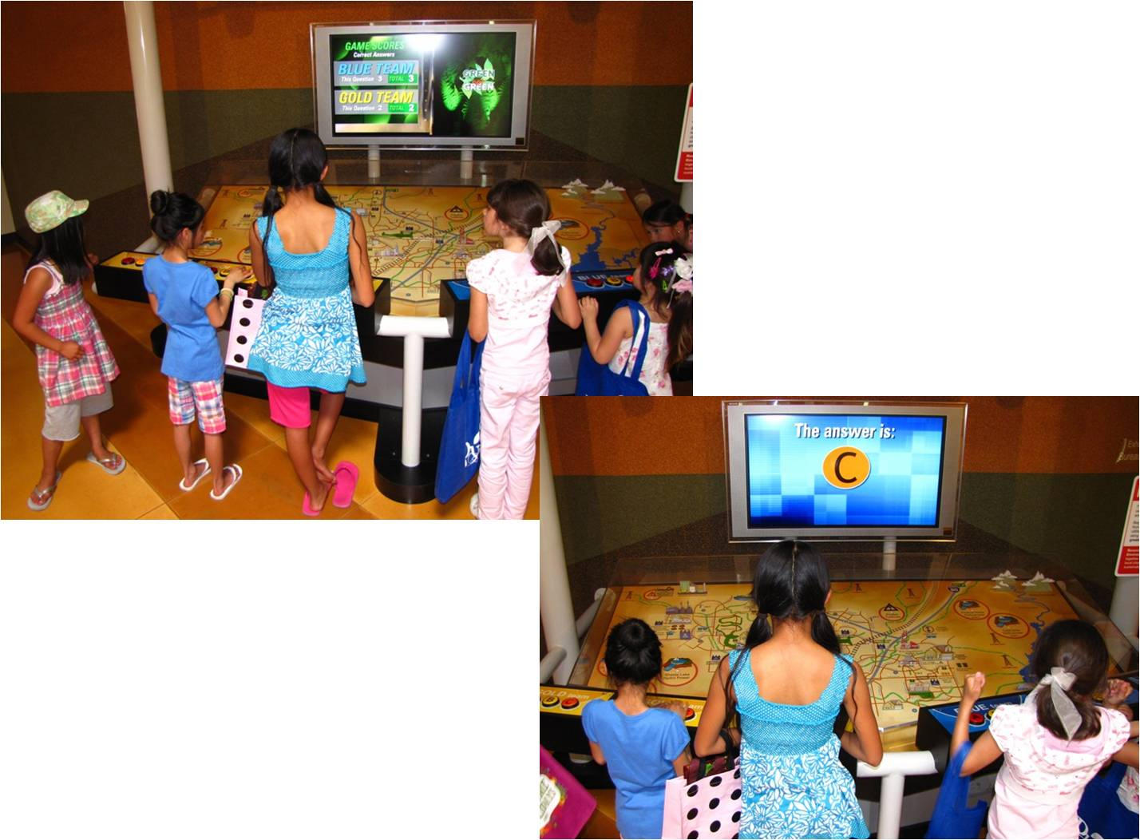
Interactive environmental education for young kids

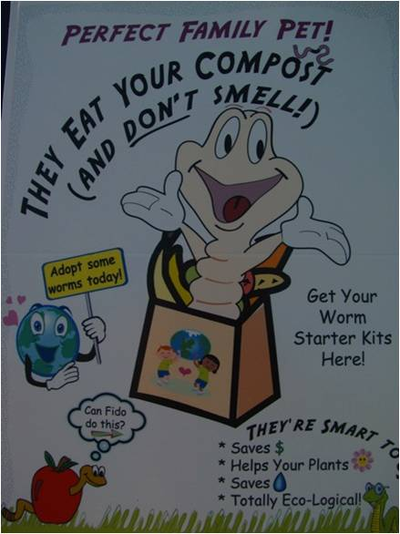
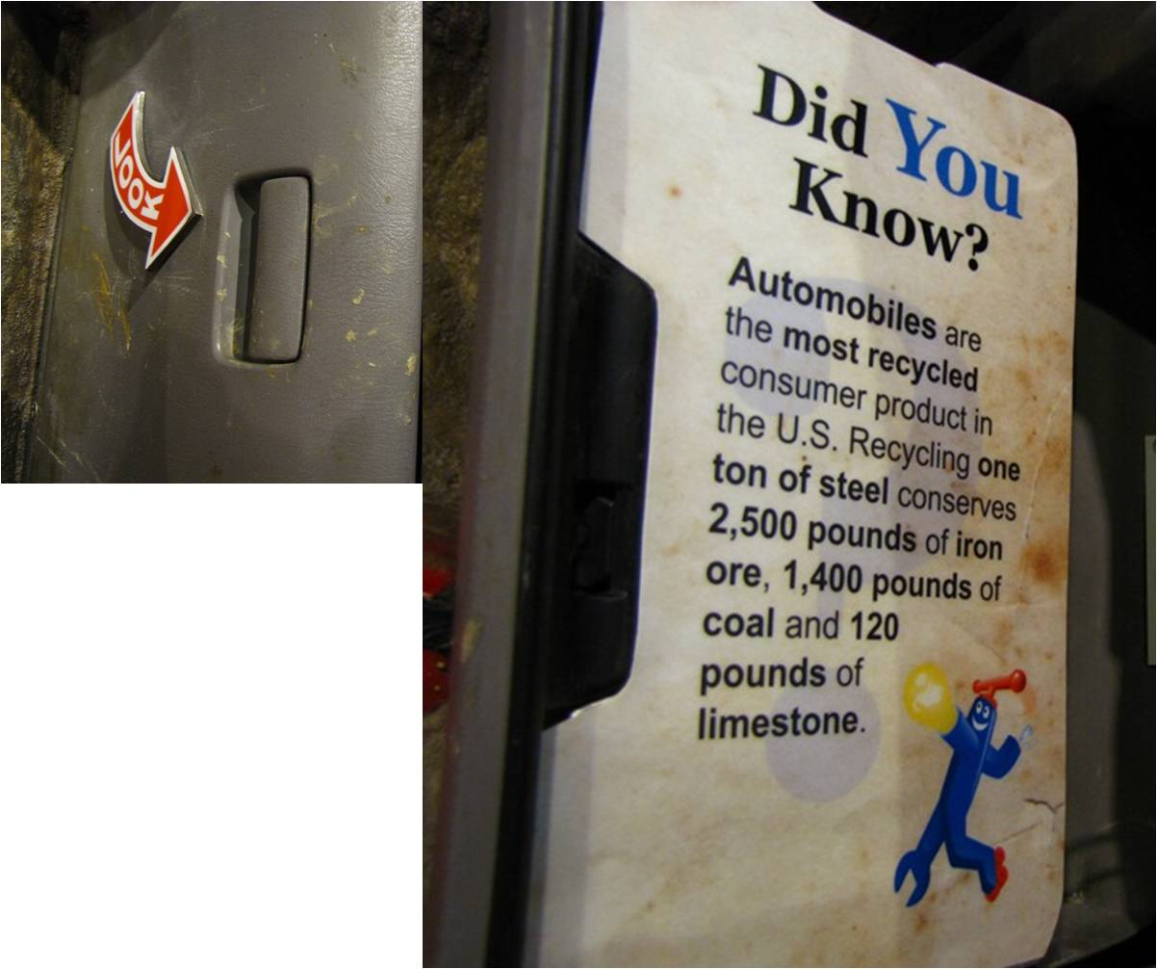
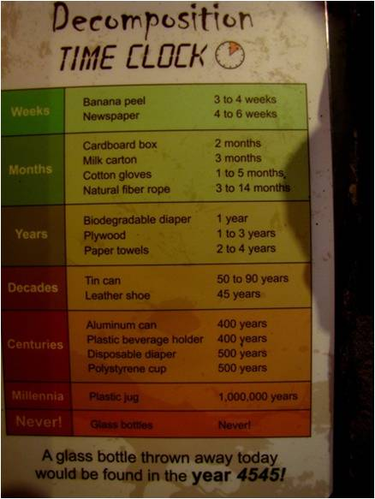
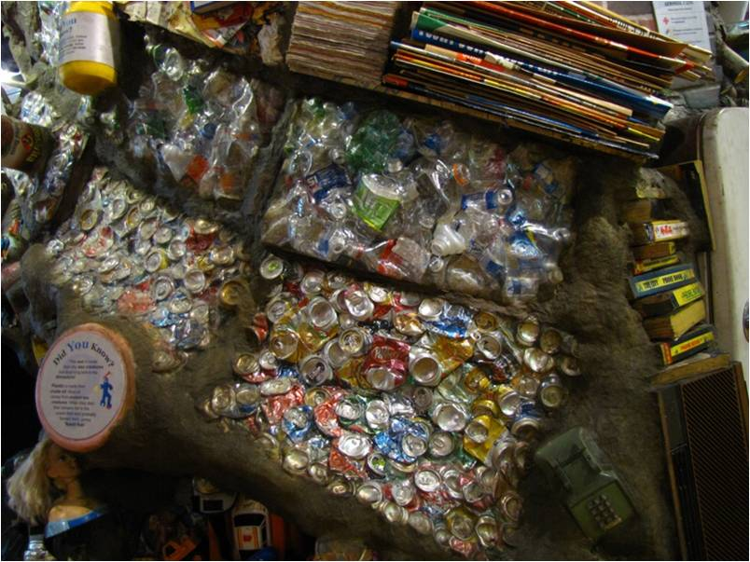
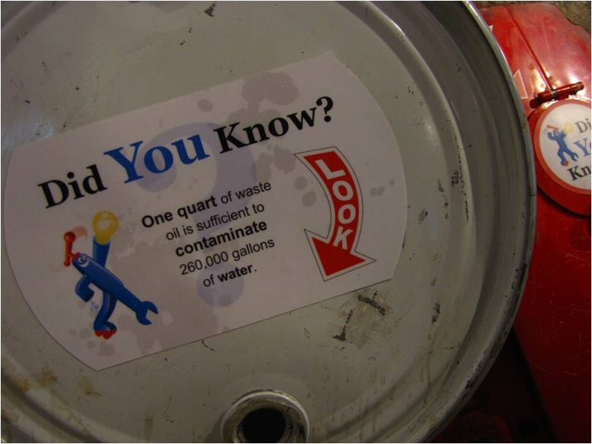
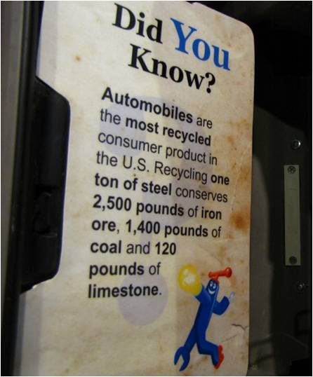
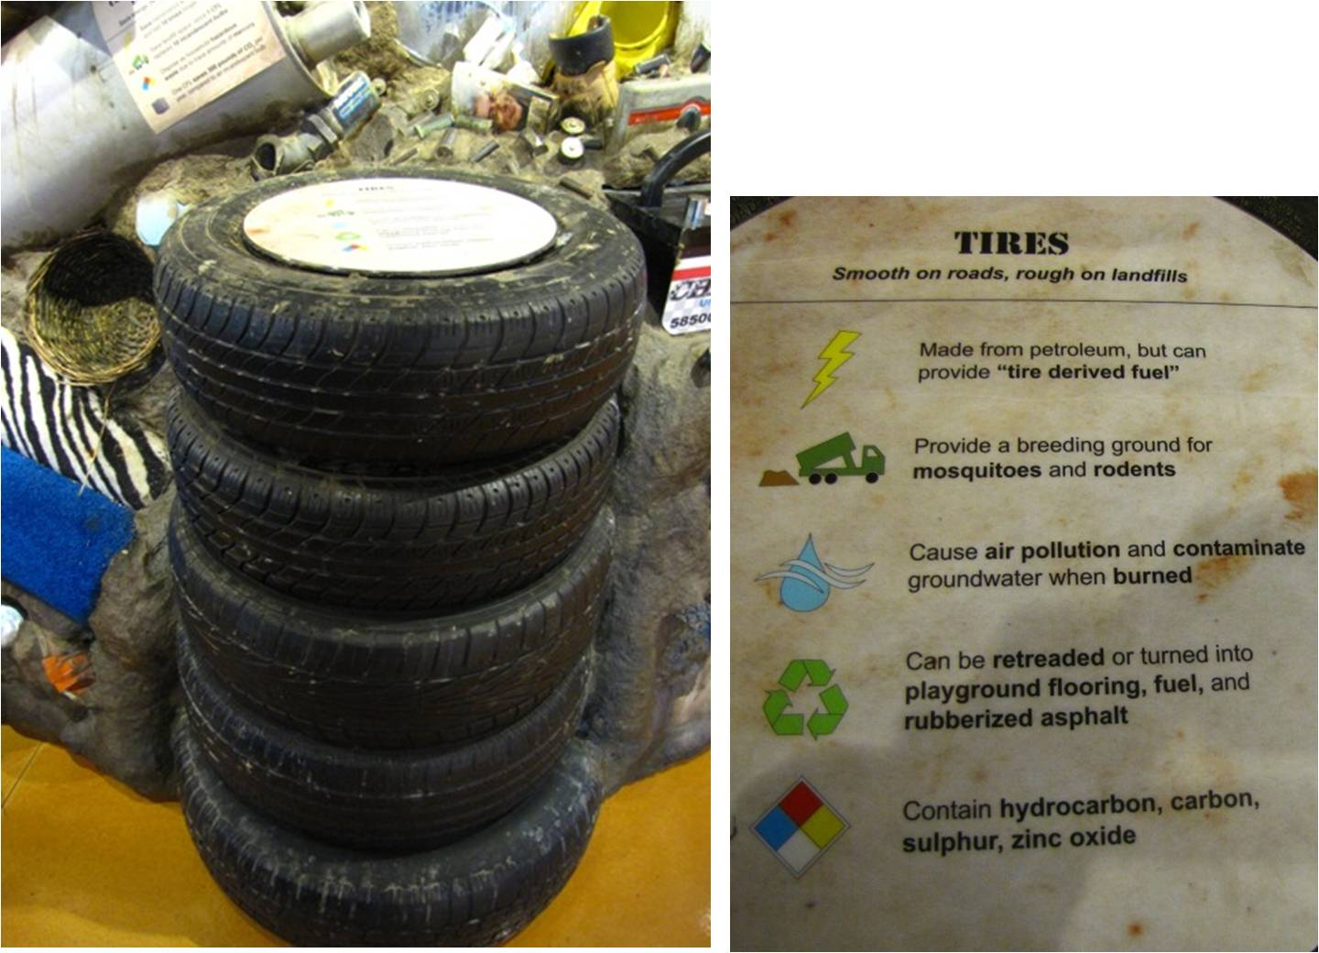
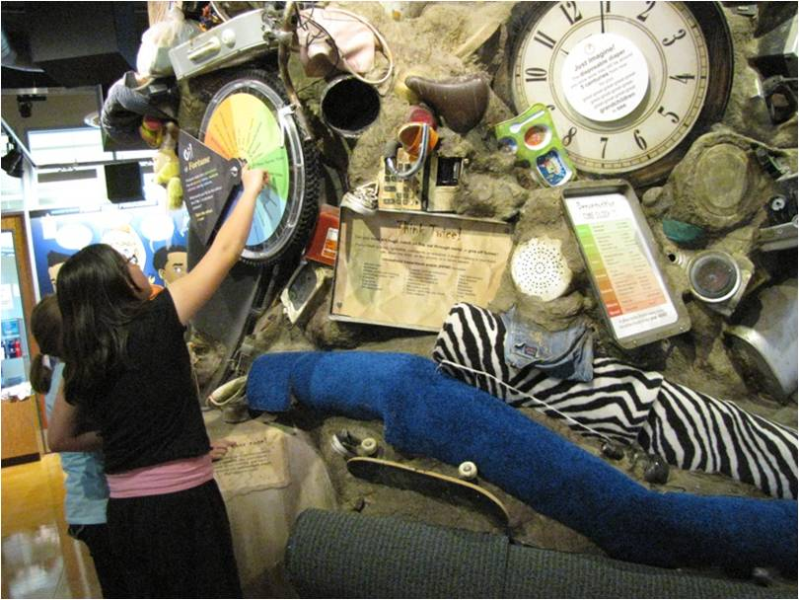
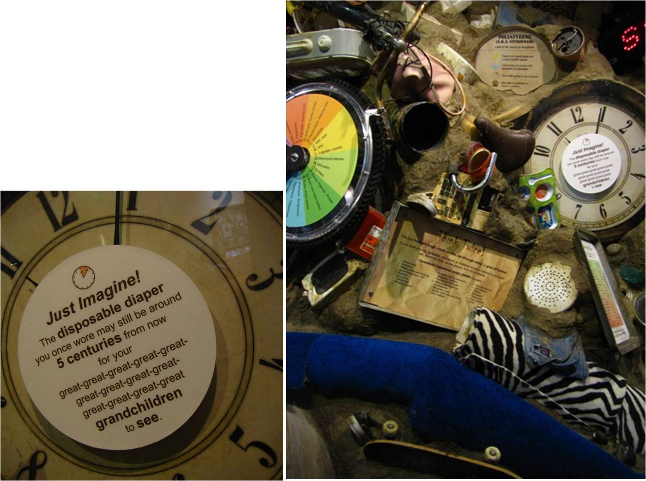
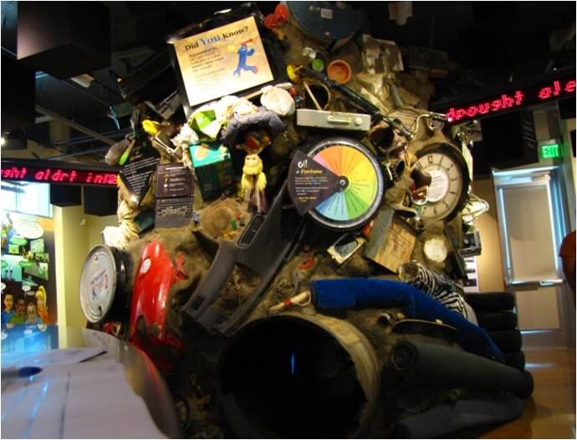
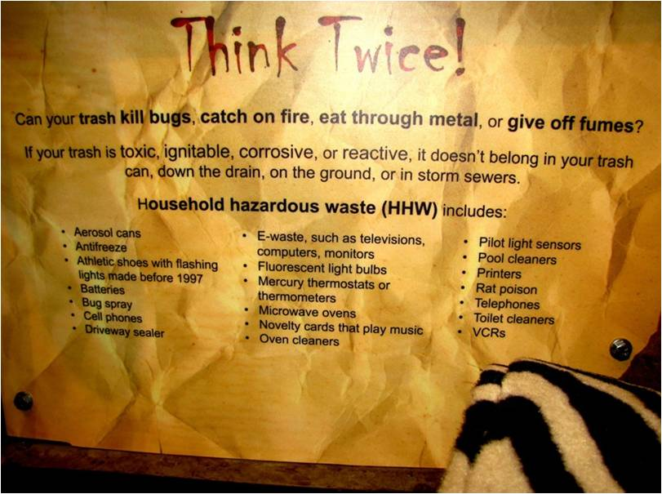
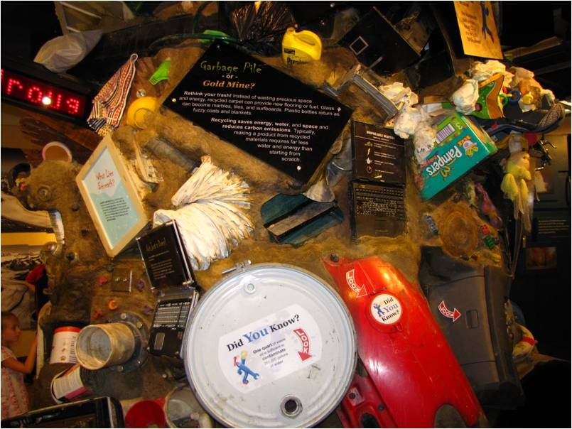
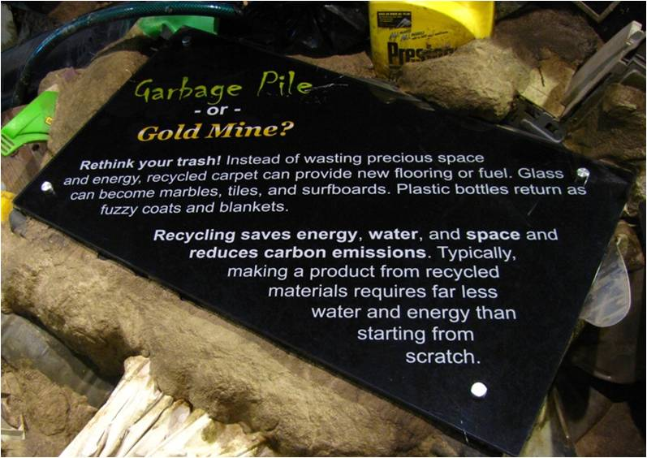
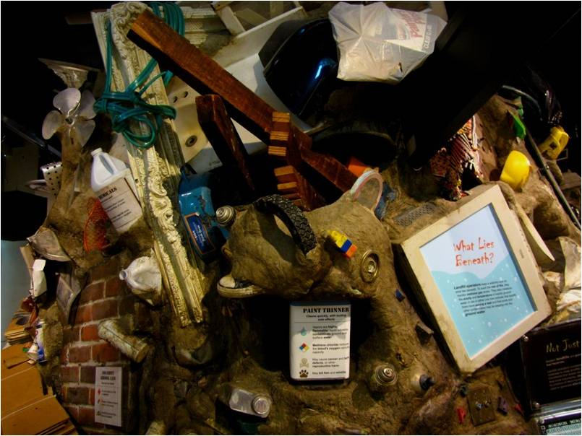
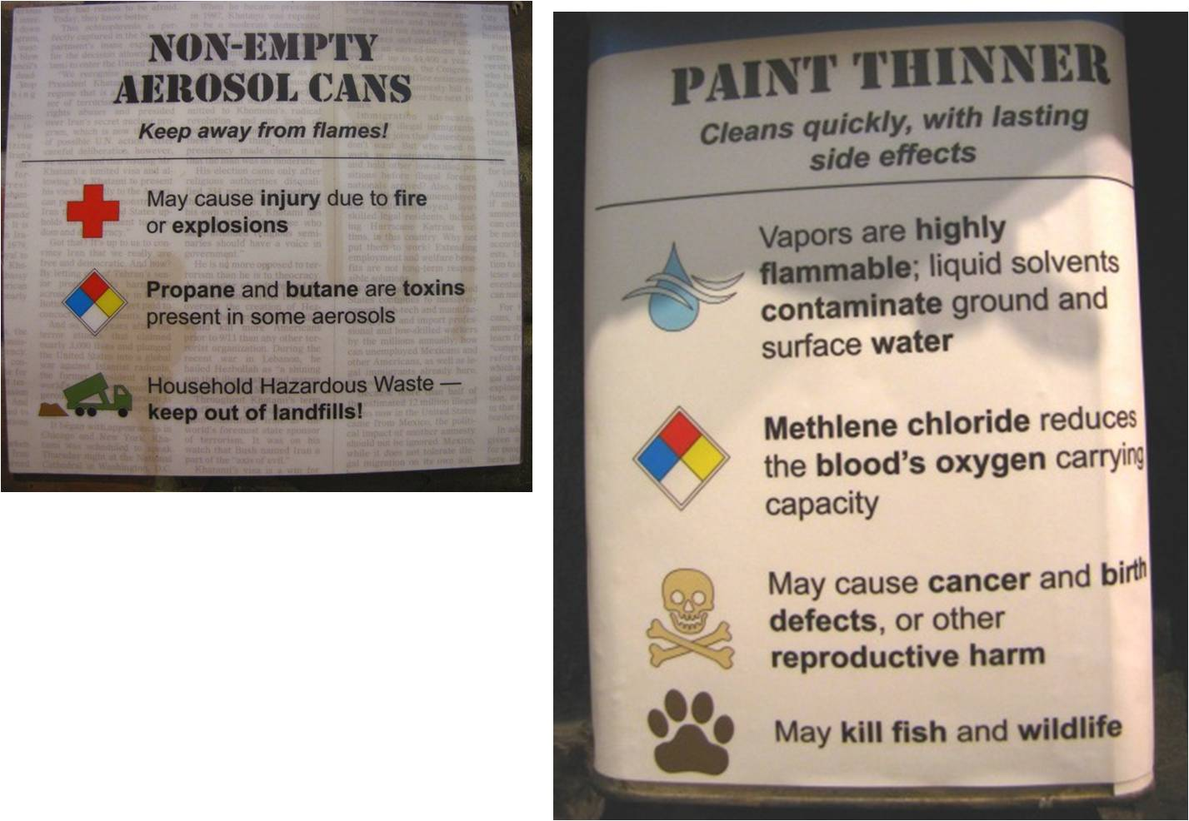
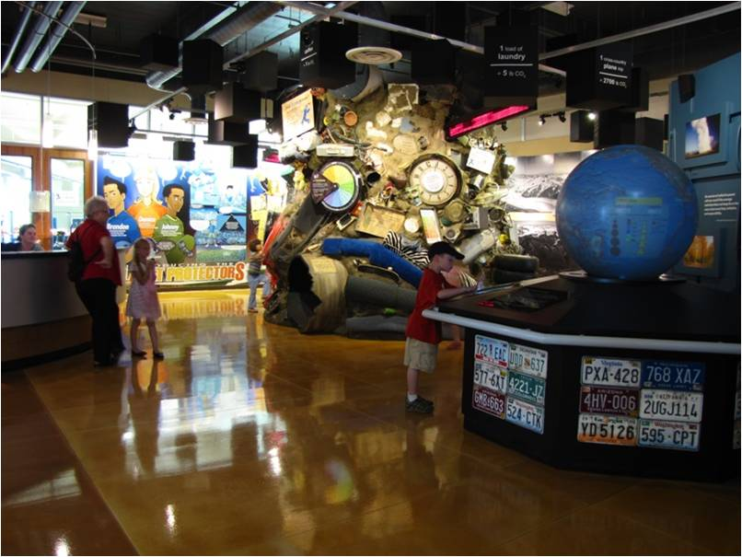
That’s the mountain garbage at the background.

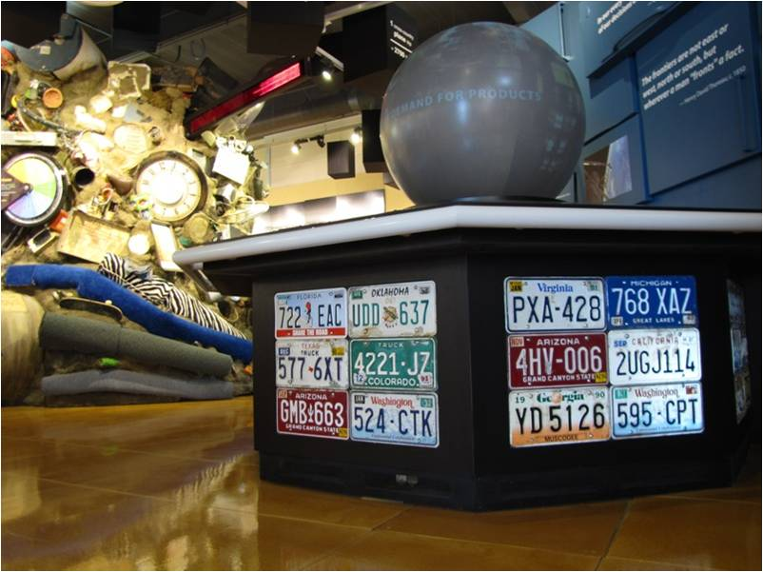
At the foreground is a revolving globe showing the environmental threats
arising from unabated population growth especially in less developed countries.


Organic fruits and vegetables for sale

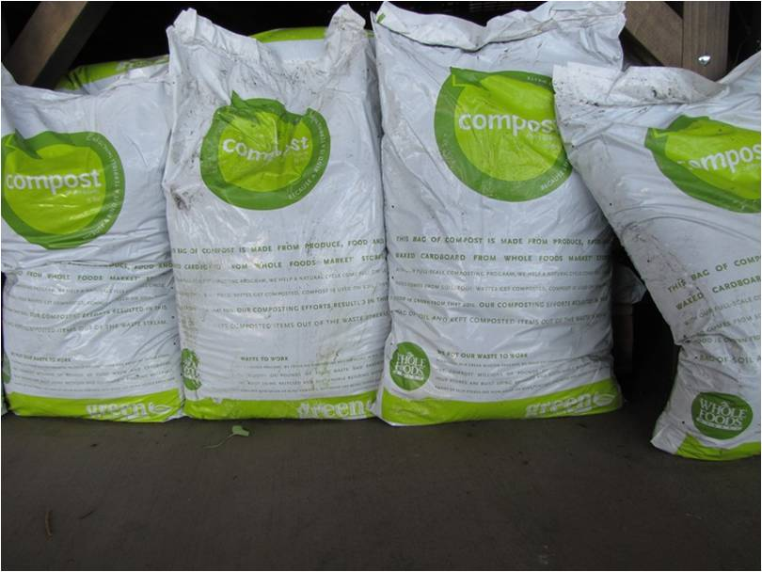
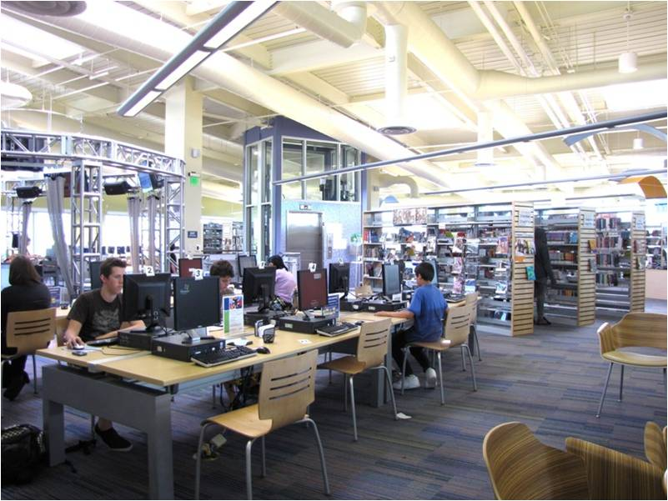
The Riley Library located at the Roseville Utility Exploration Center has one
Of the most extensive collection of environmental books and periodicals,
Plus over 40 internet-connected public computers for self-guided research.

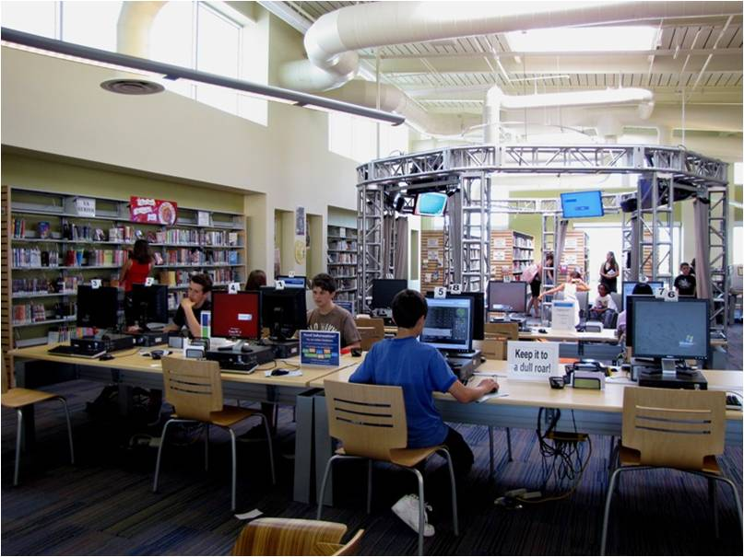
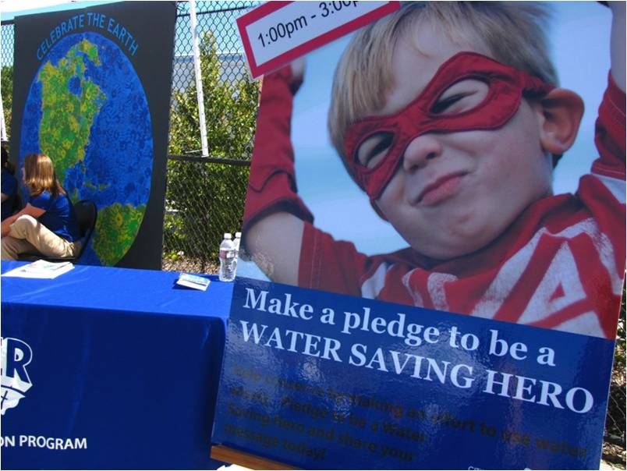
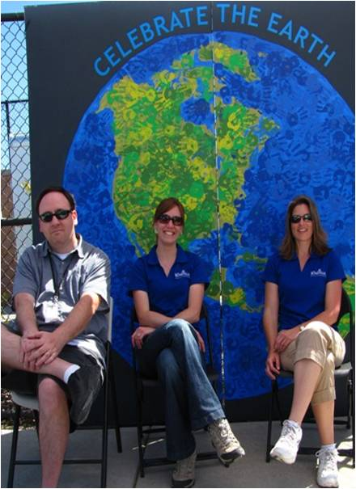
THANK YOU FOR BEING PART OF PROTECTING OUR ENVIRONMENT.

