Environmental Awareness
A monthly publication of UP BETA SIGMA FRATERNITY, INTERNATIONAL, INC.

April 2009
How interesting, indeed, that one of the tallest life forms on earth can inspire one of the most powerful human emotions that is described most frequently in one of the shortest words!
Such are the giant redwoods. They never fail to inspire awe in anyone who lays an eye on them. Towering and mighty, they can lift your soul to introspective heights. Tough and resilient, they can stir your heart to be the same.
Our guest writer for this April has seen his fair share of trees, having been in the forest business for years. Still, the rush of emotions is palpable in this narrative describing his encounter with the humbling giants in the forest.
Gerry Abenes - Editor
About the Author
Brod Johnny Regadio UPLB ’66 is a B.S. Forestry graduate. After college, he worked as an officer of the Dept. of Environment and Natural Resources and has seen the lush forests of the Philippines slowly being degraded. He migrated to California is the early 80s. He currently works in the County of Sacramento.
He was UP Northern California Chapter’s Grand Princep for 3 years – from 2002-2005. Brod Johnny is also a member of the UPBSFI, Inc. Board of Directors.

A Journey into the Ancient Redwoods
by Johnny Regadio ‘66

I still vividly remember those billboards along the roadside going up to Baguio City that were set up several meters apart with written verses of the famous poem by Joyce Kilmer, “Trees.” Every word of the poem gave meaning to my life as a professional forester. As I passed through them I imagined looking at giant trees towering towards the sky like those that I used to see in pictures from books and magazines; and I dreamed that someday I would have the chance to see them.

I have been in the United States for twenty three years. But it was not until a recent visit of my dear friend and fraternal brother, former Undersecretary of the Department of Environment and Natural Resources Rene de Rueda, that I visited the citadel of ancient redwoods in the northern coast of California.

Our one day trip was full of excitement. We were accompanied by Brod Manolo Banzon, who joined us in Sacramento, to start our trek to the world famous Avenue of the Giants. It was a six-hour drive, with brief stops along the way for food and picture taking. We had our first stop in a small rural community along Highway 101 called Willitts, a gateway to the redwoods in the heart of Mendocino County.

As we approached the 31-mile drive to the redwoods, we had a brief stop in Leggett, a small rural community on the northernmost tip of the scenic California Pacific Highway 1, connecting Highway 101. Here, we visited what was left of a 2,400 year old, 315 ft. (96 m.) tall and 21 ft. (6.4 m.) diameter coast giant redwood tree called the Chandelier Tree. The living trunk of the tree has a 6 ft. (1.83 m.) wide by 9 ft. (2.74 m.) high hole cut through its base, just enough to allow a car to drive through. Amazingly, my Toyota Sienna van was able to pass through the opening.
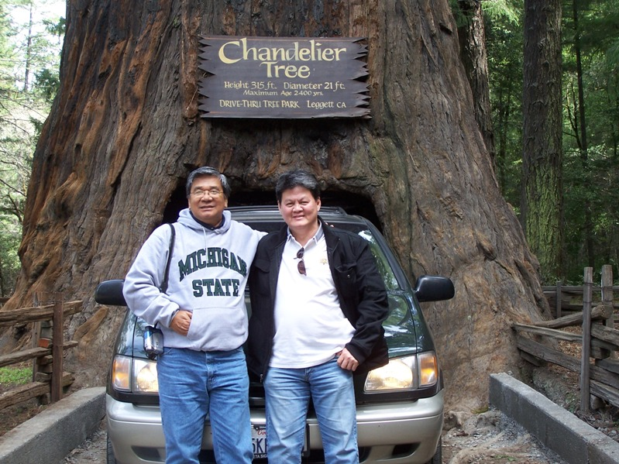

As we continued our drive to the north following Highway 101, we could already see some giant redwoods lined up along the highway. After about ten minutes drive farther north, we took an exit going to Phillipsville, which is the southern entrance to the Avenue of the Giants. We stopped at the Chimney Tree, a big hollow trunk of a 1500 year old giant redwood that was nearly destroyed in a wildfire in 1914. It still stands at 78 feet and still growing despite the absence of its heartwood.

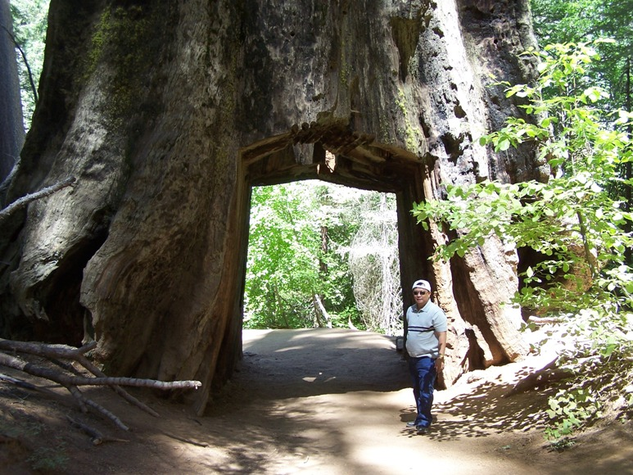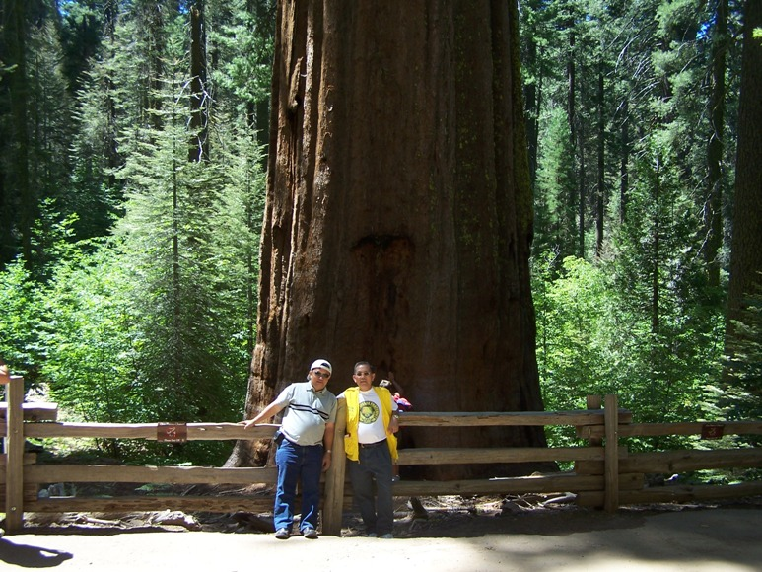

The Avenue of the Giants winds along Highway 101 inside the Humboldt Redwood State Park. It is a spectacular side road with scenic beauty of towering majestic trees. As we passed along the giant coastal redwoods, I could not contain my amazement while taking pictures at the gigantic size of coastal redwoods on both sides of the road. It was an awesome experience to see the enormous beauty of huge candle-like trees sprawled densely with barely a ray of sunlight penetrating because of the thick canopy. I felt so close to the Creator as we traversed the road with these most fascinating living trees on earth. And as I close my eyes and inhale the fresh air, I imagined walking in paradise, in the Garden of Eden, as described in the book of Genesis. My only big disappointment was that I was not able to see Adam and Eve, and the tempter snake.

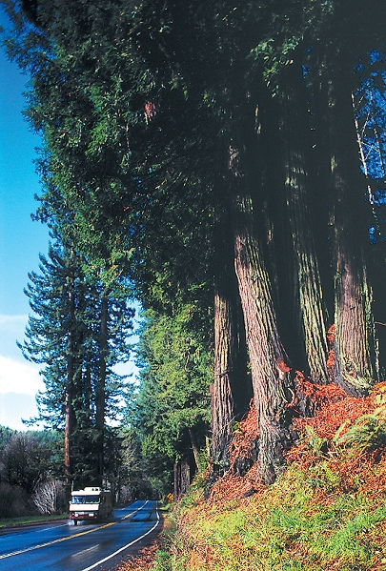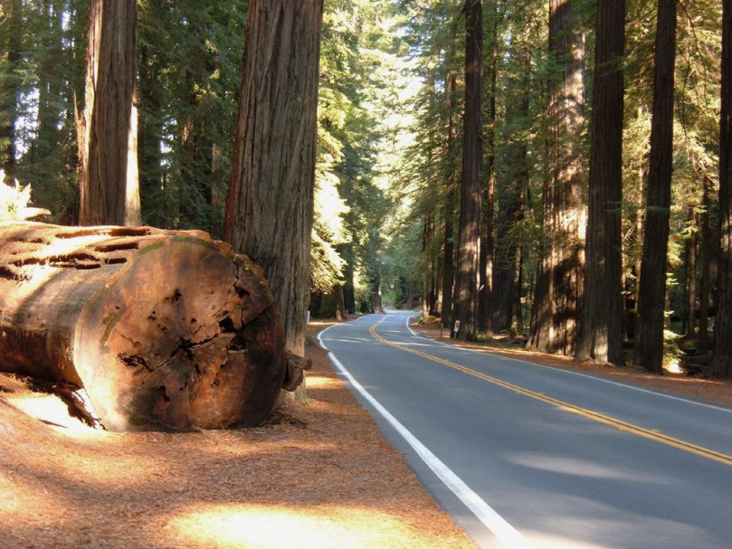

Several location shootings were made in the Humboldt Redwoods because of the giant trees and other features of the park that adapts into the story lines of the movies, like the “Star Wars: Return of the Jedi.” Likewise, scenes for the movie “The Lost World: Jurassic Park” were filmed in the area. There are about 100 miles of trails that await exploration by hikers, bikers, and horse riders. The best way to experience the redwood’s cathedral-like grandeur is to hike one of the many easy park trails. A two-mile hike normally takes about three hours. Hikers should bring water and snacks and must wear hiking boots while enjoying the leisurely trek.

There are several facilities and a variety of activities available in the park. Several accessible areas are on hand for individual or group campsites. Day use areas are also available for picnicking, family activities, for just enjoying the pristine environment. The rivers also provide fishing, boating and swimming opportunities.

Motels, inns, cabins, and RV parks are also available within or in the vicinity of the park. Visitors can stay in these facilities by making advanced reservations, especially during the summer months. There are also gift shops, art galleries, restaurants and other attractions around for visitors to have brief stops for relaxation and picture taking.

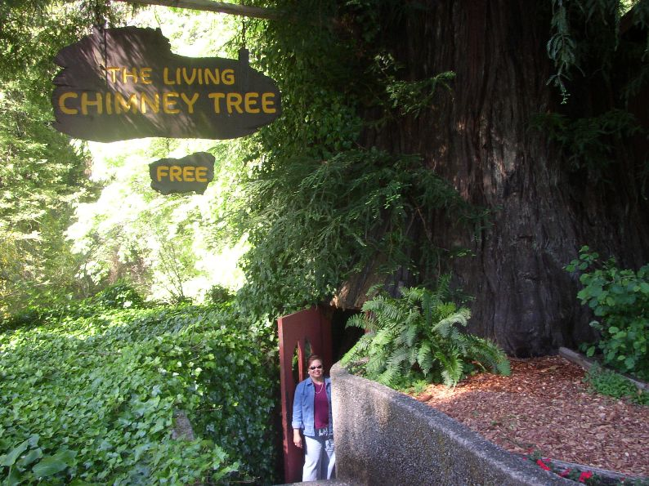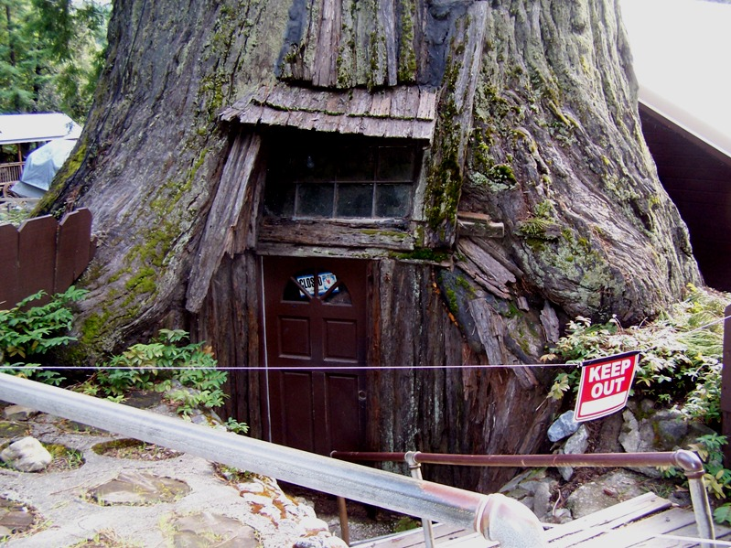

Meanwhile, as a professional forester, I have been challenged several times by my illustrious brother, Dr. Winston Acevedo, to say the least about the two known species of redwoods and their differences. Contrary to what he knows, however, there are actually three (3) species of coniferous trees known as redwoods in the U.S., namely: Sequoia sempervirens (commonly called Coast Redwood or California Redwood), Sequoiadendron giganteum (commonly called Giant Sequoia, Sierra Redwood, or Wellington) and Metasequoia glyptostroiboides (commonly called Dawn Redwood). They all belong to subfamily Sequoioideae under the cypress family Cupressaceae.

- Sequioa sempervirens (Coast Redwood or California Redwood):
Most of the trees found inside the Humboldt Redwood State Park are commonly called Coast Redwood or California Redwood. It is in this place where the tallest living tree in the planet is found. It towers at 379.1 feet (115.55 m.), which is 75 ft. taller than the Statue of Liberty, and measuring 26 feet (8 m.) diameter at breast height. This species usually grows on a narrow strip of land, approximately 470 miles (750 km.) in length and 5-47 miles (8-75 km.) in width, along the coastal areas of northwestern California and the southwestern corner of Oregon, at an elevation range of 98-1,141 ft. (30-350 m.), and occasionally at sea level up to 3,000 ft. (920 m.) elevation.

The Coast Redwood is an evergreen tree with conical crown and horizontal to slightly drooping branches. It has variable leaves, 15-25 mm. long and flat on young trees. The leaf arrangement is spiral. The trees start producing cones at 10 to 15 years of age. A full-grown tree produces six to eight million seeds each year; however, only about 5% of the seeds are viable. Between the months of November and February as winter storms blow through, the cone scales separate and the seeds are released. The seeds fall and are scattered within a few hundred feet around the parent tree and many stay in the litter found in the tree canopy.

Coast Redwoods can reproduce either sexually or asexually. Those few seeds that are viable will germinate in about a month and actually turn into seedlings. They are also capable of reproducing from dormant buds in the burls (a woody lignotuber that is capable of developing into buds) at the base of the tree, or from the stump of a fallen tree. Coast Redwood is one of the fastest growing trees in the U.S. at 130 feet in 30 years and 170 feet in 50 years.

Coast Redwoods are very tolerant to flooding and flood deposits. Old growth stands provide habitat for the federally protected spotted owl, and a variety of mammals, reptiles, birds and amphibians.

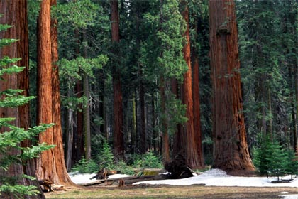

- Sequoiadendron giganteum (Giant Sequioa, Sierra Redwood, or Wellington):
Giant Sequoia or Sierra Redwood is restricted to a limited area of the western Sierra Nevada, California. The trees generally grow at an elevation ranging from 4,600 ft. (1,400 m.) to 6,600 ft. (2,000 m.) in the north along the American River in Placer County, and 5,600 ft. (1,700 m.) to 7,000 ft. (2,150 m.) to the south of the well known Yosemite National Park, where many grooves are protected at Sequoia and Kings Canyon National Park, and Giant Sequoia National Monument.

The tallest trees have been recorded to measure 311 ft. (94.8 m.) and a diameter of 57 ft. (17 m.). They grow to an average height of 165 ft. (50m.) to 280 ft. (85 m.) and a diameter of 18 ft. (6 m.) to 24ft. (8 m.). The oldest known tree based on the ring count is 3,500 years old.

Giant Sequoias or Sierra Redwoods regenerate by seeds. Young trees start to bear cones at the age of 12 years. A mature tree has been estimated to disperse from 300,000 to 400,000 seeds per year; and the winged seeds may be carried up to 600 ft. (180 m.) from the parent tree.

Fire is an essential part of Giant Sequoia reproduction. They need fire to open their cones and release seeds, and to leave cleared beds of ash where they sprout and grow best. They grow successfully in full sunlight, free from competing vegetation; hence, they require periodic wildfire.

Trees up to twenty years old may also produce stump sprouts subsequent to injury; but the mature ones do not produce sprout from the cut stumps, unlike the Coast Redwood.

The leaves of the Giant Sequoia are evergreen, 3 to 6 mm. long, and arranged spirally on the shoots. The seed cones mature in 18 to 20 months, though they typically remain green and closed for up to 20 years.

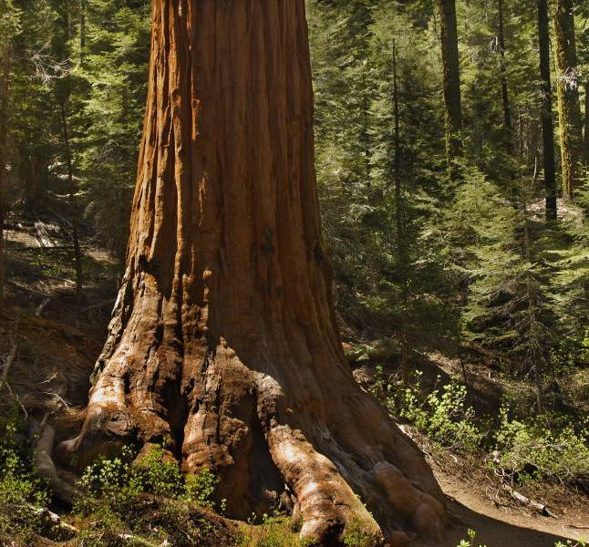

- Metasequoia glyptostroiboides (Dawn Redwood)
The third of the three species known as redwood is commonly called Dawn Redwood. This species is native to the Sichuan-Hubei region of China. They love moist weather and this explains their phenomenal growth rate in the eastern and southern United States.

The Dawn Redwood is a familiar sight in parks and gardens. They are widely planted as ornamental trees. They can also thrive in standing water.

The leaves are opposite, 1-3 cm. long, fine and flattened, much like the Coast Redwood but delicate in appearance. Although it is a conifer, the Dawn Redwood has one distinct peculiarity and that it is deciduous. The leaves turn bright orange during autumn before they drop, which is quite a spectacular sight.

The Dawn Redwood is a fast growing tree. It attains a height of 133 ft. (40 m.) to 150 ft. (45 m.) and a diameter of 7 ft. (2 m.).

As we were leaving the Avenue of the Giants, Brod Rene could not contain his excitement and whispered to me, “Thank you, brother, for bringing me here to fulfill one of my life-long dreams – to see the beautiful giant redwoods.” It was a great opportunity for me to have accompanied my brother; more so, to see for the first time the candle-like giant redwoods. It was a humbling experience to set eyes on the magnificent towering trees and be aware of the work of a power greater than us. I now recall a verse in the Bible -- “Let the field be joyful, and all that (is) in it. Then all the trees of the woods will rejoice before the Lord.”

The journey was indeed beautiful and gratifying, especially for a forester like me.

