Environmental Awareness
A monthly publication of UP BETA SIGMA FRATERNITY, INTERNATIONAL, INC.

The California Academy of Sciences
February Issue
Proudly espousing the slogan of “Exploring, explaining, and protecting the natural world”, a monument celebrating the vibrant life on our planet re-opened late last year in San Francisco after a decade of renovations. With the unassuming name of California Academy of Sciences, it is literally a breathing mammoth dedicated to reminding man of his good fortunes to be in such a hospitable environment like Earth’s. Beneath the humbling structure and breathtaking exhibits lies the hope that those who come to visit may be inspired to become a leading proponent in the global effort to preserve our planet’s natural habitats and resources.

Join us on a brief tour of the Academy with our guest writer for this February, 2009 issue of Environmental Awareness, Ms Rose Veridiano.

Gerry Abenes, Editor

About the Author
Ms Rose Veridiano works at the Personnel Department of the PG&E. She is a widely traveled lady and has gone to several places of nature in the State of California. An environmentalist in her own right, she is a special friend of UP NorCal Chapter.

Lessons in Going Green

Were it not for the Philippine Coral Reef exhibit, it might have taken me another year or so to visit the California Academy of Sciences (CAS) at Golden Gate Park in San Francisco. Do we not typically ignore that which is in our own backyard? We hop on planes, sail on ships and travel hundreds of miles across oceans to some favorite tourist destination, and gape in awe at world renowned buildings, sculptures, paintings or natural wonders. Meanwhile, back at home, we watch tourists flock to our very own treasures, be it natural or man-made, telling ourselves we’ll go there someday. After all, they’re so close by and they’ll always be there. I’ve lived in Northern California for over 25 years now, and only recently did I finally see Alcatraz. It took a guest from Australia to get me there. This summer, my husband and I visited Angel Island on the San Francisco Bay, something we had planned on doing for years. Angel Island provides sweeping vistas of the City, its hills and bridges like we had never seen before.

After a renovation that spanned 10 years at a cost of $500 million, the CAS opened on September 27, 2008. Knowing that the Philippine Coral Reef was one of the main attractions at the museum motivated me to get up early one Saturday morning in December for the 2-hour trek from Sacramento to San Francisco. It was well worth giving up precious weekend sleep for.

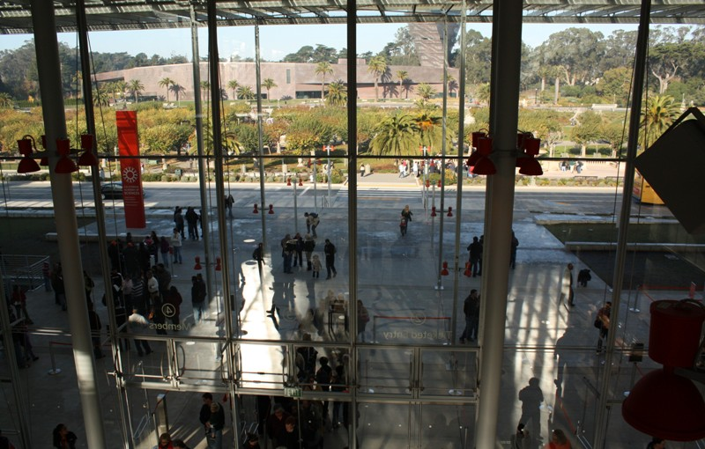

Entrance to the California Academy of Sciences. Located directly across is the De Young Museum.

Since 1853, the Academy has been devoted to increasing knowledge about diversity of life on Earth. Its research is driven by two questions: how did life on earth develop, and how can we – the stewards of this planet – sustain that life? This mission continues today with an unwavering dedication to awareness and action. The CAS is currently the world’s greenest museum, and it has earned a platinum rating, the highest possible, from the U.S. Green Building Council, for Leadership in Energy and Environmental Design (LEED). It is more than just a museum; it is also a library, laboratory and research center.

The CAS is a single structure of steel and glass. It is topped by what is known as the Living Roof, composed of seven layers of material designed to create insulation, prevent runoff, retain soil, allow for drainage and promote healthy plant growth. 1.7 million individual plants from nine native California species have been planted into over 50,000 biodegradable coconut husk trays, covering 2-1/2 acres. These trays are composed of sustainable waste products from coconut plants in the Philippines. The Living Roof maintains an average temperature that is 40 degrees cooler than a standard roof. It provides excellent insulation, keeping interior temperatures about 10 degrees cooler than normal.

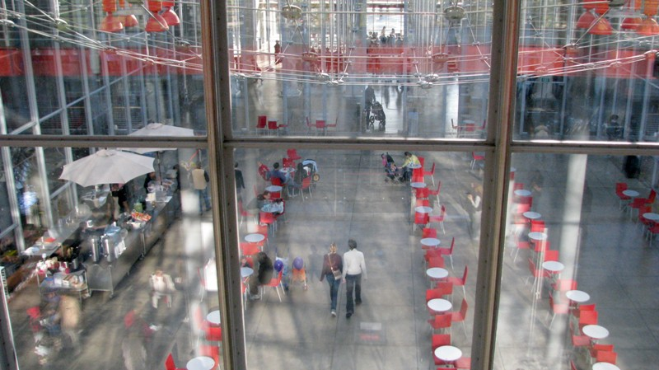
Snack bar in between the building’s two wings

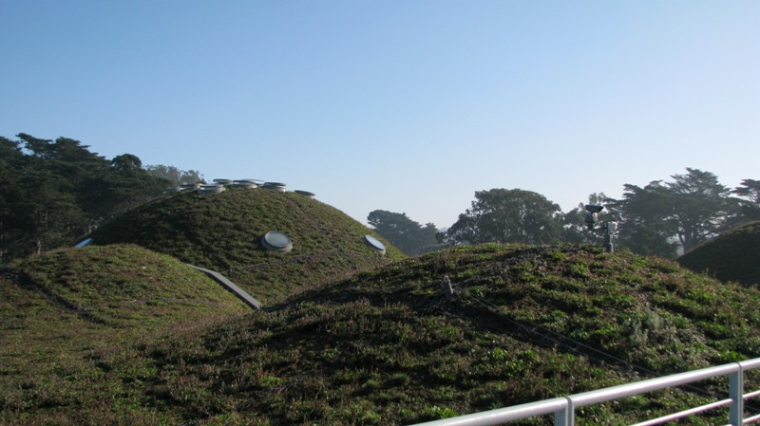
The Living Roof

Beneath the Living Roof are the Academy’s major venues including the Steinhart Aquarium, Morrison Planetarium, Kimball Natural History Museum, Tropical Rainforest and Naturalist Center.

My visit began at the planetarium, which is the largest dome in the world with a 75-foot diameter projection screen tilted at a 30-degree angle. The planetarium show, Fragile Planet, takes you on a journey into space, beyond the earth, the moon, the planets and the Milky Way. Earth is a speck of dust floating in space, one planet, one heavenly body among millions. What audacity makes us think that we are the only intelligent beings in this vast universe, that Earth is the only planet that can sustain life? And if these were so, what an awesome responsibility we have to ensure we do not extinguish that light and life.

The Steinhart Aquarium houses several exhibits, one of which is the Philippine Coral Reef. At a depth of 25 feet and holding 212,000 gallons of water, it is one of the deepest aquatic exhibits in the world, containing fish and coral from one of the most diverse reef systems in the world. Sadly, our country is not considered to be a top tourist destination in Asia. Browse through travel magazines, TV channels and websites, and places like Thailand, Singapore, and Vietnam are featured, with enticing photos of white sand beaches and luxurious hotels. Our beaches are just as picturesque, our sunsets more breathtaking, and our hospitality unmatched. Yet, only through exhibits like this can most people experience the beauty and richness of the Philippines. Though our country may be small, we bear a huge responsibility in preserving our natural resources and share it with the world, even if only through exhibits such as this.

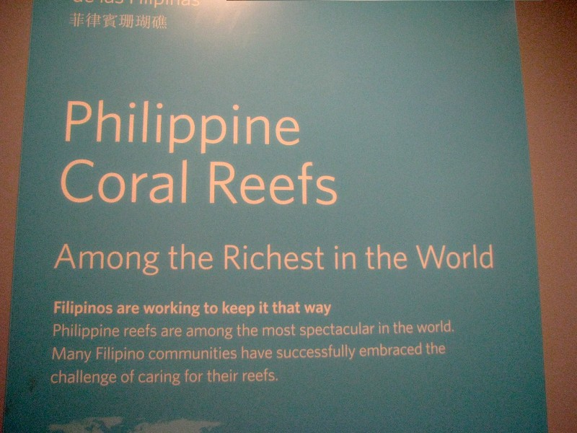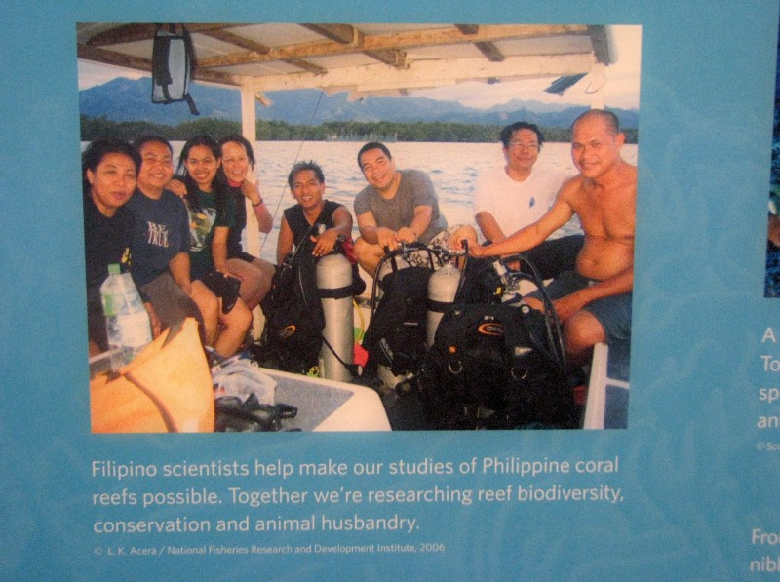

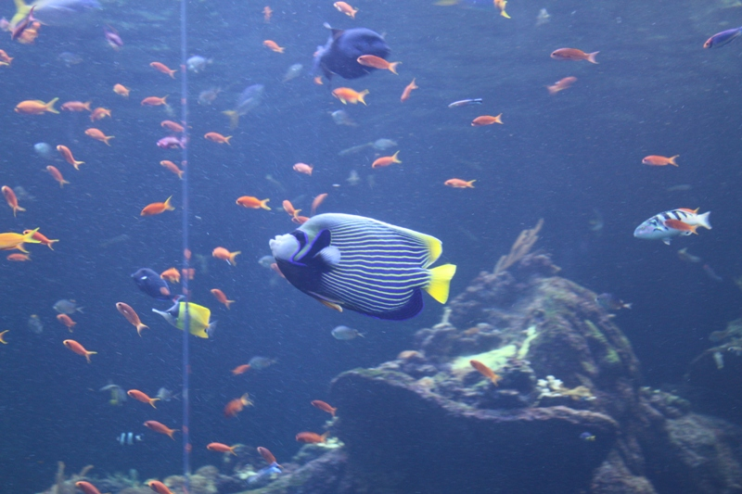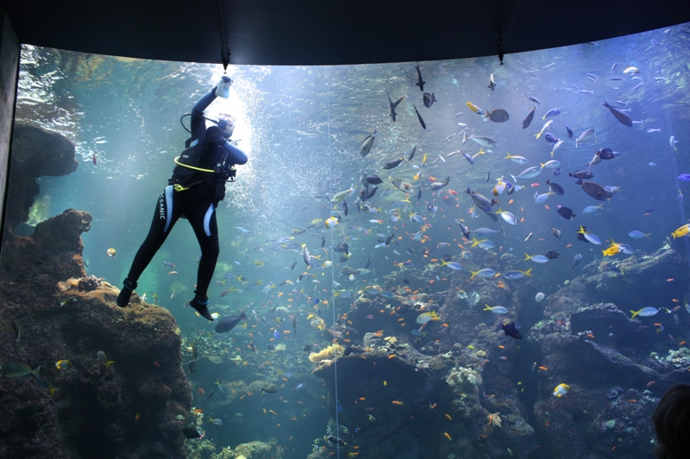

A spiral path takes visitors through the Tropical Rainforest, contained within a 90-foot diameter, 4-story glass dome. With temperatures maintained at 82-85 degrees, the sound of dripping water and chirping of birds, one is transported into the rainforests of Borneo, Madagascar, Costa Rica and the Amazon. Rare and endangered species of plants, birds, insects and animals of these fragile ecosystems are on display here.

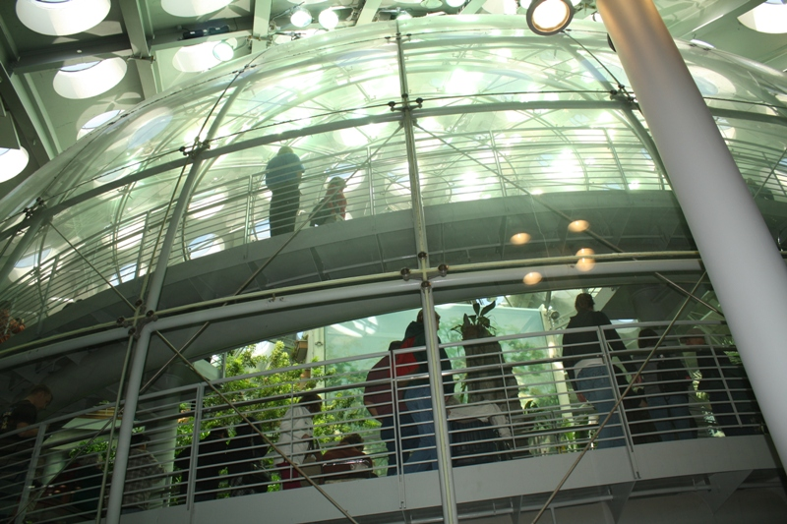 | 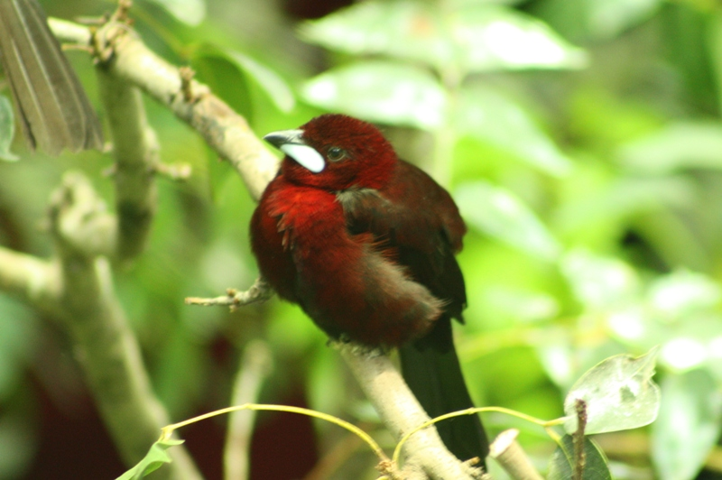
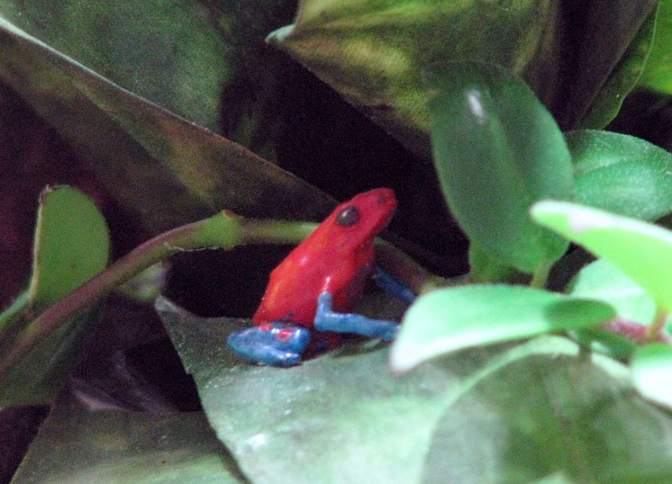 | 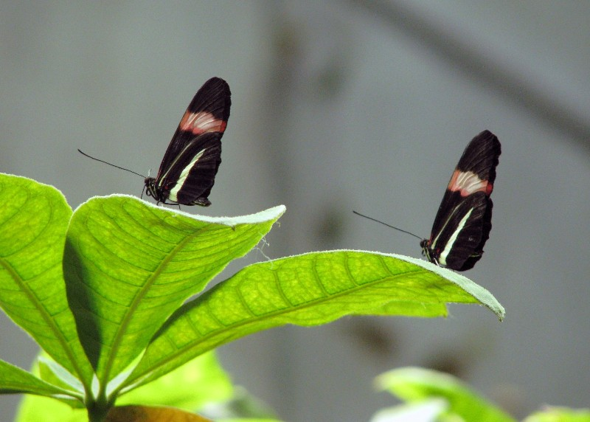

These were the highlights of my visit to the Academy, but there is more to see and even more to learn. It does not take a visit to the museum to realize that each one of us can do something to sustain our future and reduce our carbon footprints. There are simple things in our daily lives we can do - conserve gas by observing speed limits and planning trips and errands; recycle bottles, cans, plastic and paper; turn off all unnecessary lights and appliances; replace bulbs with compact fluorescents; and keep the thermostat at 78 degrees in the summer and 68 degrees in the winter. It does not take much to be a good steward of this place we call home.

For more information about the California Academy of Sciences, go to
www.calacademy.org

