Environmental Awareness
A monthly publication of UP BETA SIGMA FRATERNITY, INTERNATIONAL, INC.

Trouble in Paradise:
January Issue
The anecdotal “canaries in a coal mine” not only had its mystical days but the phrase itself has now evolved into an idiom warning of an impending misfortune. A timely question to ask at this point is: might there be other “canaries” out there trying to tell us about things worse than the build-up of toxic gas inside a cave?

This month’s issue of Environmental Awareness twiddles around that possibility as Brod Popoy Castaneda writes about the worsening condition of one of the planet’s most precious marine resources- the coral reefs. As beautiful as they are fragile, the coral reefs are facing unprecedented onslaughts from many fronts-- natural as well as manmade -- that threaten their survival. Might the coral reefs be the modern day version of the legendary canaries that are now warning us of a toxic sea?

Gerry Abenes, Editor

About the Author
Brod Popoy Castaneda needs no introduction. This is his fourth article during the past ten months in this monthly publication, thereby unselfishly sharing his vast experience and unique expertise in marine life and resources.

The End of Days for Coral Reefs

INTRODUCTION

A major concern confronting the whole world today is the threat of global warming that could lead to climate change. The consequential melting of polar ice and resulting rise in sea level predicts doom to low level coastal regions and many small island ecosystems and their inhabitants. One of the most beautiful and productive of marine ecosystems, the coral reefs, is among the most vulnerable to the effects of climate change. Of great concern are the warm water corals or Sclerectinian corals, which form coral reefs occupying a narrow belt of the seas straddling the equator 18 degrees north and 18 degrees south of the equatorial line. In order to thrive, coral reefs require seawater temperature to be above 18 degrees [no more than? please check] Celsius and clear (thereby limiting the depths of their habitat at 55-60 meters), with salinity within the vicinity of 35 parts per thousand.

It is predicted that an expected rise of 1-3 degrees Celsius in tropical ocean temperatures by the year 2100 will significantly imperil coral reef communities in the tropics, considering that they are already in the upper threshold of their temperature tolerance. Further aggravating the situation is the changing salinity of the ocean water due to runoff of melting polar ice and ice cap into the open sea. While it makes sense that some species might be able to adapt to the changing temperature and salinity, there is tenable fear that the change might be too rapid for many other species to cope with. Additionally, there is the impending biological insult posed by increasing atmospheric levels of CO2 that could increase the acidity of seawater. Ocean acidification will spell disaster to many marine animals and plants that produce calcium carbonate skeletons. Hard corals- especially calcareous algae, mollusks and planktonic organisms- utilize calcium and carbonate ions from seawater to produce skeletons. The resulting change in ocean chemistry would at the very least weaken their skeletons and inhibit their growth.

In the tropical oceans of the world, in the Caribbean Sea, the Indian Ocean and especially in the Indo-Pacific area, the predicted destruction of coral reefs is not a mere extrapolation from anecdotal scientific studies. In the communities inhabiting the small islands dotting these regions, the destruction of coral reefs is a grim and ongoing reality. Most noticeably in the much-touted Coral Reef Triangle in the Indo-Pacific area, where millions if not billions of fisher folks directly depend on the reefs for food and livelihood, the destruction of vast areas of reefs is like a noose that is strangling them out of existence.

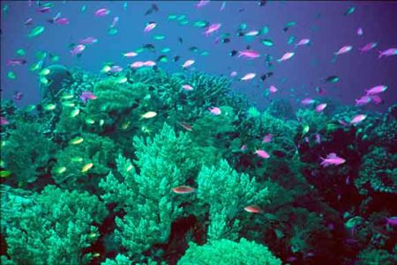
Disappearing coral reefs

To begin with, the coral reef ecosystems which is most vaunted in the Indo-Pacific region are a very fragile ecosystem. They are at the mercy of the powerful forces of nature prevailing in the region. In particular, earthquakes that cause tidal waves destroy square kilometers of coral reefs; seasonal typhoons or hurricanes obliterate shallow coral reef areas; and frequent volcanic activity in that region- famously known as the Ring of Fire-obliterate vast areas of reefs with ensuing tsunamis and pyroclastic flows. Despite the massive destruction from natural calamities, however, the most significant threat to coral reefs are still human activities, particularly near centers of civilization where vast areas of reefs have been destroyed beyond redemption by so-called infrastructure developments. Boundless construction of roads, highways and bridges, dams and hydroelectric plants, building and housing developments- have caused the sedimentation of coral reefs or smothered them altogether by altering salinity levels of reef habitats. In parts of the world where tropical rainforests exist, logging activities have caused the sedimentation of vast areas of coral reefs. Where forest cover has been obliterated, the resulting fresh water flooding of adjacent marine areas due to fresh water runoff has killed off thousands of hectares of coral reefs. Not to be overlooked are the equally damaging effects of industrial pollution, mining activities- especially open-pit mining- and poor land management and injudicious use of agricultural chemicals in agricultural areas. Also, in coastal areas where mangroves have given way to fishponds, enhanced reef destruction has been the outcome of sedimentation resulting from mangrove obliteration.

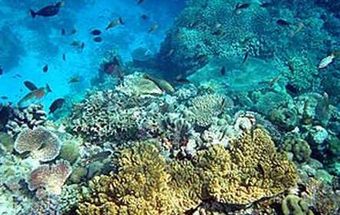
Decline of coral reefs
Often, people who are direct beneficiaries of a thriving coral reef ecosystem are also the perpetrators of their destruction. Indeed, popular magazines and scientific journals report about illegal fishermen who wreak havoc on coral reefs through the use of blast or dynamite fishing, poison, and other destructive fishing techniques such as the now-banned Muro-Ami and Kayakas (in the Philippines). Likewise, not to be exculpated are the sustenance fishermen who, in their struggle for survival, continuously scour and abrade the coral reefs for their own sustenance and in search for high-demand aquarium fish, live tropical food fish and other marine products.

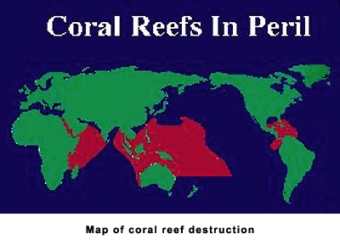

Coral reefs in the Philippines (and in other parts of the Coral Reef Triangle) are a major life support system for many coastal communities. When coral reef areas become endangered and are then declared protected, fishing activities may be suspended, thus tremendously impacting the fishing communities that traditionally depend on them. Ironically, creation of such marine protected areas does not necessarily close the area for tourism activities that also perturb the area in other ways.

