Environmental Awareness
A monthly publication of UP BETA SIGMA FRATERNITY, INTERNATIONAL, INC.

Centennial Forest Project Gets Award
December Issue
As the year 2008 draws to a close, many UPians will reflect on the legacy of their alma mater’s 100 years of blazing the educational trail. Many, likewise, will look inwards in search of meaningful ways to give back. In this issue, Brod Rene de Rueda writes about the very touching way in which the UP Visayas Beta Sigma Fraternity Alumni Association pooled its members’ creative juices to come up with a mind-blowing centennial “thank you” gift to a beloved institution. As it turns out, not only might the gift become a university treasure, it might also help reverse a global problem that is slipping out of control.
About the Author
Brod Rene de Rueda, UP Forestry Beta Sigma Batch ’64, formerly served as Undersecretary of the Department of Natural Resources, a professional forester, and consultant on forestry and environment; passionate in helping the upland poor; and happily married to Pilar from Cebu, good father to his 3 children and a happy "lolo" to his 6 grandchildren.

INTRODUCTION

The year 2008 is a very important period for the premier university of the country - THE UNIVERSITY OF THE PHILIPPINES. It is celebrating its 100 years of existence. It is therefore expected that the various UP campuses and/ or different organizations in the University, including our own UP BETA SIGMA FRATERNITY, will have their own projects that will highlight the importance of the University’s centennial celebration.

The UP VISAYAS BETA SIGMA FRATERNITY ALUMNI ASSOCIATION (UPVBSFAA) in its one of the “meetings of minds” in the year 2007 asked themselves what would be the best contribution of the fraternity to the centennial celebration of the University. They agreed on one project where they have a good track record at -- tree planting. They proposed a tree planting/ growing project, which was subsequently approved by the UP System. The UPV administration found the proposed project very relevant to the challenges facing the global communities, and solution to the needs of the future. It is called the CENTENNIAL FOREST (CENFOR) project. This is in response to the global concern on climate change and a noble contribution of the very people belonging to the “best brotherhood in the whole world” -- the UP BETA SIGMA FRATERNITY and which we in the UPBSFI, Inc. have adopted as one of its most important projects.

THE CENFOR PROJECT

The Centennial Forest Project may be considered as one of the most noble and ambitious projects in relation to the centennial celebration of our beloved alma mater. Both UPVBSFAA and UPBSFI, Inc. believe that the project will not only provide solutions to the problems brought about by climate change, but equally important is its lasting contribution to the local community and to our future generation. This is also in response to the dictum, which says, “think globally but act locally”.

The CENFOR project is located within the campus of the University of the Philippines in the Visayas (UPV) in Miag-ao, Iloilo. The UPVSFAA has reached agreement with the UPV administration to develop three hectares of its land for reforestation. The Fraternity will be the lead organization in developing the said area into a full-blown mini forest site, which ultimately will become a fully functional Forest Park. Considering that the project is a UP’s centennial project, it aims to plant some 100 species of mostly indigenous plants therein.

The expectation for the fraternity to be successful in the CENFOR project cannot be over emphasized mainly because the project site was

also the same site where three previous tree plantings of UPV had been undertaken but unfortunately failed. Hence, all eyes in the community are on the fraternity’s effort if it will be successful this time around.

As of now, the CENFOR project was able to develop about one hectare of tree plantation representing 25 tree species. The growth of the seedlings planted varies considerably, from those with very good growth with luxuriant foliage, to those that are hardly surviving. This can be attributed to the quality of the seedlings planted and the highly degraded planting site, considering that it was traditionally used as a grazing area by the local farmers. The area is now surrounded by improvised fence using indigenous bamboo materials and free from livestock grazing.

It has been impressed and duly acknowledged by the project implementers that the CENFOR project is not a simple case of tree planting but it is a continuing effort of tree growing until the trees reach a desirable development stage - a forest park, where people can commune with mother nature and experience the beauty of being surrounded by various plants and animals (e.g. insects and birds) species.

PARTNERS OF THE CENFOR PROJECT

There are about thirty listed donors who gave cash donations and materials for the project, e.g. plastic bags, seeds, seedlings, organic fertilizers. The nationally known foundation- the Luntiang Pilipinas Foundation, headed by Senator Loren Legarda has become one of the latest partners of the CENFOR project. The said foundation has acknowledged the timeliness and importance of the project particularly its mitigation and adaptation measures to the climate change and degradation of forest resources in the country. As a recognition for the project, the foundation has donated one thousand (1,000) seedlings of indigenous species of Narra and Kamagong. These seedlings will form part of the planting stock of the project during the planting season of the CY 2009.

The Honorable Julieta Flores, Mayor of Miag-ao, Iloilo, has acknowledged that the CENFOR project is the affirmation of her environment and tree planting plans for her municipality. She has good words for the project.

The UPVBSFAA – initiated CENFOR project has become a community project. Various schools, student organizations and private organizations, some of which are even coming from as far as Iloilo City, have been actively participating in the planting and or maintenance- related activities of the project.

The UP Beta Sigma Fraternity International, Inc. (UPBSFI, Inc.) and other countries has been a big motivation for the UPVBSFAA to implement, with determination and commitment, the various activities leading to the success of the CENFOR project. The invaluable assistance of these BROTHERS has always been an ingredient of the project’s success.

INITIAL IMPACT OF THE PROJECT

The CENFOR project is still in its infancy for its impact/s to be felt. The project however has not been spared from the ridicule and sneer from the pessimist groups in the local community. One possible reason was the three failed attempts to reforest the project site through tree planting. In retrospect, the prime movers of those previous activities failed to recognize that successful reforestation is not a one time affair of planting seedlings, but involves the continuing maintenance and protection, including the replacement of those seedlings failed to survive for various reasons, including but not limited to extended drought and trampling by the cattle that graze on the site. The farmer who illegally grazed his cattle in the area previously is now gathering grass/ forage for his cattle inside the fenced- plantation instead of having his livestock graze freely in the area. The same farmer has asked, and was given, four Nangka seedlings for planting in his own backyard. He now helps the project by driving out some of the illegally grazing cattle from the project site.

THE AWARD
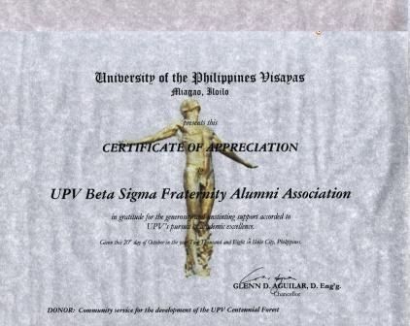

It could be said that the UPVBSFAA really deserves an award from the UPV administration. The proposal of the fraternity, as its contribution to the UP’s Centennial Celebration, was not only timely considering the global concern on climate change but was also the only proposal in the area of environment, and, as such, is considered a long- term project. In this project, the fraternity did not only bring into focus climate change- related issues but also practical and implementable solutions.

Hence, on October 20, 2008, at the Iloilo City UPV campus, the UPV administration through Chancellor Glen Aguilar, presented the Certificate of Recognition to the UPVBSFAA, through its President, Brod Yulz Alama, for spearheading a noble project as its contribution to the UP’s centennial celebration- the Centennial Forest (CENFOR) Project.

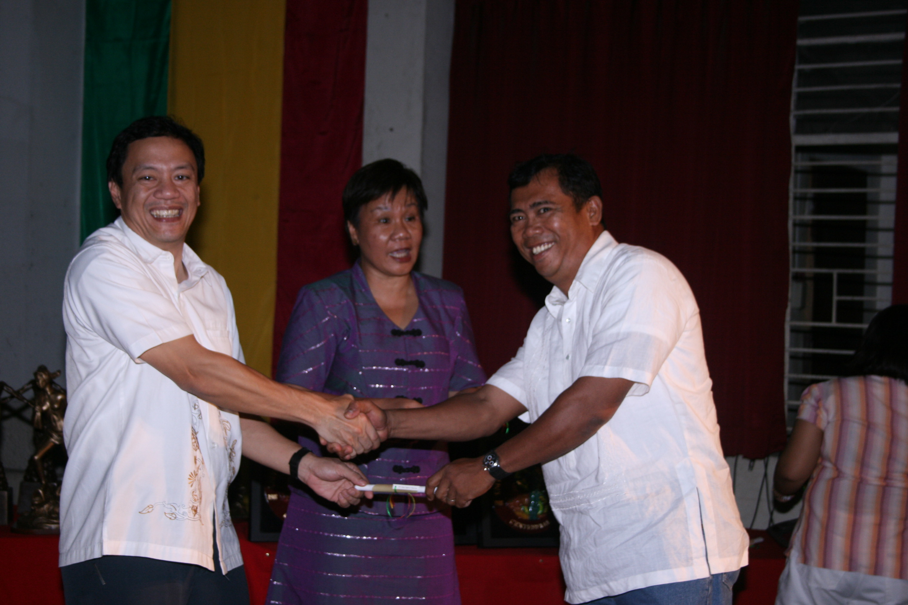
Brod Ulysses Alama, the President of the UPVBSFAA, receiving the award from UPV Chancellor,
Glen Aguilar on 20 October, 2008. The ceremonies were held at the Iloilo City campus of UPV.
(Report by Brod Taui Jamile)

THE CHALLENGES AHEAD

Establishing a tree plantation, much more a Forest Park, is definitely not an easy project. Moreover, the Philippine experience in tree planting/ reforestation by various groups, including the government, is full of frustrations, and mostly, characterized by failures. The reasons for such failures could be many, among others, destruction by fires, illegal grazing, vandalism, inferior quality of seedlings, improper observance of planting season, and extended drought. Project implementers should not only have the responsibility to accomplish the project’s various activities but should also have the required accountability, if the project experiences problems.

Tree plantation establishment demands a long term period (3-5 years) of maintenance and care and protection in order for the seedlings to grow healthy and be free from any agents of destruction. This means that the project implementers should have continuing passion and commitment, and of course the needed support, to see to it that the objectives and desired results of the projects are realized.

The experience from the project, whether short or long term, should always be a basis of learning for the implementers and its partners for better implementation strategy and solutions in the future.

The CENFOR project of the UPVBSFAA is definitely a very good project. However, it is not a one shot deal type of project. Hence it needs to focus on the multiple requirements for its success, including the active and continuing partnerships/collaborations from their old and newfound partners, but more so with their “Big Brothers” from the UPBSFI, Inc.

Once the 3- hectare project becomes a fully established tree plantation/ forest park, it can absorb an equivalent amount of 21 tons of carbon. In addition, it will also give out so much oxygen for our health needs, not mentioning the other environmental and economic benefits from the project.
The CENFOR is so important as a project and the role of the UP Beta Sigma Fraternity is so crucial for its success that “failure is not an option”.

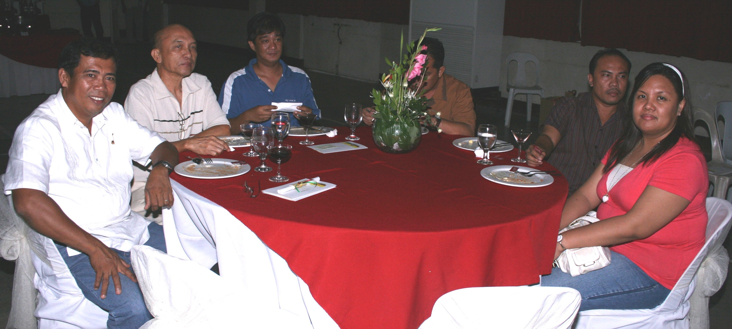
Brods Shan Buyco, Neri Perez and Yluz Alama.

NOTES:

- CENFOR has a separate website. Please visit http://centennialforest.wordpress.com under the stewardship of the UPV Beta Sigma Fraternity. It features interesting photographs, blogs, a complete list of private donors, and other interesting articles.
- Below please see a recent email from UPV Brod Taui Jamile to Brod Rene de Rueda regarding some latest details on the project.

Dear Brod Rene,
Here are the developments regarding our CenFor Site:

Weeding Activities. Weeding activities are being held regularly. Brods Yulz Alama ('89) and Prince Biñas ('92-B), both alumni members, as well as our two resident brods, Brods Joel Artajo and Sanny David Lumayno (both '07), have taken turns in the maintenance and cultivation of the seedlings planted in the CenFor Site. We have two neophytes undergoing non-physical initiation rites right now, and majority of their service is for the CenFor cause. We have finished weeding the kasuy, narra, and langka seedlings in front. Pili seedlings had also been weeded. We have started weeding the udling seedlings in the back and the makopa seedlings near the watering hole.

Tree-Planting Activities. The AIRSOFT-ILOILO City and AIRSOFT-MIAGAO spearheaded by Brod Wilmer Escuadra (CDC) had a tree-planting activity inside the CenFor Site last week of August. Just recently, Brod Noli Santua's (CPU) daughter, a student of Angelicum High Scool, led her class in visiting and planting in the site. The two neophytes have also planted various species of palm trees alongside the perimeter fence. Coconut trees were also planted around the watering holes.

Conditions of the Seedlings. About 10 sacks of basal organic fertilizers have been donated by Brod Andy Sibayan (UPLB). The seedlings seems to be growing just fine. Mortality, as of now, seems to be not a problem, this may be because of abundant rainfall. We replace seedlings that have withered with more mature seedlings. Hopefully, the seedlings could withstand the drought during the summer months.

Potting Activities. We will resume the potting activities this semestral break. We have received donations of narra and teak wood seeds. Brod Joel will be the one in charge of the potting activities. Our potting medium will be rice hull combined with clayish loam soil

Cattle Problem. There are still recalcitrant owners that let their cattles graze freely w/out being tied and do ambush grazing especially at night but they are few and far in between. Majority of the cattle owners have heeded our request for them not to leave their cattle inside the CenFor Site. But as they say, when the cat is away, the mouse will play. That is why. visibility/presence of the brods is maintained there in the CenFor Site (e.g. weeding, lecture of neophyte, planting, etc..) as deterrent for cattle owners.

By UPV Brod William“Taui” Jamile Jr.

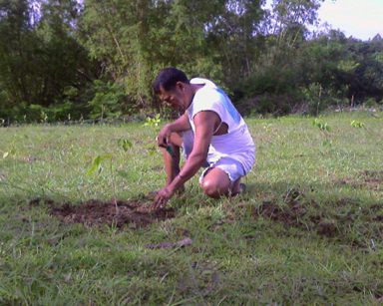
Brod Yluz Alama at CENFOR project site

