Environmental Awareness
A monthly publication of UP BETA SIGMA FRATERNITY, INTERNATIONAL, INC.

Geographic Information Systems
November Issue
Nowadays, the GPS (Global Positioning System) device has become the weapon of choice of many road warriors in navigating through the asphalt jungle. Interestingly though, even among the most adroit and inveterate GPS users, no more than a handful would probably know of its many other applications that impact the less mundane aspects of our lives. In this month’s issue of Environmental Awareness, Brod Jun Battad takes us on a tour of the “other side” of the GPS technology. A seasoned forester, Jun focuses his article on the use of the technology to enhance the judicious use of the earth’s fragile resources.
Gerry Abenes, Editor
About the Author
Brod Dionisio “Jun” Battad, UPLB 74d (The Lone Ranger Batch), has 18 years of experience in the applications of Geographic Information Systems (GIS) in natural resources management. Presently, he is a Senior Project Officer with the Department of Sustainability and Environment, Victoria, Australia. He is the Team Leader of a small multi-disciplinary group of GIS analysts, resource modellers and foresters.
Please more info about Jun at the bottom of the article.

And its Forestry Applications
In Victoria, Australia
By Dionisio “Jun” Battad, Ph.D.

With some initial hesitation, I decided to write about the Geographic Information Systems (GIS) upon the encouragement of Brod Willie “Tatang” Vergara. The GIS is rather technical and broad in scope and it will really take some effort to “laymanize” (to use Tatang’s terminology) this article for easier reading. What you see is, therefore, the result of best effort towards making this as reader-friendly as possible.

I have been a GIS user for almost 18 years now, and I’ve had to opportunity to teach the course in New Jersey, not to mention that this was my main field of study when I pursued my higher studies at the Texas A&M University. My extensive use of the GIS system includes my current job in managing the forests of Victoria, Australia.

What is Geographic Information Systems (GIS)?

GIS is a multi-billion-dollar industry employing hundreds of thousands of people worldwide. It is taught in schools, colleges, and universities throughout the world. Professionals and specialists in every discipline are becoming increasingly aware of the advantages of using GIS technology for addressing their unique spatial problems.

Originating from the fields of geography and environmental studies, GIS technology has branched out and is becoming popular in other fields of science.

A few examples of problems that can be solved with GIS are:

- A big fast food chain may want to know the best possible location of a new franchise
- A police district, with limited number of personnel, may want to prioritize patrol areas
- Farmers, in order to optimize the use of their land to increase production, may want to know the most suitable and best combination of crops to grow
- The fisheries bureau may want to locate and record abundance of fish resources
- A mining firm may want to locate mineral deposits and estimate the amount of minerals that can be extracted
- A telecommunications company may want to establish a new transmission tower and needs to find out the best location so signals can reach a wider area

In addition, information derived from GIS is becoming more readily available to the general public as technology becomes cheaper and more advanced. Many individuals are now enjoying the benefits of GIS-derived information in their everyday lives.

Some examples of the day-to-day applications of GIS are:

- Using GPS in our cars to provide direction to where we are headed, or determine the shortest ( more fuel efficient) route to our destination

- Using Google Earth find out about a particular point of interest

- Checking out the bus or tram stops nearest to where we are or our destination

- Checking out weather forecasts for places we are visiting

A geographic information system (GIS) is often defined as a computer-based tool for mapping and analyzing geographic phenomenon that exist, and events that occur, on earth. It comprises a set of tools for collecting, storing, retrieving, transforming and manipulating spatial data from the real world for particular purposes (Burrough 1986).

We commonly think of GIS as a single, well-defined, integrated computer system. Many users view it as a decision-support system for policy formulation and management. Some view it as made up of a variety of software and hardware tools – hence a toolbox.

What are the components of a GIS?
GIS integrates five key components: hardware, software, data, people and methods (Figure 1).

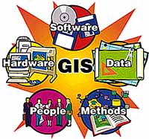
Figure 1. Components of a GIS system.

Hardware refers to the computer system on which a GIS operates. It is the physical system in which the GIS software operates. It ranges from centralized computer servers to desktop computers including printer, plotters or other systems associated with it.

The GIS software provides the functionalities to work with the geographic information. Currently, there is a variety of GIS software available and some of the leading systems (with their developers) are:

- ARC/INFO - Environmental Systems Research Institute (ESRI)
- ARCGIS – ESRI
- ARCVIEW - ESRI
- Geographic Resources Analysis Support System (GRASS) – US Army Corps of Engineers
- Idrisi – Clark University
- MapInfo – MapInfo Corporation

The Department of Sustainability and Environment (DSE), Victoria uses both ARC/GIS (which is PC-based) and ARC/INFO in a UNIX environment. For major spatial analysis work, we still rely on the latter.

The most important component of a GIS is the data – geo-referenced data and its related tabular data. Geographic data refers to two- or three-dimensional features, e.g. stand of forest, a piece of property, a stream network or a section of a road. The tabular data, often referred to as attribute data, are the description of the geo-referenced data, e.g. owner of a property, name of the road, height of a forest stand. An example of a 3-dimensional data is a digital elevation model or digital terrain model (DEM/DTM) – a digital representation of ground surface terrain or topography.

GIS technology is also of a limited value without the organizational context on which it operates - the people who manage the system and develop plans for applying it to real world problems.

GIS Data

GIS data contains both the spatial features and their attributes. The data must be geo-referenced, meaning it exists in terms of real-world map coordinates.

The spatial data in GIS comes in either in vector or raster format (Figure 2).

- Vector – Spatial data is stored or represented as points, lines or polygons. A line is made up of a series of points or vertices which has x- and y-coordinates. The intersection of 2 lines is referred to as a node. A closed feature made up of lines is referred to as a polygon. Attribute data is associated to a point, a line or a polygon.

- Raster/Image – In this data format, data is represented in a grid-cell structure where the geographic area is divided into cells identified by rows and columns. An attribute is associated to a cell.

In the GIS world, image data is often used interchangeably with raster data. It is used to represent graphic or pictorial data. These data include remotely-sensed imagery (satellite scenes, aerial photos, laser datasets) or ancillary graphics (photographs, scanned plan documents, etc.).

There are also other special types of spatial data in GIS. One of these is what is called Triangulated Irregular Networks (TIN in short). It is also used to represent 3-dimensional data and it consists of a network of triangles or facets.

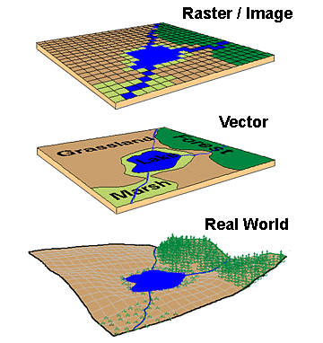

Figure 2. Various GIS data formats.

Some Forestry Applications of GIS in Victoria, Australia

The following provide a brief description of how we use GIS in forestry within the Department of Sustainability and Environment (DSE). The technology is used widely within the organization for a variety of purposes like salinity management, carbon accounting, etc. However, these are beyond the scope of this short introduction to the technology.

- Strategic Forest Planning

The ability of the forests to provide long-term multiple benefits for society depends on how well it is managed. Effective forest management is based on sound planning. A good plan depends on the quality of information it is based upon and from which decision making for its variety of uses is made.

Forestry today is becoming more complex as people begin to realize its variety of uses. Carbon and water storage, protection from soil erosion, water yield and recreation are just a few of the benefits we get from forests aside from timber.

The Sustainable Forests (Timber) Act 2004 provides the basis for sustainable forest management in native forests in the State of Victoria.

Under the Act, DSE through the Forest Resources Branch, is responsible for forest regulation and strategic forest planning. VicForests, a State-owned corporation, is responsible for commercial harvesting and sale of timber from State forests.

One of the instruments by which DSE implements strategic forest planning and regulates VicForests is through an Allocation Order. The Allocation Order is reviewed every 5 years and specifies the area of forests that VicForests can harvest in any five-year period.

We use an integrated modeling system for strategic forest planning. A brief description of the process is shown in Figure 3. The system is like a “tool-kit” in which the various components are linked together by a common data format. One of the advantages of this “loose” linkage is the great flexibility in adding new components to the system.

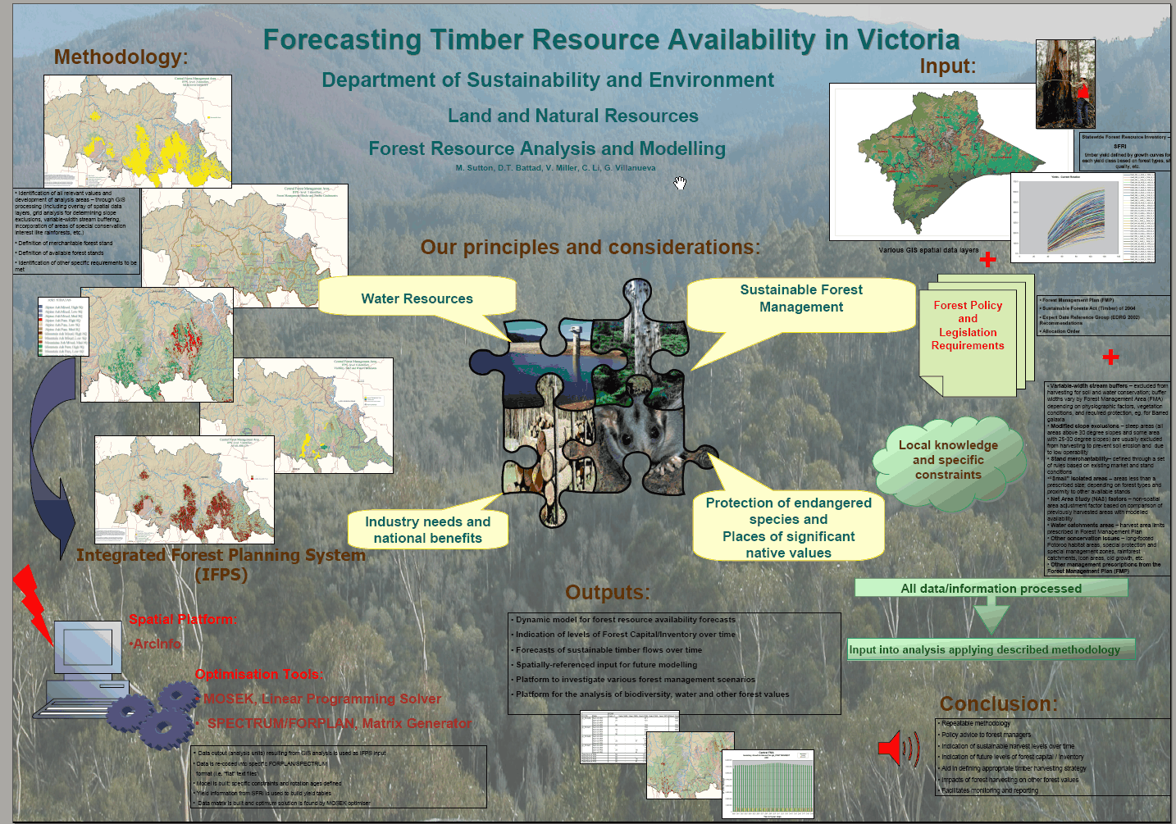

Figure 3. A general description of how we undertake strategic forest planning.

The main components of the system are the Woodstock modelling system (developed by Remsoft, Canada), ARC/INFO GIS, and Mosek linear programming system. We use GIS to create the land base which is used as the spatial input to Woodstock. The land base provides a description of the forest (forest types, etc.) and what areas are available for timber harvesting.

Growth and yield data (sawlog volume for each forest) is also coupled with the spatial data in Woodstock. Each stand of forest has a yield curve/table associated with it and provides the volume of the forest as it grows from a young age until it is ready for harvest (Figure 4).

Figure 4. Illustration of a family of yield curves used in Woodstock models.

As in any modeling system, model constraints are also used. The constraints guide how the modeling/analysis is undertaken, determines priorities for harvesting, etc. For example, one constraint is to apply a limit to the area of forest that can be harvested annually in the water catchments.

The Woodstock model optimizes the volume of sawlog harvested over time (we refer to this as the “objective function”). Woodstock uses the Mosek linear programming module to look for a solution for the objective function, subject to the different modeling constraints. Woodstock uses the area, constraints, yield curves/tables to schedule tracts of forest areas to harvest and estimate the volume from these harvested areas. A schedule of harvest is created throughout the entire length of the forecast, e.g. 200 years, and the volume of timber harvested is also estimated. (Figure 5). The spatial location of the areas harvested is also an output from Woodstock.
Figure 5. Summary of harvest levels for Ash species derived from a Woodstock model output.

Results from the modeling are then evaluated. The Allocation Order for VicForests is developed from model outputs which satisfy sustainability criteria as well as meet their license commitments (Table 1).

Table 1. Example of an Allocation Order created from Woodstock model outputs.
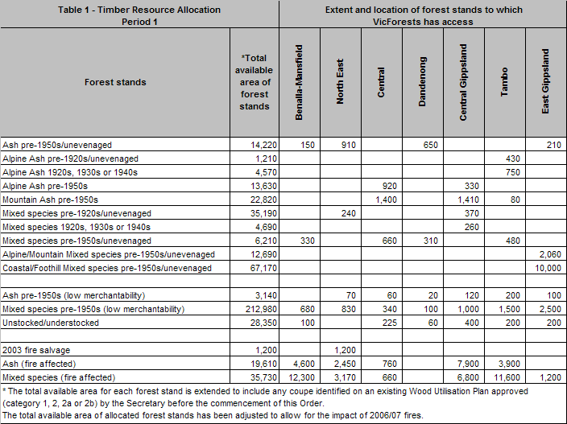

B. Forest Resource Assessment

GIS, when coupled with other systems or technology, can be used to get a better understanding of the complexity of Victoria’s forests. Traditional forestry methods involve laborious collection of data on the ground and require several experts and a number of personnel. GIS made this process simpler and cost effective.

From the traditional manual and field inventories of forest resources, GIS and remote sensing technologies are being used together to come up with accurate information about forests such as forest types, kinds of trees, timber volume per unit area, height of trees including structure of forests.

An example of a technology we recently trialed is the use of light detection and ranging technology (LiDAR). LiDAR is similar to the radar and sonar (I assume that most of us are familiar with them). Instead of sending and receiving sound or radio waves to capture data, LiDAR uses high intensity light or laser.

A light generating equipment is usually is based in an airplane. As the plane flies over a target area, it sends out light waves that hit a rotating mirror. The mirror directs the light and as it rotates, it sweeps the ground (Figure 6). The light, when it hits a solid object, is reflected back to the sensor. Since we know the speed of light, the time when the light was sent and the time it was reflected back, the distance to the object can be estimated. The sensor detects numerous returns and also the intensity of light that is bounced back. The intensity of the light bouncing back helps to identify the kind of object on the ground.

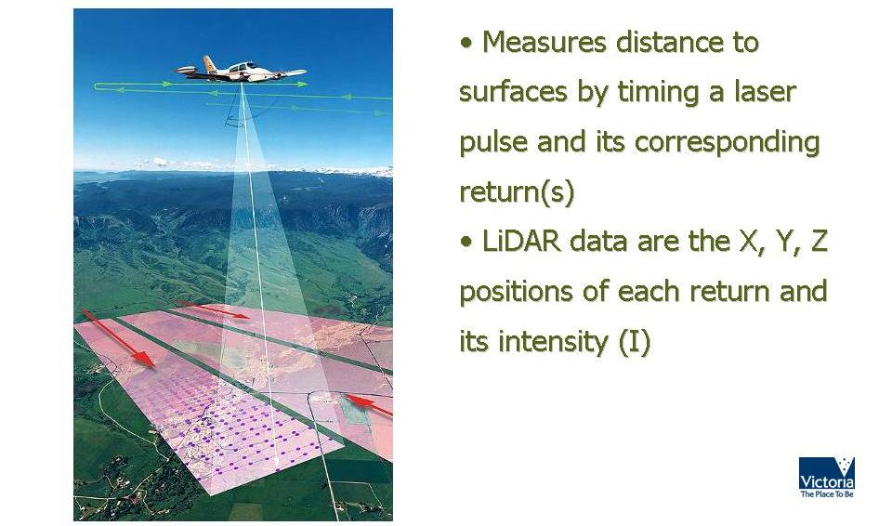

Figure 6. Illustration of how LiDAR data is collected.

The LiDAR data is a set of random points. Each point has its location on the surface of the earth (x- and y-coordinates), its z-value (elevation/height) and its intensity. GIS spatial modeling techniques are then used to process the LiDAR data.

One forestry application of LiDAR data is to analyse forest structure (Figure 7). High resolution LiDAR can be processed also in GIS to delineate the canopy surface (forest crown), individual tree crowns, determine height of trees, identify tree locations and for stand visualization.

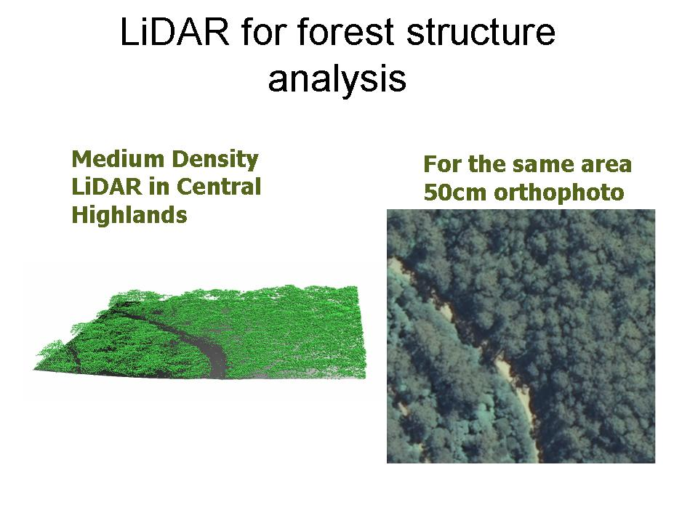
Figure 7. Forest structure derived from LiDAR data using GIS.

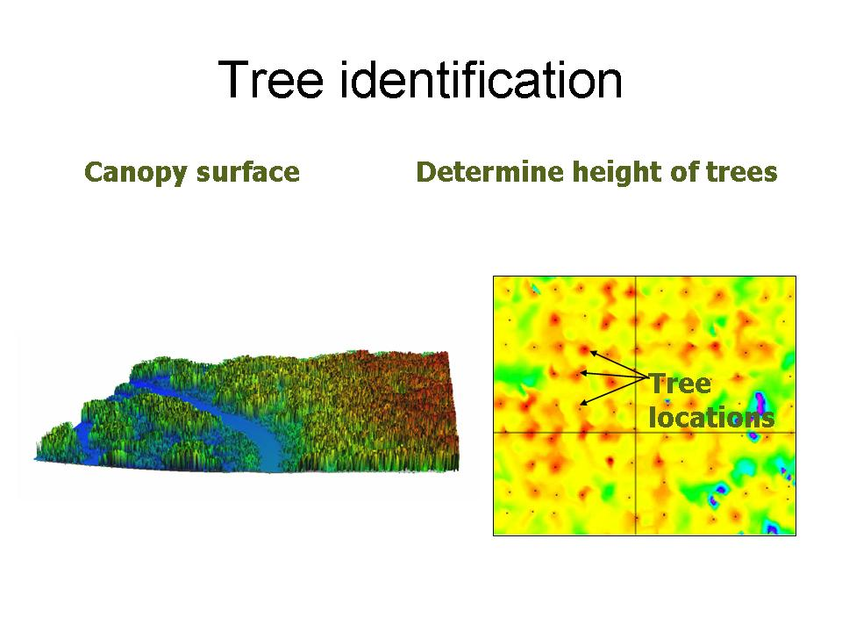
Figure 8. Tree height derived from LiDAR using GIS.

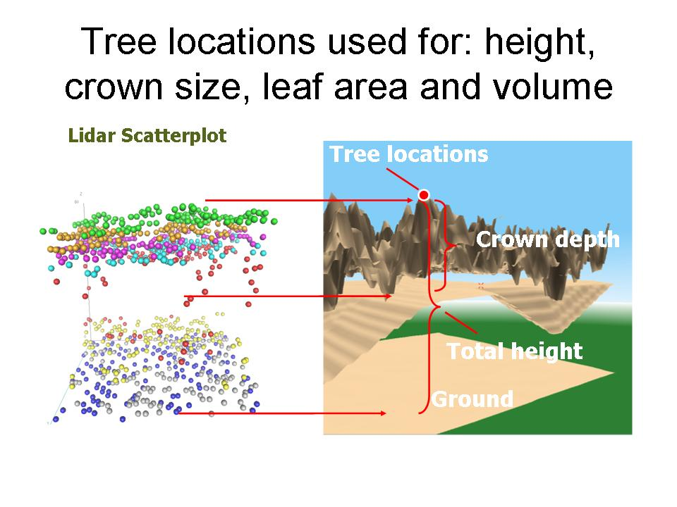
Figure 9. Stand characteristics derived from LiDAR using GIS.

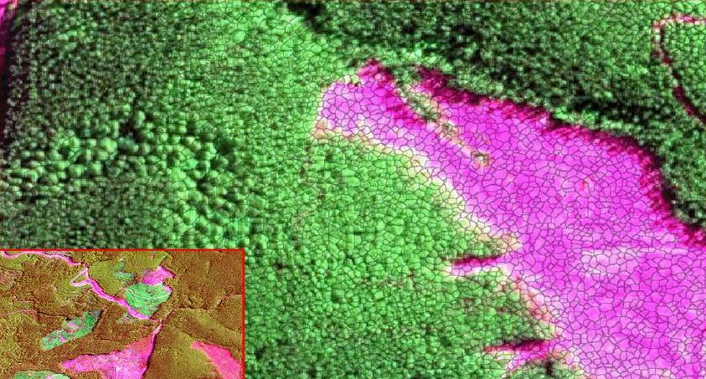
Figure 10. Visualizing forest stand structure derived from LiDAR data using GIS.

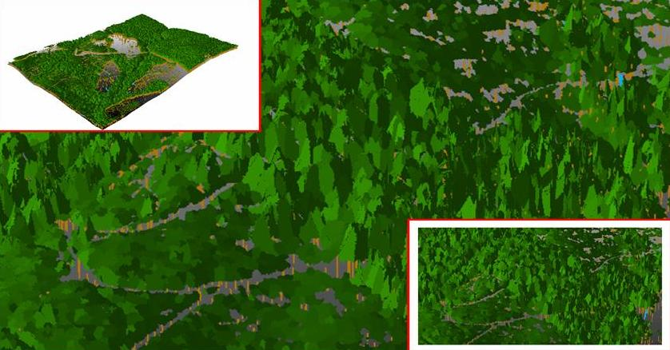
Figure 11. Another scene of the forest structure derived from LiDAR data using GIS.

C. Watershed Management

We are also using GIS to predict water yield from the catchments (watersheds) surrounding the City of Melbourne. With climate change, the Melbourne community is becoming more concerned about future water supply. People want to know how harvesting and other activities in the catchments impact its capability to provide water supply for the future.

In the past year, we have used GIS, together with the Woodstock modeling system, to assess the impacts of several forest management options on water yield and sustainable timber harvest levels in some of the water catchments that supply water to the city of Melbourne (Figure 12).

We coupled the Macaque water yield model, developed by the University of Melbourne, with GIS and the Woodstock modeling system to provide us the capability to forecast the impacts of changing harvest rotations (the number of years required to establish and grow trees to a specified size, product, or condition of maturity) in the catchments. We also assessed the impacts of reducing harvest levels through time as well as the complete cessation of any forest harvesting within the catchments.

The Macaque water yield model, a water yield simulation model, uses the very simple water balance equation (Rainfall = Water Yield + Loss). One of the outputs of the Macaque simulation model is a set of water yield variables which we then translated spatially using GIS. We took into account the vegetation types, topographic properties, water yield parameters, etc. to recreate water yield curves (Figures 13 & 14). The spatial data and the water yield curves were then combined in Woodstock with the timber yield curves. Woodstock was then used as the platform for assessing the impacts of the different forest management options.

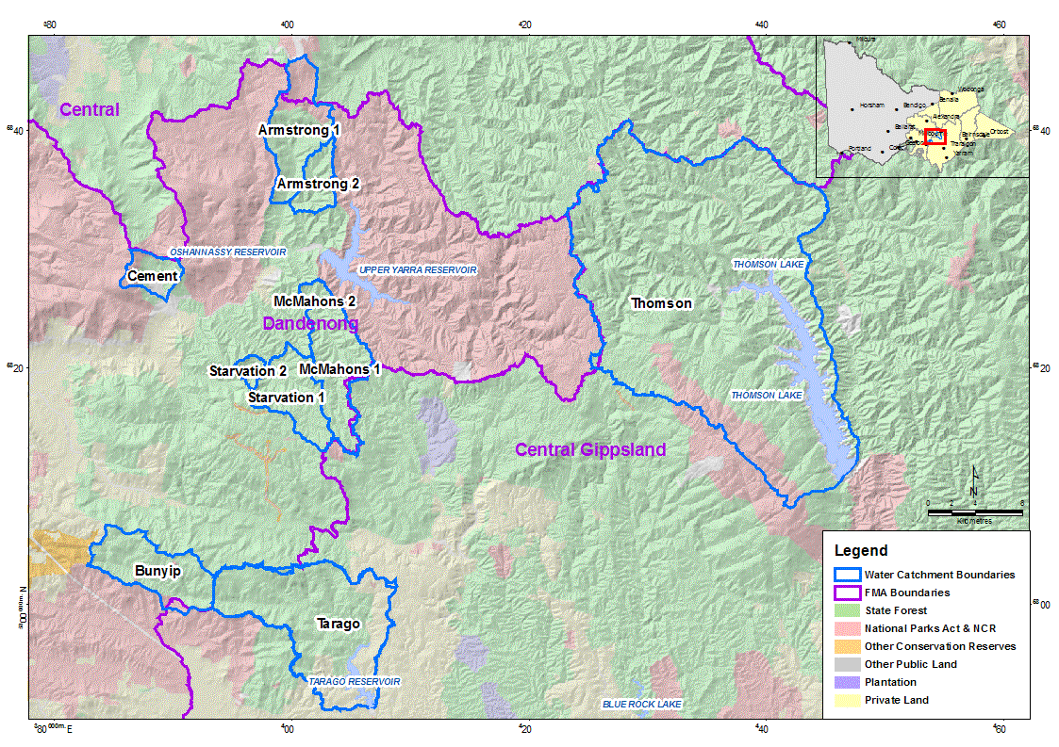
Figure 12. map showing the water catchments of the City of Melbourne, Victoria.

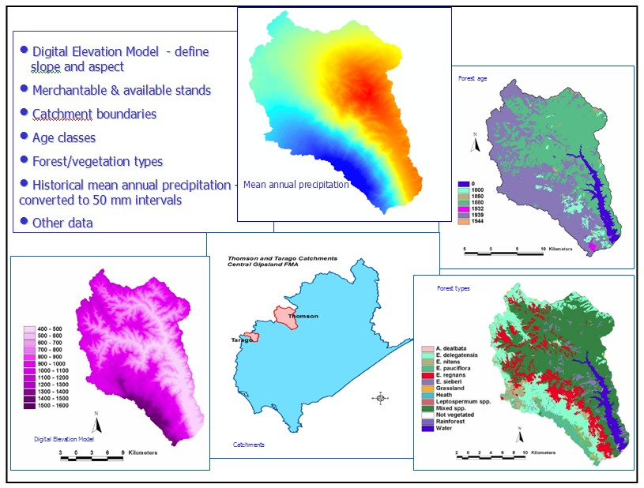
Figure 13. Some of the spatial data used in creating water yield curves.
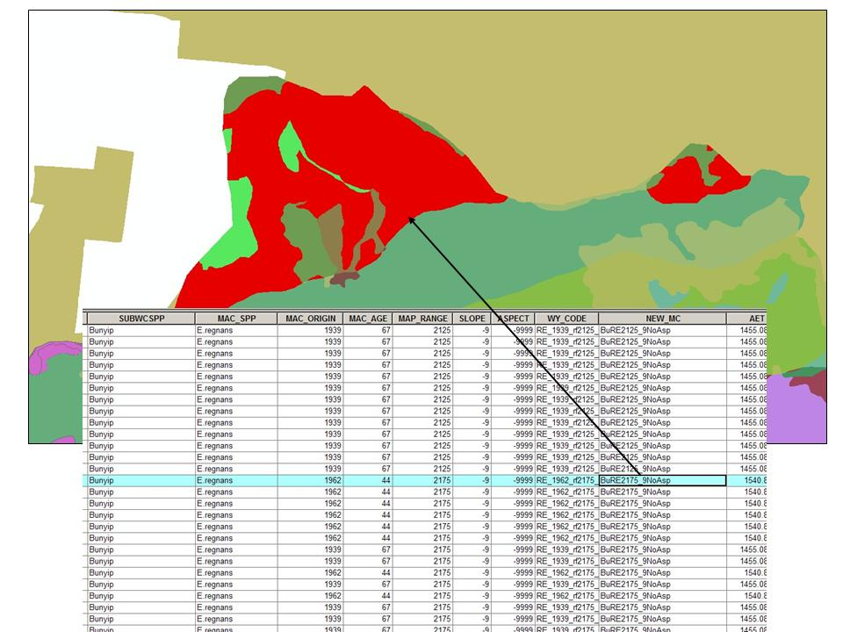
Figure 14. Illustration of the spatial data created in GIS used as the land base for the modelling (with the water yield curve attached as an attribute of a polygon).

Results of the analyses were used to provide policy advice to senior management (Table 2 and Figure 15). A paper on the modeling work was presented during Australian-New Zealand Institute of Foresters conference last year.

Table 2. Sample output from the analysis.
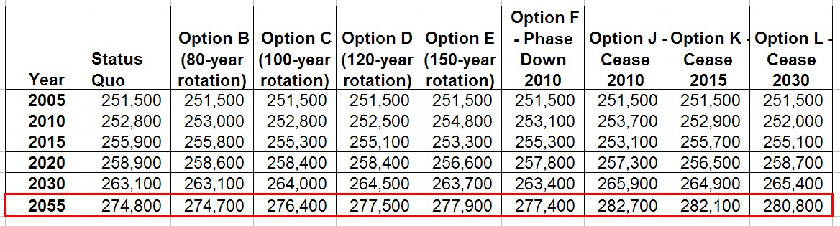

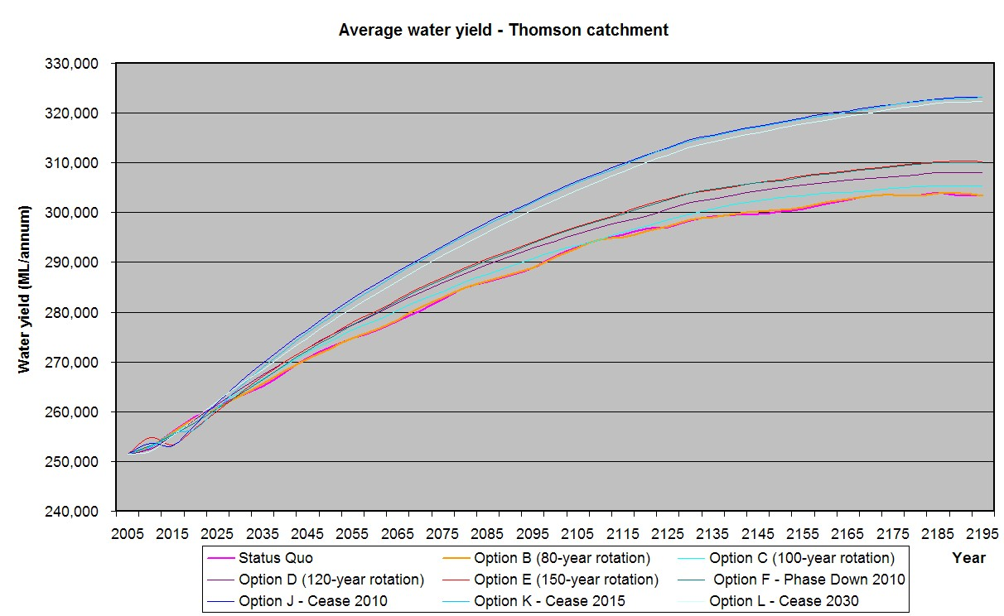
Figure 15. Comparison of the water yield impacts of the different forest management options.

D. Conservation of Biodiversity

Victoria puts a lot of emphasis on the conservation of its rich biodiversity to balance the overall use of its forest resources. Australia, being isolated from the rest of the world, boasts of different plants and animals that cannot be found anywhere else. Eighty percent of marsupials or “pouched mammals” and eucalypt trees are found only in Australia.

To facilitate biodiversity conservation planning, a forest management zoning dataset was developed to manage properly the State’s land resources. This dataset provides information about areas for biodiversity protection outside national parks. Forests which are identified as habitat for rare and endangered plant and animal species are exempted from timber harvesting. Other physical factors such as slope and stream buffers including sites with historic and socio-cultural significance are also protected.

GIS is used to develop and update the forest management zoning dataset. Within public land estate, State Forests are further subdivided into 4 major categories:

- General Management Zones - areas managed for a range of forest uses and values, with timber production a major use.
- Special Management Zones – areas managed to conserve specific features, while catering for timber production and other uses under certain conditions.
- Special Protection Zones – areas managed for conservation and timber production is excluded.
- Code of Forestry Practices – these are 20-meter buffers along streams and areas with slopes greater than 30 degrees that are exempt from timber harvesting.

GIS is also used to map other conservation areas for the protection of threatened species (Figure 16). These areas are then added to the Special Protection Zones.
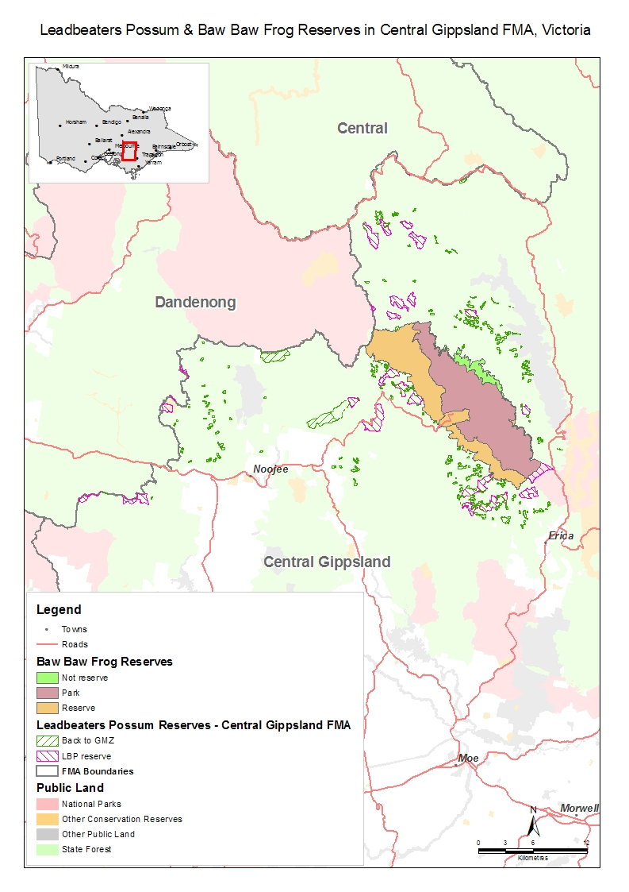
Figure 16. Map showing the habitat of threatened species, Baw Baw frog and Leadbeaters possum.

Summary

GIS is a very important technology, not only in forest resources management, but also in other fields that deal with spatial data. The importance of GIS is further magnified when it is used to assess the impacts of various forest management activities and when combined with other technologies like simulation models, remote sensing, global positioning system, expert systems and decision-support systems.

References

D.T. Battad, G. Villanueva, C. Li, V. Miller, M. Sutton. 2008. (Unpublished project report) Impacts of Timber Harvesting on Water Yield in the Central Highlands, Victoria.

D.T. Battad, G. Villanueva, C. Li, V. Miller, M. Sutton. 2007. Assessing the Impacts of Timber Harvesting on Water Yield in the Central Highlands, Victoria. The 2007 Institute of Foresters of Australia and New Zealand Institute of Forestry Conference, Coffs Harbour, NSW, 3-7 June 2007.

Battad, D., Li, C., Lau, J.. 2004. Application of spatial modelling techniques to extract forest stand structure from LIDAR (Light detection and ranging) data, 12th Australasian Remote Sensing and Photogrammetry Conference, Oct. 2004, Fremantle, WA

Burroughs, P.P. & McDonnel, R.A. 1998, Principles of GIS, Oxford University Press.

DSE, Allocation Order to VicForests Order – 2007 Amendment.

DSE, Sustainable Forests (Timber )Act 2004.

Environmental Systems Research Institute (ESRI), What is ArcGIS 9.2? Redlands, CA.

Hayward, A. Mapping forest structure across the landscape using sample plots and airborne laser scanning data (DSE presentation), 2008.

The MOSEK optimization tools manual. Version 5.0 (Revision 93), Mosek Aps, Denmark.

Woodstock 2004. Modelling Reference, Remsoft, Canada.

About the Author
Brod Dionisio “Jun” Battad, UPLB 74d (The Lone Ranger Batch), has 18 years of experience in the applications of Geographic Information Systems (GIS) in natural resources management. Presently, he is a Senior Project Officer with the Department of Sustainability and Environment, Victoria, Australia. He is the Team Leader of a small multi-disciplinary group of GIS analysts, resource modellers and foresters (It is also multicultural as the other members of the team are immigrants from Russia, China, and Peru). The group uses specialized computer technology to assess impacts of management policies on natural resources. He has a BS and MS in Forestry from UPLB, both under a Bureau of Forest Development Scholarship grant. He completed his Ph.D. in watershed management and GIS from Texas A&M University.
He had 12 years of work experience with the Department of Environment and Natural Resources, Philippines. He was mainly involved in conservation project management. Just after graduation from UPLB in 1978, he managed the Bongabong Reforestation Project in Oriental Mindoro. He was a Senior Forest Management Specialist and also the Project Manager of the Asian Development Bank–financed Third Davao Irrigation Project-Soil and Water Conservation Component in Davao del Norte until he left the Philippines to pursue his advanced studies in 1989 at Texas A&M University as an exchange scholar.

After completing his studies, he worked as a Visiting Assistant Professor of Environmental Studies at The Richard Stockton College of New Jersey. He taught GIS, remote sensing, ecology and environmental science. In 1999, he was recruited and sponsored by DSE to work and migrate with his family to Australia.

He is happily married to a UPLB Sigma Betan (Yeyet Moral). They have 2 grown-up children. Their son is soon to complete his Ph.D. in Biochemistry at Monash University, Melbourne while their daughter is an IT Analyst with the federal government in Canberra, Australian Capital Territory.

He is a GI (Genuine Ilocano) from Magsingal, Ilocos Sur and is the youngest brother of Brod Vicente ‘Vic” Battad (UPLB 68A).

