Environmental Awareness
A monthly publication of UP BETA SIGMA FRATERNITY, INTERNATIONAL, INC.

The Coral Triangle
October Issue
The cradle of the world’s marine animal species is the focus of this month’s issue of Environmental Awareness. The author, Brod Popoy Castaneda is a professional diver, self-made marine explorer, environmentalist, and a former aide to Jacques Costeau. His colorful depiction of his encounters with the many stunning marine wonders, like the one described in this issue, continue to inspire people to be wardens of our fragile world.

About the Author
At this point, Brod Popoy Castaneda needs no introduction. All one has to do in order to appreciate the depth and breath of this topic of global marine resources is to read his other works in this monthly publication.
By Popoy Castaneda

The world’s highest concentration of marine species occurs in the Southeast Asian - West Pacific region dubbed as the Coral Triangle. Encompassing the seas of eastern Indonesia, parts of Malaysia, the Philippine Islands, Papua New Guinea, Timor, and the Solomon Islands (see map below). The Coral Triangle is the world’s center for marine biodiversity. This expanse of marine waters covers an area of approximately 5.7 million square kilometers.

Eighty percent of all coral species and 50 percent of all reef fish (an estimated 3,000 species) inhabits the coral reefs of the Triangle - more than five time as rich as that of the Caribbean. Also, the Coral Triangle is inhabited by approximately 150 million people of whom 2.25 million are fishermen who are dependent on marine resources for their livelihood and subsistence. Most fish and other marine animal species - from shrimps, lobsters, shells, marine worms, starfishes and other micro marine animals (generally called invertebrates) - inhabiting the entire Indo-West Pacific have existed for more than forty millions years, but, the area where marine species diversity currently peaks looks far different forty million years ago. Back then, what are now the islands of the southern Philippines, Indonesia, Malaysia and New Guinea were widely spread on four separated tectonic plates. However, in the last 40 million years, the Pacific, Philippines, Indian Australian and the Eurasian tectonic plates have been thrust together forming the conglomeration of islands and coral reefs that are now the Coral Triangle. Thus, fishes and marine invertebrates that had evolved in habitats isolated from one another have amassed in the triangle.

In broad geographical terms, the Coral Triangle includes portions of two biogeographic regions and encompasses East Timor, Indonesia, Malaysia (Sabah), Papua New Guinea, Philippines and Solomon Islands. Indonesia and the Philippines together hold a massive 77% of the regions' coral reefs.

Marine scientists also look at the Coral Triangle, not just as an area where different marine species have aggregated, but also as the source of the world’s ocean’s species diversity. Studies by different marine scientists point to evidences that the Coral Triangle is the area where many coral reef species have originated and dispersed all over the world.

There are other factors contributing to the richness of species in the Coral Triangle, one of which is that during the movement of tectonic plates, the sea levels have risen and fallen with the periodic warming and cooling of the earth. When sea levels fall, barriers are formed such as land bridges, preventing species dispersal through the world’s oceans leading to the evolution of new species. Then, as sea levels rise, the land barriers are inundated and disappear-expanding the marine habitat and allowing the genetically different marine species to mix again.

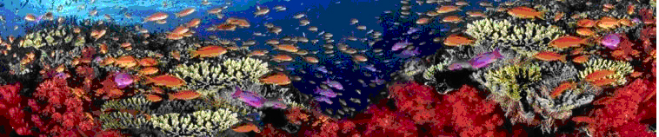

Another vital factor in the Coral Triangle’s richness in marine species is the number of habitats and habitat types available. Inundated daily by the tides, extensive areas of mangrove forests not only support mature marine species but also serves as a nursery for juvenile coral reef fishes and invertebrates. Sea grass beds also serve as nurseries, feeding grounds and habitats for coral reef species, and nearby lagoons and estuaries offer protected habitats for large reef fishes. The corals themselves are also responsible for the rich species diversity in their locality. The three-dimensional honeycombed structures of coral reefs add to the multifaceted diversity of shelters and habitats, thus supporting the greatest number and variety of fishes and marine invertebrates.

Another factor responsible for the coral reefs’ diversity is the warm and tepid tropical waters of the seas in the Coral Triangle with virtually no seasonal variations. Life goes on without environmental restrictions, reproduction occurs without any seasonal variation.

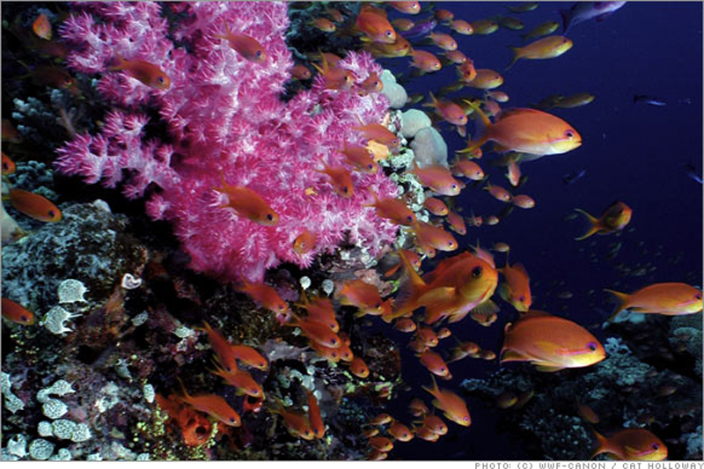

The diversity of marine life in the reefs at the Coral Triangle is further augmented by the profusion of symbiotic or close relationship between species. Observing reef life, one cannot help but notice close and interdependent associations between anemone fish and sea anemone, cleaner wrasses cleaning larger fishes of parasites, and shrimps seeking protection and habitat inside giant tridacna clams.

The diversity of reef species in the Coral Triangle has attracted the attention of marine scientists from all over the world. In the Philippines, which is at the apex of the triangle, an area is now the focus of attention of marine scientists. Early last year, Dr. Kent Carpenter, a marine scientist of the IUCN ( International Union for the Conservation of Nature and Natural Resources) initiated a study of the reef life of the Verde Island Passage, the strait that separates Mindoro Island from Luzon, to verify the theory that the area is the “hotspot for reef life diversity in the Coral Triangle”. This means that while the Coral Triangle has the highest diversity in reef species all over the world, the Verde Island Passage, specifically in the vicinity of Verde Island, has the highest species diversity in the Coral Triangle.

Dr. Kent Carpenter used to be a Peace Corps Volunteer with the Coral Reef Project of the then Ministry of Natural Resources.

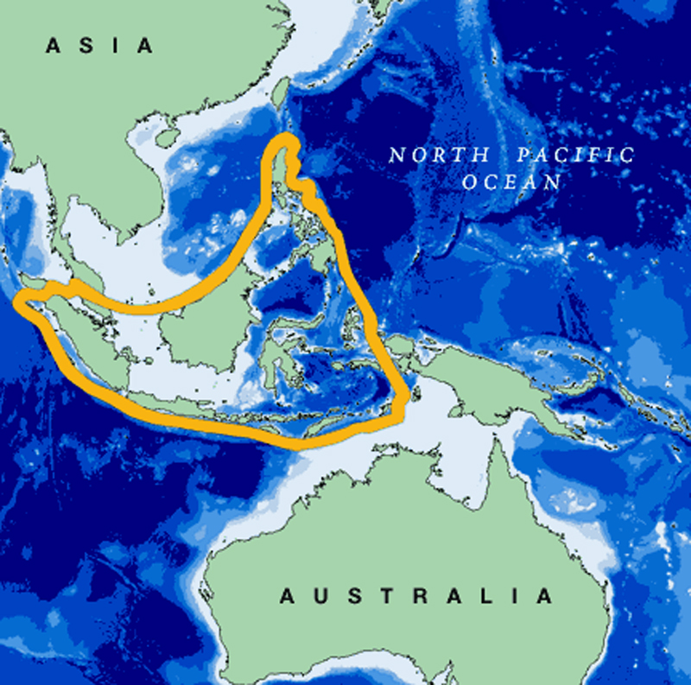

Coral reefs and other marine habitats within this region are severely threatened by human activities. Over 150 million people live within the Coral Triangle, of which an estimated 2.25 million are fishers that depend on marine resources for their livelihood. The most pervasive threats are overfishing, threatening 64% of Southeast Asia's reefs, and destructive fishing practices, threatening two-thirds of the reefs in the Philippines, Malaysia and Taiwan, and 50% of the reefs in Indonesia. Sedimentation and pollution associated with coastal development and changes in land use also put 37% of the regions reefs and marine habitats at risk. This will be the subject of another article sometime next year.

