U.P. Beta Sigma Fraternity
Diliman Residents Chapter
Martial Arts Festival
U.P. Gym, Diliman
July 10-13, 2012

Submitted by: Freddy Fajardo, UPLB’64

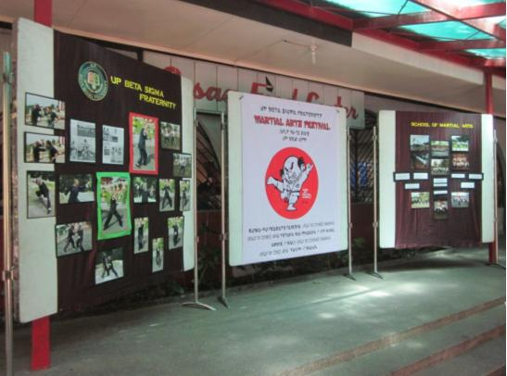
Martial Arts Photo Exhibit at the CASAA Food Court lobby, UP Diliman.
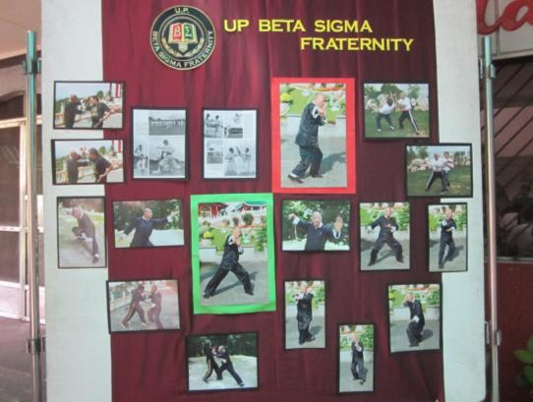
From as early as 1960, the fraternity's vaunted skill in martial arts has been widely recognized in the campus. Beta Sigmans studied in the fraternity's School of Martial Arts (SOMA). Brod Johnny Chiuten supervised and took over the leadership of the UP Beta Sigma Kung-Fu Karate Klan. Johnny studied kung-fu under the legendary master, Lao Kim. Through the years, Johnny has developed his own brand of martial art, a style he developed as a result of his extensive training in aikido, karate, arnis, and different Chinese Kung-Fu styles-Hung-gar, Tai Chi, Dragon-Tiger, and Praying Mantis.
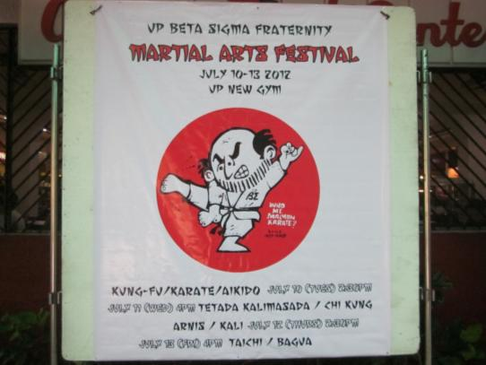

To date, the art and craft of Johnny Chiuten continue to live in the fraternity. The martial arts system is now called the Johnny Chiuten Pronus-Supinus School of Martial Arts, or JCPS_SOMA for short.

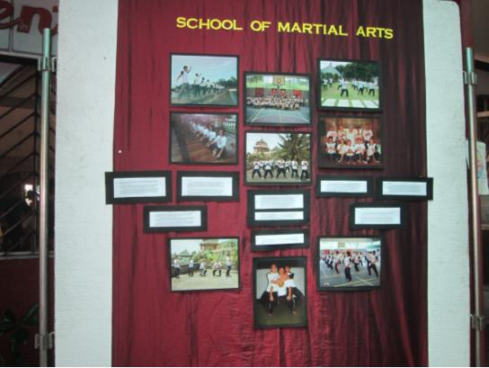
The practice of martial arts in the UP Beta Sigma Fraternity instills among its members the values of restraint, patience, perseverance, and discipline. Further, the training aims to impart self defense skills, good health and longevity, as well as the ethical philosophy that is the foundation of the Oriental martial arts.
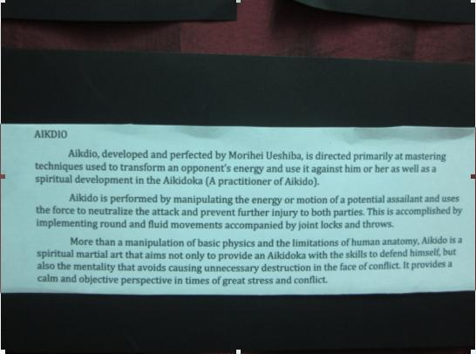
Aikido Presentation- July 10, 2012

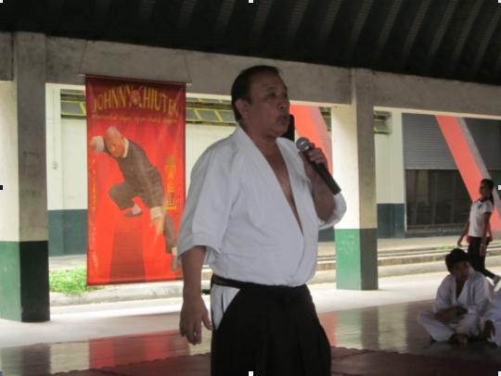
Brod Ernie Talag '64 was trained in aikido by Koichi Tohei. He is the Founder and Chief Instructor of Ki Association International. He is a Representative of Aikido Yuishinkai International of Japan and former faculty member of the College of Holy Spirit. As a recognized expert in aikido, he teaches aikido in the following agencies: Police Tactics, Manila Police Department; ISAF; SWAT-BJMP; PDEA; and conducts training for UP Ki Aikido. It was him who trained Brod Dolf Pinlac in aikido in the 60's.

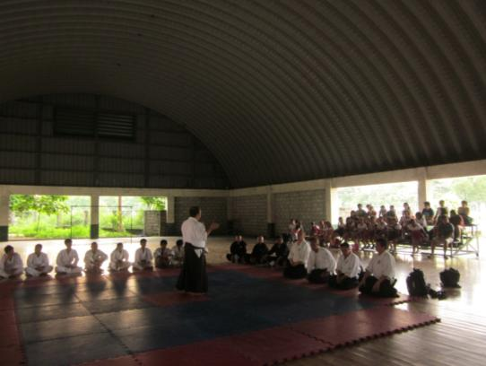

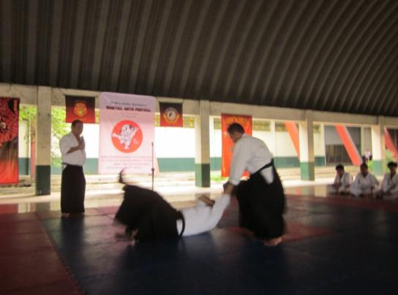
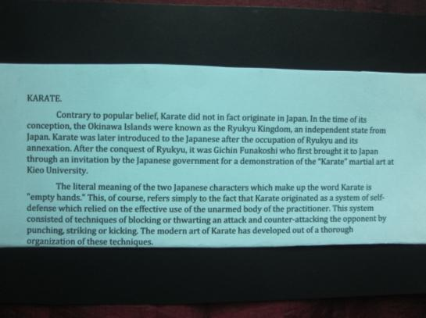
Karate Presentation- July 10, 2012

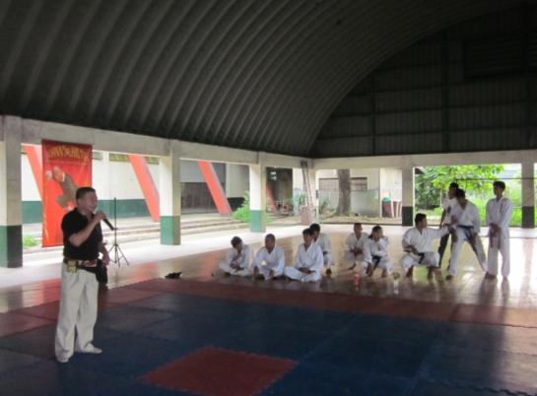
UPLB Brod Bing Lijauco '71, Okinawa Shorin-Ryu Karate Association 3rd Dan, Balck Belt, delivers his lecture. Brod Bing, together with Brod Freddy Fajardo, are the pioneer karatekas of the Black Shizuko SOMA at UPLB organized by Brod Noli Nolasco in 1972.

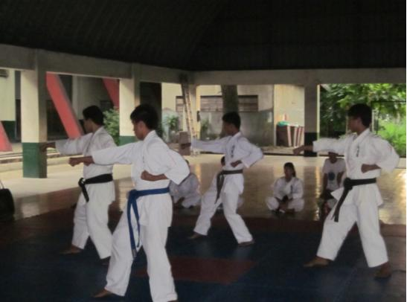

Synchronized Kata being performed by the Santa Rosa Educational Institution SOMA
karatekas of Brod Bing.

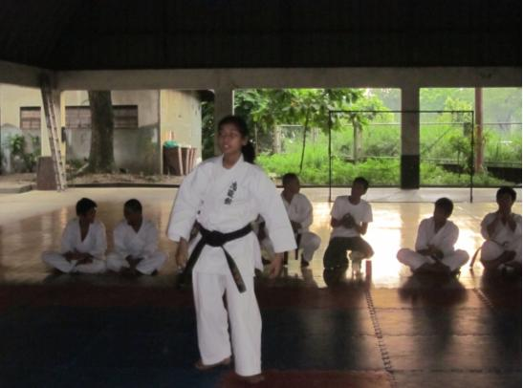

Marian Angelique performs the Shidokan kata called Koryu Pasai, an ancient form
resurrected by Hanshi Katsuya Miyahira

.
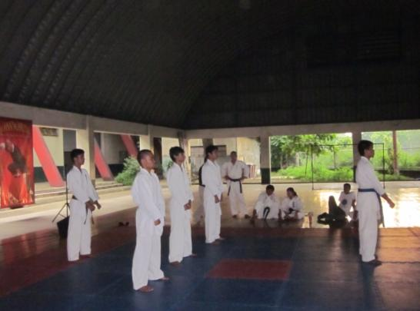

Three UPLB resident brods (white belt), with SREI SOMA karatekas, prepare to
demonstrate a pinan.

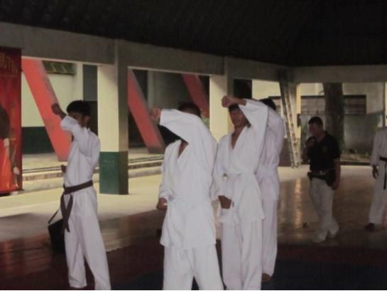

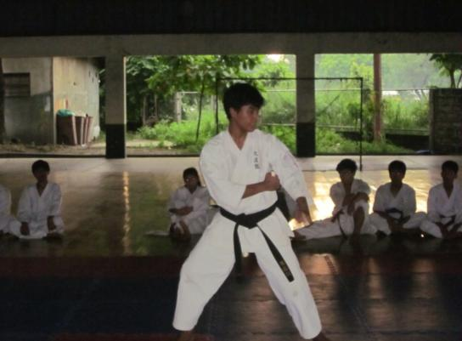

Shidokan kata called Chinto by Mark Angelo Dimailig which makes use of the
one-legged crane stance.

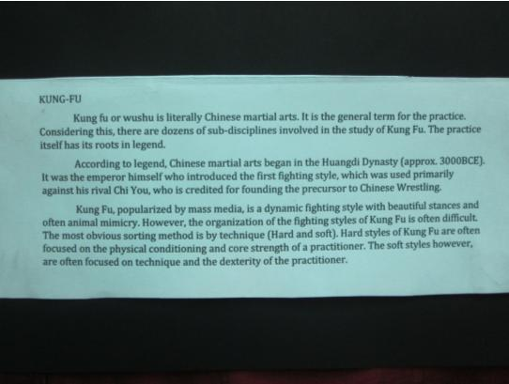

Kung Fu Presentation- July 10, 2012

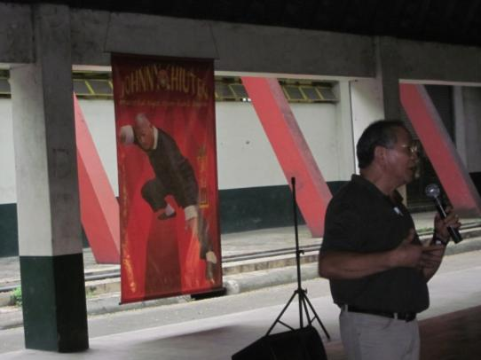

Kung Fu lecture by Brod Jopet Laraya. While achieving scholastic honors at the UP College of Veterinary science, he seriously honed his karate skills. Throughout his student life, he was one of Johnny Chiuten's loyal instructors and students. When he migrated to Canada, he established his Kung-Fu school. He continues to engage actively in Martial Arts as an instructor and a proponent of the formidable style as "Lapunti Arnis de Abanico."

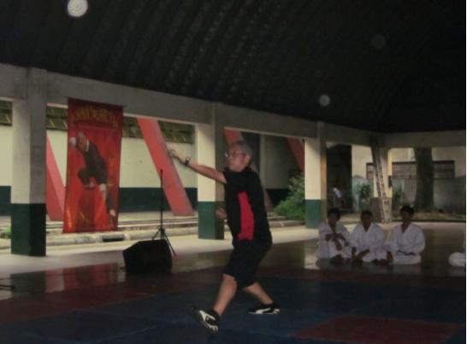

Sifu Patrick Lee in a Kung Fu form.

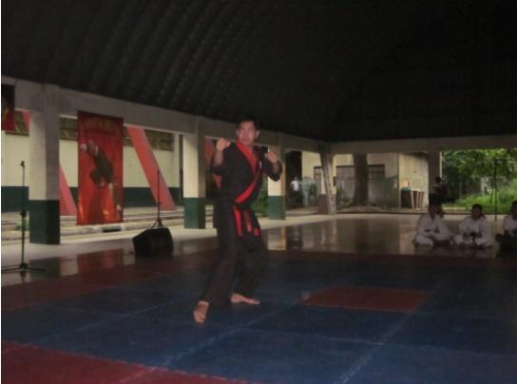

Brod Romy Castilla, from Ateneo de Naga, is a 5th Dan, Black Belt. He is Training Director,
Black Secrets SOMA (BSSOMA).

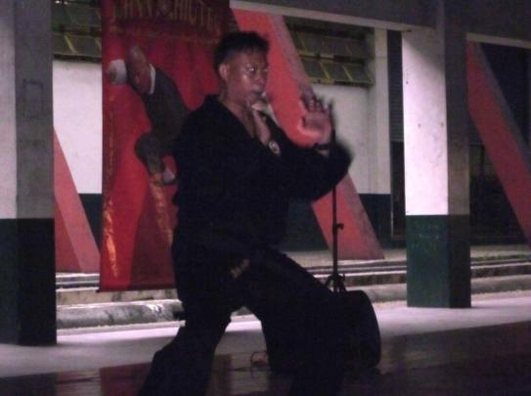

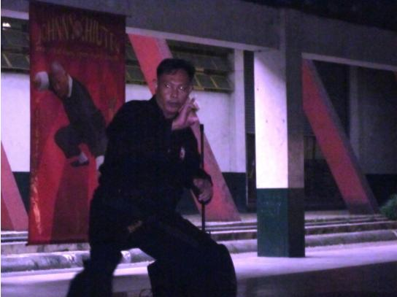

Tiger-Crane Kata by Engr. Mike Anonat, BSSOMA, Ateneo de Naga.

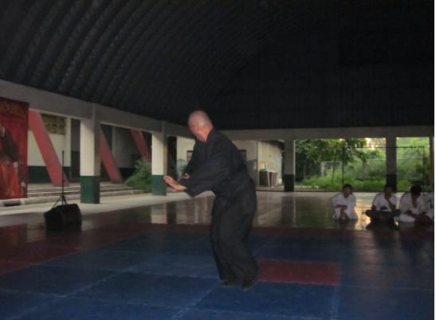
Dragon-Tiger Kata by Brod Ozzie Villaver, 6th Dan Black Belt. He is currently the Head
Instructor, BSSOMA and P.E. Instructor, Ateneo de Naga.

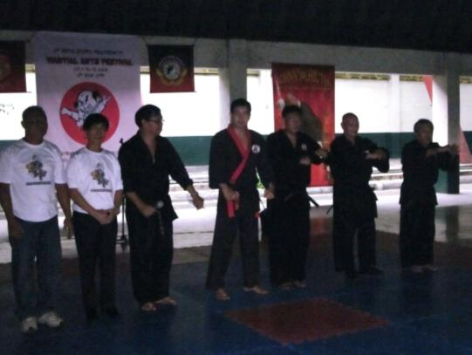

Taking a bow: Brod Nonoy Nolasco (BS Sorsogon); BS Karateka; Brod Perry Goingo,
Dean, Religious Studies, Ateneo de Naga; Romy Castilla; Mike Anonat; Ozzie Villaver;
and Brod Rolly Frejas, 6th Dan Black Belt and Executive Director, BSSOMA.

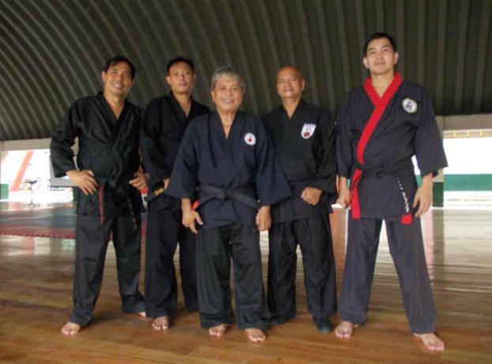

The BSSOMA karatekas (Naga, Sorsogon) who came all the way from Bicol: Perry Goingo,
Mike Anonat, Rolly Frejas, Ozzie Villaver, and Romy Castilla.

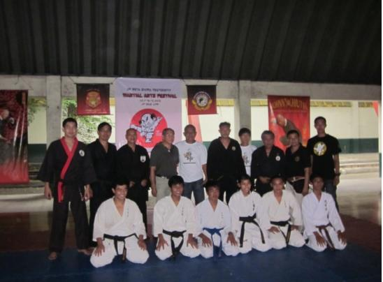

Brod Jopet Laraya with BSSOMA and SREI SOMA Karatekas.

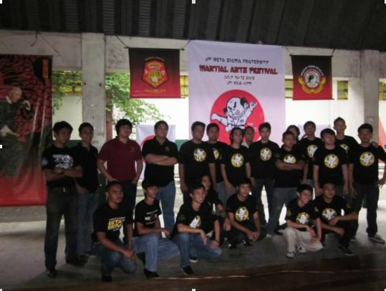

The Diliman and Los Banos resident brods who assisted in the preparations
of the 4-day Martial Arts Festival.

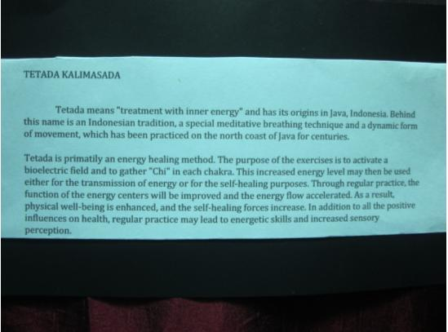

Tetada Kalimasada Presentation- July 11, 2012.

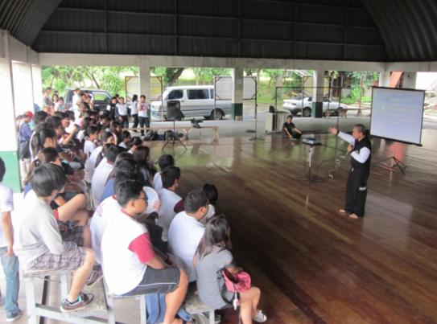

Tetada Kalimasada lecture by Brod Ollie Jumao-as, Pelatih Nasional. He holds the highest
rank of the discipline in Rizal Center, Tetada Indonesia.

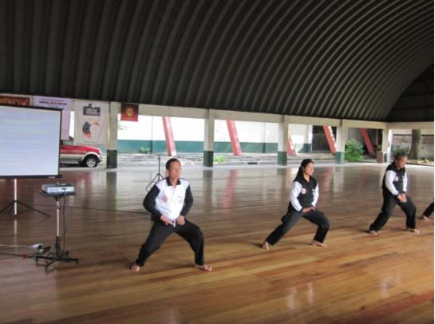

Brod Freddy, Ibu Maria, and Brod Ollie demonstrate the Jurus Rancak, a uniquely choreographed Tetada Kalimasada set of movements designed to harness the energy emitted by the energy centers of the body. In combination with triangular diaphragmatic breathing, these promote healing, prevent illness and can be used for passive self-defense.

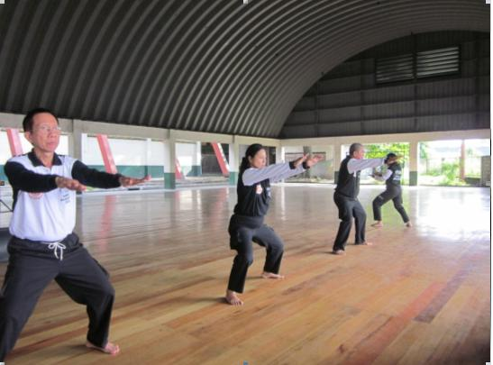

...with Ibu Grace Arandez, far right,

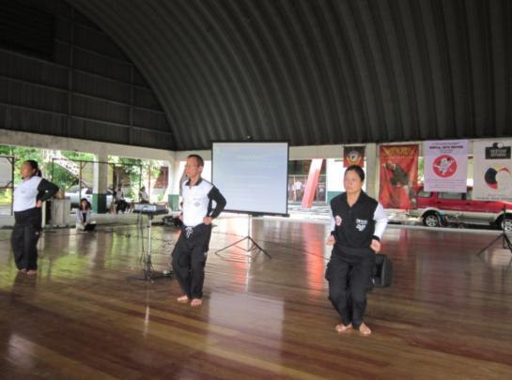

...with Ibu Jo Abad, far left.

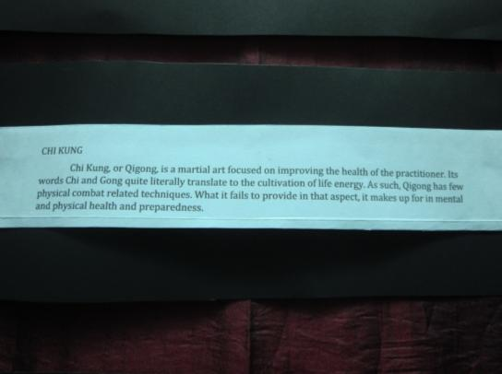

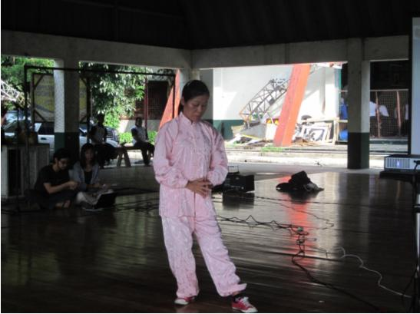

Qigong expert (8th Dan) from Hongkong, Theresa S.H. Chung.
*President-World Organization of Wushu & Kung Fu.
*Chairman-Nature's Wisdom Qigong Wushu Association.
*Association for Advancement of Buddhism Qigong of China.
Certification of Buddhism Qigong Master.
*Hexiangzhuang Qigong Tutor of China Beijing
*Yuen Long Town Hall Community Centre Qigong Class Tutor

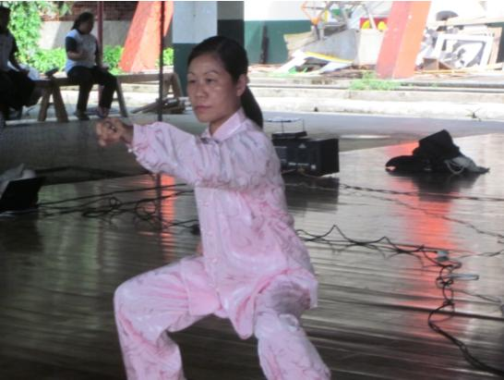

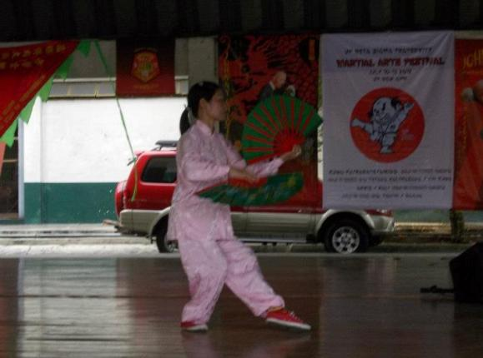

Folding fan kata.

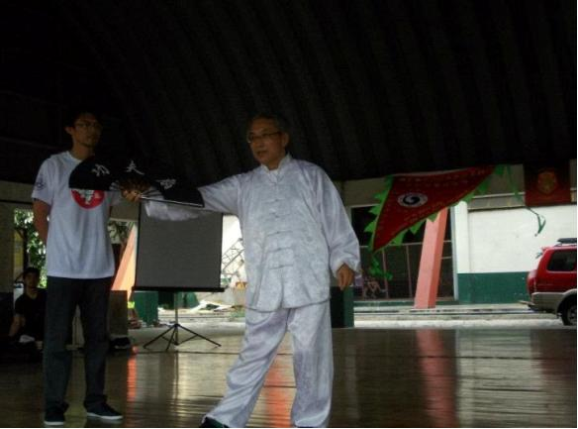

Self defense technique using a folding fan.

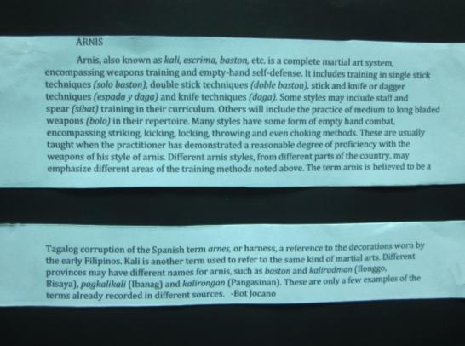

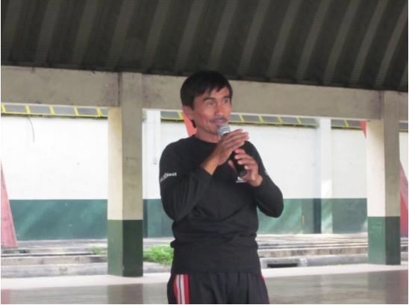
*Nicomedes Elizar, Founder/Grandmaster of World Nickelstick Eskrima (Balintawak style)
based in Cebu City.
*With Johnny Chiuten, he was featured in the book, 'Warrior Arts of the Philippines.'
*Started arnis in 1971 and has since then travelled to West Africa, France, Norway, Spain,
and Russia to teach stick fighting. He goes to Poland and Germany in September 2012.
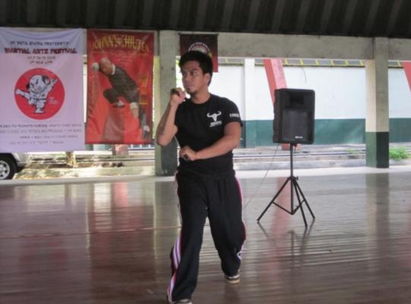

*Just like his father Nick, Norman is equally competent in arnis.
*In December 2009, RA 9850 was passed. An act declaring arnis as the National Martial Art
and Sport in the Philippines. It makes arnis as a requirement for P.E. course of DECS.

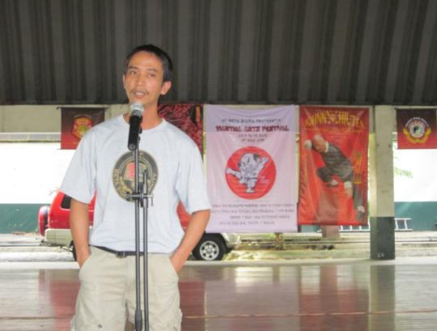
*After studying at UPLB, Brod Mike Alcaraz '89 dabbled in Pekiti Tirsia Kali or Kali for short.
*Kali originated in Negros and is an indigenous fighting art of the Philippines which advocates
the use of the blade.
*He is part of a 4-man team which conducts Kali training in the various tactical units of AFP
and PNP.
*Mike holds a senior rank as Mandala and in 2010 was featured in the National Geographic
series.

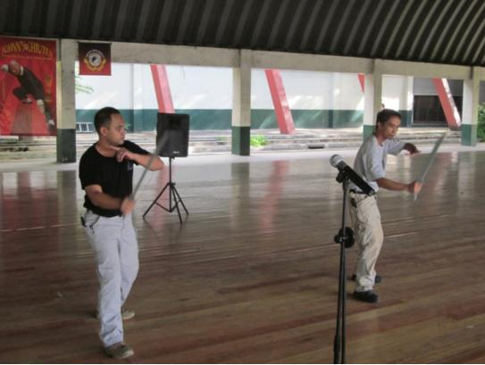

Mike with Bob Rodriguez demonstrate various long blade strikes.

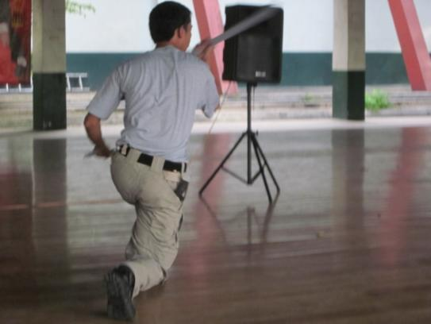

Aside from long blade, Mike is also an expert in knife fighting.

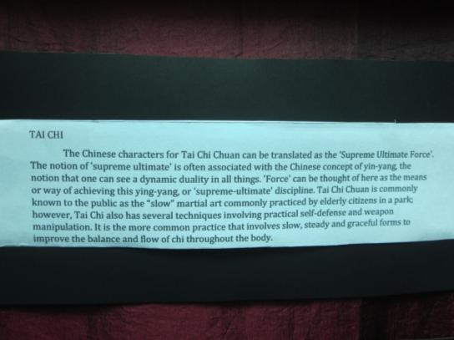

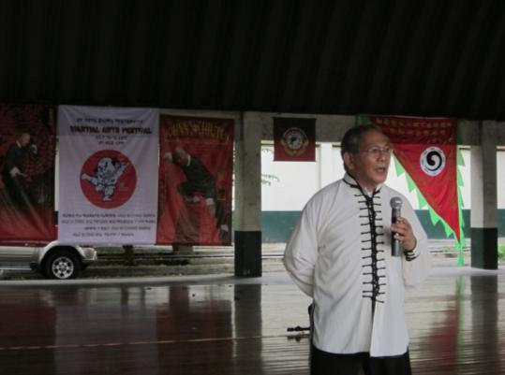

*Tai Chi is one of Jopet's favorite styles as he lectures on the subject at the UP gym.
*Brods say that he is earning more from teaching martial arts than from his veterinary
practice.

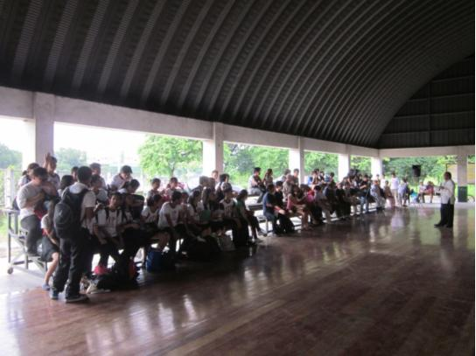

Now based in Hongkong, he continues to learn a new style of Kung Fu. He is currently working out a project in Lantau Island to contain or round up the wild water buffaloes in the island, not to teach them kung fu, but to care and manage them for potential tourism attraction

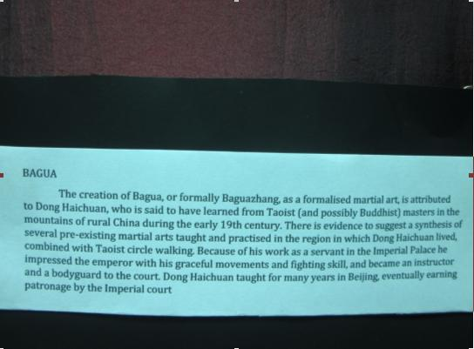

.
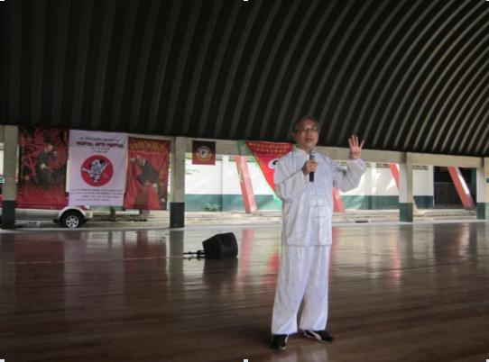

*Sifu Patrick Lee, 8th Dan Fu Style Tai Chi Bagua 3rd generation. Wudang Sword 12th
generation.
*President-World Organization of Wushu & Kung Fu Master.
*Chairman- Association for Advancement of Pa Kua Martial Arts
*Chairman- International Fu Style Tai Chi Bagua Federation
*Chairman-China HK Wudang Internal Martial Arts Federation
*Vice Chairman- China HK Traditional Wushu Federation
*Former President/Bagua Instructor- Chin Woo Athletic Association of HK Ltd.

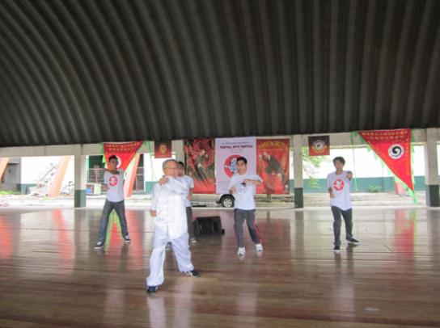

Sifu with Diliman brods Charles Alo et al. and LB Brod, John Alejar.

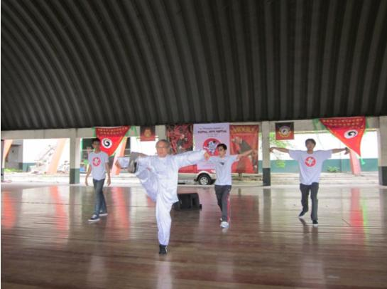

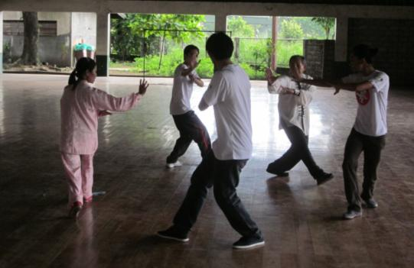

*LB brod John Alejar (foreground), Charles Alo (Diliman) with Theresa and Jopet perform
the Bagua changing palms.
*Fu style bagua consists of four hand forms (Yang palm, Yin palm, and Fu Zhen Song's
signature forms: dragon palm, and dragon palm push hands) and several weapon forms
(broad sword, straight sword, staff, and spear).
*Of the four hand forms of Fu style, the dragon palm is the highest level form in the Fu
style system.

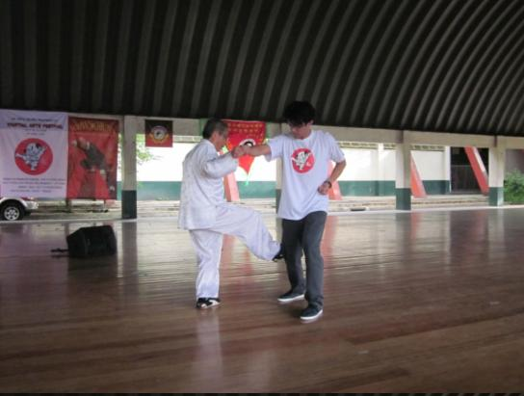

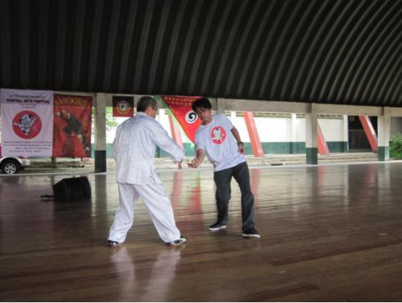

Application of a dragon palm technique.

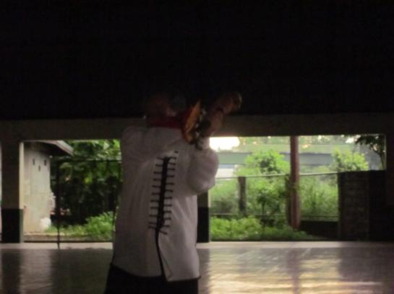

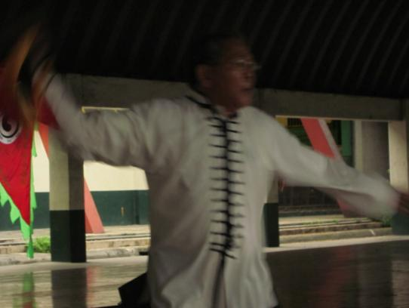

Jopet demonstrates how to use the bagua broad sword.

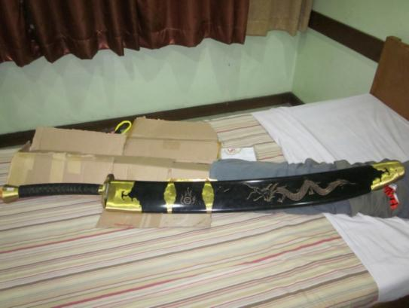

The bagua broad sword inside its scabbard.

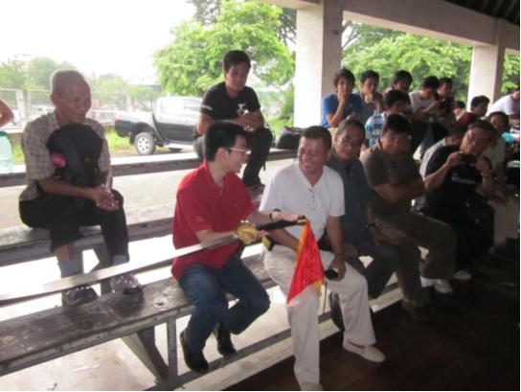

Afraid to hold the sword, the sword was passed on from Brods Mars Robosa, Rene de Rueda,
Oca Mamangon, and Bing Lijauco until finally it landed into the hands of Joram Lijauco.

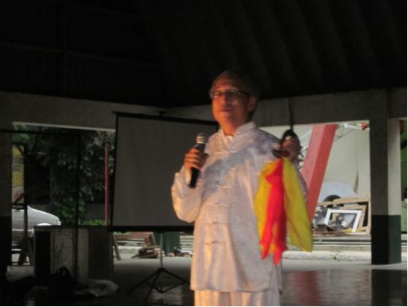

For the first time, Sifu Patrick demonstrated how to use the deer horn blade which was
popularly used by the imperial army during the early times.

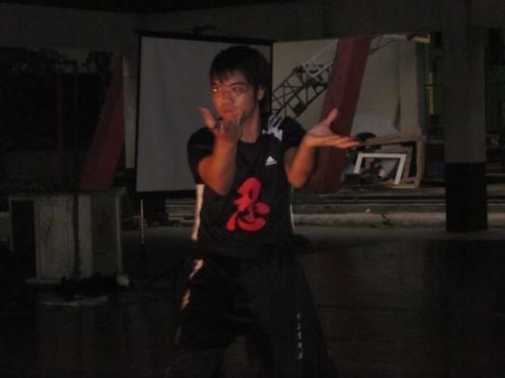

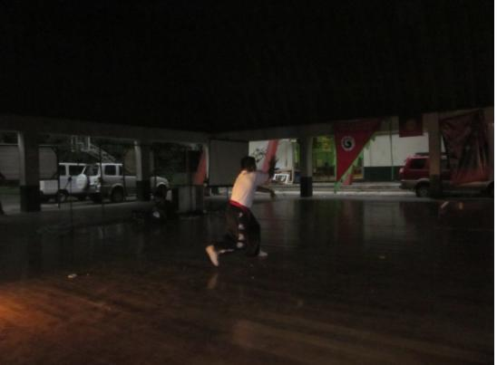

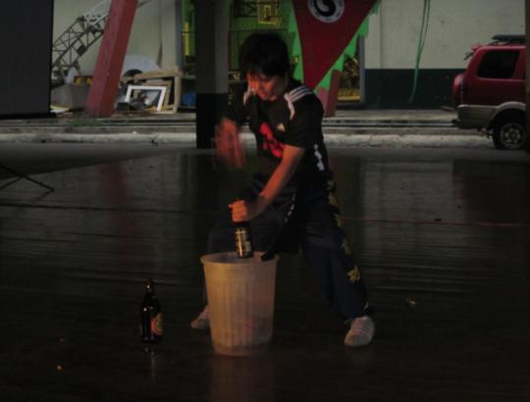

As a bonus presentation, the Shaolin Hung-Fut Kung Fu Club also performed during
the MA Festival, courtesy of Mr. Herman Bognot, instructor at UP.

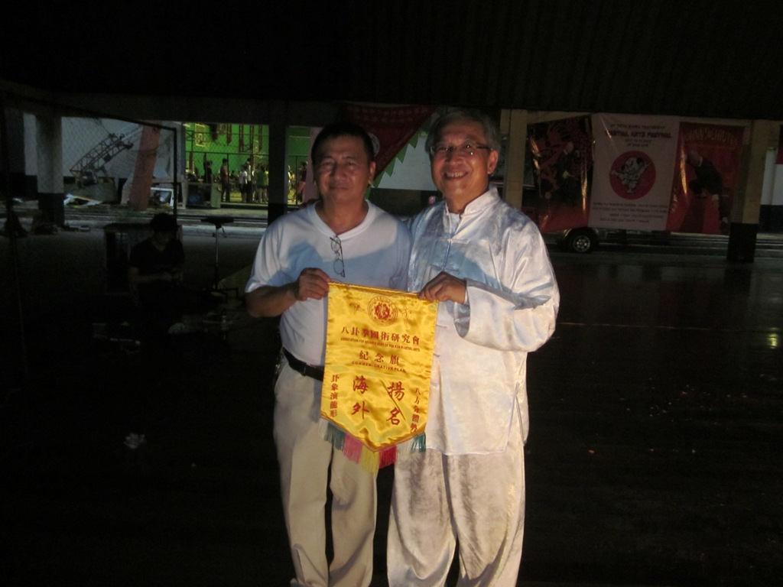

As token of appreciation, Sifu Patrick hands over to Sensei Bing the Fu Style Bagua flag.

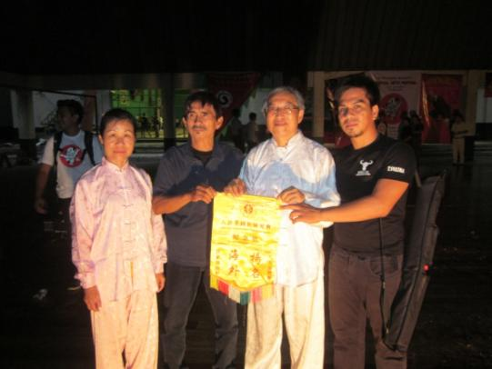

Token of appreciation likewise for Nick and Norman Elizar.

