UPDATE ON THE MURDER CHARGES FACED BY BROD RANDY MALAYAO (Batch 89 UP Visayas)

BACKGROUND:
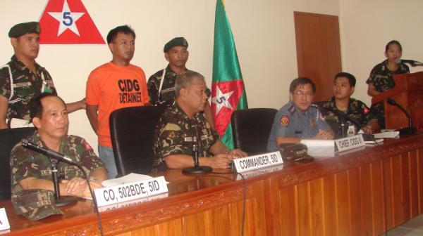
On May 15, 2008, Randy Malayao, 39 years old, UP Visayas batch 89, was on his way to a relative’s house in Pasig when he was abducted by black-clad armed men later identified as agents of the Philippine National Police Criminal Investigation and Detection Group (PNP-CIDG). Brod Randy was officially declared “missing” by human rights groups the following day. In those 5 days, Randy subjected to physical and psychological torture. Five days later, on May 20, Randy was finally presented by the PNP-CIDG at Camp Melchor Dela Cruz in Upi, Gamu, Isabela, Northern Philippines. He was brought before the Regional Trial Court in Tuguegarao, Cagayan and is, to this day currently detained in Cagayan Provincial Jail facing murder charges.

UPDATES:
- Aguinaldo Cases (3 cases – 2 murder at 1 frustrated) – there will be a hearing on February 26 at the Tuguegerao RTC. The presiding judge is the Hon. Jesarene Hilarion, a San Beda law graduate. Randy will be allowed to speak and debunk everything that the prosecution has presented.

- San Mariano Cases (ambush, direct assault with murder) –arraignment stalled because Randy filed a motion to quash.

- Cabarroquis, Quirino cases (2 frustrated murder, raid sa intel house AFP) – dismissed

- Olalia Murder, Ilagan – pending but family set to renege (iniatras na ng pamilya)

- Dibuluan, San Mariano murder (ambush) – pending in the Joint Monitoring Committee of the NDF and GRP.

- Ilagan ambush – pending in JMC of NDF and GRP.

- Ilagan murder, Ilagan ambush April 2007 – pending in JMC of NDF and GRP.

These pending cases, according to Brod Randy, serve as “reserve” cases, in the scenario that the other cases are dismissed; DOJ may still file these later on. In Randy’s own words:
“Lahat trumped up ang mga charges. Puro paningit ang pangalan ko sa lahat ng kaso. Hardly any material evidence. Gusto nila akong ipin-down. Pero kaya ko ito. I shall overcome.”

